# Orleans的Grain實作專案使用.NET Core/.NET5+的依賴注入(DI)機制

Orleans的Grain實作專案可以使用.NET Core/.NET5的依賴注入(Dependency Injection, DI)機制，這樣可以讓Grain實作專案更容易測試，也可以藉此存取到框架核心的功能，Grain State的功能就需要使用依賴注入。

## 使用依賴注入

以下示範如何使用依賴注入做到：

* Grain實作專案可以使用框架核心的功能，如Grain的實作中寫應用程式Log至Silo的彙整Log記錄上。
* Grain使用第三方提供的函式庫/服務，如[Cowsay](https://github.com/rawsonm88/Cowsay) ，就有提供使用.NET Core/.NET5+依賴注入的方式來使用：  
  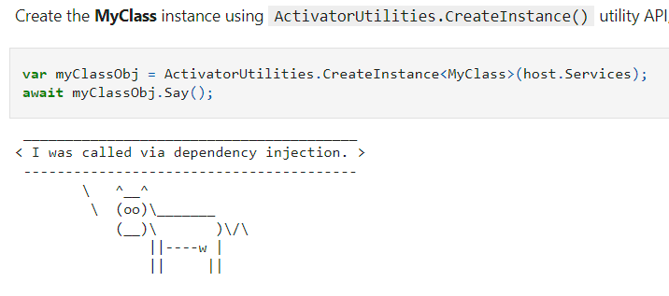  
  此函式庫的使用方法可以參考這個[.NET Interactive Notebook範例](https://github.com/windperson/jupyter_notebooks/blob/main/Cowsay_demo.ipynb)。

1. 建立新的示範Grain專案：在[昨天進度的原始碼git專案](https://github.com/windperson/OrleansRpcDemo/tree/day08)，分別建立新的RPC介面專案和Grain實作專案：

| * 路徑 | * 專案名稱 | * 專案類型 |
| --- | --- | --- |
| * src/Shared | * **RpcDemo.Interfaces.ASCIIArt** | * .NET 6 類別庫(class library) |
| * src/Grains | * **RpcDemo.Grains.Cowsay** | * .NET 6 類別庫(class library) |

* 建議將這兩個專案各自加入根目錄的Orleans.sln方案的 Shared以及Grains方案資料夾(Solution Folder)中。

1. 各專案要安裝的Nuget套件：

| * 專案名稱 | * 需安裝Nuget套件 |
| --- | --- |
| * **RpcDemo.Interfaces.ASCIIArt** | * + [Microsoft.Orleans.Core.Abstractions](https://www.nuget.org/packages/Microsoft.Orleans.Core.Abstractions)   + [Microsoft.Orleans.CodeGenerator.MSBuild](https://www.nuget.org/packages/Microsoft.Orleans.CodeGenerator.MSBuild) |
| * **RpcDemo.Grains.Cowsay** | * + [Cowsay.Abstractions](https://www.nuget.org/packages/Cowsay.Abstractions)   + [Microsoft.Extensions.Logging.Abstractions](https://www.nuget.org/packages/Microsoft.Extensions.Logging.Abstractions)   + [Microsoft.Orleans.Core](https://www.nuget.org/packages/Microsoft.Orleans.Core)   + [Microsoft.Orleans.CodeGenerator.MSBuild](https://www.nuget.org/packages/Microsoft.Orleans.CodeGenerator.MSBuild) |
| * **RpcDemo.Hosting.Console** | * + [Cowsay.Extensions.DependencyInjection](https://www.nuget.org/packages/Cowsay.Extensions.DependencyInjection)   + [Microsoft.Extensions.DependencyInjection.Abstractions](https://www.nuget.org/packages/Microsoft.Extensions.DependencyInjection.Abstractions) |

1. 將 **RpcDemo.Interfaces.ASCIIArt** 專案加入至 **RpcDemo.Grains.Cowsay** 和 **RpcDemo.Client.Console** 的專案對專案參考(project-to-project reference)中。
2. 將 **RpcDemo.Grains.Cowsay** 專案加入至 *src的 **RpcDemo.Hosting.Console** 這個Silo專案的專案對專案參考(project-to-project reference)中。
3. 在 **RpcDemo.Interfaces.ASCIIArt** 專案中，*Class1.cs* 檔案移除，使用以下內容建立一個新的C#介面檔 **ICowsayGrain.cs** ：

* using Orleans;  
    
  namespace RpcDemo.Interfaces.ASCIIArt;  
    
  public interface ICowsayGrain : IGrainWithStringKey  
  {  
   Task<string> Say(string message);  
  }

1. 在 **RpcDemo.Grains.Cowsay** 專案中，*Class1.cs* 檔案移除，使用以下內容建立一個新的C#檔 **CowsayGrain.cs** ：

* using Cowsay.Abstractions;  
  using Microsoft.Extensions.Logging;  
  using Orleans;  
  using RpcDemo.Interfaces.ASCIIArt;  
    
  namespace RpcDemo.Grains.Cowsay;  
    
  public class CowsayGrain : Grain, ICowsayGrain  
  {  
   private readonly ICattleFarmer _cattleFarmer;  
   private string? _grainId;  
   private readonly ILogger<CowsayGrain> _logger;  
    
   public CowsayGrain(ICattleFarmer cattleFarmer, ILogger<CowsayGrain> logger)  
   {  
   _cattleFarmer = cattleFarmer;  
   _logger = logger;  
   }  
    
   public override Task OnActivateAsync()  
   {  
   _grainId = this.GetPrimaryKeyString();  
   return base.OnActivateAsync();  
   }  
    
   //Demo using injected service  
   public async Task<string> Say(string message)  
   {  
   var cattle = await _cattleFarmer.RearCowAsync(_grainId ?? "default");  
   var saying = cattle.Say(message);  
   _logger.LogInformation("Cow {0} said:\r\n{1}", _grainId, saying);  
   return saying;  
   }  
  }

1. 修改**RpcDemo.Hosting.Console** Silo專案的 *Program.cs* 檔案為以下內容：

* using System.Net;  
  using Microsoft.Extensions.DependencyInjection;  
  using Microsoft.Extensions.Logging;  
  using Orleans;  
  using Orleans.Configuration;  
  using Orleans.Hosting;  
  using RpcDemo.Grains.Cowsay;  
  using RpcDemo.Grains.Greeting;  
    
  var siloHost = new SiloHostBuilder()  
   .ConfigureServices(services => { services.AddCowsay(); })  
   .UseLocalhostClustering()  
   .Configure<ClusterOptions>(options =>  
   {  
   options.ClusterId = "console-host-01";  
   options.ServiceId = "Demo Greeting Service";  
   })  
   .Configure<EndpointOptions>(options => options.AdvertisedIPAddress = IPAddress.Loopback)  
   .ConfigureApplicationParts(parts =>  
   {  
   parts.AddApplicationPart(typeof(HelloGrain).Assembly).WithReferences();  
   parts.AddApplicationPart(typeof(CowsayGrain).Assembly).WithReferences();  
   })  
   .ConfigureLogging(logging =>  
   {  
   logging.AddConsole();  
   logging.AddDebug();  
   })  
   .Build();  
    
  //Tricks to manually wait for Ctrl+C key press  
  var waitForProcessShutdown = new ManualResetEvent(false);  
  Console.CancelKeyPress += (sender, eventArgs) =>  
  {  
   eventArgs.Cancel = true;  
   waitForProcessShutdown.Set();  
  };  
    
  await siloHost.StartAsync();  
  Console.WriteLine("===\r\nOrleans Silo started and able to connect,\r\nPress Ctrl+C to shut down when client finish demonstration...\r\n===");  
  waitForProcessShutdown.WaitOne();  
    
  Console.WriteLine("Shutting down Silo...");  
  await siloHost.StopAsync().ConfigureAwait(false);  
  Console.WriteLine("===\r\nSilo shutdown complete, exiting...\r\n===");  
  Environment.Exit(0);
* 最主要的差異如下圖：  
  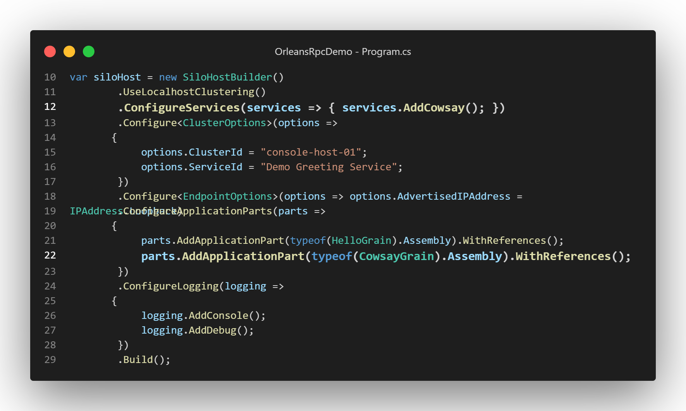  
  第12行增加了 [ConfigureServices()](https://learn.microsoft.com/en-us/dotnet/api/orleans.hosting.isilobuilder.configureservices) 方法的呼叫以便註冊依賴注入的元件，還有第22行將 CowsayGrain 加入Silo要載入的Grain類別之設定 。

1. 修改**RpcDemo.Client.Console** Client專案的 *Program.cs* 檔案為以下內容：

* using Orleans;  
  using Orleans.Configuration;  
  using RpcDemo.Interfaces.ASCIIArt;  
  using RpcDemo.Interfaces.Hello;  
    
  using static System.Console;  
    
  WriteLine("\r\n---Orleans RPCDemo Client---");  
  WriteLine("\r\n---\r\nInitializing Orleans Client...\r\n---");  
  var client = new ClientBuilder()  
   .UseLocalhostClustering()  
   .Configure<ClusterOptions>(options =>  
   {  
   options.ClusterId = "console-client-01";  
   options.ServiceId = "Demo Greeting Service";  
   })  
   .ConfigureApplicationParts(parts =>  
   {  
   parts.AddApplicationPart(typeof(IHelloGrain).Assembly).WithReferences();  
   parts.AddApplicationPart(typeof(ICowsayGrain).Assembly).WithReferences();  
   })  
   .Build();  
    
  WriteLine(  
   "Please wait until Orleans Server is started and ready for connections, then press any key to start connect...");  
  ReadKey();  
  await client.Connect();  
  WriteLine("\r\n---\r\nOrleans Client connected\r\n---");  
    
  var helloGrain = client.GetGrain<IHelloGrain>(0);  
  var helloResult = await helloGrain.SayHello("Orleans");  
  WriteLine($"\r\n---\r\nCall HelloGrain.SayHello(\"Orleans\") =\r\n{helloResult}\r\n---");  
    
  var cowsayGrain = client.GetGrain<ICowsayGrain>("default");  
  var cowsayResult = await cowsayGrain.Say("Orleans");  
  WriteLine($"\r\n---\r\nCall CowsayGrain.Say(\"Orleans\") =\r\n{cowsayResult}\r\n---");  
    
  WriteLine("Demonstration finished, press any key to exit...");  
  ReadKey();  
    
  await client.Close();  
  client.Dispose();
* 在客戶端的程式碼也是類似Silo相對應的加了對 ICowsayGrain RPC介面的註冊，後續就是取得RPC參考實體和呼叫 Say() 方法，並且輸出結果。

實際執行起來的 Demo 畫面如下，可以看到CowsayGrain藉由DI注入的Logger可以把訊息寫到Silo的Debug Console的Log訊息上：  
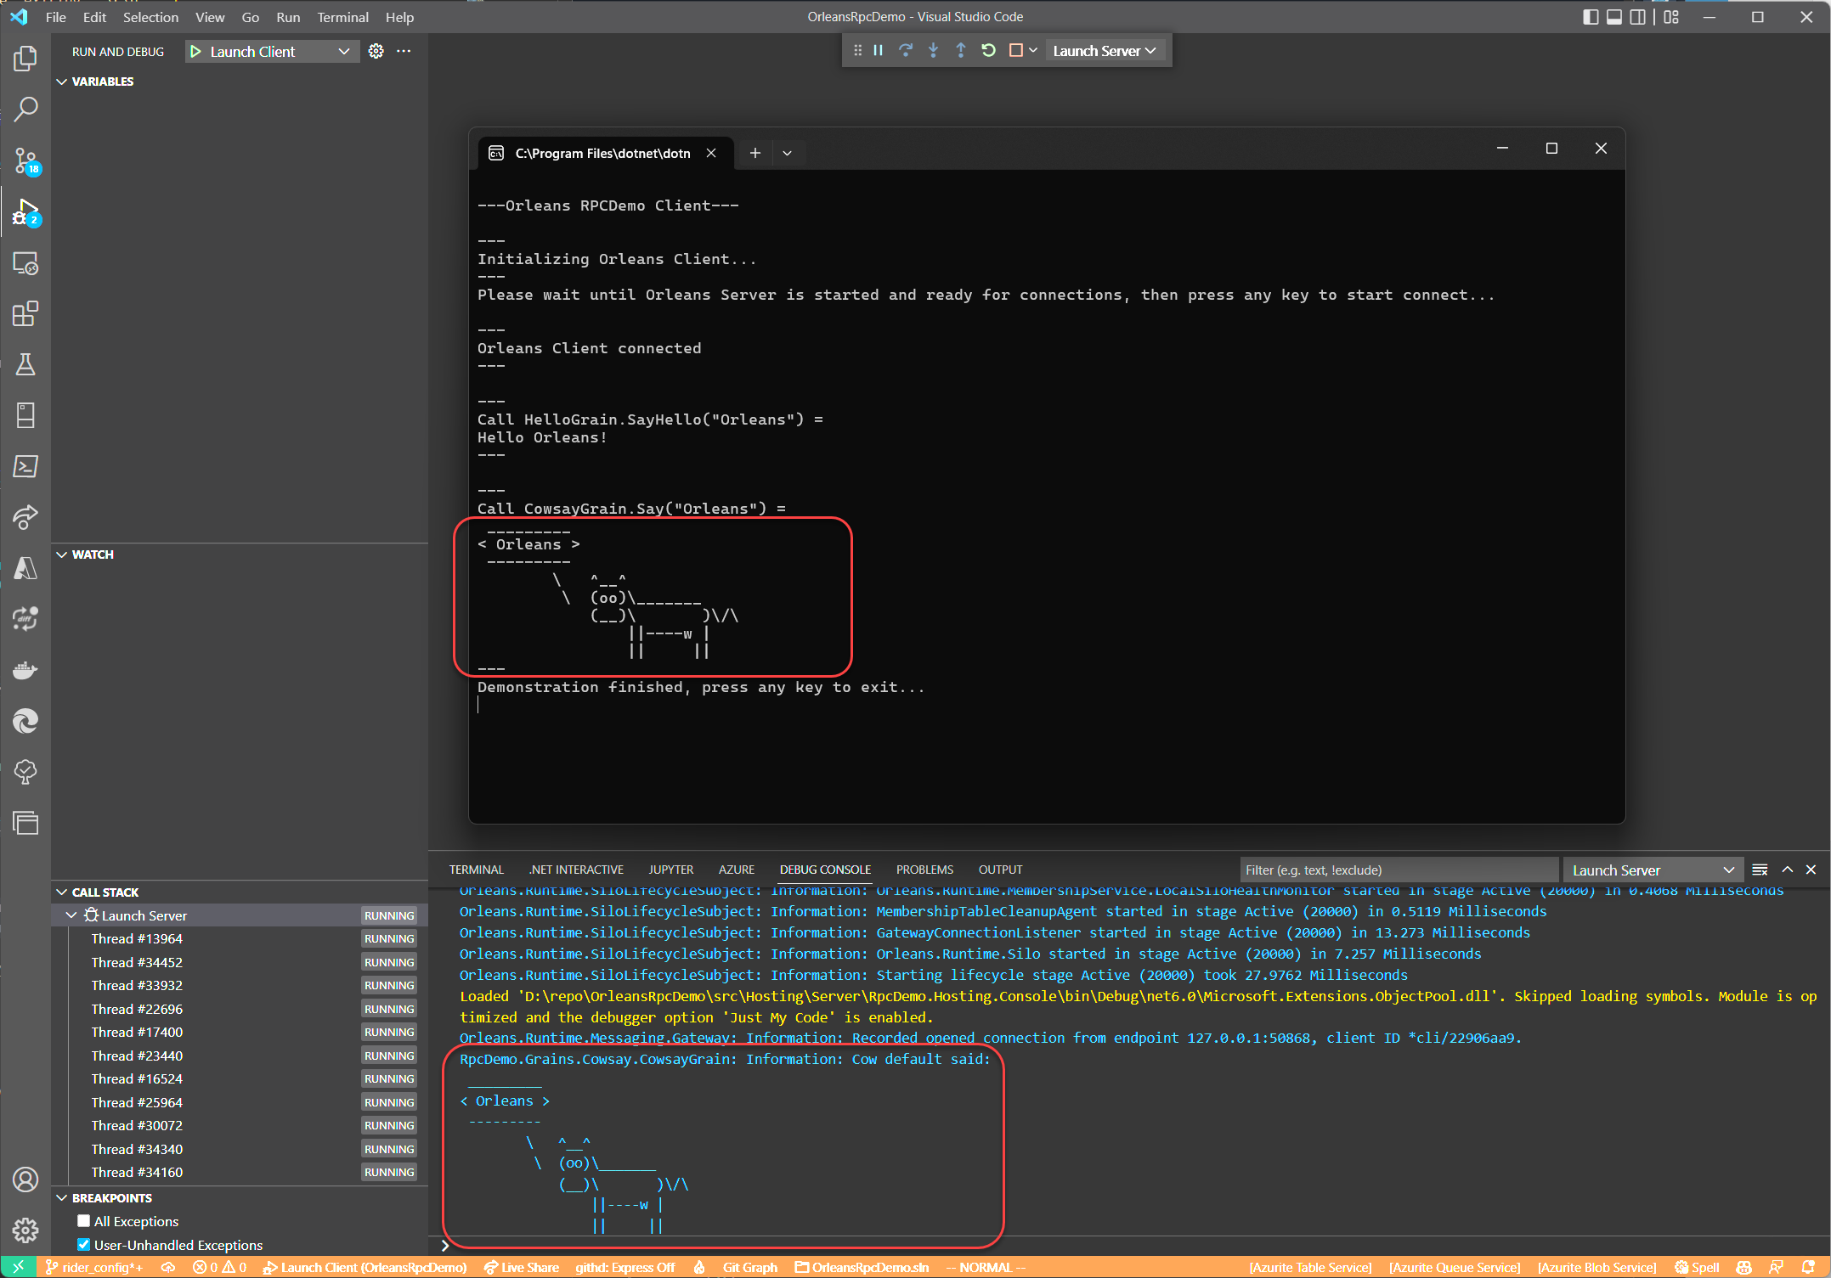

## 使用依賴注入Grain專案的單元測試

1. 在程式碼專案根目錄的 *tests* 目錄之下建立一個 **CowsayGrain.Tests** 的xUnit單元測試專案：

* dotnet new xunit --no-restore --name CowsayGrain.Tests

1. 將 [**Microsoft.Orleans.TestingHost**](https://www.nuget.org/packages/Microsoft.Orleans.TestingHost) 、 [**ILogger.Moq**](https://www.nuget.org/packages/ILogger.Moq) 、 [**Moq**](https://www.nuget.org/packages/Moq) 這幾個Nuget套件安裝到測試專案中。
2. 將 **RpcDemo.Grains.Cowsay** 專案加入至此測試專案的專案對專案參考(project-to-project reference)中。
3. 將 **CowsayGrain.Tests** 測試專案的預設 *UnitTest1.cs* 檔刪除，新增 **CowsayGrainTest.cs** 檔案為以下內容：

* using Cowsay.Abstractions;  
  using Microsoft.Extensions.DependencyInjection;  
  using Microsoft.Extensions.Logging;  
  using Moq;  
  using Orleans.Hosting;  
  using Orleans.TestingHost;  
  using RpcDemo.Interfaces.ASCIIArt;  
  using SUT = RpcDemo.Grains.Cowsay;  
    
  namespace CowsayGrain.Tests;  
    
  public class CowsayGrainTest  
  {  
   private static Mock<ILogger<SUT.CowsayGrain>>? _mockLogger;  
    
   private class TestSiloConfigurator : ISiloConfigurator  
   {  
   public void Configure(ISiloBuilder siloBuilder)  
   {  
   _mockLogger = new Mock<ILogger<SUT.CowsayGrain>>();  
   var mockLoggerFactory = new Mock<ILoggerFactory>();  
   mockLoggerFactory  
   .Setup(x => x.CreateLogger(It.IsAny<string>()))  
   .Returns(() => _mockLogger.Object);  
    
   var mockCow = new Mock<ICow>();  
   mockCow  
   .Setup(x => x.Say(It.IsAny<string>(), It.IsAny<string>(), It.IsAny<string>(), It.IsAny<int>(),  
   It.IsAny<bool>()))  
   .Returns((string message, string eyes, string tongue, int cols, bool isThought) => message);  
    
   var mockCattleFarmer = new Mock<ICattleFarmer>();  
   mockCattleFarmer.Setup(x => x.RearCowAsync(It.IsAny<string>())).ReturnsAsync(mockCow.Object);  
    
   siloBuilder  
   .ConfigureServices(services =>  
   {  
   services.AddSingleton(mockCattleFarmer.Object);  
   services.AddSingleton(mockLoggerFactory.Object);  
   });  
   }  
   }  
    
   [Fact]  
   public async Task SayTest()  
   {  
   //Arrange  
   var builder = new TestClusterBuilder();  
   builder.AddSiloBuilderConfigurator<TestSiloConfigurator>();  
   var cluster = builder.Build();  
   await cluster.DeployAsync();  
   const string expected = "Hello Orleans!";  
    
   //Act  
   var grain = cluster.GrainFactory.GetGrain<ICowsayGrain>("default");  
   var result = await grain.Say(expected);  
    
   //Assert  
   Assert.Equal(expected, result);  
    
   _mockLogger!.VerifyLog(logger =>  
   logger.LogInformation("Cow {0} said:\r\n{1}", It.IsAny<string>(), It.IsAny<string>()), Times.Exactly(1));  
   }  
  }
* [ILogger.Mq](https://github.com/adrianiftode/Moq.ILogger)可換掉實際被依賴注入的Logger實體以便在測試專案內檢驗Grain實作程式碼時是否有呼叫到寫Log的功能，如 LogInformation()；而使用[Moq](https://github.com/moq/moq4)來換掉原本Cowsay函式庫的依賴注入介面： ICattleFarmer 的 RearCowAsync() 方法和 ICow物件實體呼叫 Say() 方法提供的的結果，以便在測試專案內換掉原本Cowsay函式庫會印出ASCII圖案的行為，直接回傳原本輸入的訊息，方便做Assert驗證。

而原本Cowsay函式庫提供用來簡化依賴注入註冊樣版程式碼的service.AddCowSay()擴充方法，其[內部的實作機制](https://github.com/rawsonm88/Cowsay/blob/f1f3dd153e3d1c9b951bfeafbcf575ea5d4fdef7/Cowsay.Extensions.DependencyInjection/ServiceCollectionExtensions.cs#L13)就是將 ICattleFarmer 以Singleton生命週期註冊到DI容器中；因此在測試Silo的配置設定程式碼中，只需也做同樣的方式註冊預備好的mock物件，就可以在跑單元測試時換掉原本的依賴注入實體來使用，同樣的技巧也可以換掉 Orleans 一些提供公開介面(Interface)的框架層級物件，以方便測試。

整個完成的範例程式GitHub專案在：<https://github.com/windperson/OrleansRpcDemo/tree/day09>

明天將繼續介紹Orleans最特殊的Grain State狀態儲存功能，敬請期待。