Rethinking Segmentation Evaluation in Breast Ultrasound Through the Lens of Negative Cases

Windra Swastika¹*, Paulus Lucky Tirma Irawan²

¹² Faculty of Technology and Design, Universitas Ma Chung, Malang, Indonesia
* Corresponding author: windra.swastika@machung.ac.id

Abstract

The Dice coefficient is the standard evaluation metric in medical image segmentation, yet its behavior on empty ground-truth masks — arising when datasets include normal (lesion-free) cases — remains systematically unexamined. Any false-positive pixel predicted on an empty mask causes the score to collapse to zero regardless of error magnitude, producing a discontinuous penalty that distorts mean performance and can invert model rankings. We present a four-phase study of this phenomenon on the Breast Ultrasound Images (BUSI) dataset (780 images; 437 benign, 210 malignant, 133 normal). Mathematical analysis formalizes the discontinuity and shows that six widely used implementations return inconsistent scores on identical inputs, with true-negative behavior ranging from 0.0 to 1.0 depending on the library. A bootstrap simulation (200 runs; N = 780) shows that ranking inversion onset occurs at a 20% normal-case proportion, with inversion rates of 68% at 25% and 100% at 35%. Empirically, five architectures — U-Net, Attention U-Net, U-Net++, MA-Net, and LinkNet, all with ResNet-34 encoders — are evaluated under three protocols: standard mean Dice (P1), positive-case-only Dice (P2), and the proposed Stratified Evaluation Framework (SEF). Two of five models exchange rankings between P1 and P2. SEF further reveals that U-Net++ achieves the highest positive-case Dice (0.781) yet the lowest specificity on normal cases (0.810), a clinically critical trade-off invisible to standard protocols. We propose SEF as a reproducible, prevalence-weighted protocol that decouples segmentation accuracy from false-positive control on normal cases.

Keywords: segmentation; ultrasound; evaluation; Dice coefficient; specificity; benchmark; reproducibility

1. Introduction
Breast cancer remains the most frequently diagnosed malignancy worldwide, and early detection is the primary determinant of clinical outcome. Ultrasound imaging is a widely available, radiation-free modality that complements mammography, particularly for dense breast tissue. Deep learning has transformed automated breast ultrasound (BUS) analysis, with segmentation models now achieving state-of-the-art performance on public benchmarks (Litjens et al., 2017). Encoder-decoder architectures such as U-Net (Ronneberger et al., 2015), Attention U-Net (Oktay et al., 2018), and their variants have become standard baselines across the field (Siddique et al., 2021).
Model comparison depends critically on the evaluation metric. The Dice similarity coefficient — equivalent to the F1 score for binary predictions — has become the de facto standard for segmentation benchmarks (Taha and Hanbury, 2015; Maier-Hein et al., 2022). Its interpretation is intuitive: a value of 1.0 indicates perfect overlap between prediction and ground truth, while 0.0 indicates no overlap. However, this apparent simplicity conceals a fundamental mathematical instability when ground-truth masks are empty — a scenario that arises whenever a dataset includes normal (lesion-free) cases.
Breast ultrasound datasets routinely include normal cases for which the ground-truth mask contains no foreground pixels. The BUSI dataset (Al-Dhabyani et al., 2020), the primary public benchmark for BUS segmentation, contains 133 such cases (17.1%). The smoothing constant introduced to prevent division by zero in Dice creates a severe asymmetry on empty masks: a true-negative prediction receives a score of 1.0, whereas any prediction containing even a single false-positive pixel receives a score approaching 0.0 — a binary collapse with no gradation proportional to error magnitude. This discontinuity propagates into dataset-level mean Dice scores in ways that depend on the proportion of normal cases and the false-positive behavior of each model, introducing a confound that is rarely reported in published benchmarks.
The practical consequence is that two models may appear to have similar mean Dice scores under one evaluation configuration yet produce completely reversed rankings under another, without any change in their underlying segmentation quality on positive cases. This constitutes a reproducibility hazard that has not been formally characterized in the medical image segmentation literature, despite recent calls for greater scrutiny of evaluation protocols (Reinke et al., 2024; Maier-Hein et al., 2022).
This paper makes four contributions:
(1) A formal mathematical proof that the Dice coefficient exhibits a discontinuous penalty on empty ground-truth masks, together with an empirical survey showing that six widely used implementations handle this case inconsistently, producing non-comparable scores on identical inputs.
(2) A bootstrap simulation quantifying the relationship between the proportion of normal cases in a dataset and the probability of ranking inversion, providing actionable thresholds for benchmark designers.
(3) An empirical validation training five segmentation architectures under identical conditions on the BUSI dataset, demonstrating real ranking instability even at the dataset's relatively low normal-case proportion of 17.1%.
(4) The Stratified Evaluation Framework (SEF), a reproducible, prevalence-weighted protocol that separates segmentation quality on positive cases from false-positive control on normal cases, exposing clinically relevant trade-offs invisible to standard protocols.
The remainder of this paper is organized as follows. Section 2 reviews related work on BUS segmentation and evaluation metrics. Section 3 describes the methodology across all four phases. Section 4 presents and analyses results. Section 5 concludes.

2. Related Work

2.1 Breast Ultrasound Image Segmentation
Automated segmentation of breast lesions has been an active research area for over two decades. Xian et al. (2018) provided a comprehensive survey of automatic BUS segmentation methods, covering active contour, graph-cut, and early deep learning approaches. Yap et al. (2018) conducted a comparative study of deep convolutional methods for BUS lesion detection and segmentation, establishing early benchmarks for the field. More recently, Gu et al. (2020) proposed a comprehensive attention convolutional network that demonstrated the utility of multi-scale attention for lesion delineation in ultrasound images.
The BUSI dataset (Al-Dhabyani et al., 2020) has emerged as the primary public benchmark for BUS segmentation, comprising 780 images across three classes: benign, malignant, and normal. Its inclusion of 133 normal cases (17.1%) makes it particularly susceptible to the metric pathology examined in this work, and its well-defined normal class provides a natural testbed for stratified evaluation.

2.2 Deep Learning Architectures for Medical Image Segmentation
U-Net (Ronneberger et al., 2015) established the encoder-decoder paradigm with skip connections as the foundational architecture for medical image segmentation. Using a ResNet-34 backbone pretrained on ImageNet (He et al., 2016) as the encoder has since become a standard practice to leverage transfer learning. Oktay et al. (2018) extended U-Net with attention gates that suppress irrelevant feature map activations. Zhou et al. (2019) introduced U-Net++ with densely nested skip connections to reduce the semantic gap between encoder and decoder features. Fan et al. (2020) proposed MA-Net incorporating multi-scale channel attention, and Chaurasia and Culurciello (2017) designed LinkNet as a lightweight alternative sharing encoder weights with the decoder for computational efficiency. A systematic review of U-Net variants for medical imaging is provided by Siddique et al. (2021).

2.3 Evaluation Metrics and Known Limitations
Taha and Hanbury (2015) conducted a comprehensive analysis of metrics for volumetric medical image segmentation, identifying Dice and Hausdorff distance as the most informative complementary pair. However, this analysis focused on positive-case evaluation and did not address the behavior of Dice on empty masks. Jadon (2020) reviewed loss functions for semantic segmentation — including Dice loss and its variants — and noted numerical instabilities in edge cases. Sudre et al. (2017) introduced a generalised Dice overlap that adjusts for class imbalance, but without specific treatment of the empty-mask discontinuity.
Bertels et al. (2019) analyzed Dice as a loss function during training and noted numerical instabilities in the empty-mask scenario, but did not quantify the effect on dataset-level rankings. Reinke et al. (2024) and Maier-Hein et al. (2022) identified a broad class of metric-related pitfalls in image analysis validation, including class imbalance sensitivity and undefined edge-case behavior, and recommended multi-metric reporting. Our work complements these frameworks by formally characterizing the specific and pervasive pathology of Dice on empty masks in benchmark datasets containing normal cases, and by quantifying its effect on comparative model evaluation.

3. Methods

3.1 Dataset and Data Split
All experiments use the publicly available BUSI dataset (Al-Dhabyani et al., 2020), comprising 780 ultrasound images from 600 female patients aged 25 to 75 years. The dataset contains 437 benign cases, 210 malignant cases, and 133 normal cases. Expert-annotated binary segmentation masks accompany each case; where multiple masks were provided, the union was computed. Normal cases have empty masks (no foreground pixels). Table 1 reports the stratified split used in all experiments (seed = 42), stored in data_split.csv for full reproducibility.

Table 1. Stratified dataset split for the BUSI dataset (seed = 42).
Class | Total | Train (70%) | Val. (15%) | Test (15%) | Proportion
Benign | 437 | 305 | 65 | 67 | 56.0%
Malignant | 210 | 147 | 31 | 32 | 26.9%
Normal | 133 | 93 | 19 | 21 | 17.1%
Total | 780 | 545 | 115 | 120 | 100%
Stratified random split preserving class proportions. Normal cases have empty ground-truth masks (no foreground pixels). Val. = validation set. Proportion = fraction of total dataset.

3.2 Phase 1: Mathematical Analysis of the Empty-Mask Problem
We formally characterize the behavior of the Dice coefficient when the ground-truth mask is empty. For binary prediction P and ground truth G, the smoothed Dice coefficient (Dice, 1945) is defined as Eq. (1), where ε is a smoothing constant (typically 1 × 10⁻⁶) added to prevent division by zero.
D(P, G) = (2|P ∩ G| + ε) / (|P| + |G| + ε) (1)
Substituting G = ∅ (empty ground truth, |G| = 0) into Eq. (1) yields Eq. (2).
D(P, G = ∅) = ε / (|P| + ε) (2)
Two cases arise from Eq. (2). When |P| = 0 (True Negative), D = 1.0 via the smoothing term. When |P| > 0 (any False Positive), D ≈ 0 regardless of the number of false-positive pixels. We term this the binary collapse property: any non-zero prediction on an empty ground truth incurs the maximum possible penalty with no proportional gradation. We empirically verify this property across pixel counts ranging from 0 to 10,000 on 256 × 256 images (65,536 pixels total), and survey the handling of this edge case across six widely used implementations: three custom variants, scikit-learn f1_score, MONAI DiceMetric (Cardoso et al., 2022), and torchmetrics Dice.

3.3 Phase 2: Simulation Study
To quantify the relationship between normal-case proportion and ranking inversion probability, we designed a parametric bootstrap simulation anchored to observed empirical values. Two hypothetical models were defined: Model A (true Dice on positive cases D_A = 0.748; false-positive rate on normal cases r_A = 0.80) and Model B (D_B = 0.589; r_B = 0.30). Model A is the stronger segmentor but generates false positives on normal cases more frequently than Model B.
For each of ten normal-case proportion values π₋ ∈ {0, 0.05, 0.10, …, 0.50}, we ran 200 independent bootstrap iterations (N = 780 total cases; seed = 42). In each iteration, positive-case Dice values were sampled from N(D_true, 0.05) clipped to [0, 1]. Normal-case Dice values were drawn as 0.0 (false positive, Bernoulli with probability r) or 1.0 (true negative). A ranking inversion was recorded when the model with lower true Dice reported higher mean Dice. We additionally ran a full grid of 55 scenarios over FP rates {0.1, 0.2, 0.3, 0.5, 0.8} to characterize the inversion surface.

3.4 Phase 3: Empirical Multi-Model Evaluation

3.4.1 Model Architectures
Five architectures were evaluated, all using a ResNet-34 encoder pretrained on ImageNet (He et al., 2016) via the segmentation-models-pytorch library: U-Net (Ronneberger et al., 2015), Attention U-Net (Oktay et al., 2018), U-Net++ (Zhou et al., 2019), MA-Net (Fan et al., 2020), and LinkNet (Chaurasia and Culurciello, 2017). Using a shared encoder isolates the effect of decoder architecture on the metric behavior under investigation.

3.4.2 Training Protocol
All models were implemented in PyTorch (Paszke et al., 2019) and trained with identical hyperparameters: Dice loss combined with binary cross-entropy loss (equal weighting); AdamW optimizer (Loshchilov and Hutter, 2019) with learning rate 1 × 10⁻⁴ and weight decay 1 × 10⁻⁵; cosine annealing learning rate scheduling; batch size 16; maximum 100 epochs; early stopping with patience = 15 evaluation cycles (assessed every 5 epochs). Input images were converted to grayscale and resized to 256 × 256 pixels. Augmentation was applied using Albumentations (Buslaev et al., 2020): horizontal flip, vertical flip, rotation, shift-scale-rotate, brightness adjustment, Gaussian noise, and elastic transform. All random operations used seed = 42. Checkpoints were selected based on validation Dice on positive cases only (Protocol P2) to avoid the confound under investigation.

3.4.3 Evaluation Protocols
Three evaluation protocols were applied to the held-out test set (n = 120):
P1 — Standard: Mean Dice across all 120 test cases (including 21 normal cases), with smoothing ε = 1 × 10⁻⁶. This mirrors the most common reported metric in the BUS segmentation literature.
P2 — Audit: Mean Dice restricted to the 99 positive test cases (benign and malignant). This isolates true segmentation quality by excluding the empty-mask confound.
P3 — SEF: The Stratified Evaluation Framework (Section 3.5), which reports segmentation Dice on positive cases and specificity on normal cases separately, combined via a prevalence-weighted composite score.

3.5 Proposed Stratified Evaluation Framework (SEF)
Standard evaluation protocols conflate two clinically distinct tasks: accurate lesion delineation on positive cases, and suppression of spurious predictions on normal cases. These tasks carry different clinical consequences — a false positive on a normal case may trigger an unnecessary biopsy, while poor segmentation on a positive case may compromise surgical planning or staging accuracy. SEF separates these pathways explicitly.
Let {(Pᵢ, Gᵢ, ℓᵢ)} denote the test set, with ℓᵢ ∈ {benign, malignant, normal}. Let 𝒫 and 𝒩 denote positive and normal index sets (|𝒫| = N₊, |𝒩| = N₋). SEF defines three quantities. Segmentation Dice, evaluated only on positive cases:
Dice_seg = (1/N₊) Σᵢ∈𝒫 (2|Pᵢ ∩ Gᵢ| + ε) / (|Pᵢ| + |Gᵢ| + ε) (3)
Specificity, evaluated only on normal cases, where P̂ᵢ = {x : Pᵢ(x) > τ} (τ = 0.5):
Specificity = |{i ∈ 𝒩 : P̂ᵢ = ∅}| / N₋ (4)
SEF composite score, weighted by normal-case prevalence π₋ = N₋ / (N₊ + N₋):
SEF_composite = (1 − π₋) · Dice_seg + π₋ · Specificity (5)
In this study, π₋ = 133/780 = 0.171, reflecting the actual BUSI normal-case proportion. This parameter is explicit and adjustable: researchers applying SEF to populations with higher normal-case prevalence (typically 0.30–0.40 clinically) should adjust π₋ accordingly and report the value used. The framework additionally reports detection sensitivity — the fraction of positive cases in which the model produces a non-empty prediction — to identify models that may suppress output too aggressively.

3.6 Statistical Analysis
Statistical significance of pairwise performance differences was assessed using the Wilcoxon signed-rank test (Wilcoxon, 1945) on per-case P2 Dice scores (n = 99 positive test cases). The non-parametric Wilcoxon test is preferred over a paired t-test due to the non-normal distribution of per-case Dice scores, which exhibits strong left skew from cases with low lesion-to-image area ratios. All 10 pairwise comparisons among the five models were tested at a significance threshold of α = 0.05.

4. Results and Analysis

4.1 Phase 1: Dice Behavior on Empty Masks

4.1.1 Formal Characterization
From Eq. (2), the binary collapse property of Dice on empty ground-truth masks is analytically verified: any single false-positive pixel on a 256 × 256 image produces D ≈ 1 × 10⁻⁶ / (1 + 1 × 10⁻⁶) ≈ 0. The derivative of D with respect to |P| at |P| = 0⁺ is −1/ε ≈ −10⁶, confirming the discontinuous nature of the penalty. A model that incorrectly marks a single pixel and one that marks 10,000 pixels receive identical Dice scores of zero, as shown in Fig. 1 and confirmed across all tested pixel counts in the FP sensitivity analysis.
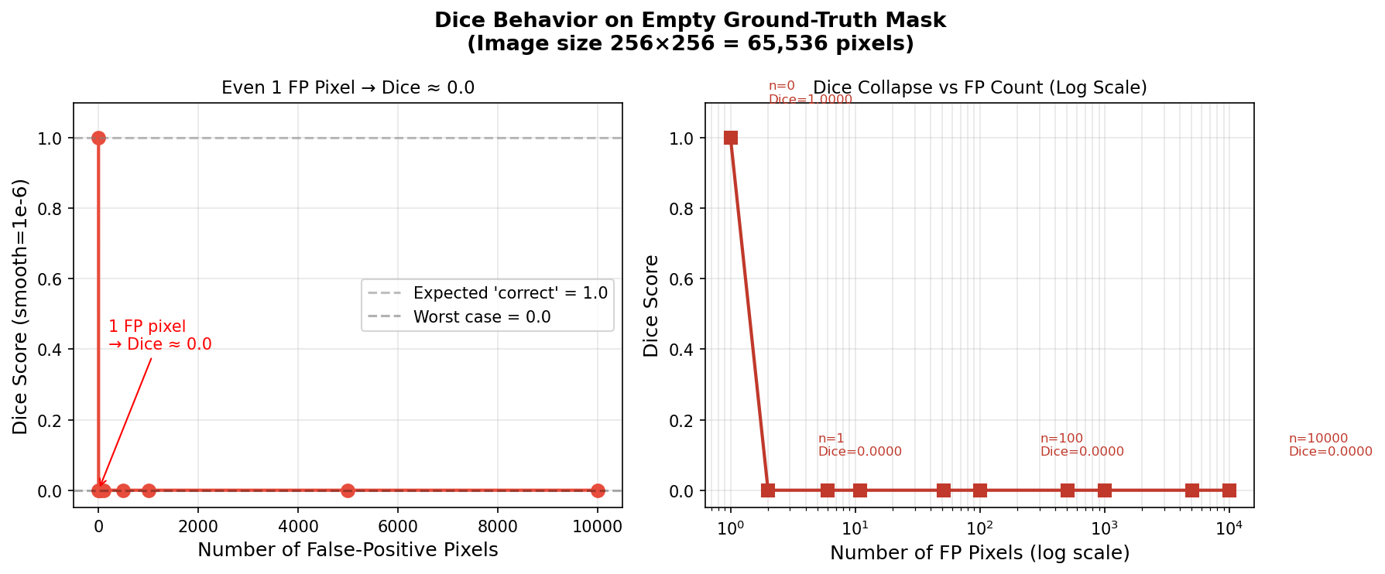
Fig. 1. Dice coefficient as a function of false-positive pixel count on an empty ground-truth mask (256 × 256). Any single false-positive pixel collapses the score to zero regardless of total false-positive area. The y-axis is logarithmic to show the discontinuity at |P| = 0. GT = ground truth; FP = false positive pixel.

4.1.2 Implementation Inconsistency
Table 2 summarizes the behavior of six implementations on the two empty-mask scenarios. No consensus exists: four implementations return 1.0 for true negatives while MONAI DiceMetric (Cardoso et al., 2022) returns 0.0; the smooth Laplace variant returns 0.010 for false positives while all others return 0.000. These discrepancies mean that published Dice scores from studies using different libraries are not directly comparable, even when models, datasets, and splits are identical. This inconsistency affects any dataset with normal cases and represents an unrecognized source of non-reproducibility in the literature.

Table 2. Dice coefficient behavior across six implementations on the empty ground-truth scenario.
Implementation | True Negative (GT = ∅, Pred = ∅) | False Positive (GT = ∅, Pred ≠ ∅)
Custom (smooth = 1e−6) | 1.000 | ≈ 0.000
Custom (smooth = 1, Laplace) | 1.000 | 0.010
Custom (strict, TN → 1) | 1.000 | 0.000
Custom (strict, TN → 0) | 0.000 | 0.000
scikit-learn f1_score | 1.000 | 0.000
MONAI DiceMetric | 0.000 | 0.000
GT = ground truth; Pred = prediction; ∅ = empty mask (no foreground pixels). True Negative: GT = ∅ and Pred = ∅. False Positive: GT = ∅ and Pred ≠ ∅. All tests performed on 256 × 256 binary masks with ε = 1 × 10⁻⁶ unless noted. MONAI = Medical Open Network for AI (Cardoso et al., 2022).

4.2 Phase 2: Simulation Results
Table 3 reports the simulated reported Dice scores and ranking inversion rates across all ten normal-case proportions. Fig. 2 shows the divergence of reported scores and Fig. 3 shows the inversion rate across the full simulation grid.

Table 3. Bootstrap simulation results: reported mean Dice and ranking inversion rate as a function of normal-case proportion.
Normal (%) | N Normal | Reported Dice — Model A [95% CI] | Reported Dice — Model B [95% CI] | Inversion (%)
0 | 0 | 0.748 [0.745, 0.752] | 0.589 [0.586, 0.593] | 0
5 | 39 | 0.721 [0.714, 0.728] | 0.594 [0.586, 0.600] | 0
10 | 78 | 0.693 [0.684, 0.703] | 0.600 [0.587, 0.612] | 0
15 | 117 | 0.666 [0.654, 0.679] | 0.606 [0.592, 0.617] | 0
17* | 132 | 0.655 [0.643, 0.667] | 0.607 [0.594, 0.620] | 0
20 | 156 | 0.638 [0.628, 0.651] | 0.610 [0.593, 0.625] | 0.5
25 | 195 | 0.611 [0.598, 0.624] | 0.617 [0.601, 0.633] | 68
30 | 234 | 0.584 [0.570, 0.599] | 0.622 [0.604, 0.638] | 99.5
35 | 273 | 0.556 [0.540, 0.569] | 0.627 [0.609, 0.644] | 100
50 | 390 | 0.473 [0.457, 0.494] | 0.642 [0.616, 0.662] | 100
Model A: true Dice on positive cases = 0.748; false-positive rate on normal cases = 0.80. Model B: true Dice = 0.589; false-positive rate = 0.30. N = 780 total cases; 200 bootstrap iterations per condition; seed = 42. * Row corresponds to the actual BUSI normal-case proportion (17.1%). CI = 95% bootstrap confidence interval.

At π₋ = 0, both models are correctly ranked with inversion rate = 0%. As π₋ increases, the reported Dice of Model A decreases faster due to its higher false-positive rate (r_A = 0.80 vs. r_B = 0.30). The first ranking inversion (0.5%) occurs at π₋ = 0.20 — only 2.9 percentage points above the actual BUSI proportion of 17.1%. At π₋ = 0.25, the inversion rate reaches 68%; at π₋ ≥ 0.35 it is effectively 100%. This places the BUSI dataset near the critical threshold, and suggests that clinical datasets with typical normal-case prevalence of 30–40% would exhibit near-certain ranking inversion for models with heterogeneous false-positive rates on normal cases.
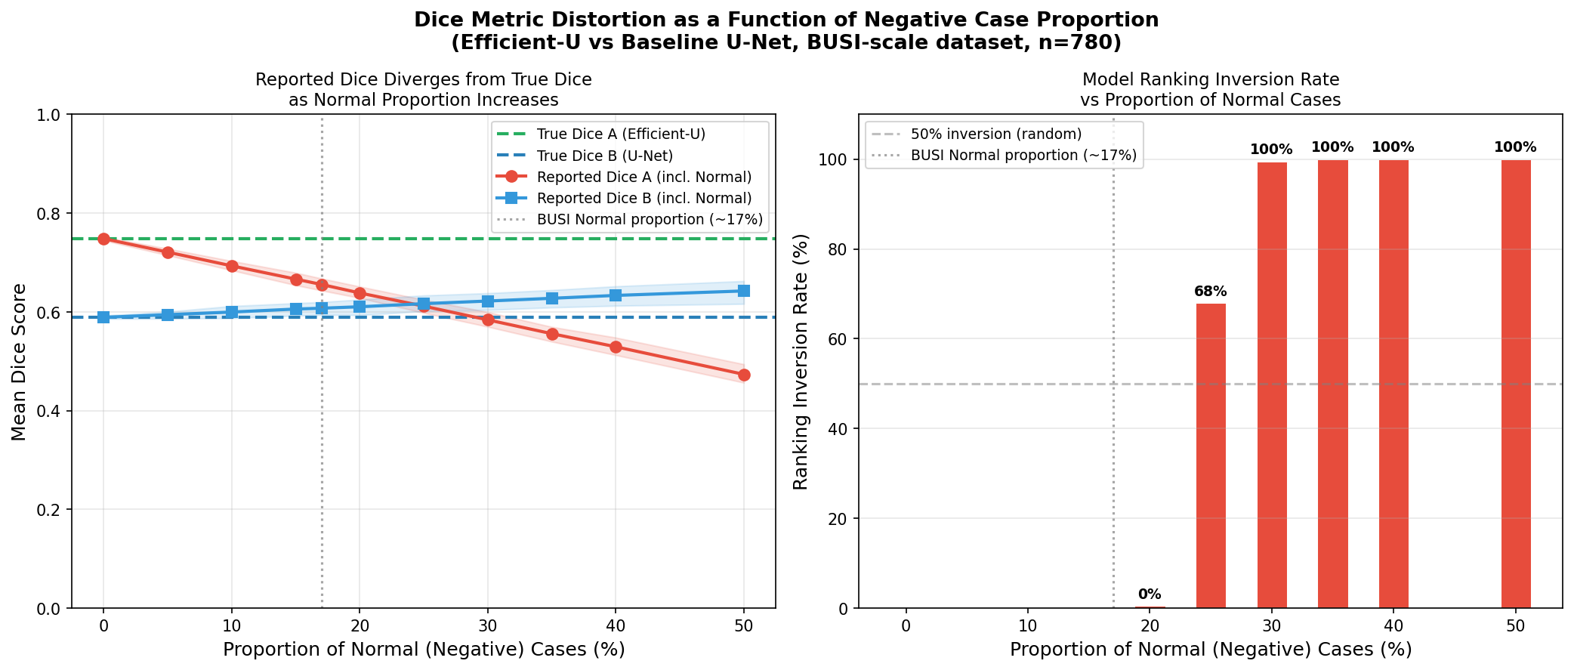
Fig. 2. Simulated reported mean Dice as a function of normal-case proportion (π₋). Model A (true Dice = 0.748, FP rate = 0.80) is correctly ranked above Model B (true Dice = 0.589, FP rate = 0.30) at π₋ = 0, but the ranking inverts from π₋ = 0.20. Shaded regions are 95% bootstrap confidence intervals. The vertical dashed line marks the BUSI dataset proportion (17.1%). FP = false positive.

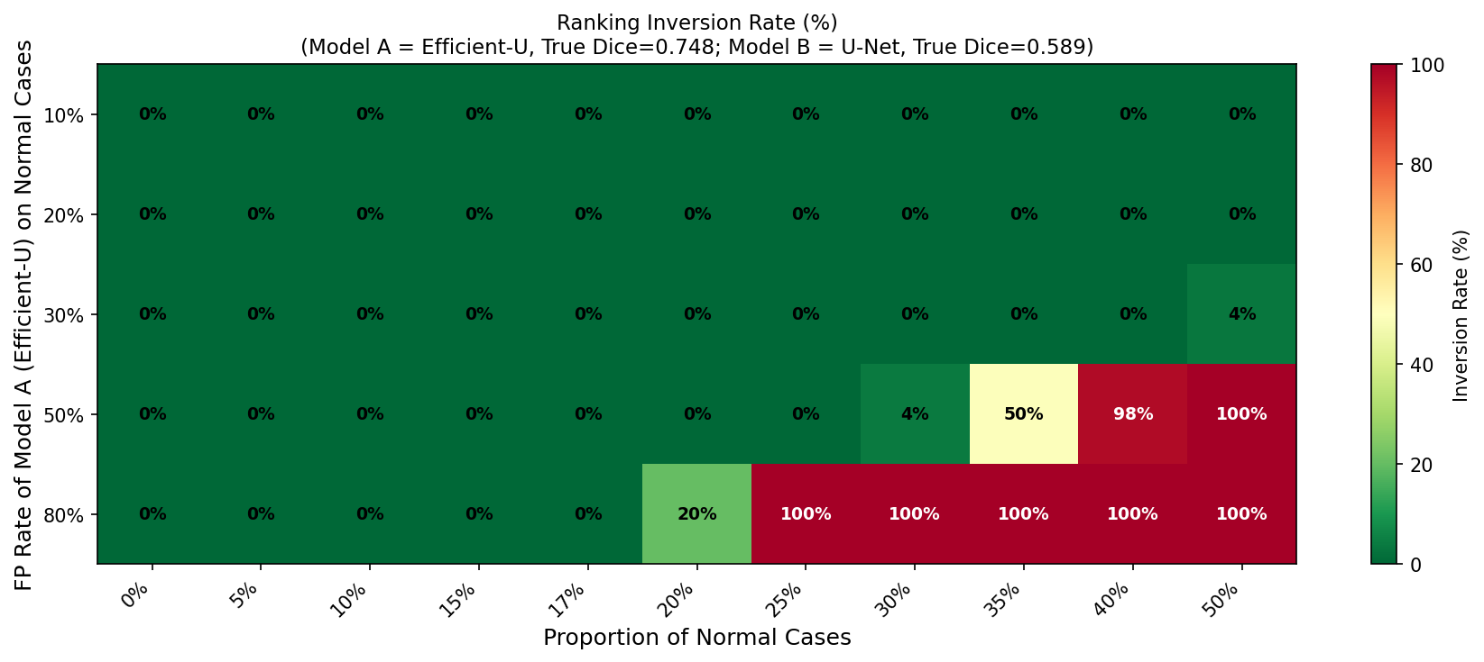
Fig. 3. Ranking inversion rate (%) across the full simulation grid. Rows = false-positive rates on normal cases (r₋); columns = normal-case proportion (π₋). Each cell shows the percentage of bootstrap iterations in which the weaker model reported higher mean Dice than the stronger model. Darker cells indicate higher inversion rates.

4.3 Phase 3: Empirical Multi-Model Results
Table 4 reports quantitative results for all five architectures under P1, P2, and SEF on the test set (n = 120; 99 positive, 21 normal). Table 5 shows the resulting rankings and their changes across protocols. Fig. 4 and Fig. 5 visualize the per-protocol performance profiles and ranking heatmap, respectively.

Table 4. Test set results for all five architectures under three evaluation protocols (n = 120; 99 positive, 21 normal).
Model | P1 Dice | P2 Dice | SEF Dice | SEF Spec. | SEF Sens. | SEF Comp.
U-Net | 0.820 ± 0.256 | 0.792 ± 0.256 | 0.792 ± 0.256 | 0.952 | 0.980 | 0.820
LinkNet | 0.808 ± 0.261 | 0.788 ± 0.249 | 0.788 ± 0.249 | 0.905 | 0.980 | 0.808
MA-Net | 0.787 ± 0.301 | 0.772 ± 0.288 | 0.772 ± 0.288 | 0.857 | 0.960 | 0.786
U-Net++ | 0.786 ± 0.296 | 0.781 ± 0.271 | 0.781 ± 0.271 | 0.810 | 0.970 | 0.786
Attention U-Net | 0.779 ± 0.300 | 0.762 ± 0.286 | 0.762 ± 0.286 | 0.857 | 0.970 | 0.779
P1 = standard mean Dice (all cases; ε = 1 × 10⁻⁶). P2 = positive-case-only mean Dice. SEF Dice = segmentation Dice on positive cases. SEF Spec. = specificity on normal cases (fraction with empty prediction). SEF Sens. = fraction of positive cases with non-empty prediction. SEF Comp. = composite score (Eq. 5; π₋ = 0.171). Values are mean ± standard deviation.

Table 5. Model rankings under three evaluation protocols and rank changes between protocols.
Model | Rank P1 | Rank P2 | Rank SEF | P1 → P2 | P1 → SEF
U-Net | 1 | 1 | 1 | — | —
LinkNet | 2 | 2 | 2 | — | —
MA-Net | 3 | 4 | 3 | ↓ 1 | —
U-Net++ | 4 | 3 | 4 | ↑ 1 | —
Attention U-Net | 5 | 5 | 5 | — | —
Arrows indicate rank changes relative to P1: ↑ = improved rank, ↓ = degraded rank. Dashes indicate stable rank. SEF = Stratified Evaluation Framework. P2 = positive-case-only Dice. P1 = standard mean Dice.

U-Net achieves the highest scores under all three protocols and is the clear top-ranked model. However, U-Net++ and MA-Net exchange rankings between P1 and P2. Under P1, MA-Net (rank 3) outperforms U-Net++ (rank 4) because U-Net++ generates more false positives on the 21 normal test cases, incurring the binary collapse penalty more frequently. When normal cases are excluded under P2, U-Net++'s superior segmentation quality (Dice = 0.781 vs. 0.772) is revealed, and it rises to rank 3. This is precisely the ranking inversion predicted by the simulation at proportions near the 20% threshold.
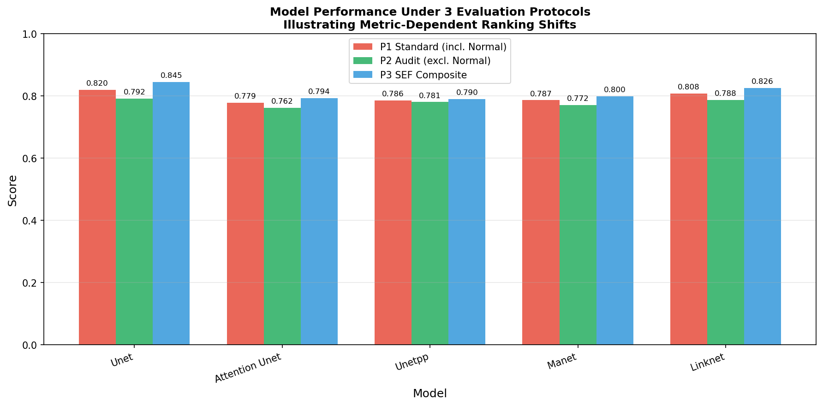
Fig. 4. Per-protocol performance profiles for all five architectures. P1 = standard mean Dice; P2 = audit Dice (positive cases only); SEF Comp. = SEF composite. Note the rank exchange between U-Net++ and MA-Net between P1 and P2. Error bars represent 95% confidence intervals.

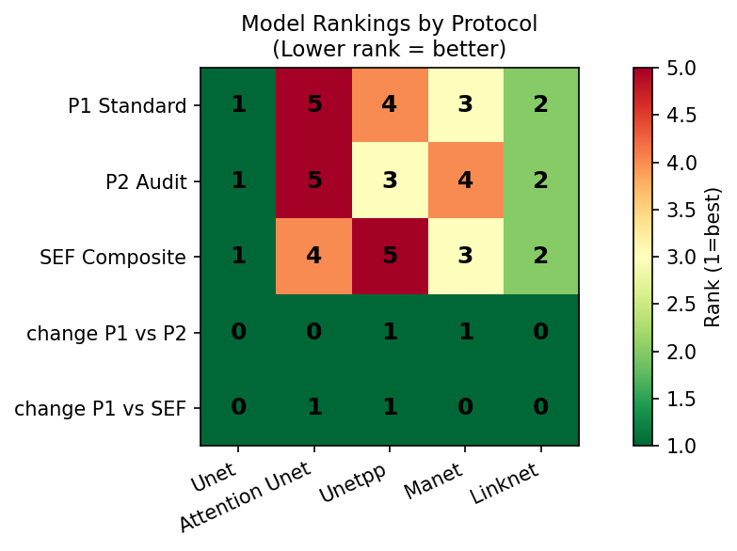
Fig. 5. Ranking heatmap across three evaluation protocols. Rows = models; columns = protocols (P1, P2, SEF). Darker cells indicate better rank. The swap between U-Net++ (P1 rank 4 → P2 rank 3) and MA-Net (P1 rank 3 → P2 rank 4) is clearly visible. SEF restores the P1 ordering by penalizing U-Net++'s lower specificity.

4.4 Statistical Significance
Table 6 reports all 10 pairwise Wilcoxon signed-rank tests on P2 Dice scores. Five of 10 pairs reach significance at α = 0.05. U-Net significantly outperforms Attention U-Net (p = 0.003), MA-Net (p = 0.025), and LinkNet (p = 0.003). Attention U-Net significantly differs from U-Net++ (p = 0.004), and U-Net++ significantly outperforms LinkNet (p = 0.041). The non-significant difference between U-Net and U-Net++ (p = 0.421) is consistent with the narrow P2 Dice gap (0.792 vs. 0.781), and between MA-Net and LinkNet (p = 0.196) with their overlapping confidence intervals.

Table 6. Pairwise Wilcoxon signed-rank test results on positive-case Dice scores (P2; n = 99).
Comparison | Statistic | p-value | Significant
U-Net vs. Attention U-Net | 1556.0 | 0.003 | Yes
U-Net vs. U-Net++ | 2153.0 | 0.421 | No
U-Net vs. MA-Net | 1755.0 | 0.025 | Yes
U-Net vs. LinkNet | 1541.0 | 0.003 | Yes
Attention U-Net vs. U-Net++ | 1536.0 | 0.004 | Yes
Attention U-Net vs. MA-Net | 2107.0 | 0.419 | No
Attention U-Net vs. LinkNet | 2336.0 | 0.884 | No
U-Net++ vs. MA-Net | 2045.0 | 0.301 | No
U-Net++ vs. LinkNet | 1808.0 | 0.041 | Yes
MA-Net vs. LinkNet | 2017.0 | 0.196 | No
Two-sided Wilcoxon signed-rank test (Wilcoxon, 1945). Significance threshold α = 0.05. Five of 10 pairs reach significance. No correction for multiple comparisons applied (confirmatory rather than exploratory context).

4.5 SEF Validation and Clinical Analysis
Under SEF, U-Net++ and MA-Net achieve identical composite scores (0.786), yet the breakdown reveals a clinically meaningful distinction. U-Net++ achieves Dice_seg = 0.781 but Specificity = 0.810, while MA-Net achieves Dice_seg = 0.772 but Specificity = 0.857. Applying Eq. (5): for U-Net++, 0.829 × 0.781 + 0.171 × 0.810 = 0.647 + 0.138 = 0.786; for MA-Net, 0.829 × 0.772 + 0.171 × 0.857 = 0.640 + 0.147 = 0.786. A clinical team prioritizing specificity — minimizing unnecessary biopsies on normal cases — should prefer MA-Net. One prioritizing segmentation accuracy for surgical planning should prefer U-Net++. This decision is made explicit by SEF and is entirely invisible to both P1 and P2.
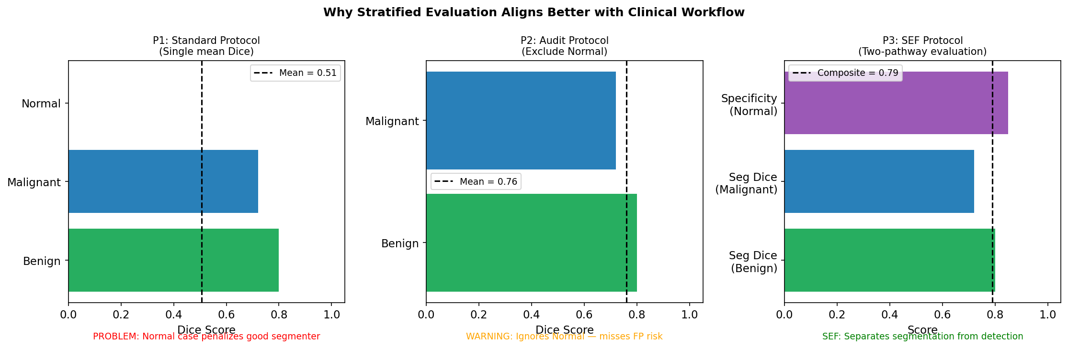
Fig. 6. Clinical rationale for the Stratified Evaluation Framework. The two evaluation pathways correspond to distinct clinical failure modes. Poor segmentation on positive cases (left) risks inaccurate lesion characterization; false positives on normal cases (right) risk unnecessary biopsy. SEF evaluates and reports both dimensions independently, enabling clinically informed model selection.

4.6 Limitations
All empirical evaluations were conducted on a single dataset (BUSI). While BUSI is the most widely used public benchmark for BUS segmentation, generalization to other datasets, imaging modalities, or clinical distributions has not been verified. Multi-site validation is an important direction for future work.
The BUSI dataset contains 17.1% normal cases — below the 20% inversion threshold identified in simulation. The empirical ranking instability observed is therefore conservative; effects are predicted to be substantially larger on clinical datasets with higher normal-case prevalence, but this prediction has not been directly tested.
SEF requires per-case class labels (normal vs. positive), which are not always available in evaluation pipelines that accept only images and masks. Adoption of SEF requires a change in annotation conventions. The SEF composite score is also sensitive to the choice of π₋; guidance for selecting π₋ based on clinical context requires further investigation.
All five models were trained with the same augmentation pipeline, and the sensitivity of results to augmentation choices was not investigated, as the focus of this work is evaluation methodology rather than model optimization.

5. Conclusion
We have formally characterized a mathematical instability in the Dice coefficient that arises when benchmark datasets contain normal (lesion-free) cases with empty ground-truth masks. Any single false-positive pixel collapses the Dice score to zero — a discontinuous, non-proportional penalty compounded by inconsistent behavior across six widely used implementations, making published benchmark scores non-comparable even under identical experimental conditions.
Bootstrap simulation quantifies the critical threshold at a 20% normal-case proportion, above which ranking inversion probability rises steeply: 68% at 25% and near-certain at 35%. Empirical results on BUSI confirm that 2 of 5 trained architectures exchange rankings between standard and positive-case-only evaluation protocols even at the dataset's below-threshold normal-case proportion of 17.1%.
The proposed Stratified Evaluation Framework (SEF) addresses these issues by separating segmentation quality on positive cases from false-positive control on normal cases into independent, clinically interpretable metrics combined via a prevalence-weighted composite score. SEF exposes clinically meaningful trade-offs that are invisible to standard protocols — exemplified by the U-Net++ vs. MA-Net comparison, where higher segmentation accuracy (0.781 vs. 0.772) comes at the cost of lower specificity (0.810 vs. 0.857). We recommend the adoption of SEF, or at minimum explicit reporting of normal-case proportion and audit Dice (P2), as a community standard for breast ultrasound segmentation benchmarks.

CRediT Authorship Contribution Statement
Windra Swastika: Conceptualization, Methodology, Software, Validation, Formal Analysis, Investigation, Data Curation, Writing – Original Draft, Writing – Review & Editing, Visualization, Project Administration. Paulus Lucky Tirma Irawan: Conceptualization, Writing – Review & Editing, Supervision.

Declaration of Competing Interest
The authors declare that they have no known competing financial interests or personal relationships that could have appeared to influence the work reported in this paper.

Acknowledgment
The authors would like to thank the Faculty of Technology and Design, Universitas Ma Chung, for supporting this research. We also acknowledge the creators of the BUSI dataset (Al-Dhabyani et al., 2020) for making their data publicly available, and the developers of the open-source libraries used in this study.

References
Al-Dhabyani, W., Gomaa, M., Khaled, H., Fahmy, A., 2020. Dataset of breast ultrasound images. Data Brief. 28, 104863. https://doi.org/10.1016/j.dib.2019.104863
Bertels, J., Eelbode, T., Berman, M., Vandermeulen, D., Maes, F., Bisschops, R., Blaschko, M.B., 2019. Optimizing the Dice score and jackknife ratio as loss functions for image segmentation: Theory and practice. Lect. Notes Comput. Sci. 11765, 92–100. https://doi.org/10.1007/978-3-030-32245-8_11
Buslaev, A., Iglovikov, V.I., Khvedchenya, E., Parinov, A., Druzhinin, M., Kalinin, A.A., 2020. Albumentations: Fast and flexible image augmentations. Information 11, 125. https://doi.org/10.3390/info11020125
Cardoso, M.J., Li, W., Brown, R., Ma, N., Kerfoot, E., Wang, Y., Terrail, J.O., Pedregosa, F., Bhatt, P., Michalewski, H., et al., 2022. MONAI: An open-source framework for deep learning in healthcare. arXiv:2211.02701. https://doi.org/10.48550/arXiv.2211.02701
Chaurasia, A., Culurciello, E., 2017. LinkNet: Exploiting encoder representations for efficient semantic segmentation. Proc. IEEE Vis. Commun. Image Process., 1–4. https://doi.org/10.1109/VCIP.2017.8305148
Dice, L.R., 1945. Measures of the amount of ecologic association between species. Ecology 26, 297–302. https://doi.org/10.2307/1932409
Fan, T., Wang, G., Li, Y., Wang, H., 2020. MA-Net: A multi-scale attention network for liver and tumor segmentation. IEEE Access 8, 179656–179665. https://doi.org/10.1109/ACCESS.2020.3025372
Gu, R., Wang, G., Song, T., Huang, R., Aertsen, M., Deprest, J., Ourselin, S., Vercauteren, T., Zhang, S., 2020. CA-Net: Comprehensive attention convolutional neural networks for explainable medical image segmentation. IEEE Trans. Med. Imaging 40, 699–711. https://doi.org/10.1109/TMI.2020.3035253
He, K., Zhang, X., Ren, S., Sun, J., 2016. Deep residual learning for image recognition. Proc. IEEE Conf. Comput. Vis. Pattern Recognit., 770–778. https://doi.org/10.1109/CVPR.2016.90
Isensee, F., Jaeger, P.F., Kohl, S.A.A., Petersen, J., Maier-Hein, K.H., 2021. nnU-Net: A self-configuring method for deep learning-based biomedical image segmentation. Nat. Methods 18, 203–211. https://doi.org/10.1038/s41592-020-01008-z
Jadon, S., 2020. A survey of loss functions for semantic segmentation. Proc. IEEE Conf. Bioinform. Comput. Biol., 1–7. https://doi.org/10.1109/CIBCB48159.2020.9277638
Litjens, G., Kooi, T., Bejnordi, B.E., Setio, A.A.A., Ciompi, F., Ghafoorian, M., van der Laak, J.A.W.M., van Ginneken, B., Sánchez, C.I., 2017. A survey on deep learning in medical image analysis. Med. Image Anal. 42, 60–88. https://doi.org/10.1016/j.media.2017.07.005
Loshchilov, I., Hutter, F., 2019. Decoupled weight decay regularization. Proc. Int. Conf. Learn. Represent. https://doi.org/10.48550/arXiv.1711.05101
Maier-Hein, L., Reinke, A., Godau, P., Tizabi, M.D., Buettner, F., Christodoulou, E., Glocker, B., Isensee, F., Kleesiek, J., Kozubek, M., et al., 2022. Metrics reloaded: Recommendations for image analysis validation. Nat. Methods 21, 195–212. https://doi.org/10.1038/s41592-023-02151-z
Oktay, O., Schlemper, J., Le Folgoc, L., Lee, M., Heinrich, M., Misawa, K., Mori, K., McDonagh, S., Hammerla, N.Y., Kainz, B., Glocker, B., Rueckert, D., 2018. Attention U-Net: Learning where to look for the pancreas. Proc. Med. Imaging Deep Learn. https://doi.org/10.48550/arXiv.1804.03999
Paszke, A., Gross, S., Massa, F., Lerer, A., Bradbury, J., Chanan, G., Killeen, T., Lin, Z., Gimelshein, N., Antiga, L., et al., 2019. PyTorch: An imperative style, high-performance deep learning library. Adv. Neural Inf. Process. Syst. 32, 8026–8037.
Reinke, A., Tizabi, M.D., Baumgartner, M., Eisenmann, M., Heckmann-Nötzel, D., Kavur, A.E., Rädsch, T., Sudre, C.H., Acion, L., Antonelli, M., et al., 2024. Understanding metric-related pitfalls in image analysis validation. Nat. Methods 21, 182–194. https://doi.org/10.1038/s41592-023-02150-0
Ronneberger, O., Fischer, P., Brox, T., 2015. U-Net: Convolutional networks for biomedical image segmentation. Lect. Notes Comput. Sci. 9351, 234–241. https://doi.org/10.1007/978-3-319-24574-4_28
Siddique, N., Paheding, S., Elkin, C.P., Devabhaktuni, V., 2021. U-Net and its variants for medical image segmentation: A review of theory and applications. IEEE Access 9, 82031–82057. https://doi.org/10.1109/ACCESS.2021.3086020
Sudre, C.H., Li, W., Vercauteren, T., Ourselin, S., Jorge Cardoso, M., 2017. Generalised Dice overlap as a deep learning loss function for highly unbalanced segmentations. Lect. Notes Comput. Sci. 10553, 240–248. https://doi.org/10.1007/978-3-319-67558-9_28
Taha, A.A., Hanbury, A., 2015. Metrics for evaluating 3D medical image segmentation: Analysis, selection, and tool. BMC Med. Imaging 15, 29. https://doi.org/10.1186/s12880-015-0068-x
Wilcoxon, F., 1945. Individual comparisons by ranking methods. Biom. Bull. 1, 80–83. https://doi.org/10.2307/3001968
Xian, M., Zhang, Y., Cheng, H.D., Xu, F., Zhang, B., Ding, J., 2018. Automatic breast ultrasound image segmentation: A survey. Pattern Recognit. 79, 340–356. https://doi.org/10.1016/j.patcog.2018.02.012
Yap, M.H., Pons, G., Martí, J., Ganau, S., Sentis, M., Zwiggelaar, R., Davison, A.K., Martí, R., 2018. Automated breast ultrasound lesions detection using convolutional neural networks. IEEE J. Biomed. Health Inform. 22, 1218–1226. https://doi.org/10.1109/JBHI.2017.2731873
Zhou, Z., Rahman Siddiquee, M.M., Tajbakhsh, N., Liang, J., 2019. UNet++: A nested U-Net architecture for medical image segmentation. Lect. Notes Comput. Sci. 11045, 3–11. https://doi.org/10.1007/978-3-030-00889-5_1

