Ye sung Park

Professor Thorkelson

Anglo American Culture and Film

28 April 2025

Midterm Ad Project

The Ad script promotes Australia as a premier travel destination by highlighting its unique and diverse wildlife, emphasizing the opportunity for tourists to encounter rare and iconic animals in their natural habitats. By showcasing the country’s commitment to conservation and responsible tourism, the ad aims to inspire viewers to explore Australia's unmatched biodiversity while contributing to the protection of its endangered species. Through a combination of stunning visuals, educational content, and a focus on the importance of wildlife preservation, the ad encourages viewers to not only visit Australia but also engage in sustainable travel practices that support the country's conservation efforts. I’ll make three scenes with the following scripts.

In Scene 1, Ad shows Australia’s Unique Wildlife. Scene begins with a breathtaking aerial shot of the Australian coastline like golden beaches, lush rainforests, and turquoise waters. In this scene Narrator said "Australia, a land where nature’s wonders come to life. Here, adventure awaits around every corner, and the wildest creatures roam free in their natural habitats. According to Australia’s official tourism website, australia.com, the country offers unique experiences unlike anywhere else in the world, with attractions such as pink lakes and numerous national parks. It is also spoken by the narrator. " And, move the scene to a serene river, where a platypus swims gracefully, its webbed feet paddling. And, the Narrator said "Meet the platypus, a true marvel of nature. An egg-laying mammal that thrives in Australia’s waters—an animal found nowhere else on Earth." Like scripting this way, we can establish Australia as a Unique Destination by what the narrator speaks.

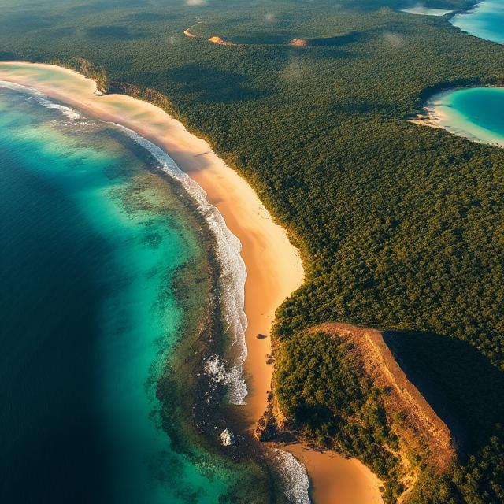

Scene 1

And we go to Scene 2. Theme is The Power of Conservation and Responsible Travel

Scene starts at A lush national park. We can see tourists walking on a guided wildlife tour, photographing animals in their natural habitats in this scene. And the narrator explains Australia. "In Australia, it’s not just about observing—it’s about connecting. Through responsible tourism, you have the chance to experience these extraordinary creatures up close while helping protect them for future generations." And the scene changes with a family that is participating in wild animal rescuing. Hearing wild animal’s sound of pain makes people want to rescue animals and visit or donate to Australia. It highlights the Connection Between Tourists and Nature. Australian wildlife is not just something to admire from afar, but something that can be experienced up close in a respectful and meaningful way.

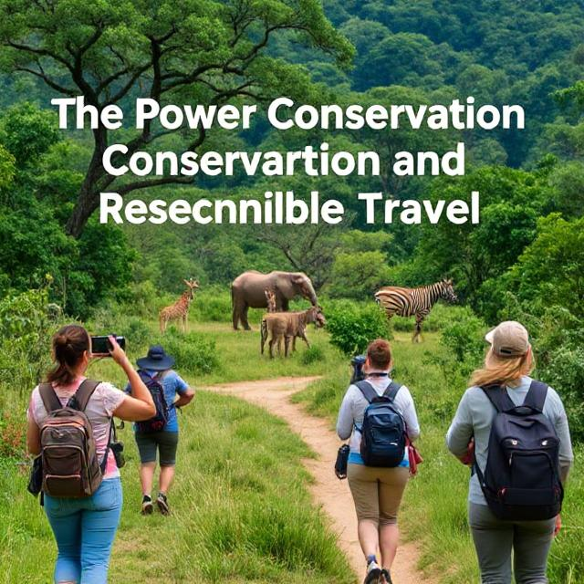

Scene 2

And we go to the last scene. Scene transitions to a vibrant cityscape of Sydney, where tourists explore bustling streets, dine at local cafes, and take in views of the Sydney Opera House and Harbour Bridge. "Beyond the wild, Australia’s cities offer a perfect blend of culture, adventure, and relaxation. Explore the art, the food, and the history of cities like Sydney and Melbourne, where world-class experiences await." Narrator said. Cut to tourists enjoying a boat tour on the Great Barrier Reef, snorkeling through the colorful coral reefs and swimming among tropical fish. The narrator introduces a boat ride of the Great Barrier Reef. The scene begins with a vibrant cityscape of Sydney, where tourists are seen exploring bustling streets, dining at local cafes, and taking in iconic views like the Sydney Opera House and the Harbour Bridge.



Scene 3

It focuses on Unique Wildlife and Adventure. The ad immediately draws viewers in with the promise of encountering Australia’s unique wildlife. So, it will be a place that will be well-received and recommended to people who have traveled to Australia. Also, it remains a message about conserving nature. From “What's causing natural destruction in Australia?”, most Australian think Habitat destruction causes natural destruction in Australia. And my advertisement emphasizes we can solve it by touring Australia. Other than just focusing on the fun aspects of visiting Australia, it makes viewers aware of the importance of protecting the wildlife they come to see. It also promotes Australia by showing that we will never have this experience again because of environmental destruction.

Works Cited

"How to Write a Script (Step-by-Step Guide)" <https://boords.com/how-to-write-a-script>

"MLA General Format" <https://owl.purdue.edu/owl/research_and_citation/mla_style/mla_formatting_and_style_guide/mla_general_format.html>

"Australia’s most famous natural landmarks" <https://www.australia.com/en/things-to-do/nature-and-national-parks/australias-top-natural-attractions.html>

“what’s causing nature destruction”

<https://www.acf.org.au/whats-causing-nature-destruction>

Answer these questions: (10 points)

Ad Concept

My advertisement aims to promote Australia as a unique and exciting travel destination, with a special focus on its diverse wildlife. While Australia shares English as its primary language, it offers experiences that stand apart from other English-speaking countries. The main theme of the ad highlights the incredible variety of native Australian animals, such as the platypus (an endangered mammal that lays eggs), the emu (the world’s second-largest bird, which cannot fly), and the great white shark (a formidable ocean predator). Iconic animals like koalas and kangaroos are also major attractions. What makes this concept stand out is the chance for tourists to encounter these creatures in the wild, allowing for a deeper connection to nature.

Reason for Focus on This Aspect of Australian Culture

I chose to center the ad around Australia’s wildlife because I’ve always had a fascination with animals and biodiversity. Australia’s evolution in isolation, following the breakup of landmasses according to the theory of continental drift, has given rise to some of the most unique and rare species in the world (Biocyclopedia). I also discovered that Australia takes significant steps in protecting its environment, which allows tourists the rare opportunity to see animals living freely in their natural habitats rather than in captivity. Given that Australia is an English-speaking country, it provides a great balance of adventure and convenience for travelers.

Insights Gained About the Target Culture

While preparing the ad, I learned much more about Australia’s wildlife than I initially expected. I knew about the famous animals like kangaroos and koalas, but I was surprised to learn about the platypus, the emu, and the great white shark—species that many people are unfamiliar with. Moreover, I discovered that many of these animals are endangered and in need of conservation efforts to thrive. Through tourism, people can contribute to the protection of these species by raising awareness and supporting conservation initiatives. This realization added a deeper layer of purpose to the ad, as promoting Australian tourism goes beyond fun—it also helps preserve unique wildlife.

What Viewers Will Learn About Australia from the Ad

From watching the ad, viewers will gain a newfound appreciation for Australia’s unique wildlife and understand that the country’s animals are more diverse and astonishing than they may have realized. They will also learn how their travels can contribute to conservation efforts. Simply visiting, learning about the animals, and sharing their experiences can help raise awareness and support important wildlife protection initiatives. Since Australia is an English-speaking country, tourists can also feel more comfortable navigating their travels. Overall, the ad aims to inspire curiosity, foster a deeper connection to biodiversity, and encourage responsible travel that supports environmental preservation.

Works Cited

"Animals in Australia." Kids World Travel Guide. Retrieved from <https://www.kids-world-travel-guide.com/animals-in-australia.html>

"Continental Drift Theory." Biocyclopedia. Retrieved from <https://biocyclopedia.com/index/general_zoology/continental_drift_theory.php>

"Our Animals." Australia Zoo. Retrieved from <https://australiazoo.com.au/wildlife/our-animals/>