SEHS4701 ADVANCED INFORMATION SYSTEMS DEVELOPMENT
Group: G101-08

Au Cheuk Shing
LAM Ting Hin
LAW Kwai Cheung
TING Tim Lok
WONG Tsz Fung
Wong Yi Kin

Table Of Content:
Functional Specification 3
1. Client Background 3
2. Business Rules 4
3. UI Design 5
4. Database Design 5
5. System Diagrams and Workflow 6
6. Test Cases 6

Functional Specification of Donation System

1. Background
Hong Kong Homeless Care (HKHC) is a non-profit organization targeting to solve the urgent needs of homeless individuals in Hong Kong. They provide immediate relief and long-term solutions for the homeless. The organization operates through a network of volunteers, donors, and partner organizations to offer services and resources to the most vulnerable members of our society and propagate to the society to raise their attention to this issue.

2. Requirement of client
As one of Hong Kong Homeless Care (HKHC) non-profit charity organization (as they are representing HKHC in this sector, they will be abbreviated as HKHC in the following), they plan to collect donation from public through web channel.

The details are as follows:
1. Create a web application by using J2EE.
• Its main functions consist of
A. Collection of a donor (personal or organizational) data.
B. A donor can choose which type of donation program and amount of money he wants to support, e.g., $1,000 for “Homeless Children Program”.
C. HKHC can view each donation by choosing different selection criteria in MySQL database afterwards, e.g. amount larger than $5,000.
D. A donor can receive an appreciation acknowledgment from a donatee.

2. All data will be stored into MySQL database.

3. Business Rules, definitions and descriptions
Business Rules:
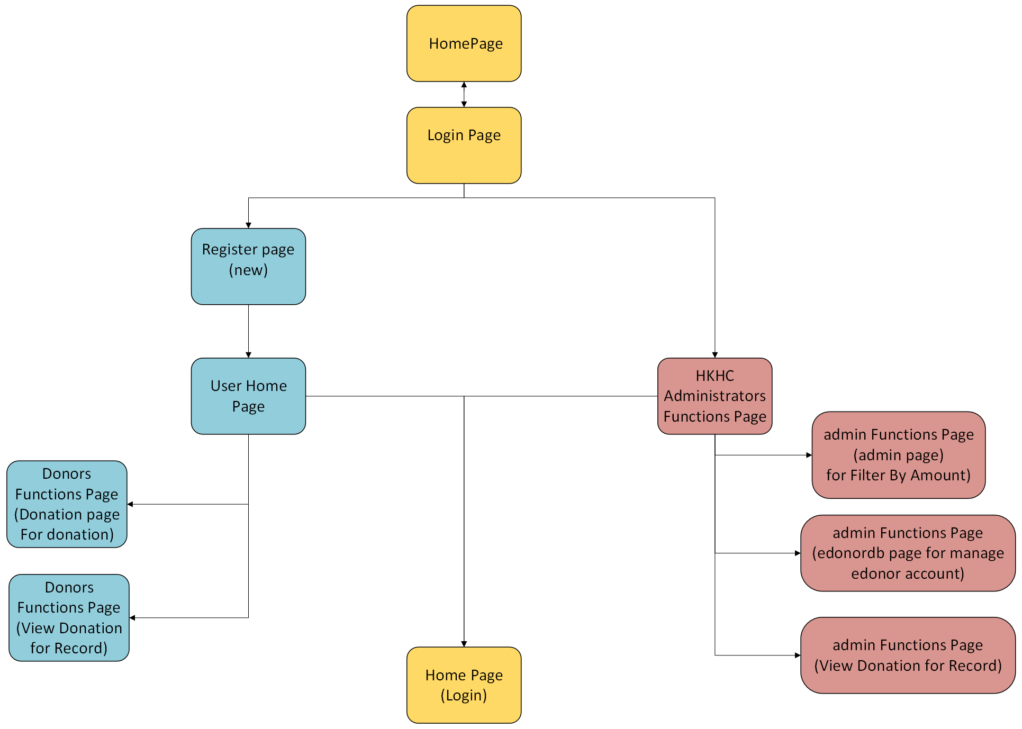
Yellow: Common Page
Blue: User Page
Red: Admin Page

3.2 Definitions
Component | Definition
Donation Program | Each contribution program given by HKHC supports a specific topic of help, such as homeless children, health care, or food distribution, allowing donors to choose their preferred option.
Login Account | Donors must use their own account to use the contribution site. This account was created during the registration process and might be individual or organizational.
Campaign Deadline | Each donation campaign is time-bound, with specific start and end dates. Donations after the deadline will not be accepted, at the same time results will be published accordingly.
Donation | Donors can give online as a visitor or after logging in, where they can select programs and define their desired donation amount, which is restricted to 2000000000 as an upper bound and does not include floating points.
Requirement | Donors must supply authentic personal or organizational information when registering.
Publishing Result | Following the campaign, HKHC publishes a summary of contribution outcomes on its website, including the total cash collected and impact data.

3.3 User Classes and Characteristics
1. Donors
Donors are people or organizations who want to help HKHC by donating money or resources. They use the web application to register, donate, and view acknowledgment messages and also the published donation results.

2. HKHC Administrators
Administrators represent HKHC's internal staff in charge of processing donations and supervising operations. They guarantee that organizational goals are met while also providing donor support.

User Access and System Security
- The web application frontend allows everyone to view, while the backend access is restricted to authorized users only.
- Personal data, such as donor details and donation records, is stored securely in a MySQL database.
- Account credentials and sensitive information are encrypted to prevent unauthorized access.

Feature | Donor | HKHC Administrator
Registration and Login | ✔ | N/A
Donation Options | ✔ | ✔
View Donation History | ✔ | ✔
Generate Reports | N/A | ✔
Manage Programs | N/A | ✔

3.4 List of Functions
Common Functions
- Login
- Showing information
- Register
- Logout
- View own Donation Record
User Only Functions
- Donation
Admin Only Functions
- Filter By Amount
- Manage edonor Account
- View all Donation Record

1. Login

- Users submit their email address and password on the login page.
- The system checks the credentials against the database.
- If the donation is legitimate, they are routed to their account dashboard.
- If the input is invalid, an error notice is displayed, and the user is prompted to try again.

2. Showing Information

- Displays a list of current contribution programs (e.g., Homeless Children Program, Health Care).
- Donors can access general information regarding HKHC's activities and the impact of their gifts.

3. Register

- Donors complete a registration form with needed information (name, email, password).
- The system checks for duplicate email addresses.
- After verification, the donor can log in and donate.

4. Logout

- When the donor selects the "Logout" button, the system ends the session and sends the user to the home or login page.
- The session data is cleared to prevent unauthorized access.

5. View Own Donation Record

- The donor may visit their account dashboard, which displays the total amount provided, the projects sponsored, and the date of gift.

User Only Functions

1. Donation

- The donor chooses a contribution program from a list of available options.
- The donor sets the gift amount (which can be pre-set or customized up to $2,000,000,000).
- The donor verifies their gift and advances to the confirmation page.
- When the gift is properly completed, a thank-you message, and acknowledgement are shown.

Admin-Only Functions

1. Filter By Amount

- Administrators can provide criteria for filtering donations (for example, reveal donations greater than $5,000).
- The system sorts the contribution records by the stated criteria and shows the appropriate donations.
- Administrators can access donor information and donation details in a management.

2. Manage Donor Account

- Admins may examine donor profiles, which include registration information, donation history, and acknowledgment status.
- Administrators can change donor information (for example, correcting inaccuracies in contact information).
- Administrators can cancel or suspend donor accounts if questionable conduct is identified.

3. View All Donation Records

- Administrators may see a complete record of all donations made during a campaign or overtime.
- Admins may sort and filter donations based on a variety of factors, including gift amount, donor type, and program support.
- The system shows detailed gift data, which includes donor names, amounts, programs, and donation dates.

4. UI Design
Page Name | User Interface | Explanation
1.home | 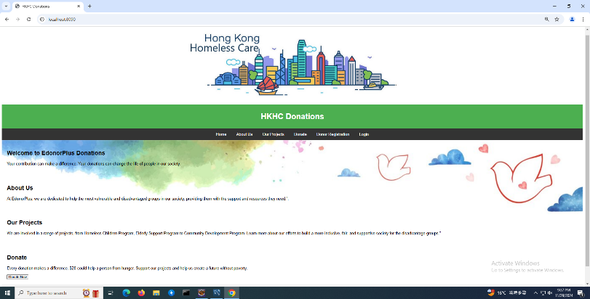 | The home screen, which shows description of the charity before logging in, after logging in, users can donate
2.registration | 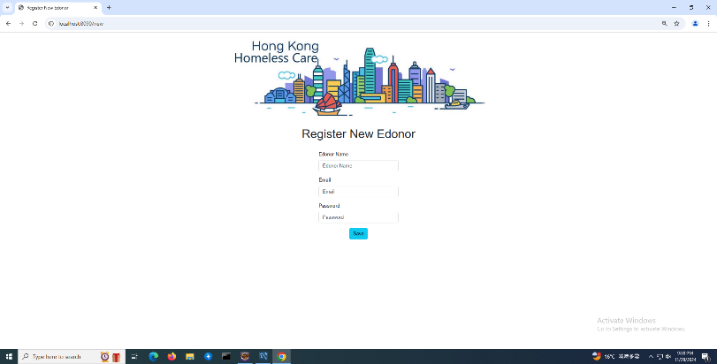 | To register as a donor
3.Login | 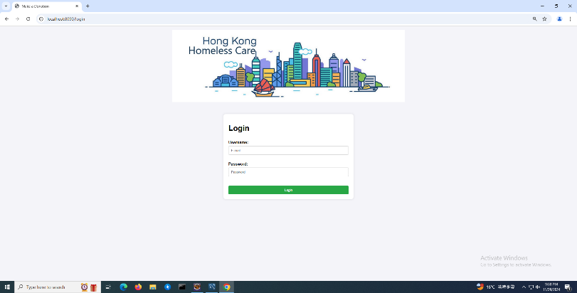 | Login Page
4.Homepage after logging in | Edonor user:  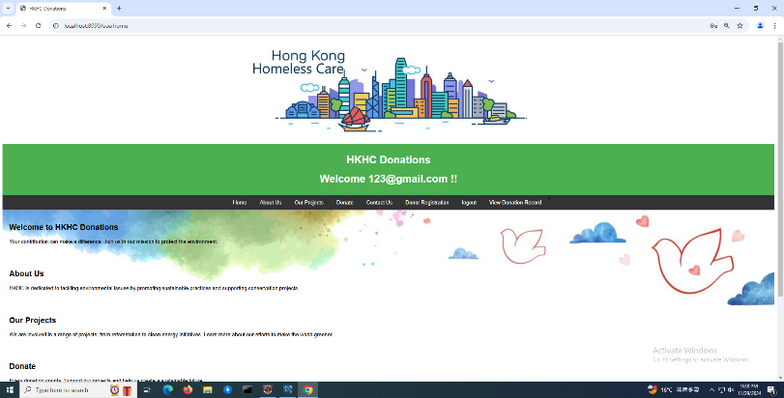  Admin user:  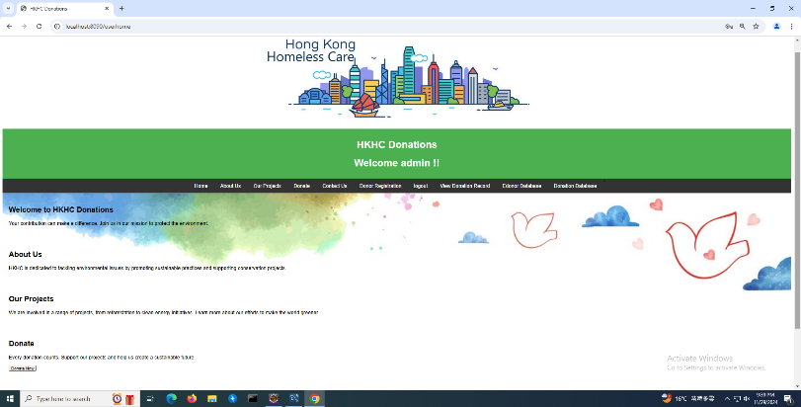 | Edonor user:  On this screen, users can donate, contact HKHC is just a decoration.  On the tabs above, they can choose “Home”, “Donate”, “Donor Registration”, “logout” and “View Donation Record”  Admin user:  Admins can use “Home”, “logout”, “View Donation Record” of donors, and view “Edonor Database” and “Donation Database”
5.Donation | 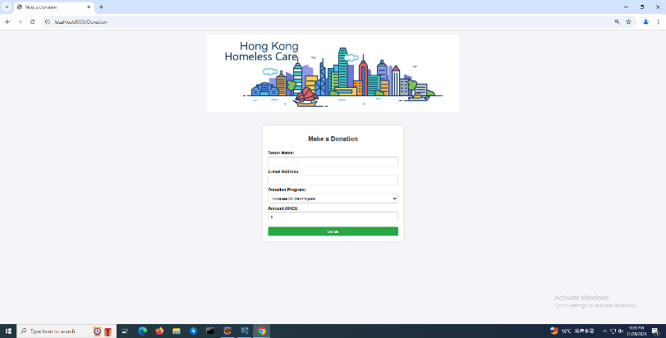 | Donors can enter the name they wish to be shown, email address, program to donate (3 programs are available at this moment), and amount of donation and donate pressing the green button.
6.Success | 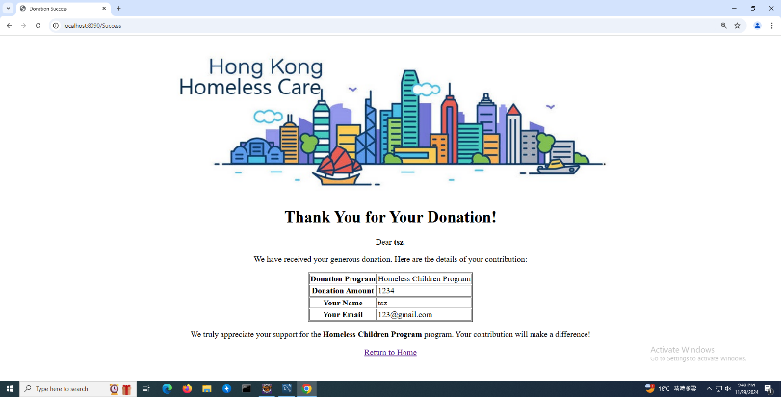 | After donation an appreciation acknowledgment will appear
7.edonordb | 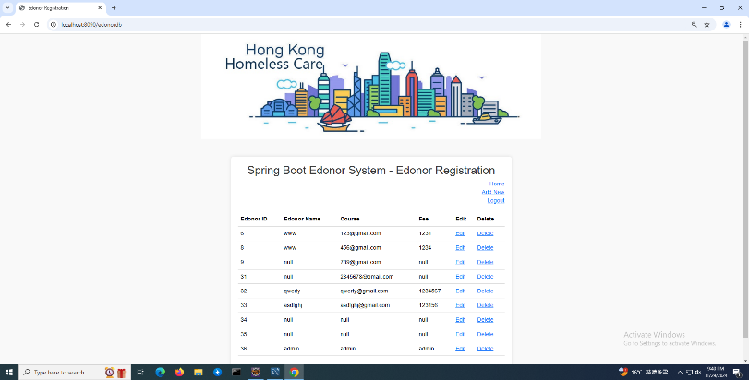 | Admins can manage edonor account
8.admin | 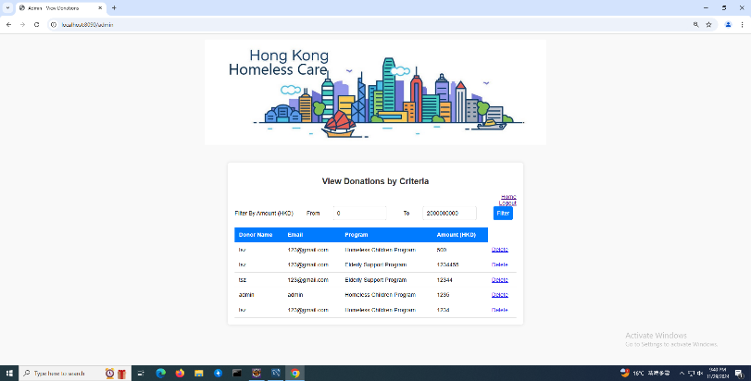 | Filter By Amount
9.userDonationHistory | Edonor user:  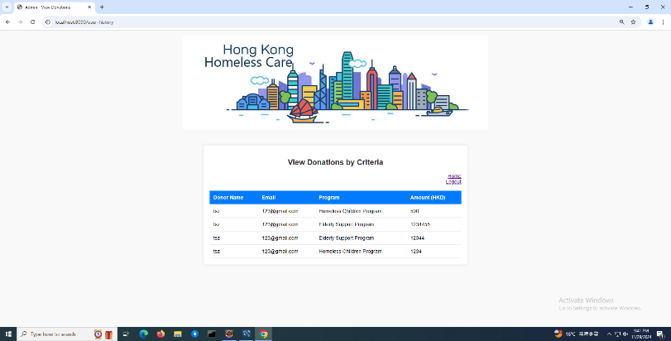  Admin user:  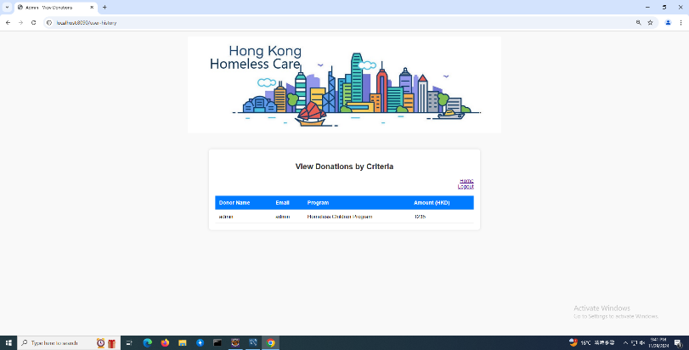 | For each user to view their donation history

5. Database Design

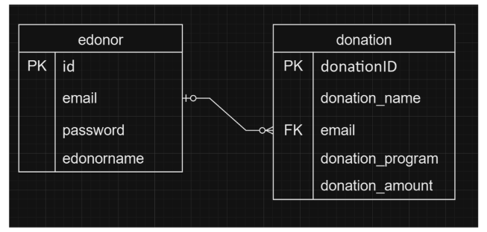

Database: MySQL
1. edonor Table
- Primary Key (PK): id
- Columns:
- email
- password
- edonorname

2. donation Table
- Primary Key (PK): donationID
- Foreign Key (FK): email (references edonor.email)
- Columns:
- donation_program
- donation_amount

Relationships
- The donation table has a foreign key linking it to the edonor table via the email field, establishing a relationship where each donation is associated with a specific donor.
-One edonor can have many donation records
- Each donor (represented by a unique id in the edonor table) can make multiple donations.

6. System Diagrams and Workflow

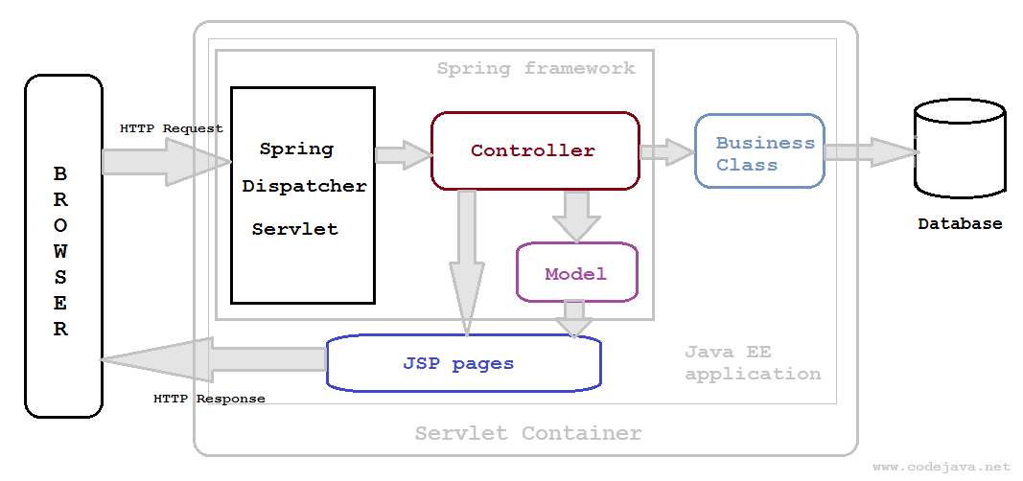
System Diagram:
User Side: User Interface → Application Logic (J2EE with Spring Boot) → MySQL Database.
Admin Side: Admin Interface → Application Logic → Database.

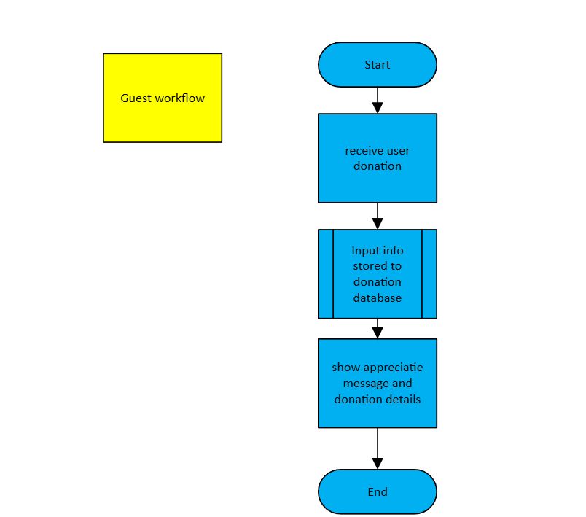

Workflow:
- Viewing: Guest can view the information of our program.

- Donor Registration: New donors register; details stored in Donors table.

3. Making a Donation:
Donor logs in, selects a program, enters donation amount.
Data is saved in Donations table, linked to donor and program.
Acknowledgment generated and saved in Acknowledgments table.

4. Admin Management:
Admin logs into dashboard.
Uses filters to view donations (by amount, program, donor type).
Generates reports as needed.

7. Test Cases

Donor Registration Test: Check if new users can register successfully and if all fields validate properly.

Login Test: Verify login functionality, password recovery, and session management.

Donation Functionality: Test for successful donations, receipt generation, and correct data entry into the Donations table.

Data Filters for Admins: Test filtering options to ensure accurate data is displayed according to criteria (e.g., donations over a specific amount).

Test ID | Function | Function Description | Precondition | Test Scenario | Expected Result | Pass/Fail Reason
1. | Login | Validates that users with correct credentials can log in successfully. | A valid donor account exists in the system. | 1. Navigate to the login page.  2. Input correct email and password.  3. Click the "Login" button. | Users are successfully logged in and redirected to their dashboard (e.g., donor functions page). | Pass: Successful login.  Fail: Incorrect redirection.
2. | Login | Validates administrator login functionality. | A valid administrator account exists. | 1. Navigate to the login page.  2. Input correct admin credentials.  3. Click the "Login" button. | Administrators are redirected to the modified user dashboard with relevant functions available. | Pass: Admin functions accessible.  Fail: Access denied or incorrect redirection.
3. | Login | Validates that invalid credentials block login. | No precondition. | 1. Navigate to the login page.  2. Input incorrect email/password combination.  3. Click the "Login" button. | A warning message "Invalid email or password" is displayed, and login is not permitted. | Pass: Appropriate error message displayed.  Fail: Users gain access with incorrect credentials.
4. | Donation | Validates the functionality of processing a donation. | A valid donor account exists. | 1. Log in as a donor.  2. Navigate to the donation page.  3. Select a program and specify an amount.  4. Submit the donation. | The donation is successfully processed, and a confirmation message is displayed. | Pass: Donation appears in donor history.  Fail: Donation not saved or incorrect confirmation message.
5. | View History | Validates that donors can view their donation history. | A donor account with donation records exists. | 1. Log in as a donor.  2. Navigate to the donation history page. | Donation history is displayed accurately, showing all previous donations. | Pass: Records displayed correctly.  Fail: Missing or incorrect donation records.
6. | Logout | Validates that users can log out securely. | Logged-in user cookie exists. | 1. Log in as any user.  2. Click the "Logout" button. | User session is terminated, and the user is redirected to the home page (Guest). | Pass: User is logged out securely.  Fail: User remains logged in or is redirected incorrectly.

