- Create database :
CREATE TABLE edonor ( id bigint NOT NULL AUTO_INCREMENT, email varchar(255) DEFAULT NULL, password varchar(255) DEFAULT NULL, edonorname varchar(255) DEFAULT NULL, PRIMARY KEY (id), UNIQUE KEY unique_email (email) ) ENGINE=InnoDB AUTO_INCREMENT=8 DEFAULT CHARSET=utf8mb4 COLLATE=utf8mb4_0900_ai_ci;
--------------------- ---------------------
CREATE TABLE donation ( donationID int NOT NULL AUTO_INCREMENT, donation_name varchar(255) DEFAULT NULL, email varchar(255) DEFAULT NULL, donation_program varchar(255) DEFAULT NULL, donation_amount double DEFAULT NULL, PRIMARY KEY (donationID) ) ENGINE=InnoDB AUTO_INCREMENT=35 DEFAULT CHARSET=utf8mb4 COLLATE=utf8mb4_0900_ai_ci;
----------------------- -----------------------
INSERT INTO edonor (email, password, edonorname) VALUES ('admin', 'admin', 'admin')

- Import the zip file
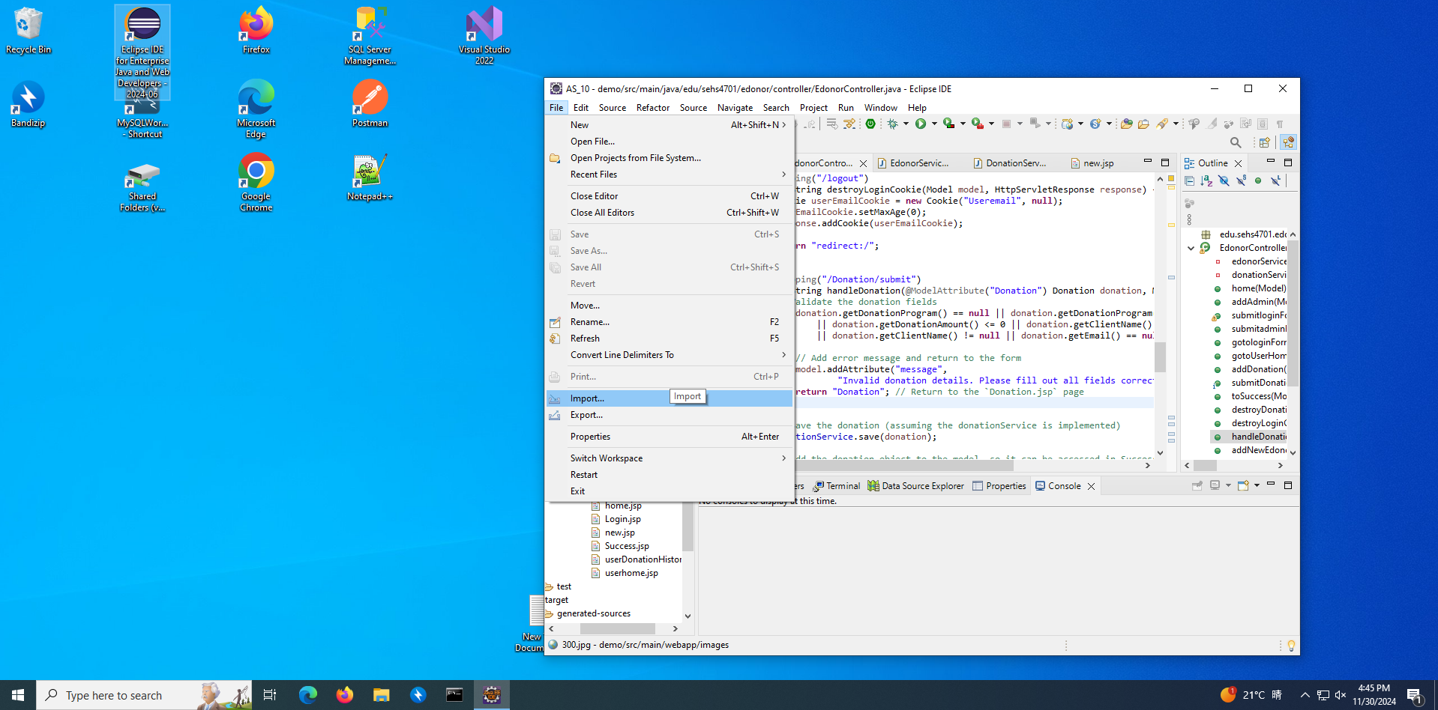

- Starting the spring boot
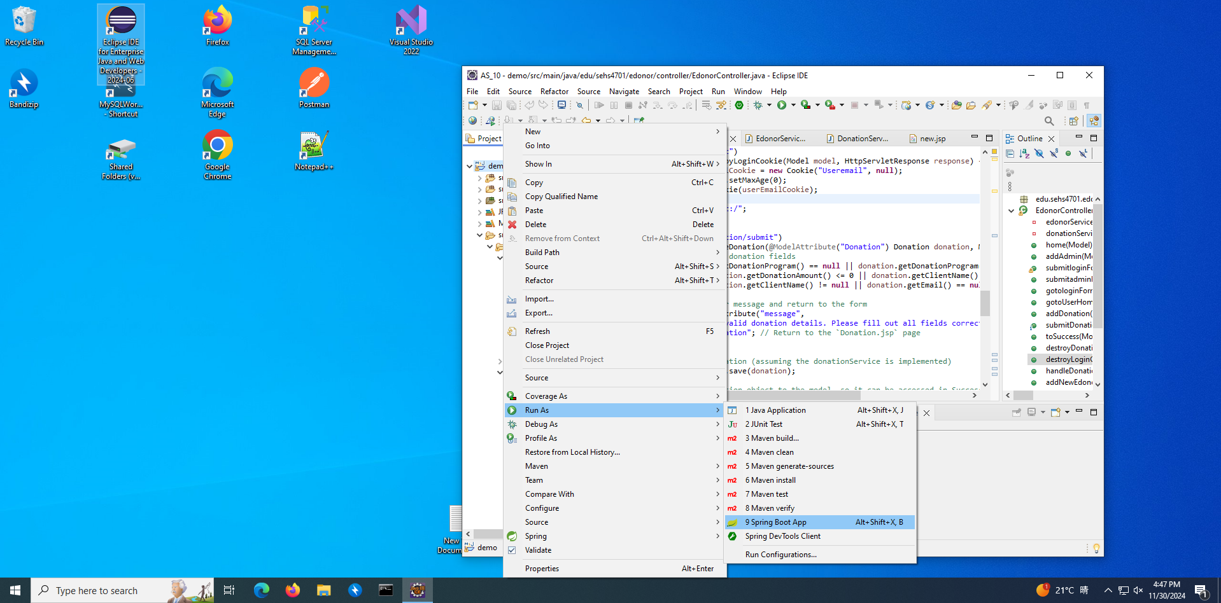

- Open in the browser
http:// http://localhost:8090/


