1. Proposal
A. Introduction
1. Detailed description of idea:
The proposed repository system is intended as a comprehensive library management system for WK_Library. The system will streamline the book borrowing and returning process and facilitate efficient management of library resources and user records.

2. Type of data stored:
The database will store various types of data, including:

Information
The library, such as its name, location, contact details (phone, email).
Student data, including unique identification number (Student_ID), name, grades, and contact information (phone, email).
Employee data, including unique identification number (Staff_ID), name, title, and contact information (phone, email).
Book details such as unique identifier (Book_ID), title, author, publisher, and available quantity.
Available data types include VARCHAR, NUMBER.

A record of transactions, including a unique identifier (Transactions_ID), references to the books, students, and staff involved in the transaction, transaction type, and timestamps of borrow and return dates.
This table's data types have numbers, timestamps.

3. Who will use the database system?
The database system will be mainly used for:
Library staff are responsible for managing book transactions, maintaining inventory, and updating student and faculty records.
Students borrowing and returning books from the library.

4. How do they use the database system?
Library staff: They will use the system to:

Add new books to inventory.
Keep records of student borrowing and returning books.
Update student and staff records as needed.
Generate reports on book transactions and inventory status.
Students: They will use the system to:

Borrow books by providing your student ID and selecting the books you want.
Return the book by providing the necessary details, such as the book ID or title.

B. Business rules:
There are few assumptions. first, we only use WK_Library and only serve the students from WK campus. Also, one student only borrows or return one book by every transaction. The student can borrow same book many times unlit the book quantity is 0.
A student can borrow multiple books, but each book can be borrowed by multiple students.
Library staff facilitate the borrowing and returning process.
Each book must have a unique identification number (Book_ID).
Each student and staff member must have a unique identification number (Student_ID and Staff_ID).
Transactions must be recorded using a unique identifier (Transactions_ID).

C. Concept data modeling:
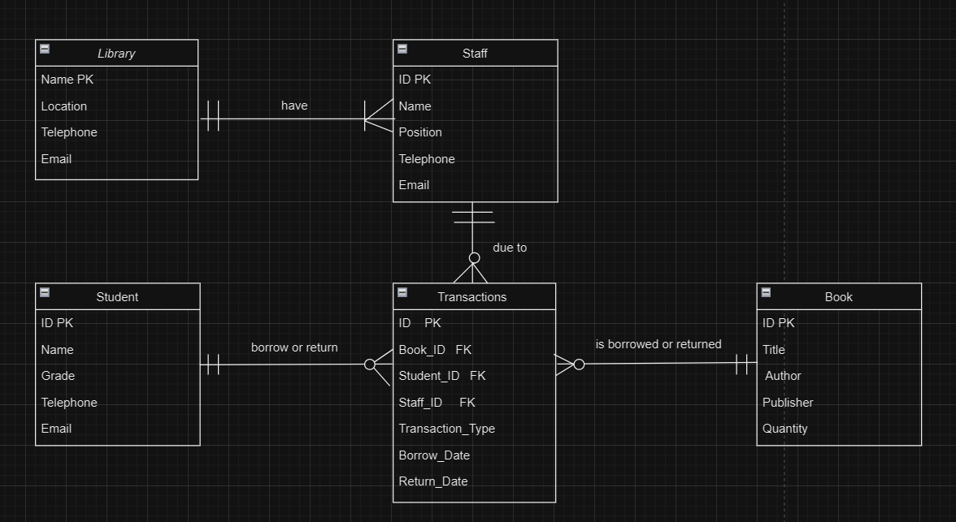
The database system should satisfy all relationship types:
One library can be the location for many staff. Therefore, the relationship between library and staff is 1:M.
One staff member is due to complete many tasks of transaction or don’t need complete any tasks. The relationship between staff and transaction is 1:M.
One student borrows or returns many books or don’t need to borrow any book. Therefore, the relationship between staff and transaction is 1:M.
One book is borrowed or returned by many students. So, the transaction may be a lot of or nothing. Therefore, the relationship between Book and transaction is 1:M.

- Implementation Details
Create table:
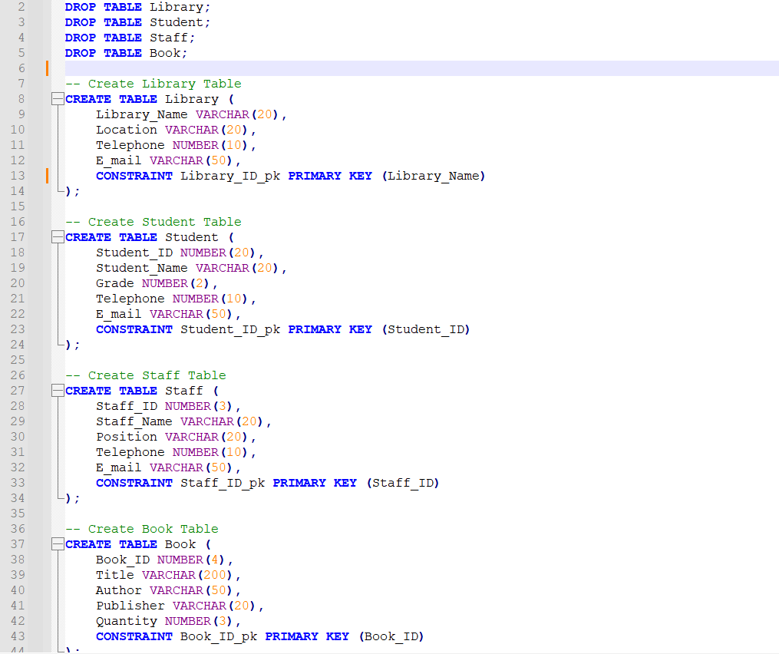
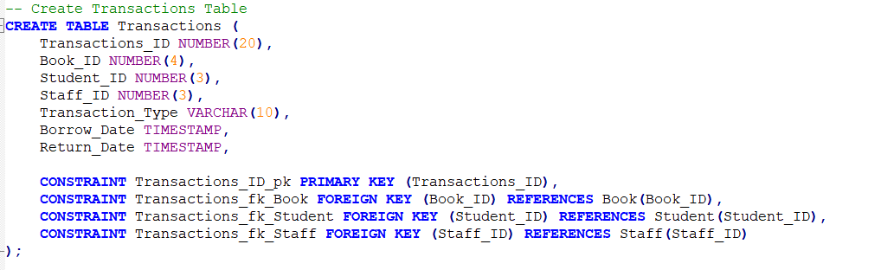
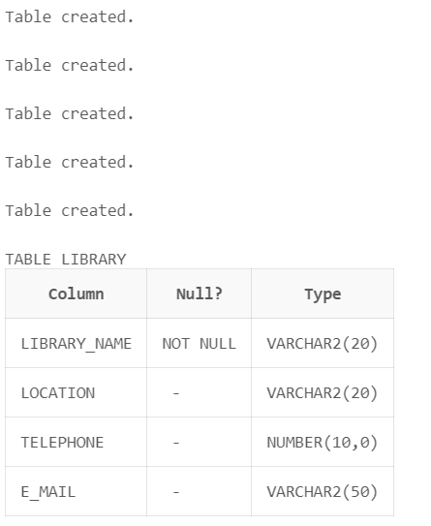
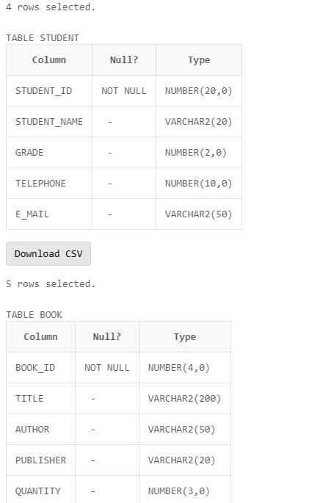
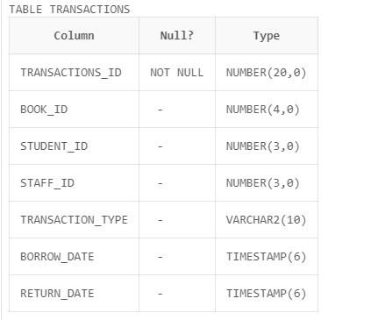
Insert value:
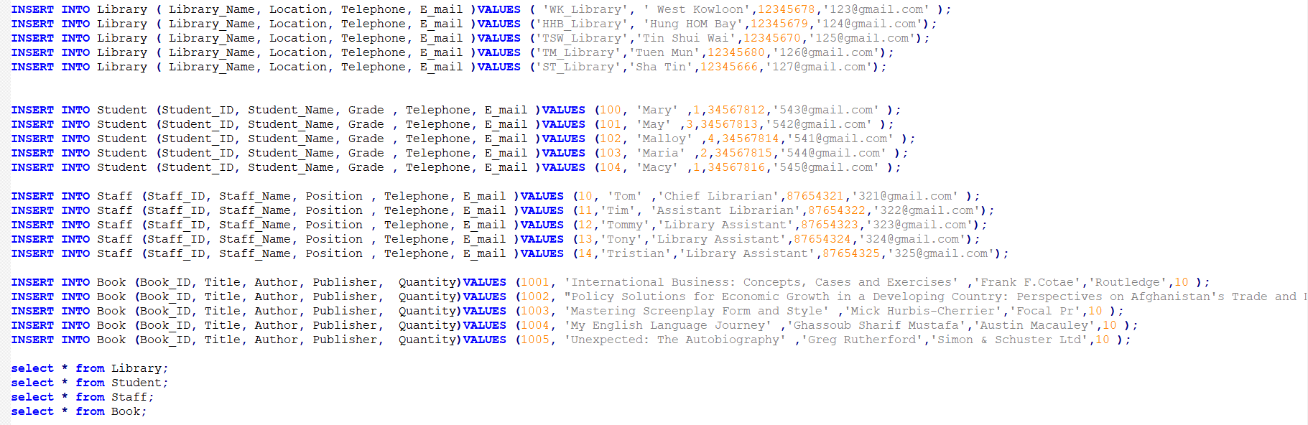
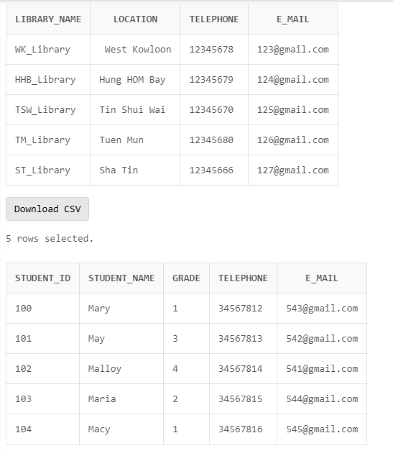
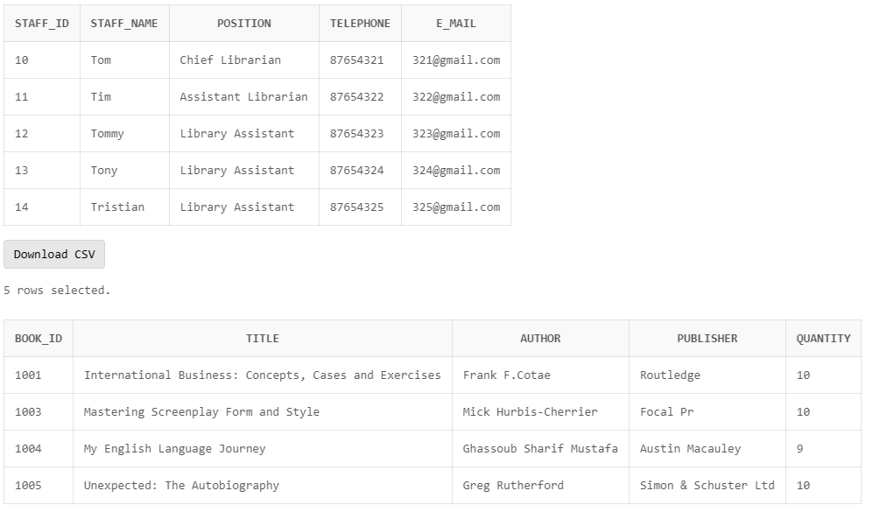
Trigger:
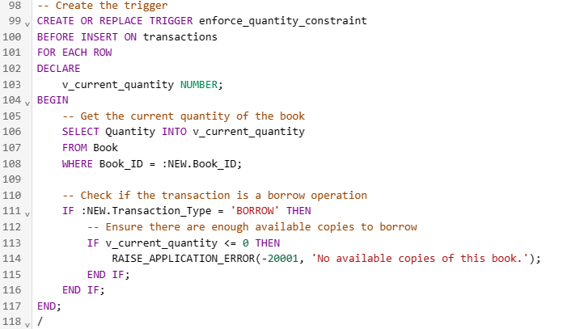
When the quantity is <=0. Then the book cannot checkout again.
For example:
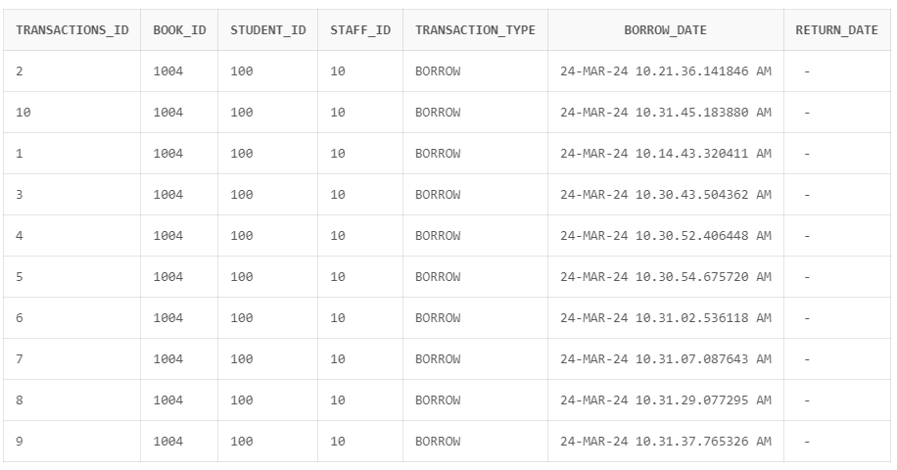

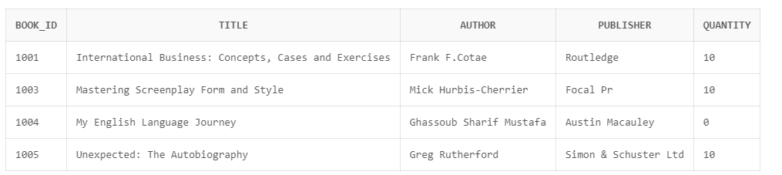
Then it will show you the error messages.
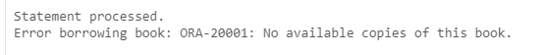

Procedure:
1.Borrow Book
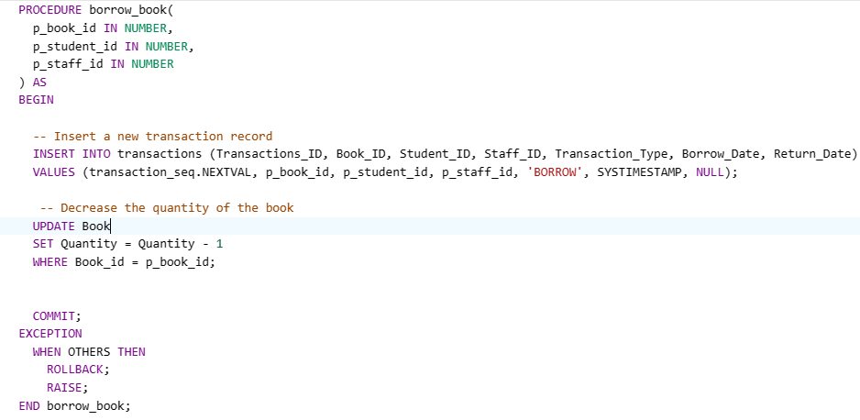
When someone borrows a book. The value of data will insert to transaction table about Student ID, transaction Type and Borrow Date. And the quantity of the book will reduce until to 0.
For example:
- Return Book
When someone returns the book. The value of data will update to transaction table about Return Date, transaction data type and, the quantity of the book.
For example:
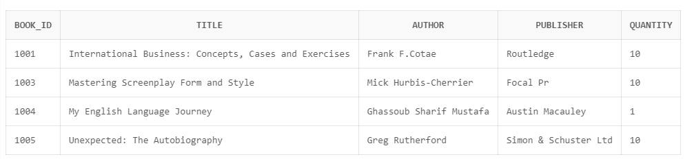
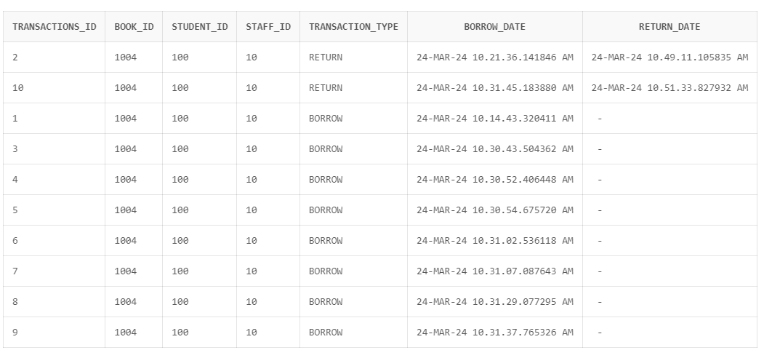
Function:
Get available book and get borrowed book.
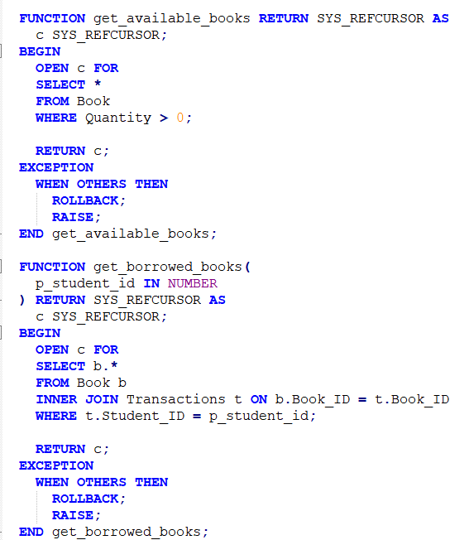
Function of get_available_book is checking quantity of the book from Book table. If the quantity >0, it is available to borrow to student.
Function of get_borrowed_books is getting the value about the book and student to procedure.

Query:
- Check Out
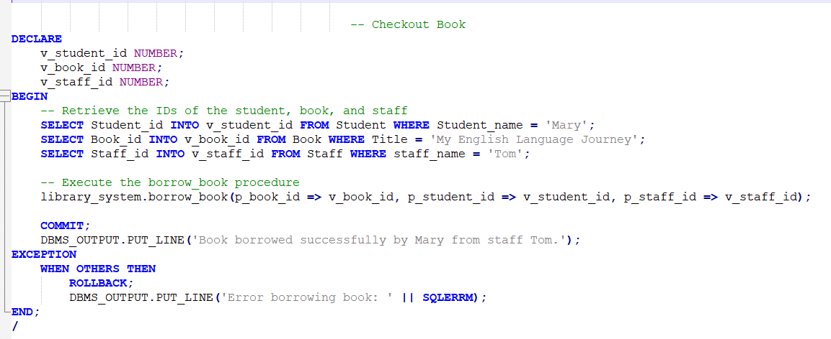
Mary (Stundent_ID: 100) borrows the book called ‘My English Language Journey’ (Book_ID: 1004) and the staff Tom (Staff_ID: 10) due to complete the transaction of check out.
The result:

- Return Book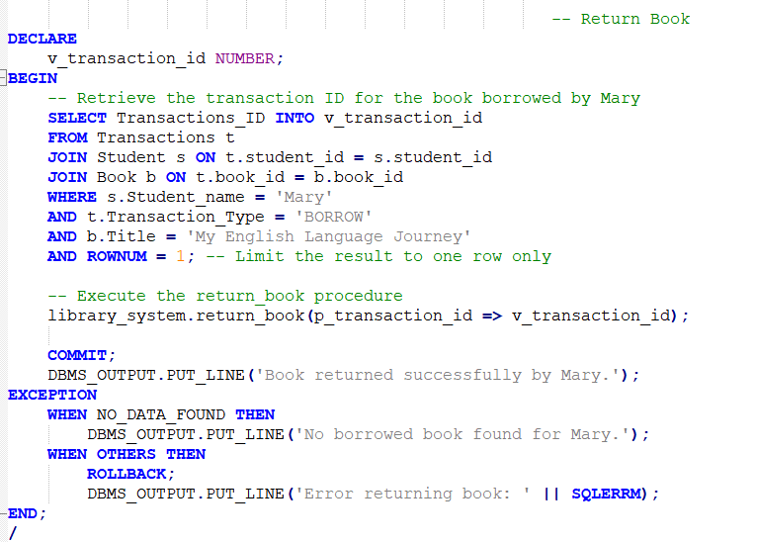
Mary (Stundent_ID: 100) returns the book called ‘My English Language Journey’ (Book_ID: 1004) and the staff Tom (Staff_ID: 10) due to complete the transaction of check out.

The result:

- query with all SELECT, FROM, WHERE, GROUPBY, HAVING AND ORDER BY clauses on a table
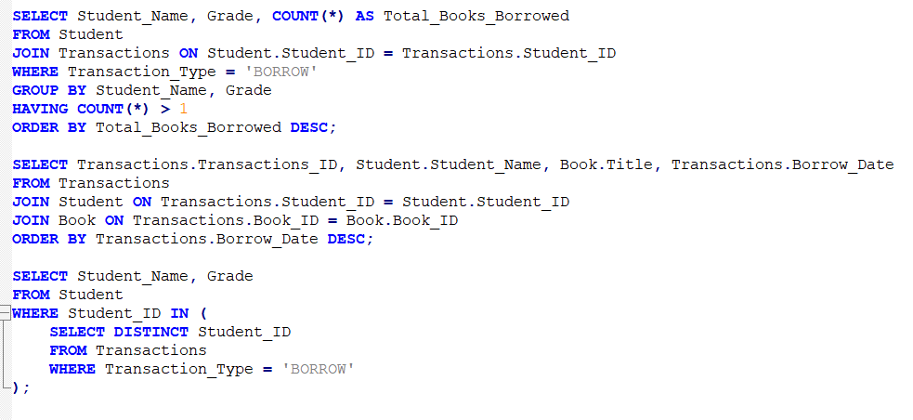
Checking the student how many did she borrowed
The result:
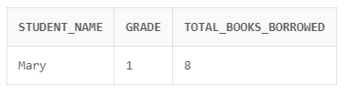

- 1 query that joins at least two tables
Checking the record of borrowed book
The result: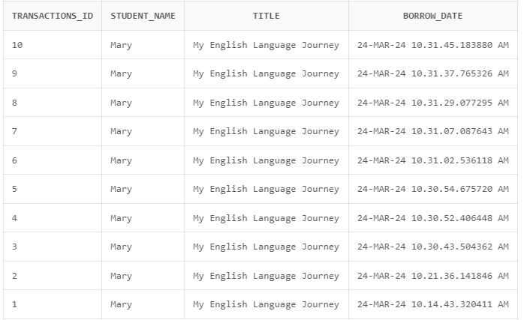

- 1 query that uses a subquery
Checking the grade of students who borrowed a book.
