|  |
| --- |
| SOUTHERN CROSS UNIVERSITY |

**ASSIGNMENT COVER SHEET**

For use with online submission of assignments

Please complete all of the following details and then make this sheet the **first page of each file of your assignment – do not send it as a separate document.**

Your assignments must be submitted as either **Word documents, text documents with .rtf extension or as .pdf documents**. If you wish tosubmit in any other file format please discuss this with your lecturer well before theassignment submission date.

|  |  |
| --- | --- |
| Student Name: | **Yi Zhong** |
| Student ID No.: | **23348000** |
| Unit Name: | **Data Communications and Networks** |
| Unit Code: | **CSC00240** |
| Tutor’s name: | **Yun Sheng Yan** |
| Assignment No.: | **2** |
| Assignment Title: | **Assignment 2** |
| Due date: | **18 April 2019 11:00 PM** |
| Date submitted: | **2019/4/15** |

Declaration:

*I have read and understand the Rules Relating to Awards (*[*Rule 3 Section 18 – Academic Misconduct Including Plagiarism*](http://policies.scu.edu.au/view.current.php?id=00140#s18)*) as contained in the SCU Policy Library. I understand the penalties that apply for plagiarism and agree to be bound by these rules. The work I am submitting electronically is entirely my own work.*

|  |  |
| --- | --- |
| Signed:  (please type your name) | Yi Zhong |
| Date: | 2019/4/15 |

# Advanced Medical Limited (AML) Network Design Report

# 

**Executive Summary**

**Executive summary with**

The purpose of this report is to analyze existing Advanced Medicos Limited (AML) companies to recommend network solutions, integrate networks with their business objectives, and make appropriate recommendations. To modernize the network and meet the needs of the company in the next five years.

**Business purposes of network**

* Improve network communication standards for communications, wireless, and videoconferencing.
* Available free of charge,
* Protect the company's business information,
* Take into account the fact that the company will have more than 400 employees in the future.
* Excellent technology.

**Technical solution**

* The current network and computer room will be upgraded to a modern network (campus design) to meet the needs of developers and employees.
* Scalability-remember that they want to expand over the next five years.
* Availability-Wireless network access is available to all employees as well as some outdoor areas of software developers and employees.
* Employees can access corporate resources from the company and the home (different servers).
* Performance-Network performance must be high.
* Reliability-No single point of failure.
* Security-protects company information and other IT assets.

Content

SOUTHERN CROSS UNIVERSITY 1

Advanced Medical Limited (AML) Network Design Report 3

1. INTRODUCTION 1

1.1 Reporting purpose 1

1.2 Background introduction 1

1.3 Scope of the report 1

2. ORGANISATIONAL DESCRIPTION 2

2.1 Overall Departmental Structure 2

2.2 Physical Structure 4

2.3 Network Solution Purpose and Solution Objectives 4

3. Current Network Analysis from User Requirements 5

3.1User Requirements Analysis 5

3.2Expected Functionality 6

3.3 Capacity Evaluation 6

4.Description & Analysis of Current Network 9

4.1 Data Transmission Media/Circuits 9

4.2 Network Hardware 9

4.3 Logical network(s) topology 9

4.4 Network physical topology 11

4.5 Analysis of existing network(s) 13

5.Network Design for Recommended Network(s) 14

5.1 Data Transmission Media 14

5.2 Hardware (network and user) 14

5.3 Proposed Software 15

5.4 Logical network(s) design including diagram(s) 15

5.5 Network physical including network diagram(s) 16

6. Topology 17

7. IPv4 Addressing plan 19

8.Cost Estimation 23

9. Conclusion 25

10.Referencing 26

# 1. INTRODUCTION

# 1.1 Reporting purpose

The purpose of this report is to evaluate and analyze AML's existing network and recommend network solutions, while meeting AML's needs to build a new network to meet its needs in the next five years.

## 1.2 Background introduction

Advanced Medicos Limited (AML) is a digital health company that sells health products. The existing network consists of 90 workstations and 18 printers controlling workstations in two adjacent buildings. All workstations, printers and other equipment are connected through wired networks. Self-contained devices are not supported. Recently, AML intends to provide medical services through the network in addition to its sales system. In addition, the general manager of AML has proposed to build a network that can accommodate the current and next five years’ load and provide space for further expansion. In view of this, the current network structure cannot be maintained. In order to meet the company's future development goals, AML needs to upgrade its network.

## 1.3 Scope of the report

This report describes the current organization's network structure and business objectives, and also analyses user needs and existing networks, including:

* User communities and their priorities
* Bandwidth and network security, remote access and mobile device requirements
* Capacity assessment
* Network hardware and software (client, server, network operating system)
* Network logic, topology and layout.
* Analysis of Current Network

At the same time, the report recommends a network solution, which is designed to use the latest technology and network, to adapt to the current and future five years of load, and to make room for further expansion.

# 2. ORGANISATIONAL DESCRIPTION

AML is divided into four departments: software development department, production department, market department and administration department.

## 2.1 Overall Departmental Structure

***Current:***

* Managing Director: The general manager is responsible for managing the operation of the whole company. He has a broad business background, including professional skills in sales and software development. The department managers of each department report to the general manager.
* Software Development Department: The Software development department. Leaded by the software development manager, responsible for the development and iteration of the company's software, but also responsible for the company's software operations and testing, including daily network operations, user support and network maintenance operations are managed in this department.
* Production Department: Software: The product department is responsible for the iteration of product development and related product work. Everyone has technical knowledge to understand the product development process. The product manager is responsible for this department.
* Market Department: The marketing department is responsible for the promotion, research and sales of the company's products, and is managed by the marketing department.
* Administration Department: The administrative department is mainly responsible for the collation and printing of documents, the daily processing of documents operated by the company and some dispatching arrangements and personnel handling in the administration of the company. The administrative director is responsible for this department.

***Future:***

The Branch: The new branch has only two departments: software development (25 hosts) and marketing (6 hosts). The branch is about 100 kilometers from the company's headquarters. They need to be connected to the headquarters network of existing software development companies.

## 2.2 Physical Structure

AML is located in two adjacent three-storey buildings (Building A and Building B). The distance between the two buildings is 20 meters. AML currently has 200 employees. Software development and marketing are on Building A and the other two departments are on Building B. The network is a simple switching network without wireless support. The server farm is located in Building B. At present, there is no direct connection between the two buildings. The two buildings access each other through a portal website. Edge routers (routers connected to the Internet and providing Internet access to the organization) are located in Building A.

## 2.3 Network Solution Purpose and Solution Objectives

Data communication and network are necessary for AML's business development. They are mainly used to improve communication, wireless, video conferencing and other business, protect company information, and provide network communication convenience for more than 400 employees in the future. At the same time, it also provides the company with modern network in order to expand the company's business scale in the next five years, provide higher online accessibility without affecting security, and ensure stable and secure video conferencing between headquarters and its branches. In addition, in terms of technology, the current network and computer room will be upgraded to a modern network to meet the needs of developers and employees. For all employees, especially software developers, AML's data network needs to ensure that wireless network access can be used in some outdoor areas, whether in the company or at home, through the set of No. With servers to access corporate networks, Elopers and employees, * employees can access corporate resources from companies and households (different servers). The whole AML data network should provide AML with stable and reliable resources, no single point of failure, and easy to maintain and manage, in order to achieve the company's short-term and long-term business and demand goals.

# 3. Current Network Analysis from User Requirements

## 3.1User Requirements Analysis

***(1) Building B:***

Managing Director

**Located Building B**

**Priority of user: Standard**

**Number of Hosts: 1**

Applications used: E-mail, Internet browser, desktop operating systems, remote conference, file sharing, sending and receiving, Intranet, office application, accounting, finance, and HR applications, company management system, virus protection and printer access, etc.

Administration Department

**Located Building B**

**Priority of user: High**

**Number of Hosts: 5 workstations, 2 printers**

Applications used: Intranet, e-mail, Web, general ledger and payroll, file sharing, intranet, general "office" applications, company management system, virus protection and printer access, while the administration is a priority group.

Production Department

**Located Building B**

**Priority of user: High**

**Number of Hosts: 5 workstations, 2 printers**

Applications used: E-mail, Browser, desktop operating systems, graphical database, file sharing, Intranet, Office application, Video conferencing, virus protection and printer access. The data storage space required by this department is large, and the storage demand will be higher than the average level.

***(1) Building A:***

Marking Department

**Located Building A**

**Priority of user: High**

**Number of Hosts: 10 workstations, 4 printers**

Applications used: E-mail, Web, desktop operating systems, graphical database, file sharing, Intranet, Office application, Video conferencing, virus protection and printer access. The data storage space required by this department is large, and the storage demand will be higher than the average level.

Software Development:

**Located Building A**

**Priority of user: High**

**Number of Hosts: 70 workstations, 10 printers**

Applications used: Email, Web, Project Management Software, File sharing, Intranet, general “office” applications, web designers (text, audio, video, graphic and animation) application and authoring tools, network operating and management application, program (software) development, desktop conferencing, whiteboard software for company, software for mobile devices, software for remote access, virus protection and access to printers.

## 3.2Expected Functionality

1. Change the culture of the workplace. Employees and management in particular want to be able to work at home for software development teams. All software developers (65) will get a laptop / MacBook Pro so that they can take it home.
2. AML also needs additional resources to support new online services, and production processes will be updated. The production team needs 60 new computers to control the 3D printer. The Administration Department will add eight workstations and two printers to handle the extra workload.
3. AML also wants to be more open, allow BYOD, and ensure network security.
4. AML also needs to be connected to the WAN of a branch just opened in another city.

## 3.3 Capacity Evaluation

AML has standard business hours of 9.00am to 5.00pm Monday to Friday.

Terminology:

***High***: users have a large amount of network access and require high application operating capacity, including high-capacity applications and printing requirements.

***Medium***: user's network access is general, and the required application operation capacity is medium.

***Low***: user network access is low, and the required application running capacity is small.

***User communities***

***Community 1: Administration Department, 5 workstations, 2 printers***

***Type of user: Medium***

***Typical daily usage patterns of this community:***

* From 9:00 to 9:30 a.m., the administrative department met to discuss the company's administrative matters to be handled today.
* From 9:30 a.m. to 12:30 p.m., the usage of network, e-mail and Intranet servers is higher.
* Lunch break is between 12:30 p.m. and 2:00 p.m., during which user community network traffic decreases.
* From 2:00 p.m. to 5:00 p.m., Internet browser, company management system and HR applications will increase again.

***Community 2: Production Department, 5 workstations, 2 printers,***

***Type of user: Medium***

***Typical daily usage patterns of this community:***

* From 9:00 to 9:45 a.m. every day, the product department holds a 45-minute meeting to discuss the company's product-related issues.
* Between 10 a.m. and 12.30 p.m., product planning, iteration, and testing can lead to peak network usage.
* As a result of lunch time, network usage decreased between 12:30 noon and 2:30 p.m.
* Between 3 p.m. and 5 p.m., application traffic will increase again.

***Community 3: Marking Department, 10 workstations, 4 printers***

***Type of user: Medium***

***Typical daily usage patterns of this community:***

* From 9:30 a.m. to 1:00 p.m., Internet, e-mail, browsers and marketing applications have high usage.
* Due to lunch and rest time, usage decreased between 1 p.m. and 2 p.m.
* The network traffic of this group is high from 2 p.m. to 5 p.m.

***Community 4: Software Development, 70 workstations, 10 printers***

***Type of user: High***

***Typical daily usage patterns of this community:***

* Software development, compilation and software testing between 9 a.m. and 12 p.m. can lead to heavy use of network traffic.
* During the lunch break between 12 noon and 2 pm, network traffic decreased.
* Network operation and Management Application, Program (software) Development, Web Design (text, audio, video, graphic and animation) Application and authoring tools traffic will increase again between 2 p.m. and 5 p.m.

***Community 5: Managing Director and Branch, PC users***

***Type of user: low***

***Typical daily usage patterns of this community:***

* From 9:00 a.m. to 10:00 a.m., video conferencing and e-mail usage rate is high.
* From 10:00 to 12:00 a.m., the network and company management system began to increase.
* Between 12:00 noon and 2:00 p.m., there is lunch and rest time, and the peak network traffic is low in this period.
* Between 2:00 p.m. and 5:00 p.m., the community's network traffic increased significantly for work needs.

**Usage Patterns**

# 4.Description & Analysis of Current Network

## 4.1 Data Transmission Media/Circuits

AML's network routing is a simple switching network without wireless support. All workstations, printers and other devices are connected through a wired network. Self-contained devices (BYOD) are not supported. The server farm is located in Building B. At present, there is no direct connection between the two buildings. The two buildings access each other through a portal website.

## 4.2 Network Hardware

***Software Development Department:*** 70 workstations, 10 printers, Located in Building A

***Production Department:***5 workstations, 2 printers, Located in Building B

***Marketing Department:***10 workstations, 4 printers, Located in Building A

***Administration Department:***5 workstations, 2 printers, Located in Building B

***Another Network Hardware:***

***Router:*** Edge routers (routers that connect to the Internet and provide Internet access to organizations) are located in Building A.

***Servers:*** Here’s a server farm in Building B.

## 4.3 Logical network(s) topology

**(1) Description of Existing Network Logical Topology**

The software development department has 70 workstations and 10 printers. In addition, an edge router is used to connect to the Internet. There is a file server, a web server, and a firewall on the edge router. In addition, offices of each department are interconnected through switches.

The administrative department has five workstations and two printers, and a server farm is located in Building B. The offices of each department are interconnected by switches, and then connected to the edge router through a general switch to access the Internet.

**(2) Diagram**

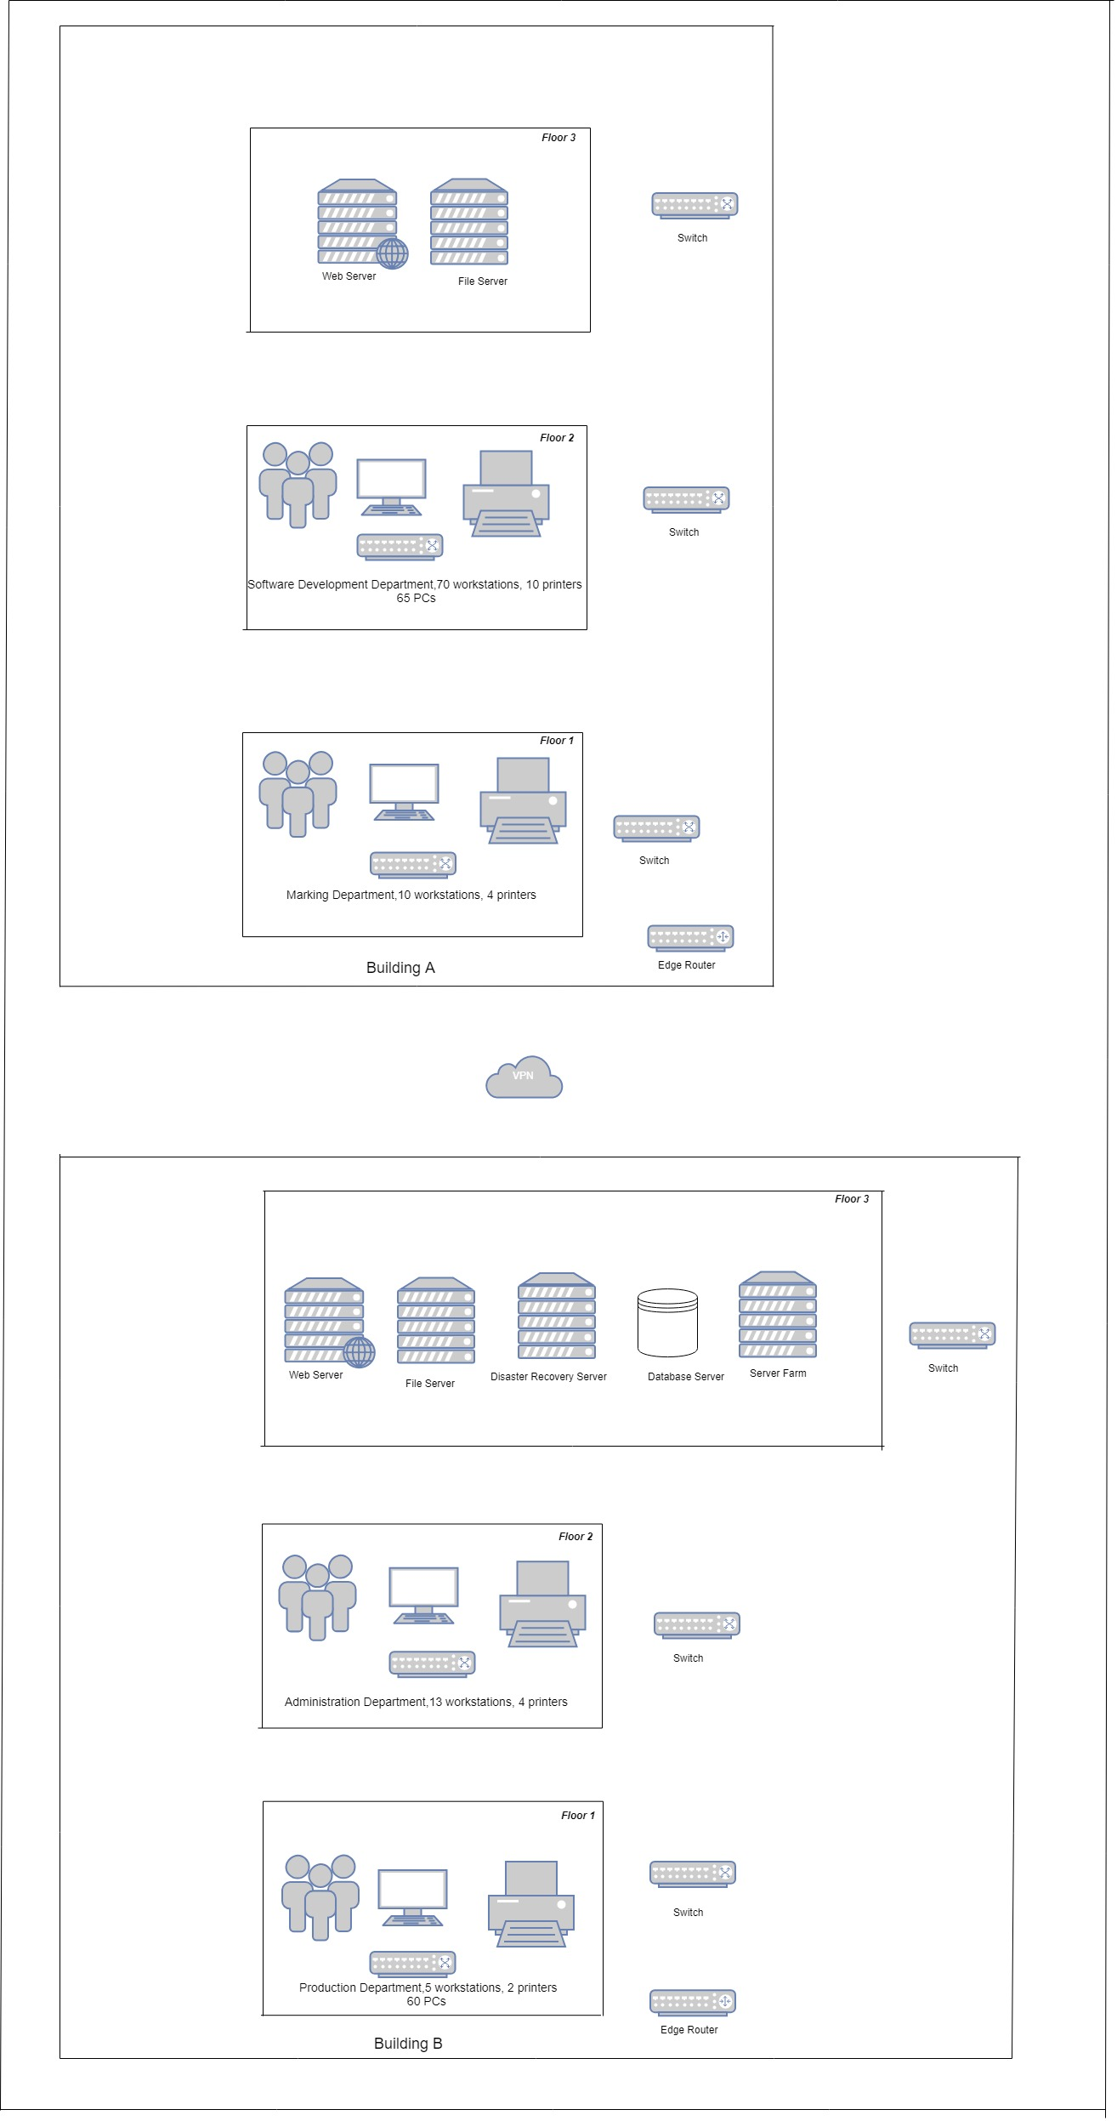

## 4.4 Network physical topology

**(1) Description of Existing Network Logical Topology**

***Building A:***

The software development department has 70 workstations and 10 printers. In addition, an edge router is used to connect to the Internet. There is a file server, a web server, and a firewall on the edge router. In addition, offices of each department are interconnected through switches.

***Building B:***

The administrative department has five workstations and two printers, and a server farm is located in Building B. The offices of each department are interconnected by switches, and then connected to the edge router through a general switch to access the Internet.

**(2) Diagram**

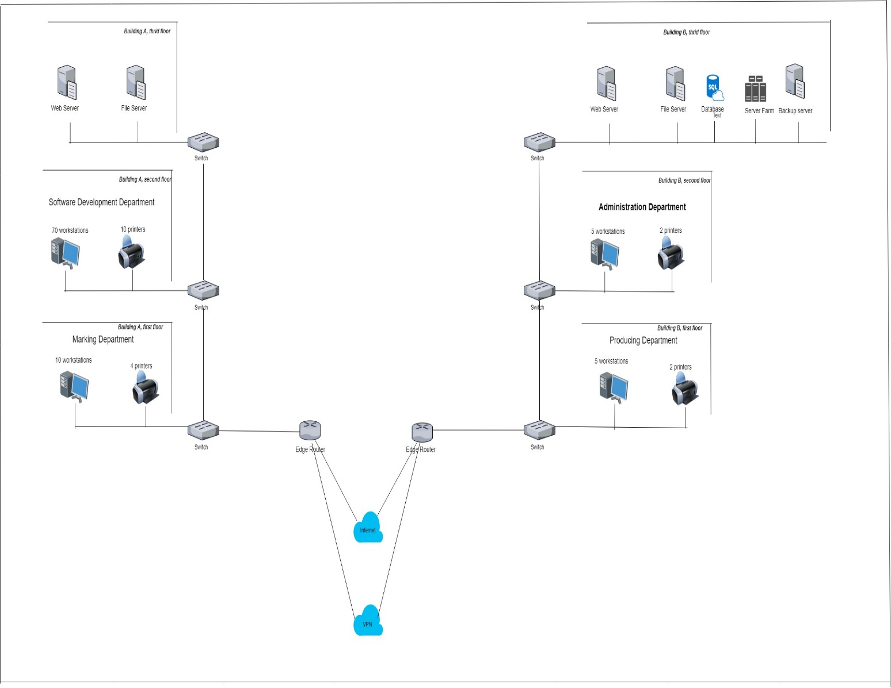

## 

## 4.5 Analysis of existing network(s)

* In buildings A and B, the bus network design results in slow response of all users and poor application performance. This is because more and more user communities compete for server bandwidth and response as backbone connections/cables are gradually accessed outward.
* Building B and Building A are accessed through portals. This problem will become more complex due to the limited bandwidth and high latency of site-to-site. In addition, accessing each other in this way also threatens the internal network security of the company.
* In terms of software, considering the company's development plan for the next five years, there are compatibility and version iteration issues in the current Windows system.
* With regard to the current peak load of network traffic, besides lunch and rest time, the network has a high peak of traffic access. A large number of software developers, marketing staff, product and administrative personnel, as well as a large number of application software used in file sharing, backbone design and server farm in Building B are accelerating the tension of the whole network.
* Server plays the role of saving space and cost and improving network utilization in building a scalable network. However, with the development and scalability of AML, considering business continuity, hierarchy, disaster recovery and how to protect server data should be considered in the current network.

# 5.Network Design for Recommended Network(s)

## 5.1 Data Transmission Media

**Suggested network circuit changes:**

Considering the long relay distance, anti-electromagnetic interference and confidentiality of optical fiber, it is better (Li Feng (2004)). Optical fibers are considered for transmission media between building A and building B. The distance between buildings is about 20 meters. Considering the connection with the data center, the recommended optical fiber length is about 30 meters. Installation costs will include installation costs (building to building) and cable costs themselves.

The dedicated optical fiber connection between building A and building B will improve the efficiency of network resource sharing. Reliability and resource sharing efficiency, both buildings need high-speed exchange and storage of information in order to effectively perform tasks and improve productivity, the current way of only wired connections between all working equipment is not suitable for the current level of efficiency required. In addition, with the development of the company, there will be more and more demand for employee equipment.

Consider introducing Gigabit networks into the backbone of each building. Increase the bandwidth of each floor to 10GB or consider the bandwidth of more than 10GB.

## 

## 5.2 Hardware (network and user)

The current network user layer mainly connects wired through switches.

**Suggested network hardware changes or additions:**

**Switches:**

Two 48-interface switches are placed in the software development department of Building A, one in the market department, one in the Administration Department of Building B, and two in the product department.

**Firewall/Router:**

The performance of an enterprise network is affected not only by its protocol specification, its communication channel, design capacity and architecture of the firewall but also by its implementation and traffic management. Firewall is a perimeter security solution that is useful for addressing network traffic (Tegenaw, Hailu & M. Kifle (2015)). Both buildings use a router to set up firewalls to terminate Internet connections when network security is threatened. There is a site-to-site VPN tunnel between the two routers, which is connected through the Internet. S router is the default gateway in every office. It routes traffic to the Internet or between offices and acts as a firewall between LAN and WAN. The device also allows remote communicators to connect to VPN tunnels in offices when necessary.

**Servers:**

Two additional high-end servers will be required to perform server virtualization and disaster recovery functions.

Basic specifications of the two new servers are suggested as:

Product category: rack type

Product structure: 4U

CPU model: Xeon E7-4820 V4

Standardized CPU Number: 2

Memory type: DDR4

Memory capacity: 64GB

Hard disk interface type: SAS

Standard Hard Disk Capacity: 2*1.2TB

Operating System (for each separate logical server): Windows Server 2019

Virtual Operating System: VMWare 2015

## 5.3 Proposed Software

1. Microsoft Office suite (Microsoft Word, Power Point and Excel Files),
2. Internet Browser
3. Desktop Operating systems
4. Accounting, Finance, and HR applications
5. Web designers (text, audio, video, graphic and animation) application and authoring tools
6. Anti-malware
7. Network operating and Management Application
8. Software Development
9. Desktop conferencing
10. Video conferencing
11. Whiteboard Software for company
12. Company management system
13. Software for mobile devices
14. Software for remote access
15. VMWare Sphere
16. Windows Server 2012

## 5.4 Logical network(s) design including diagram(s)

* The proposed network uses 48-interface switches in the backbone (distribution network) and access layer to make full use of the optical fiber and eight types of unshielded twisted pair connections between buildings, and to be used in distribution layer and network segment.

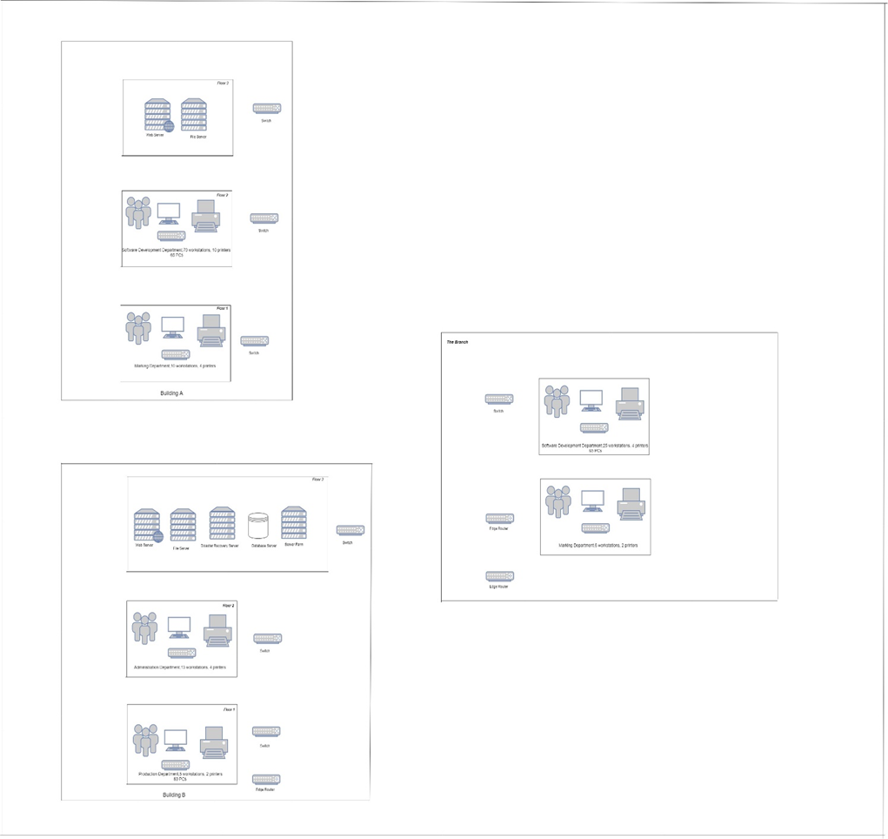

## 

## 5.5 Network physical including network diagram(s)

* Each Department office uses fiber optic cables. It needs two subnets, one for each building, and a wireless network through routers or switching agencies to connect mobile devices and improve performance through traffic priority.
* The high end of the newly purchased servers for disaster recovery is located in the server farm of Building B.

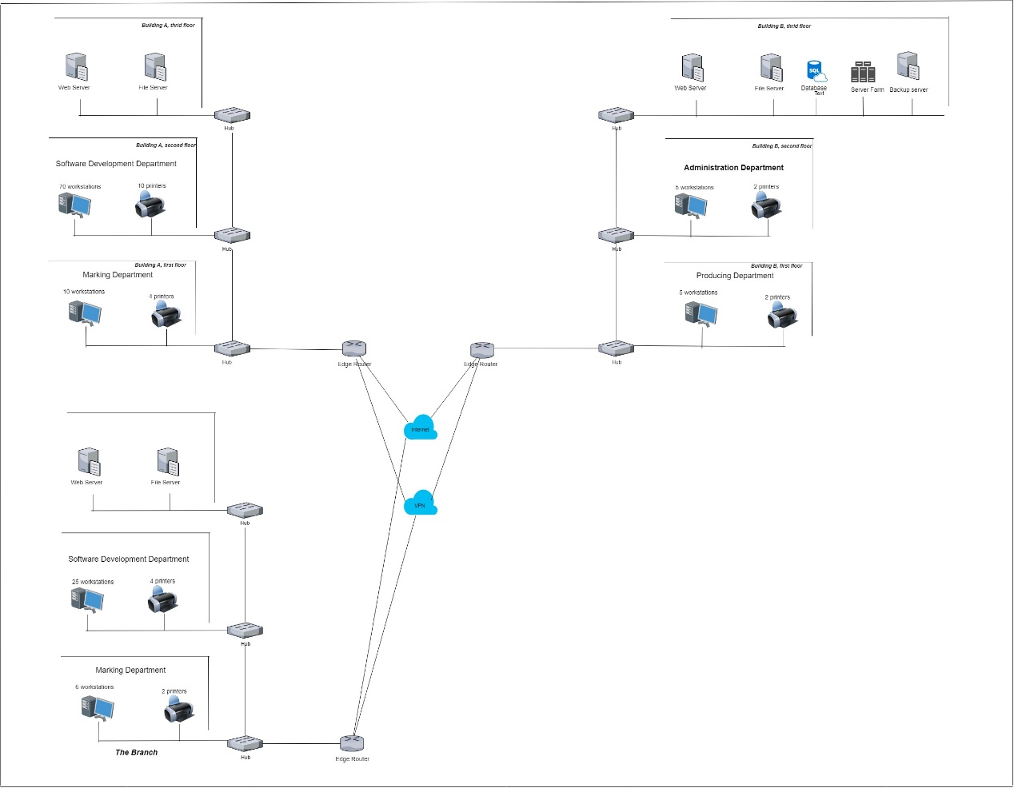

# 

# 6. Topology

(1) In both the current and the proposed network, the logical topology is a Star as pictured below:

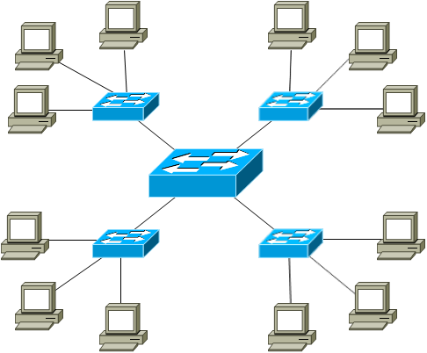

***Logical topology: Star (switched Ethernet)***

(2) In both the current and proposed network, the physical topology is a Star.

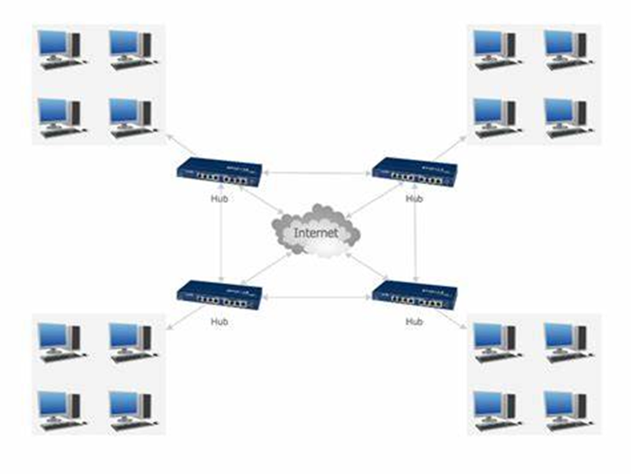

# 

# 7. IPv4 Addressing plan

With the increasing lack of IP addresses, how to use limited IP addresses effectively and reasonably is the first problem to be solved in network applications. In the planning of IP addresses, it is necessary to allocate IP addresses efficiently and reasonably, not only to meet the expected requirements, but also not to waste IP addresses. The problem of IP address allocation can be well solved by using variable subnet mask and classless inter-domain routing (Zhang Xiaoming(2011)).

|  |  |  |  |  |  |  |  |  |  |  |  |  |  |
| --- | --- | --- | --- | --- | --- | --- | --- | --- | --- | --- | --- | --- | --- |
| **Name of subnet and** | |  | **Default** | |  | **Subnet Mask** | |  |  |  |  | **Broadcast** | |
| **Network Address** | |  | **Gateway** | |  |  | **Valid Hosts** | |  |
|  |  | **Of sub net** | |  |  | **Address** | |
| **(Network Users)** | |  | **Address** | |  |  |  |  |  |
|  |  |  |  |  |  |  |  |  |
|  |  |  |  |  |  |  |  |  |  |  |  |  |
| **Building-A (80+)** |  |  | 172.16.159.0 |  |  | 255.255.255.128 |  |  | 172.16.159.1 |  |  | 172.16.159.127 |
|  |  |  |  |  |  |
| **172.16.159.0/25** |  |  |  |  |  |  | 172.16.159.126 |  |  |
|  |  |  |  |  |  |  |  |  |  |  |
|  |  |  |  |  |  |  |  |  |  |  |  |  |
| **Building – B (78+)**  **172.16.159.128/25** |  |  | 172.16.159.128 |  |  | 255.255.255.255.128 |  |  | 172.16.159.129  172.16.159.254 |  |  | 172.16.159.255 |
|  |  |  |  |  |  |  |  |  |  |  |  |  |
| **Branch (31)**  **172.16.160.64/23** |  |  | 172.16.160.0 |  |  | 255.255.255.128 |  |  | 172.16.160.1  172.16.161.126 |  |  | 172.16.161.127 |
| **Building A-Printers (14)** |  |  | N/A | |  | N/A | | 172.16.159.111 | |  |  | N/A | |  |
|  |  |  | 172.16.159.125 | |  |  |  |
|  |  |  |  |  |  |  |  |  |  |  |  |  |
| **Building B-Printers (6)** |  |  | N/A |  |  | N/A |  | 172.16.159.247  172.16.159.253 | |  |  | N/A |  |  |
| **Servers (3+)** |  |  | 172.16.160.128 |  |  | 255.255.255.240 |  |  | 172.16.160.129 |  |  | 172.16.160.143 |  |  |
|  |  |  |  |  |  |  |  |
| 172.16.160.128/28 |  |  |  |  |  |  | 172.16.160.142 |  |  |  |  |
|  |  |  |  |  |  |  |  |  |  |  |  |  |
|  |  |  |  |  |  |  |  |  |  |  |  |  |  |  |
| **WAN 1** |  |  | N/A | | 255.255.255.252 | | | 172.16.160.137 | |  | 172.16.160.139 | |  |  |
| **172.16.160.136/30** |  |  | 172.16.160.138 | |  |  |  |
|  |  |  |  |  |  |  |  |  |  |  |  |
|  |  |  |  |  |  |  |  |  | |  |  |  |  |  |
| **WAN 2** |  |  | N/A |  |  | 255.255.255.252 |  |  | 172.16.160.141 |  |  | 172.16.160.143 |  |  |
|  |  |  |  |  |  |  |  |  |
| **172.16.160.140/30** |  |  |  |  |  |  | 172.16.160.142 |  |  |  |  |
|  |  |  |  |  |  |  |  |  |  |  |  |  |
|  |  |  |  |  |  |  |  |  |  |  |  |
| **WAN 3** |  |  | N/A | | 255.255.255.252 | | | 172.16.160.145 | |  | 172.16.160.147 | |  |  |
| **172.16.160.144/30** |  |  | 172.16.160.146 | |  |  |  |
|  |  |  |  |  |  |  |  |  |  |  |  |

|  |  |  |
| --- | --- | --- |
| Subnet Name | Needed Size | Allocated Size |
|  |  |  |
| BUILD A | 80 | 126 |
|  |  |  |
| BUILD B | 10 | 126 |
|  |  |  |
| SERVER | 3 | 14 |
|  |  |  |
| WAN LINK 1 | 2 | 2 |
|  |  |  |
| WAN LINK 2 | 2 | 2 |
|  |  |  |
| WAN LINK 3 | 2 | 2 |
|  |  |  |

Given below table is shown the IP address of interface (router) and server address.

|  |  |  |  |
| --- | --- | --- | --- |
| Name of Device | Name of Interface | IP address / CIDR | Default Gateway |
| (Building-A) R1 | Gigabit Ethernet 0/0 | 172.16.160.137 | N/A |
| Gigabit Ethernet 0/1 | 172.16.160.141 | N/A |
| Gigabit Ethernet 0/2 | 172.16.159.1 | N/A |
| (Building-B) R2 | Gigabit Ethernet 0/0 | 172.16.160.142 | N/A |
| Gigabit Ethernet 0/1 | 172.16.160.146 | N/A |
| Gigabit Ethernet 0/2 | 172.16.159.129 | N/A |
| (Branch) R3 | Gigabit Ethernet 0/0 | 172.16.160.138 | N/A |
| Gigabit Ethernet 0/1 | 172.16.160.145 | N/A |
| Gigabit Ethernet 0/2 | 172.16.160.1 | N/A |
| FTP Server | Fast Ethernet 0/0 | 172.16.160.130/29 | 172.16.160.128 |
| DNS/DHCP Server | Fast Ethernet 0/0 | 172.16.160.130/29 | 172.16.160.128 |
| Web Server | Fast Ethernet 0/0 | 172.16.160.130/29 | 172.16.160.128 |

# 8.Cost Estimation

***Switches:***

***680 yuan per unit***

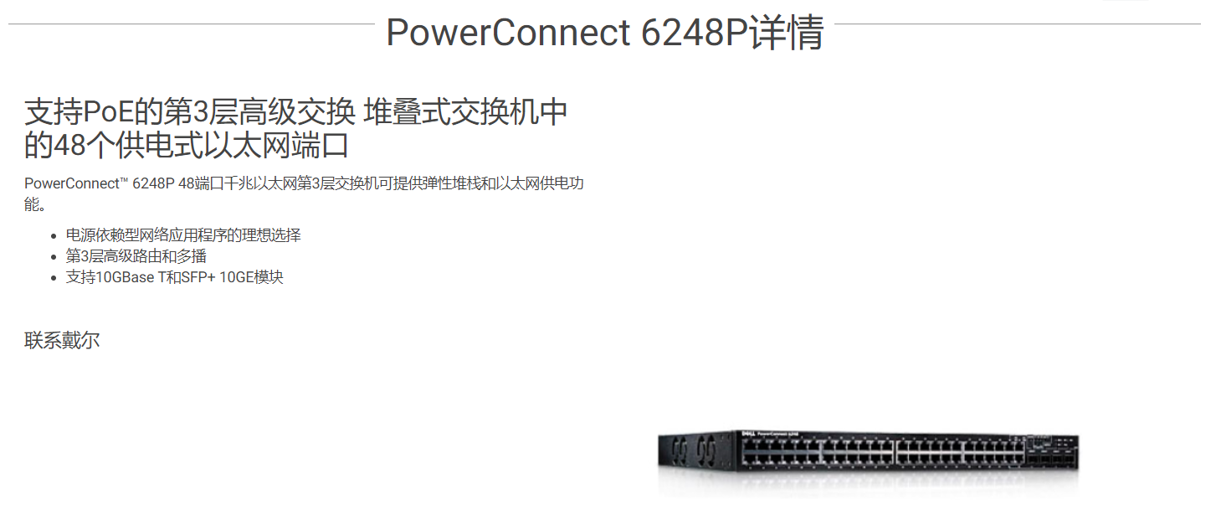

***Gateway/Firewall:***

30,000 yuan per unit

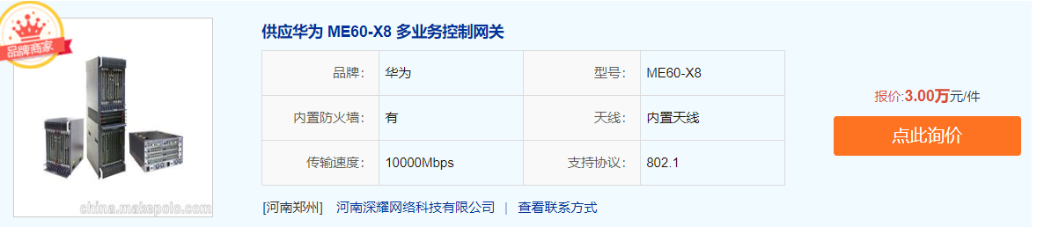

***Servers:***

***50000yuan/unit***

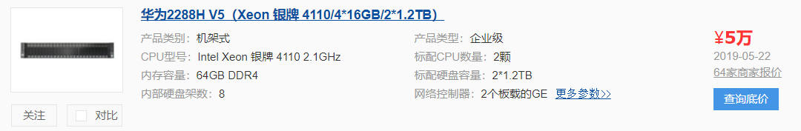

***Software:***

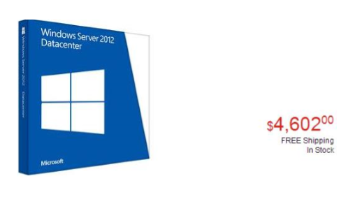

…………

A total of $6347

***Optical fiber Installation:***

Prices & vendors vary:

<http://www.189.cn/fj/kd/>

***Total:***

|  |  |
| --- | --- |
| ***General Cost Summary*** | |
| ***Switches/Hub*** | 680 * 9 RMB |
| ***Gateway/Firewall*** | 30000 * 3 RMB |
| ***Servers*** | 50000 * 6 RMB |
| ***Software*** | $ 6347 |
|  | $ 75792.71 |

# 9. Conclusion

AML company has no direct physical layer connection in building A and B. At present, it is sharing information and data through the tunnel or wireless signal from VPN site to site. Therefore, the bandwidth and network utilization are limited. In addition, system compatibility of server should be considered on the later server. Best of all, there is no disaster recovery opportunity for company data at present. However, it should be noted that data backup must be done at regular intervals.

# 10.Referencing

[1] Advanced routing. (1995). Alexandria, Va.: Time-Life Books.

[2] McQuarrie, S. (2005). CCNA self-study. Indianapolis, Ind.: Cisco Press.

[4] Knipp, E. and Danielyan, E. (2002). Managing Cisco network security. Rockland, MA: Syngress.

[5] Pardalos, P. and Du, D. (1998). Network Design. Providence: American Mathematical Society.

[6] Li Feng. "Superiority of Optical Fiber Communication." Shanxi Architecture 30.22 (2004): 97-98.

[7] Zhang Xiaoming. "The Principle and Application of IP Address Subnet Partition." Journal of Taiyuan University (Social Science Edition) 12.1 (2011): 114-116.

[8] Tegenaw, Hailu , and M. Kifle . "Application aware firewall architecture to enhance performance of enterprise network." *IEEE AFRICON 2015* IEEE, 2015.