|  |
| --- |
| **SOUTHERN CROSS UNIVERSITY** |

**ASSIGNMENT COVER SHEET**

For use with online submission of assignments

Please complete all of the following details and then make this sheet the **first page of each file of your assignment – do not send it as a separate document.**

Your assignments must be submitted as either **Word documents, text documents with .rtf extension or as .pdf documents**. If you wish tosubmit in any other file format please discuss this with your lecturer well before theassignment submission date.

|  |  |
| --- | --- |
| Student Name: | **Yi Zhong** |
| Student ID No.: | **23348000** |
| Unit Name: | **Database Systems** |
| Unit Code: | **CSC72001** |
| Tutor’s name: | **Zheng Jing Huang** |
| Assignment No.: | **Assessment 3** |
| Assignment Title: | **Enhanced Entity Relationship Diagram** |
| Due date: | **Monday, 18th November 2019 at 11.30 PM** |
| Date submitted: | **2019/11/18** |

Declaration:

*I have read and understand the Rules Relating to Awards (*[*Rule 3 Section 18 – Academic Misconduct Including Plagiarism*](http://policies.scu.edu.au/view.current.php?id=00140#s18)*) as contained in the SCU Policy Library. I understand the penalties that apply for plagiarism and agree to be bound by these rules. The work I am submitting electronically is entirely my own work.*

|  |  |
| --- | --- |
| Signed:  (please type your name) | Yi Zhong |
| Date: | 2019/11/12 |

ASSESSMENT 3A

REPORT

BY <Yi Zhong>

# Table of contents:

Contents

Table of contents: 3

Entity Relationship Diagram 4

Part A: Analysis and Design 5

1. Client Business Rules 5

2. Assumptions Made 5

3. Naming Conventions 5

# Entity Relationship Diagram

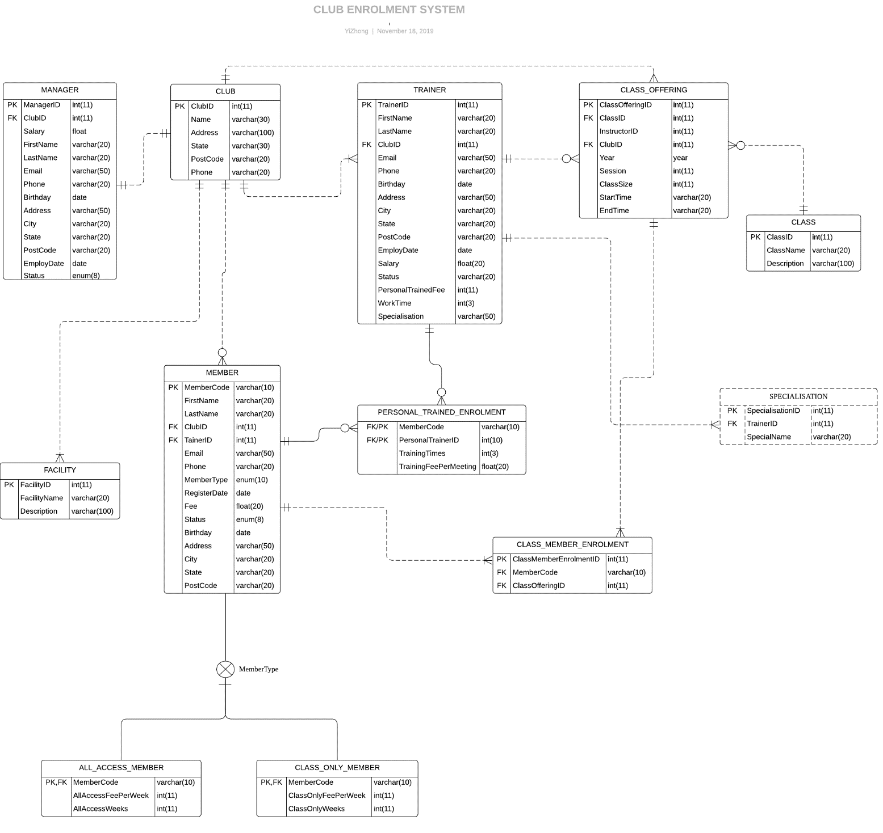

# Part A: Analysis and Design

## Client Business Rules

FIT CLUB Health Centre is a fitness centre with various facilities and has many branches across Australia. A branch is called a club and supervised by a manager. Each club must have a manager (will need to manage club facilities, members, trainers and arrange classes), some trainers (will provide class and personal training services), standard classes (set by FIT club, each class for each club) There will be different schedules depending on the availability of the trainer), some facilities (depending on the manager's preferences), but the standard facilities for each club should be a 24-hour gym and swimming pool, and other available facilities including bicycles Studio, children's playroom, sauna and outdoor training ground, etc.

* Club rules：

1. The fitness center has multiple clubs.
2. A club is managed by a manager.
3. One club has more than one trainer, but two clubs cannot employ one trainer at the same time.
4. A club has several facilities, which is decided by the manager's preference.

* Member rules:

1. Two types of members ：
2. the first category is all access members who can access all facilities in clubs.
3. the second category is class-only members who are only participating in the club’s classes.
4. Members must choose a family club when they register, but membership allows them to visit any clubs in Australia.
5. Any type of member can register at the club
6. If a member wishes to leave the club, the member data will still be stored although the membership status will be set to inactive.
7. If a member leaves Australia for more than one month (such as vacation or overseas work), his/her membership can be suspended and reactivated.
8. Each member must bear additional fees to enjoy personal training services

* Class rules:

1. All clubs exist the same classes.
2. every club have a different class timetable depending on instructor’s availability.

* Trainer rules：

1. Every trainer can provide personal training services.
2. Every trainer can be the instructor of classes.

* Facility rules：

1. the standard facilities for each club should be a 24-hour gym and swimming pool, and other equipment is determined by the manager's preference.

* Manager rules：

1. A manager manages a club.
2. The manager is responsible for managing the club's facilities, membership, training and course arrangement.

## Assumptions Made

*Club Assumptions：*

1. We need to know the club's name.
2. We need to know the club's address and zip code.
3. We need to know the club's phone number.
4. We need to know the club's manager

*Manager Assumptions：*

1. We need to know the manager's name, email, phone, address, post code and other information, so that we can contact him.
2. We need to know the current state of manager: inactive state, active state.
3. We need to know the working hours of the manager so that we can pay the salary.

*Facility Assumptions：*

1. We need to know the price of the facility, and if the facility is damaged, we need to count the loss of the facility.
2. We need to know which club the facility is located at.
3. We need to know the manufacturer of each facility or equipment so that we can contact the manufacturer for maintenance.
4. We need to know the date of production of the equipment so that we can replace it.

*Trainer Assumption:*

1. We need to know the name, email, phone, address and post code of the trainer so that we can contact him.
2. We need to know the current state of trainer: inactive state, or active state.
3. We need to know the salary of the coach in order to pay the salary.
4. We want to know the trainer's expertise in order to allocate one-to-one members and classes.
5. We want to know the employment time of the trainer so that we can record his working years.

*Member Assumption：*

1. We need to know member's name, email, phone, address, post code and other information, so that we can contact him.
2. We need to know member's birthday so that we can send them our wishes on their birthday.
3. We want to know the membership type and registration time of member, so as to facilitate the charge management.
4. We would like to know the prices and privileges of two different types of members
5. Personal training services are selected at any time and do not require time attributes.
6. Personal training service should record the corresponding Trainer so that member can query and contact the corresponding Trainer.
7. We need to know the current state of member: inactive state, active state, suspended state, so as to remind member to join class, or continue to join club.

*Class Assumption：*

1. We want to know the different arrangement of the same class.
2. We would like to know the start and end dates of the class and the start and end times of the class to ensure that members do not miss the class.
3. We want to know the name, address, Club and instructor of class.
4. We would like to know the maximum number of members allowed to register in the class, more than the maximum number of members allowed to register will not be allowed to register, in order to ensure the effectiveness of teaching.

## Naming Conventions

To keep consistency, the database will use strict naming conventions that will allow easy implementation and maintenance of the database when completed. The following conventions apply:

1. The first letter of the field name is capitalized. If it is a word combination, the first letter of each word is capitalized.
2. Database table names should be meaningful and easy to understand.
3. When naming a database table, you should use the singular form of English words, such as employee table: you should name employees instead of employees.
4. Database table names should be simple, preferably no longer than three English words in length
5. Do not include data types in the names of columns and fields.
6. Before table creation is complete, table annotations should be added to the table.
7. It is not recommended to use database keyword naming
8. Primary Keys should be on the unique data for the row
9. Unique Identifiers and Primary Keys, every table gets a row identifier