|  |
| --- |
| SOUTHERN CROSS UNIVERSITY |

**ASSIGNMENT COVER SHEET**

For use with online submission of assignments

Please complete all of the following details and then make this sheet the **first page of each file of your assignment – do not send it as a separate document.**

Your assignments must be submitted as either **Word documents, text documents with .rtf extension or as .pdf documents**. If you wish tosubmit in any other file format please discuss this with your lecturer well before theassignment submission date.

|  |  |
| --- | --- |
| Student Name: | **Yi Zhong** |
| Student ID No.: | **201700408059** |
| Unit Name: | **System Analysis and Design** |
| Unit Code: | **ISY00243** |
| Tutor’s name: | **Viettrung Luong** |
| Assignment No.: | **Assignment 2** |
| Assignment Title: | **Case Study: Grow Your Business** |
| Due date: | **Friday, 23 November 2018, 11:55 PM** |
| Date submitted: | **22/11/2018** |

Declaration:

*I have read and understand the Rules Relating to Awards (*[*Rule 3 Section 18 – Academic Misconduct Including Plagiarism*](http://policies.scu.edu.au/view.current.php?id=00140#s18)*) as contained in the SCU Policy Library. I understand the penalties that apply for plagiarism and agree to be bound by these rules. The work I am submitting electronically is entirely my own work.*

|  |  |
| --- | --- |
| Signed:  (please type your name) | Yi Zhong |

|  |  |
| --- | --- |
| Date: | 13/11/2018 |

Farm Business and Management Information System Report

*Analyst: Yi Zhong*

**Contents**

SOUTHERN CROSS UNIVERSITY 1

Executive Summary 2

Introduction 2

Background 2

Organisation Chart 3

Business Function 5

System Vision Document 6

Problem Description 6

System Capabilities 6

Business Benefits 6

Project Planning 7

Gantt Chart 7

PERT Chart 8

Risk Analysis 9

Tangible Benefits 10

Intangible Benefits 10

Cost / Benefits Analysis 10

Feasibility 11

Recommendation 11

Investigating System Requirements 12

Fact-finding techniques: 12

Interview Plan: 13

Questions 13

Use Case 14

Brief Use Case……………………………………………………………………………………………….15

Full Use Case…………………………………………………………………………………………………16

Activity Diagram 19

System Sequence Diagram 21

Entity Relationship Diagram ………………………………………………………………………...22

UML………………………………………………………………………………………………………………………………....23

Database Design 23

Database datatypes and samples…… 23

Conclusions 31

Appendices 31

Bibliography 32

# Executive Summary

# This report carefully designs and analyses the needs of the farm to “Grow Your Business” system. The report introduces the background and organization chart of "GYB", including and so on. In addition, it also lists the tangible benefits and tangible benefits that the new information system will bring, such as expanding the market size, increasing the rate of return, increasing the profit, etc., in addition to the feasibility and risk analysis of the project. At the same time, it also introduces a lot of use-case-related information and use-case diagrams, and summarizes some of the conclusions.

# Introduction

John returned to his family and converted the dairy farm into a farm because of the expanded commercial prospects of the farm. He also hired many assistants to help him manage the farm. But as the scope and quantity of production and the number of customers increased, John needed a more convenient way to help manage the farm business. The information system can design and solve these problems according to his needs, including product distribution, order and payment processing, and customer account processing.

# Background

John grew up on a farm. He loved farms very much, but unlike his parents, he used most of the land on the farm to grow vegetables. John was mainly responsible for farm production. Jane was mainly responsible for customer-related businesses. They all had their own assistants. These assistants were responsible for businesses such as Below:

Noel, Noeletta, Nick, Netta: Assist in farmer production.

Chris, Christina, Cathy, Charlie: Answer customer orders, report orders to Jane, assist in gardening activities at leisure, and other employees who specialize in gardening activities.

Mark, Masha, Dirk: Sorting and packing products and distribution.

Tim, Terry, Tina: Manipulating and maintaining agricultural machinery.

Sam, Samantha: Responsible for account status and payment method.

# Organisation Chart

# Business chart

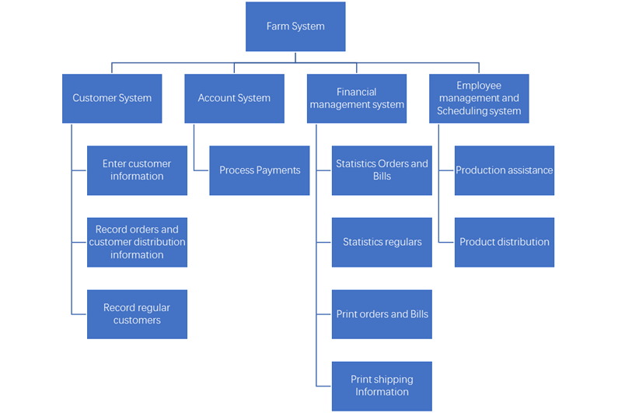

**Business Function**

|  |  |  |  |  |
| --- | --- | --- | --- | --- |
|  | Function | | | |
| Customer System | Enter customer information | Record orders and customer distribution information | Record regular customers |  |
| Account System | Process Payments |  |  |  |
| Financial management system | Statistics Orders and Bills | Statistics regulars | Print orders and Bills | Print shipping Information |
| Employee management and Scheduling system | Production assistance | Product distribution |  |  |

# 

|  |
| --- |
| System Vision Document |
| Problem Description A new farm scheduling, sales and recording system，as farm products become more and more popular and customers become more and more, problems in farm transactions and management are highlighted, including complex order processing, inability to determine whether customers are paying, and farm traffic congestion. It is proposed to develop and deploy new systems to facilitate farm transactions and management.Customers can also communicate with farm employees more quickly through the system, which can also be deployed on the Web. |
| System Capabilities The new system should be capable of：  (1) Record orders, billing and customer payment information  (2) Record customer history purchase records and customer contact address and other distribution information.  (3) Dispatch employee distribution  (4) Print customer order and order related distribution information  (5) Dispatch employees to assist the farm production |
| Business Benefits (1) Optimize the customer purchase experience, so that customers do not have to come to the farm in person, but also the farm traffic conditions are relieved.  (2) Reduce the number of deliveries and labour costs, so that they can be in a day at a suitable time to unify the delivery of products.  (3) Support record of customer payment records, product booking and other ways to reduce the cost of payment time and hire payee, but also to avoid the customer on the order and bill the risk of non-payment.  (4) Record the customer's order history, make it convenient for the customer to buy next time, optimize the customer experience, and also make it convenient for the farm to count the popular agricultural products, so as to increase the profit of the farm.  (5) Record customer reservation, convenient to stock the farm in advance, reduce the loss of agricultural products. |

# Project Planning

## Gantt Chart

**Own design：**

## 

**Purchase from other companies：**

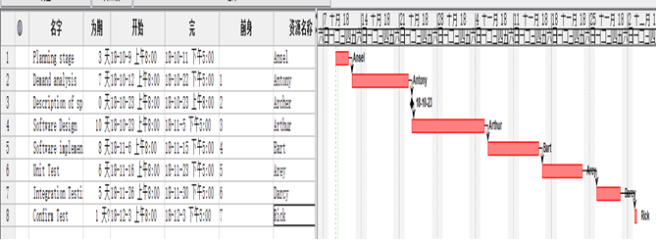

## PERT Chart

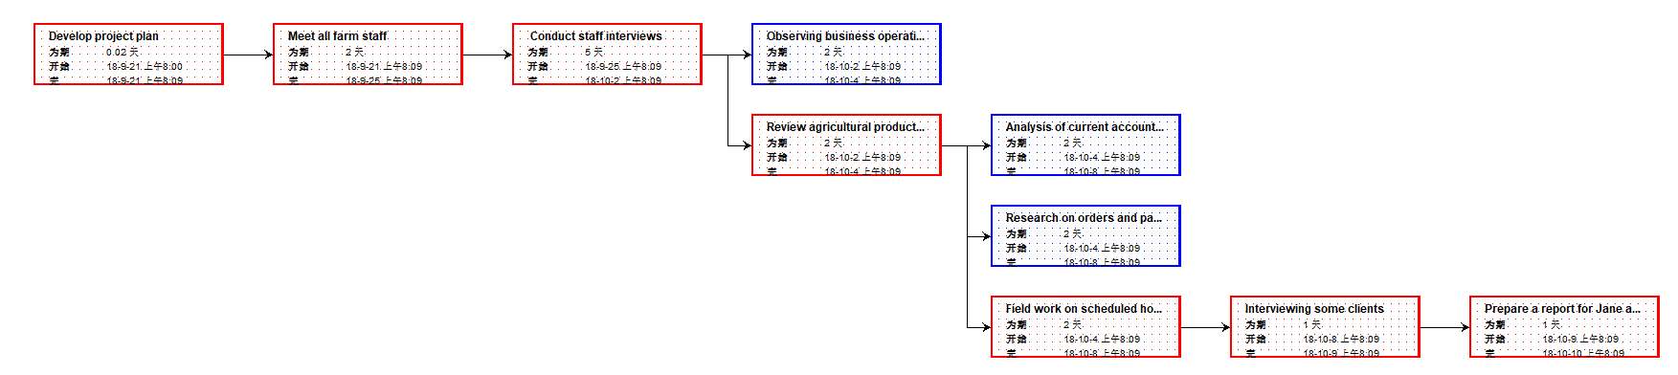**Own design：**

# 

**Purchase from other companies：**

**Risk Analysis**

|  |  |  |  |
| --- | --- | --- | --- |
| Risk description | Potential impact on project [high, medium, low] | Likelihood of occurrence [high, medium, low] | Difficulty of timely anticipation [hard, medium, easy] |
| System Vulnerabilities | low | low | medium |
| Compliance Issues | medium | low | low |
| Employee resignation | low | medium | medium |
| Security Flaws | high | low | medium |
| Efficiency Weakness | low | low | low |
| Interface does not support system | medium | low | medium |
| impact on User Operations | medium | medium | low |
| Hardware damage | high | medium | hard |
| Lack of experience in Project Manager | high | low | hard |
| Capital Chain Rupture | low | low | hard |

## 

## Tangible Benefits

1. Get more profits,
2. Cost reduction,
3. Increase in market share,
4. Increase in number of customers.

## Intangible Benefits

1. Improving customer satisfaction,
2. Improving customer satisfaction,
3. Enhancing market competitiveness, raise productivity,
4. Improving employee morale.

# Cost / Benefits Analysis

Option 1: Build In-house

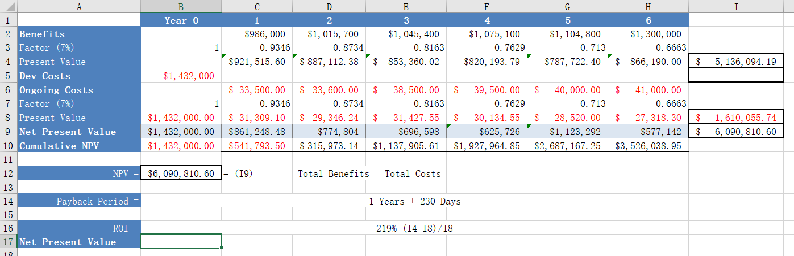

Option 2: Analysis from other commercial companies’ packages

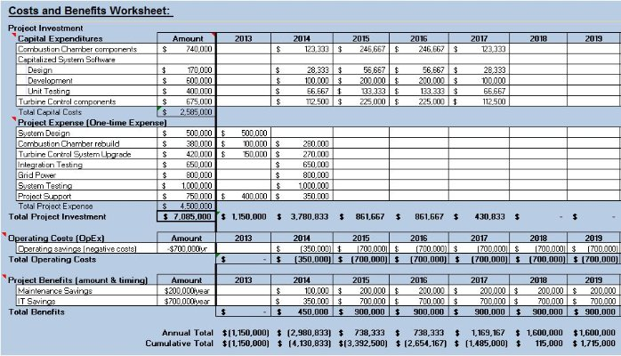

# Feasibility

From the perspective of organizational feasibility, most farm employees may have no experience in using computer systems, lack of implementation experience or our organizational planning is not good, but this risk can be avoided, which can be solved through employee training and detailed and perfect planning of the project. In terms of technology and resource feasibility, technical support and necessary resources may be lacking, but in system development, we can solve it with more skilled technicians and more costs. As for the feasibility of the schedule plan, we have a very complete project schedule plan, which can be fully developed in our plan, so this aspect is also easy to achieve. In a word, this project is very feasible.

# Recommendation

Through the analysis of the system feasibility report, we believe that the farm's new business system can be upgraded in many ways.

1. thoroughly understand the development framework and level of software, and ensure the normal maintenance of software and information systems in the future.

2. control hardware level, timely maintain hardware and strictly require deployment environment.

3., strengthen systematic training for employees and enhance their basic skills in system operation.

4. update the system in time to avoid losses caused by system vulnerabilities.

# Investigating System Requirements

## Fact-finding techniques:

Besides interview planning in appendix, there are some other recommendations to find out the requirements for the new system:

**1. Reviewing input, output, and flow**

***Advantages*:** Reviewing documents for existing processes helps identify business rules and records that are not mentioned in the interview. It also helps to identify differences and redundancy in business processes.

***Disadvantages***: Process records cannot be updated in real time and usually contain errors. To ensure that assumptions and business rules from existing records are correct, analysts should check with users.

**2.Observing and documenting business processes**

***Advantages*:** People can learn more about business functions and understand the necessity of easy use of the system.

**Disadvantages:** Business processes usually change, and over-observation will make users nervous, so we should try not to be abrupt.

**3.Collect reviewers' comments and Suggestions**

***Advantages***: Users can provide specific recommendations for improving and defining missing requirements and for improving requirements.

***Disadvantages:*** Before users interact with the system that implements these requirements, users usually cannot accurately or completely describe their needs. For these reasons, we should carefully and carefully analyze the comments and suggestions of active users.

**4.** **Research supplier solutions**

***Advantages:*** Studying supplier solutions can avoid costly mistakes and save time and money. At the same time, we study these solutions can draw good ideas from them and apply them to your company's structure and culture.

***Disadvantages:*** Using this fact discovery technology has certain risks. Sometimes users may buy a supplier's solution prematurely, but if they buy too quickly and fail to do enough research, they may find that these solutions can only meet part of the demand.

***Interview Plan***

# 

# Use Case

## *U*se-case diagram

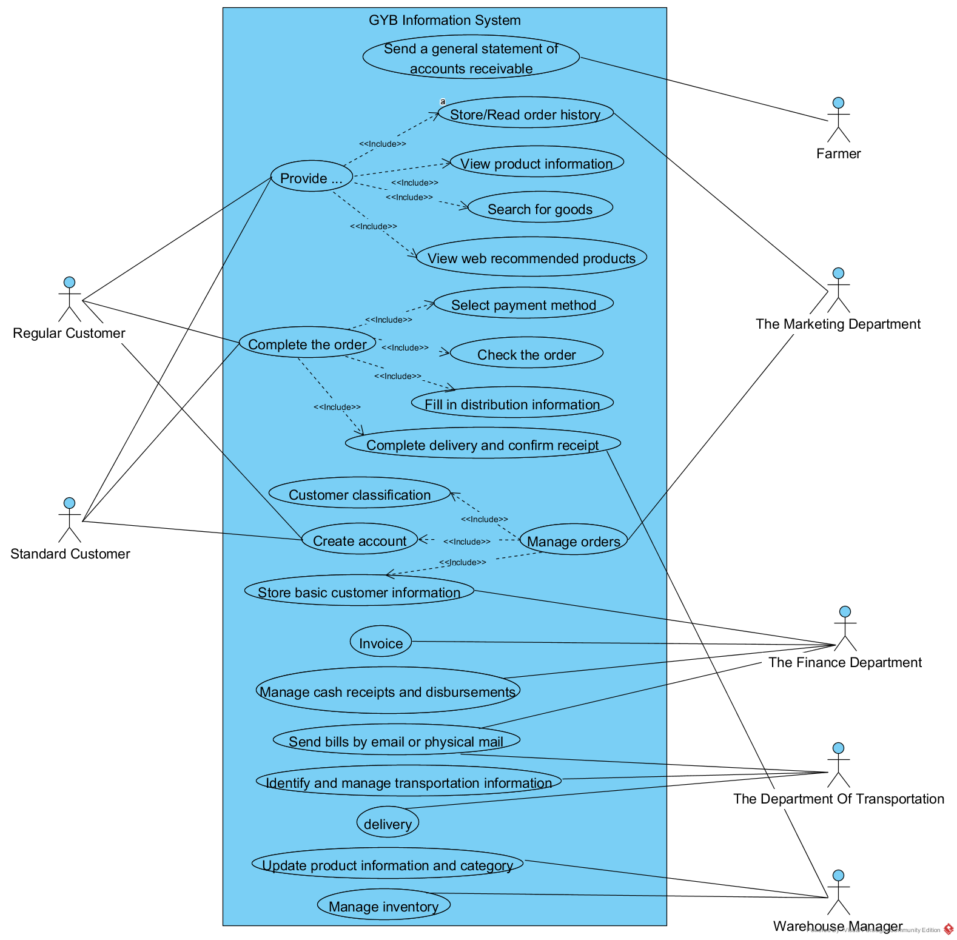

**Brief Use Case Description**

|  |  |
| --- | --- |
| Use case | Brief use case description |
| Order creation | The system displays the default order selection, and customers can provide their own order, or modify the default order through the checkbox interface, then the system stores the order and returns other system management information. |
| Account classification | The system divides customers into standard customers and regular customers according to customer order history. When customers create orders, if the system reads the product inventory is insufficient, it will give priority to regular customer order supply. |
| Product distribution | The system reads the order distribution information and sends it to the distribution department. The Distribution Department arranges the distribution of the distribution personnel. The user confirms the receipt of the goods. The Distribution Department uploads the distribution completion information. The system marks the completion of the order. |
| Account creation | User submits account creation requirement, GYB system creates account and returns customer information to fill in page, user fills in basic user information and submits it to system. |
| Sales Report Management and Generation | Records of daily sales and operating costs are stored in systematic accounting software. The GYB system automatically generates daily and monthly sales reports, and at the end of each quarter, generates a quarterly profit and loss report including the income and cost of each vegetable. |
| Financial Management and Statement Generation | At the end of the month, the system transfers the money remitted by farmers through GYB account to local bank account, keeps remittance record and generates report forms at the end of the month. |

**Full Use Case Description**

**a.**

|  |  |  |
| --- | --- | --- |
| **Use Case name** | Product distribution | |
| **Scenario:** | Transport goods according to order and address information | |
| **Trigger event:** | Distribution Department receives orders or notifies Distribution Department of new orders by system. | |
| **Brief description:** | The system reads the order distribution information and sends it to the distribution department. The Distribution Department arranges the distribution of the distribution personnel. The user confirms the receipt of the goods. The Distribution Department uploads the distribution completion information. The system marks the completion of the order. | |
| **Actor:** | Transport personnel, Warehouse personnel, Distribution Department | |
| **Related use cases:** | Related to " Order creation " | |
| **Stakeholders:** | The department of transportation  Warehouse manager  Customer | |
| **Preconditions:** | Orders must be given;  Address and customer information must be ensured correct;  The commodity must exist; | |
| **Postconditions:** | Mark successful appointments as "reminders"；Mark unsuccessful appointments as "reminders unfinished". | |
| **Flow of activities:** | **Actor** | **System** |
| 1.1 Distribution Departments Receive Distribution Messages  2.1 Warehouse Receiving Order Requirements  2.2 Warehouse personnel pack products and deliver them to Distribution Department  3.1 Distribution Departments Receive Products and Arrange Personnel Distribution  3.2 Customers receive packages | 1. Notify the Distribution Department of new orders  2. Notify warehouse manager of order requirements  3. Read and send distribution information  4. System updates commodity types and inventory. |
| **Exception condition:** | 3. If the distribution address is not the default address, the system sends the customer's designated address to the distribution department.  3.2 If the customer's order is unpaid, the order is marked as unpaid and the goods can be received after payment. | |

# b.

|  |  |  |
| --- | --- | --- |
| **Use Case name** | Order creation | |
| **Scenario:** | Based on customer demand to create orders | |
| **Trigger event:** | Customers generate product requirements | |
| **Brief description:** | The system displays the default order selection, and customers can provide their own order, or modify the default order through the checkbox interface, then the system stores the order and returns other system management information. | |
| **Actor:** | Customer | |
| **Related use cases:** | Related to " Account creation " and “Account classification” and “Sales Report Management and Generation” and “Financial Management and Statement Generation” | |
| **Stakeholders:** | The sales department  The department of transportation  Warehouse manager  Boss | |
| **Preconditions:** | Account must be given;  Customers have no bad purchase credit records;  The system must function properly. | |
| **Postconditions:** | Mark successful orders as "reminders"；Mark unsuccessful orders as "reminders unfinished". | |
| **Flow of activities:** | **Actor** | **System** |
| 1. Customer submission order requirements  2. Customer check the finished product order and submitted to the system.  3. Customers fill in distribution address and related logistics information  4. Customers choose payment method. If payment is made online, payment is completed and orders are submitted. | 1.1 The system stores the order application and returns the pop-up product selection page.  2.1 System receives orders demand, to determine whether a product inventory sufficient.  3.1 System Jump to Payment Interface  4.1 The system keeps transaction records  5.System Update Page Information |
| **Exception condition:** | 2.1 If the stock is enough, system jump to the payment page  2.1 If the Insufficient inventory, system determine customer categories, and if the normal user, will give priority to supply.  4. If the payment method is offline payment, the system will mark the order as unpaid. | |

# Activity Diagram

**a.**

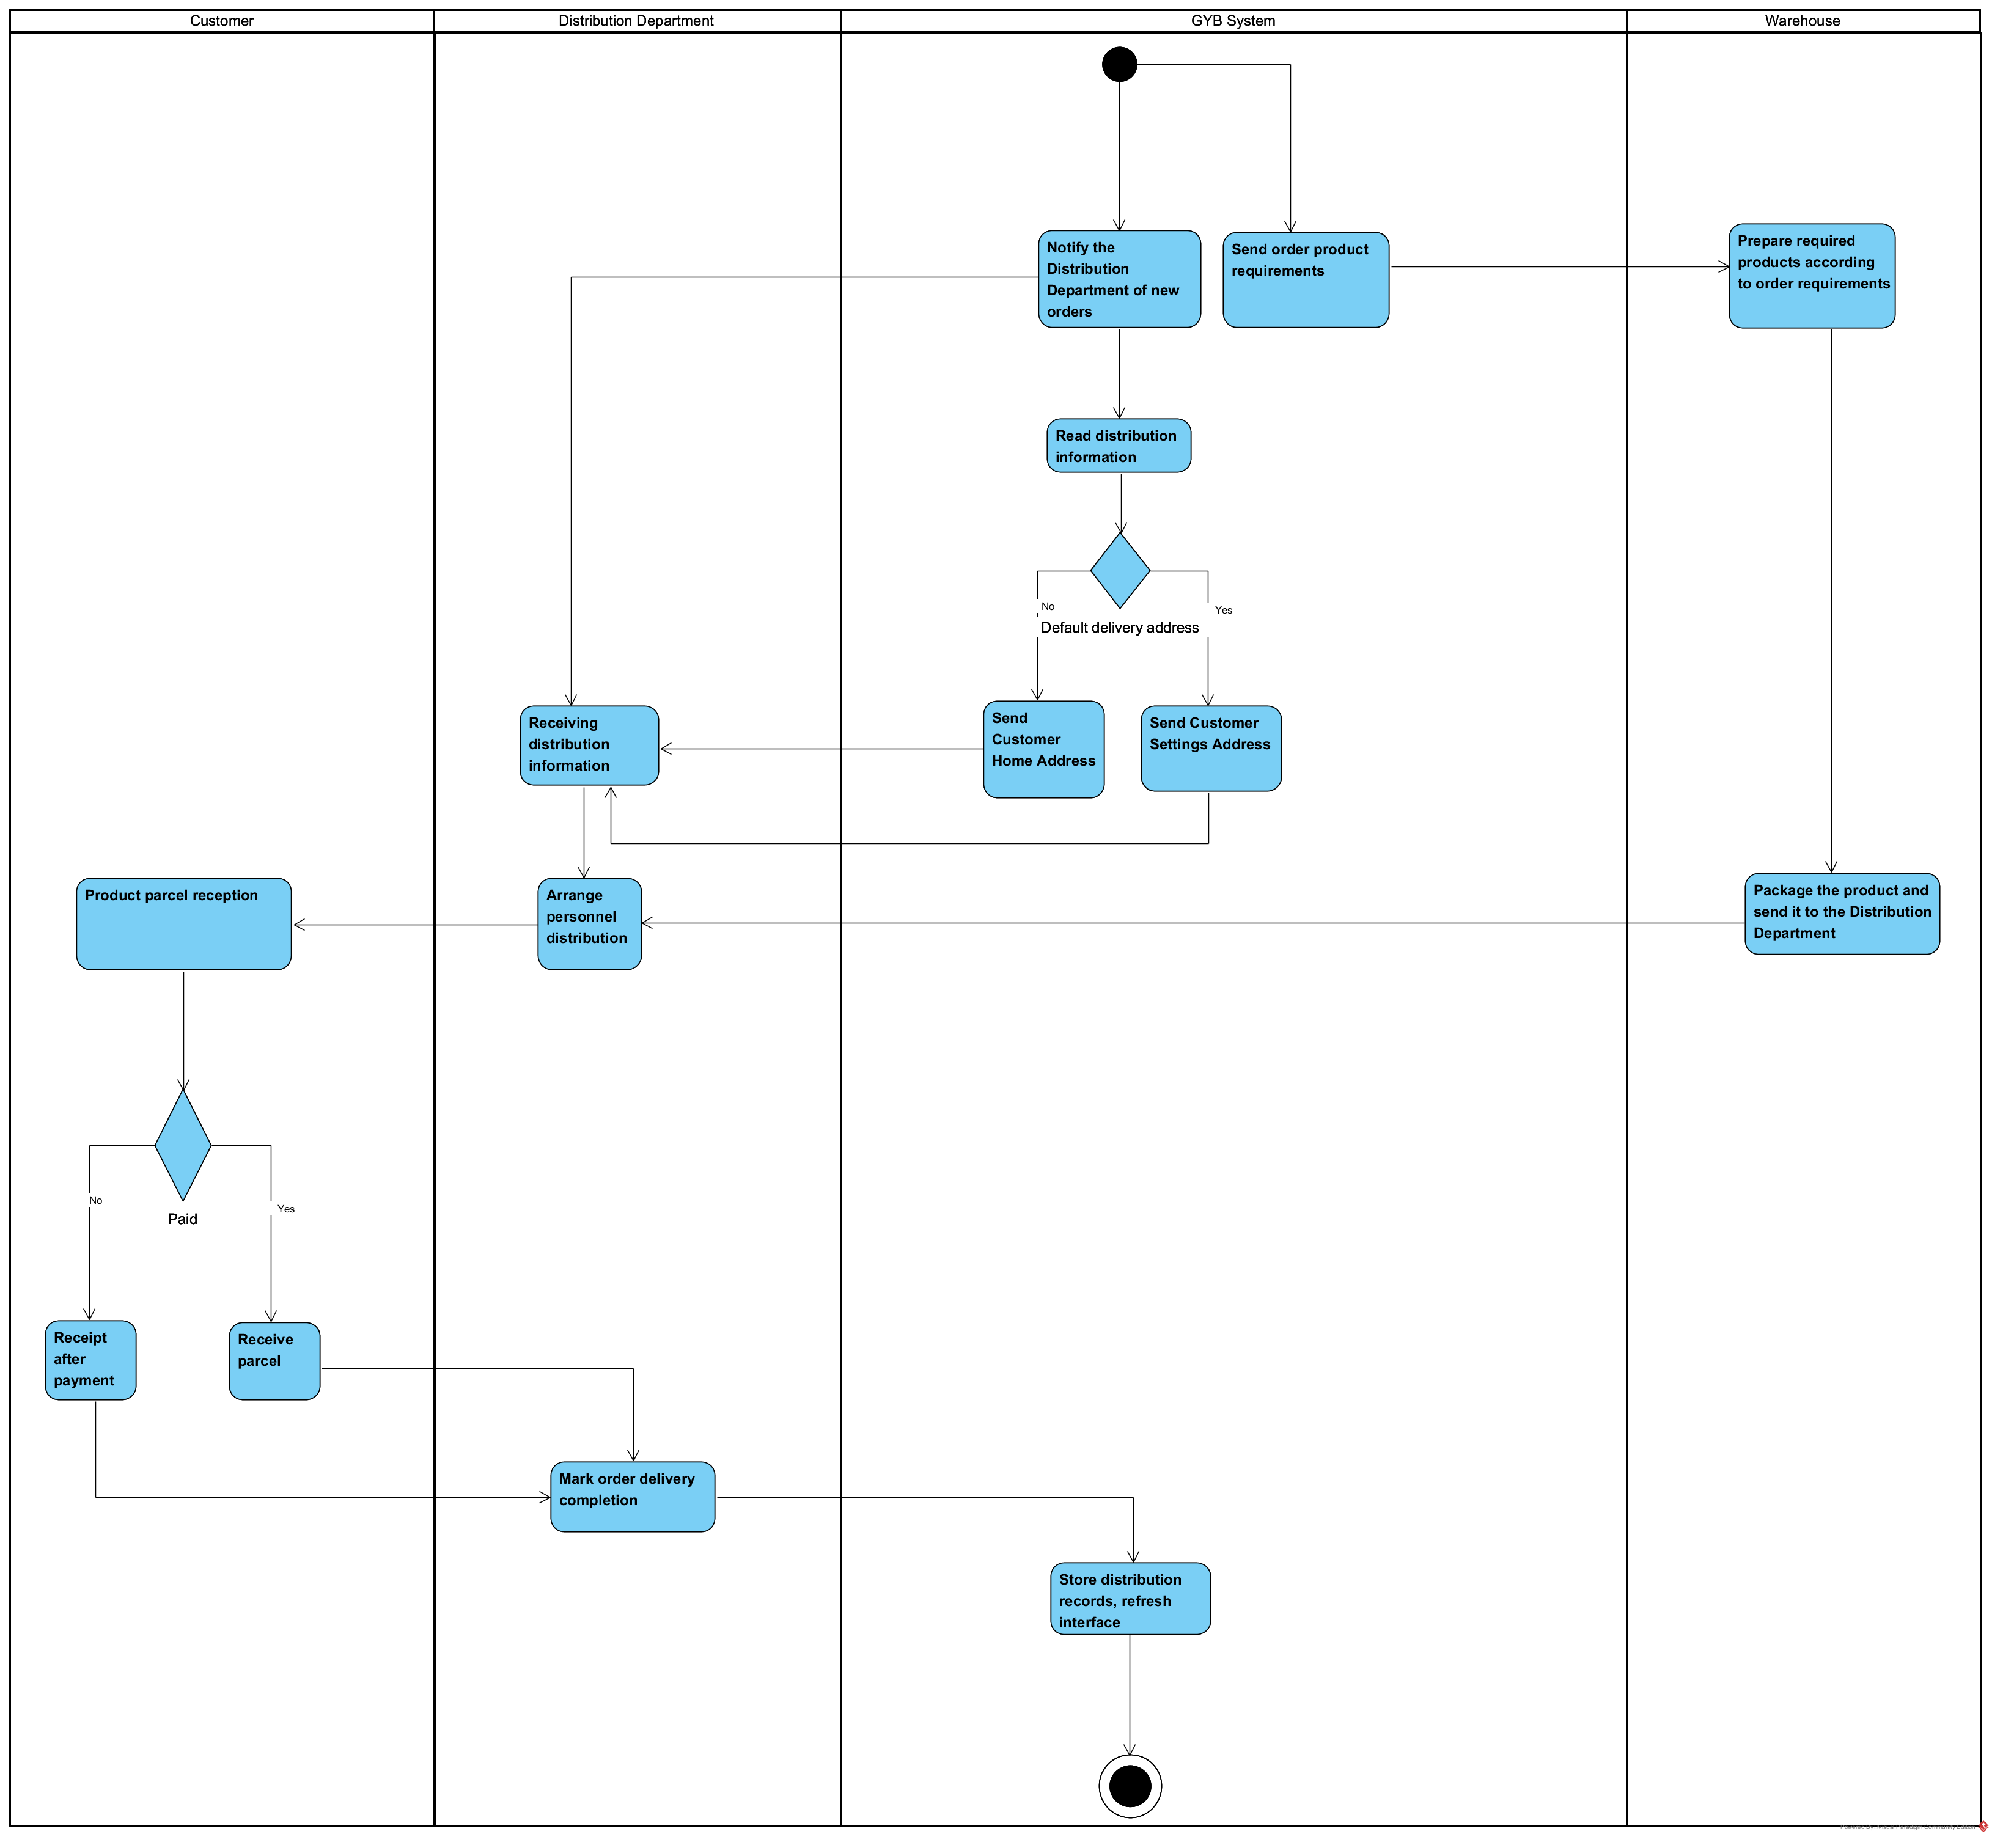

**b.**

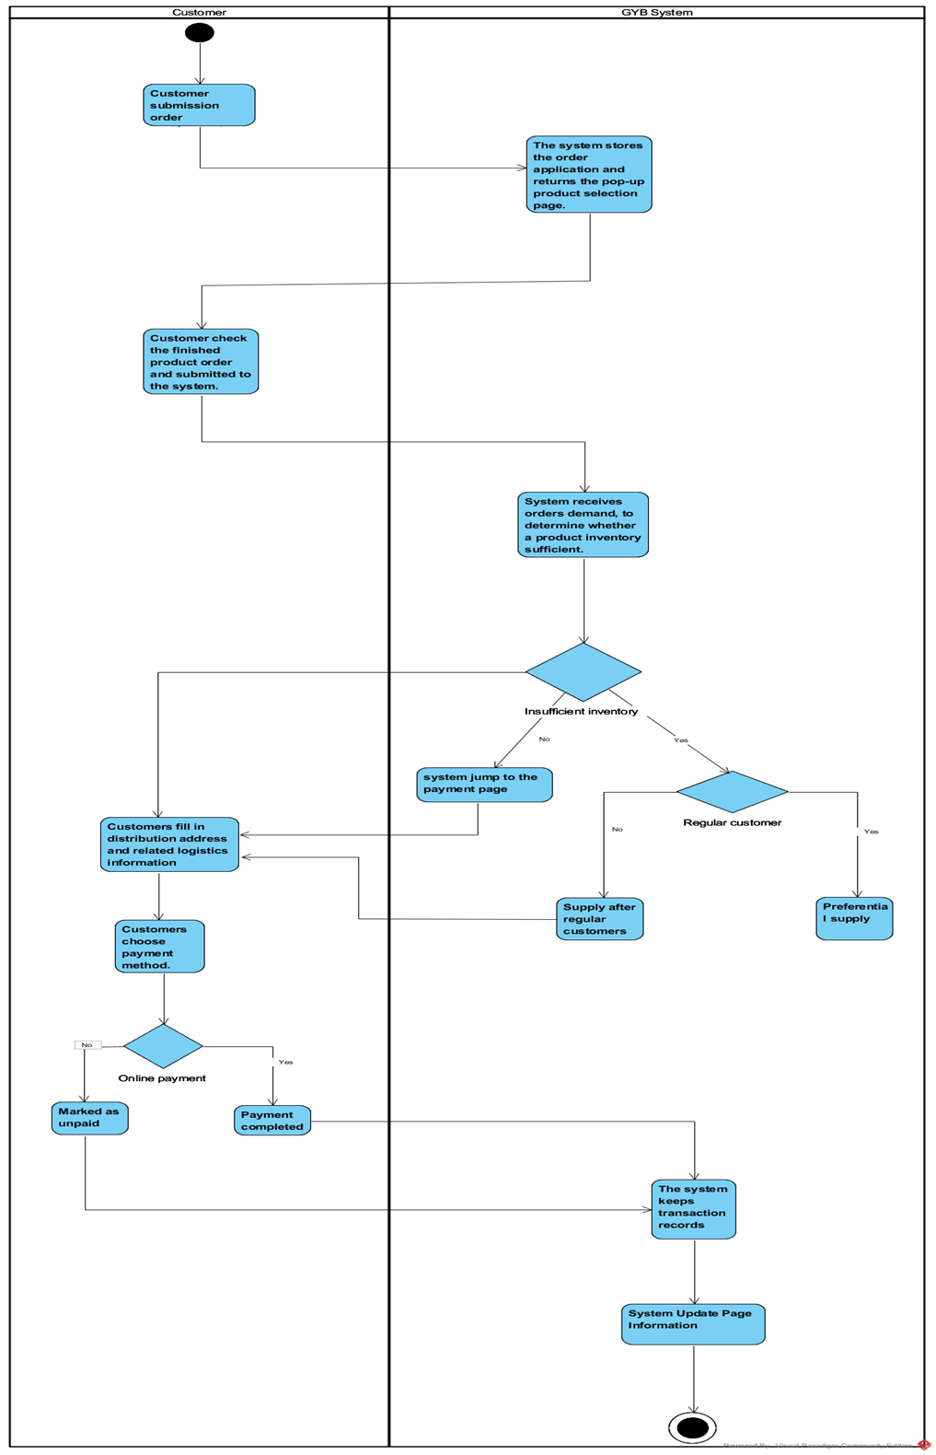

**System Sequence Diagram**

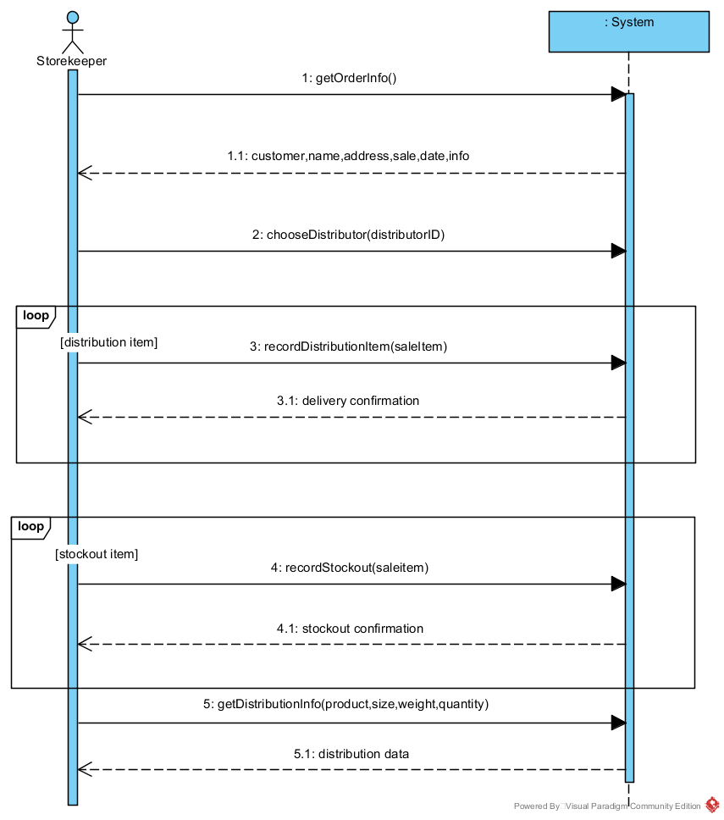

# ERD & Database schemas

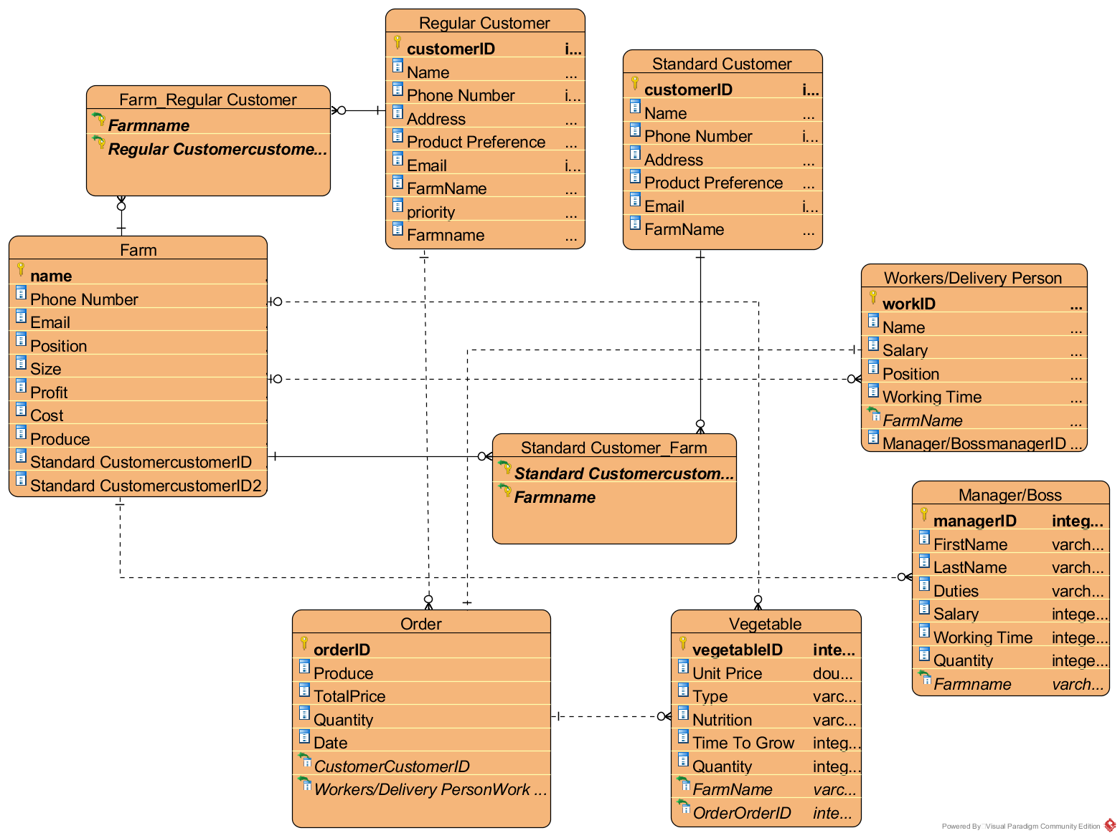

# UML

# 

# Database Design

# Database datatypes and samples

**Database datatypes format**

|  |  |  |
| --- | --- | --- |
| Entity | Attribute | Format |
| Farm | name: varchar {key} | Name1+1PhoneNumber + Email + Position + Size + Profit + Cost |
| Phone Number: integer |
| Email: integer |
| Position: varchar |
| Size: integer |
| Profit: integer |
| Cost: integer |
| Produce: varchar |
| Regular Customer | regularCustomerID: integer {key} | regularCustomerID + Name + Email + VegrtablePreference + Address + Phone Number +priority |
| Name: varchar |
| Email: integer |
| Vegetable Preference: varchar |
| Address: varchar |
| Phone Number: integer |
| Priority: varchar |
| *Farm Name {foreign key}* |
| Standard Customer | standardCustomerID: integer {key} | standardCustomerID + Name + Email + VegrtablePreference + Address + Phone Number |
| Name: varchar |
| Email: integer |
| Vegetable Preference: varchar |
| Address: varchar |
| Phone Number: integer |
| *Farm Name {foreign key}* |
| Order | orderID: integer {key} | orderID + Date + Produce + Total Price +Quantity |
| Date: integer |
| Produce: varchar |
| Total Price: double |
| Quantity: integer |
| Customer ID {foreign key} |
| *Worker/WorkID {foreign key}* |
| Vegetable | vegetableID: integer{key} | vegetableID +Type + Unit Price + Nutrition + Quantity +TimeTOGrow |
| Type: varchar |
| Unit Price: double |
| Nutrition: varchar |
| Quantity: integer |
| Time to Grow: integer |
| *orderID {foreign key}* |
| *FarmName {foreign key}* |
| Workers/Delivery Person | workID: integer{key} | workID + Name + Salary + Position + Working Time |
| Name: varchar |
| Salary: integer |
| Position: integer |
| Working Time: integer |
| *Farm Name {foreign key}* |
| Manager/boss | managerID: integer{[key} | managerID + FirstName + Last Name+ Duties + Salary + Working Time +Quantity |
| FirstName: varchar |
| Last Name: varchar |
| Duties: varchar |
| Salary: integer |
| Working Time: integer |
| Quantity: integer |

Samples for entity *worker/stuff*:



Samples for entity *farm*:



Samples for entity *Regular customer*:



Samples for entity *Standard customer*:



Samples for entity *vegetable/product*:



Samples for entity *order*:



# Samples for entity *manager/boss*：



# Other commercial software package’s Options and Recommendations

***Here are three potential commercial software packages that could be suitable:***

|  |  |  |  |  |
| --- | --- | --- | --- | --- |
| **Business software package** | **Function** | **Feature** | **Strengths and weaknesses** | **Adaptability** |
| 1.SAP MTC agricultural software package | 1.Integrated Management Platform: put through all links (e.g. seedling care, plants growing, plants picking & collection, processing, packaging, and sales) of the entire industry chain, and realize the process carding of the entire business cycle.  2.Various Production Modes: support corporation & base & farmer, corporation & base and many other production modes. Support multi-variation products cultivation management.  3.Accounting System: multi-dimensional accounting of cost and personnel performance of the entire business cycle.  4.Cost and Profit Analysis: Analyse cost and profit composition of the entire business cycle.  5.Quality Management: do the defects analysis strictly based on the base, batch & product management system.  6.Planning Management: better the virtuous cycle of planting planning management, operation management. Inventory analysis and sales prediction. Ensure the freshness and low loss of food.  7.Quality Traceability: establish real-time & accurate safety and quality traceability system of the entire food industry chain.  8.Business-Critical Points Management: management of purchasing, seedling care, cultivation, irrigation, fertilization, vaccination, inventory, sales deduction rate, etc.  9.Acquire real-time & accurate business data, and provide managers with all-round & multi-perspective data analysis for decision making. | 1.Seamless integration between business units;  2.Integration of financial and business;  3.Integration of business and workflow;  4.Integration of system and 3rd party software;  5.Integration of master data, documents and reports between business units; | ***Strengths：***  1.Put through the business flow of the entire industry chain from seedling care to sales, and achieve the lean management that integrates finance, purchasing, sales, production, inventory and other business units.  2.Establish a well-rounded, regulated, accurate and coordinated information management platform. Enhance operation efficiency and make business with good expandability and replicability.  3.Lean analysis of production efficiency that dives into in/output & personnel performance of every single base, production phase, product or batch.  4.Accurate & scientific cost and profit accounting system that provides multi-dimensional and composition analysis over the cost and profit of each single product, base, and production phase.  5.Realize the “three-tier” quality traceability system of the entire planting industry chain. Real-time inquiry and feedback available of information like seedlings, fertilizers, drugs and vaccines applied in planting.  6.Build a highly efficient cycle of sales prediction, planting planning and inventory management that is able to increase turnover rate and reduce wastage. Secure enterprises with higher ROI and lower risks.  7.Real-time planning & report & analysis, make the business processes more transparent and management decisions more scientific.  ***Weaknesses：***  1. Too expensive, the commercial software costs a lot.  2. The operation is more complicated.  3. Requirements for deployment environment are high. | The commercial software package has higher adaptability. |
| 2.Plantator business software package | Built-in Accounting  Contract Management  CRM  Crop Management  Inventory Management  Order Processing  Pricing Management  Supplier Management  Traceability | 1.Improvement of process details  2.Manageability  3.Configurability  4.Monitoring  5.Planning  6.Measurability | ***Strengths：***  1.Autonomously managing the use and generation of background data  2.Ensuring the security of sensitive data  3.System update, simple use and easy maintenance and operation.  4. The System is both professional and easy in use and not overburdened with unnecessary features  ***Weaknesses:***  1. Fewer functions are provided.  2. Lower cost  3. The deployment environment is low and easy to maintain. |  |

**3.Internally developed software package:**

Internally developed software package with employee information management, customer classification, online payment, warehouse management, order book, financial management, the function such as logistics query, it was characterized by both single sex and networking at the same time, the network dependence is low, in addition, but also has low cost, easy operation and upgrade, friendly interface beautiful, etc.

**Recommended for commercial package:**

Through the feasibility analysis and risk analysis of the new system, we realize that it is very reasonable to develop a new potential commercial farm package to meet the requirements of the farm, but its development and maintenance cycle is long and the system response time to events is slow. Therefore, the potential business software package provided by SAP company meets the needs of the growing business of the farm, so it is more appropriate for farms to buy potential commercial packages from SAP.

# Conclusions

The newly developed GYB information system has already fulfilled the business needs of John's farm very well. At the same time, it has increased and expanded the farm's business and market, such as customer system order reception, customer information preservation, financial system responsible for farm's financial management and customer payment, and logistics department responsible for product distribution. At the same time, the system will greatly save farm costs and increase farm income. However, in the short term, the risks and costs of the system will not be filled by the benefits, but we will do our best to improve the system.

# 

# Appendices

|  |
| --- |
| Discussion and interview Agenda |
| **Setting**  Objective of interview  *Determining new requirements for the system*  Date, Time, and Location  *October. 5, 2018, at 9:00 a.m. in John’s office*  User Participants (names and titles/positions)  *William McDougal, vice president of marketing and sales, and several of his staff*  Project Team Participants  *Nick and Sam* |
| **Interview/Discussion** |
| *1. Who is the main object of using the system?*  *2. Do you know the basic operation procedures and functions of the new sales system?* *Is it convenient to use?*  *3.* *What is the range of vegetables and the availability in a year?*  *4.Does the report generated by the information system need to be formatted? Or do you need to save it?*  *5.* *Which way do you prefer to input information system? Direct input or scan input?*  *6. How often do you expect to deliver the goods?* *How do you want to promote products? E-mail? Telephone or something else?*  *7.* *Are there any restrictions on the number of orders placed by users?*  *8. What aspects of customer cancellation may be caused by farm failures?* |
| **Follow-Up** |
| Important decisions or answers to questions  *See attached write-up on commission policies*  Date and time of next meeting or follow-up session  *October 10, 2018, at 9:0O a.m.* |

# 

# Bibliography

1.Buy from other company’s grant chart: <https://image.baidu.com/search/detail?ct=503316480&z=0&ipn=d&word=%E7%94%98%E7%89%B9%E5%9B%BE&step_word=&hs=2&pn=9&spn=0&di=197175607200&pi=0&rn=1&tn=baiduimagedetail&is=0%2C0&istype=0&ie=utf-8&oe=utf-8&in=&cl=2&lm=-1&st=undefined&cs=374743768%2C3062809681&os=2395437186%2C1293979988&simid=4204950639%2C605532383&adpicid=0&lpn=0&ln=1897&fr=&fmq=1539068059674_R&fm=&ic=undefined&s=undefined&se=&sme=&tab=0&width=undefined&height=undefined&face=undefined&ist=&jit=&cg=&bdtype=0&oriquery=&objurl=http%3A%2F%2Fg.hiphotos.baidu.com%2Fzhidao%2Fpic%2Fitem%2Fa6efce1b9d16fdfaf95ec7cbb18f8c5494ee7be0.jpg&fromurl=ippr_z2C%24qAzdH3FAzdH3Fzit1w5_z%26e3Bkwt17_z%26e3Bv54AzdH3Fq7jfpt5gAzdH3Fnldc0dmalnb9d9blmc_z%26e3Bip4s&gsm=0&rpstart=0&rpnum=0&islist=&querylist>=

2.Book: Introduction to Systems Analysis and Design An Agile, Iterative Approach Six Edition.

3. Two URL for potential commercial software packages:

SAP MTC agricultural software package’s Url:

<http://www.mtcsys.com/en/>

Plantator Business software package’s Url:

https://www.capterra.com/p/146781/Plantator-System/