# **Einstein in the maritime**

## The famous physicist and Nobel Prize laureate left Germany at the end of 1932, shortly before the National Socialists came to power. His voyage to California on board the “Oakland”, a Hapag ship, would turn out to be a farewell forever.

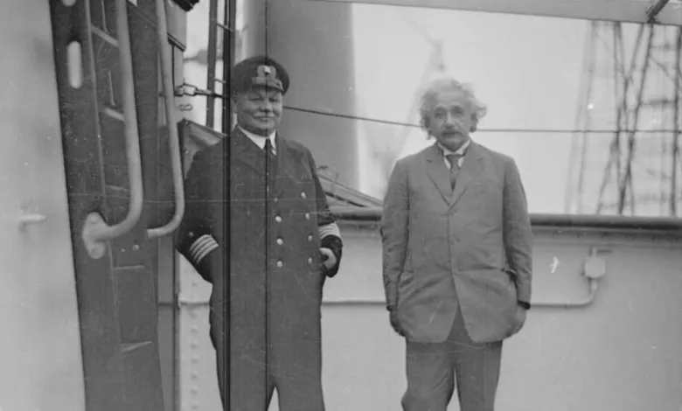

Albert Einstein is regarded as a true man of the world. On the one hand, he travelled a lot after his theory of relativity was confirmed by experiments around 1920 and he was awarded the Nobel Prize in Physics. Specialist conferences, university lectureships and social events provided many opportunities for him to move around.

On the other hand, Einstein was also a citizen of the world as a matter of conviction. “I always respect the individual and have an insurmountable aversion to violence and fanaticism ,” he confessed. “For all these reasons, I am a passionate pacifist and anti-militarist, rejecting all nationalism, even if it is only masquerading as patriotism.”

Einstein travelled several times on Hapag vessels. He was a big fan of sea voyages, who very much enjoyed the stay on board and the peace he found there before he became famous and an object of public attention.

Einstein’s diaries contain interesting details about what he was thinking and doing during these times on board, what he was working on, what he was reading, and what he was doing in the ports of call. Describing himself as “passionately curious”, he also recorded details on the lively conversations he had with the ships’ captains and other crew members.

The Nobel Prize winner also had contact with individuals in Hapag’s management.

For example, while returning from the United States on the “Deutschland” in March 1931, he wrote a letter of thanks to the executive board of the shipping company in which he praised how the steamer was run and furnished, saying: “The food can only be described as enticing – too good for a modest person.”

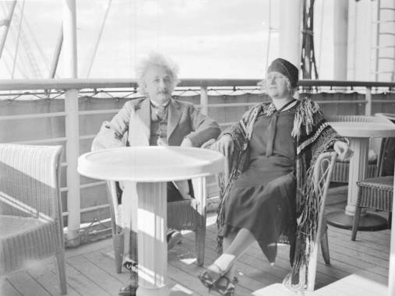

His wife Elsa, who accompanied him, underlined this to the head of Hapag’s New York branch, writing: “We have been wonderfully satisfied in every respect on the ‘Deutschland’. The food here has been a delight. I don’t ever recall enjoying this kind of cooking in a hotel or on a ship. If we can somehow arrange it, we will only travel on Hapag ships from now on. They are the most perfected thing there is in this field.”

A short time later, Einstein travelled from Berlin to Oxford, England, via Hamburg. While in the latter, he even met in person with the banker and Hapag Supervisory Board Member Max Warburg and Wilhelm Cuno, the Chairman of the Executive Board. Then it was off to Southampton in the “wonderful cabin” of the “Albert Ballin”, a Hapag steamer. “It’s a pity that this glorious time will be so short,” Einstein noted with regret in his diary.

He had more time on board again when he sailed to Los Angeles on Hapag’s “Portland” towards the end of 1931. Einstein, who was a member of the Prussian Academy of Sciences and director of the Kaiser Wilhelm Institute for Physics in Berlin, had been invited by a research university in Pasadena for a visiting professorship lasting several months.

Back in Germany, the political and social climates were worsening at this time. Facing increased attacks because of his openly pacifist stance and for being a Jew, Einstein had already thought of giving up his German citizenship.

On board the “Portland”, his thoughts also centred on the future. On 6 December 1931, he recorded in his diary: “Today, I decided to basically give up my job in Berlin. So I’ll be a migratory bird for the rest of my life! Seagulls are still accompanying the ship while constantly in flight. They will reportedly stay with us all the way to the Azores. These are my new colleagues.” The degree of alienation that this citizen of the world felt from the country of his birth was now very advanced.

A year later, the Einsteins left for another research residency in California. On 10 December 1932, exactly 90 years ago today, they boarded the Hapag motor ship “Oakland” in Bremen, with which they reached the Port of Los Angeles in early 1933.

Shortly before leaving, when locking up his small summer villa near Berlin, Einstein reportedly expressed a dark premotion to Elsa, saying: “Take a very good look at it … You will never see it again.” And that turned out to be true.

After Adolf Hitler was appointed Reich Chancellor on 30 January 1933, Einstein resigned from the Prussian Academy of Sciences and publicly announced that he did not intend to return there in light of the circumstances now prevailing in Germany.

In keeping with this sentiment, he also avoided ships sailing under the German flag from that point on. A Red Star Line steamer took the Einsteins to Belgium in April, where the physicist gave up his passport at the German Embassy. After settling in the United States, the couple never returned to Germany, as they viewed their voyage on board the “Oakland” as a journey of no return.