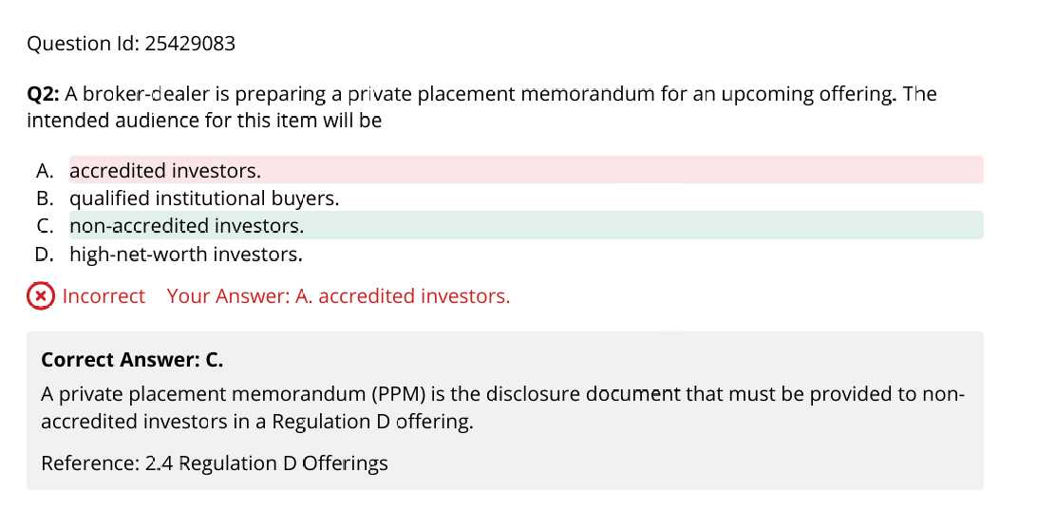
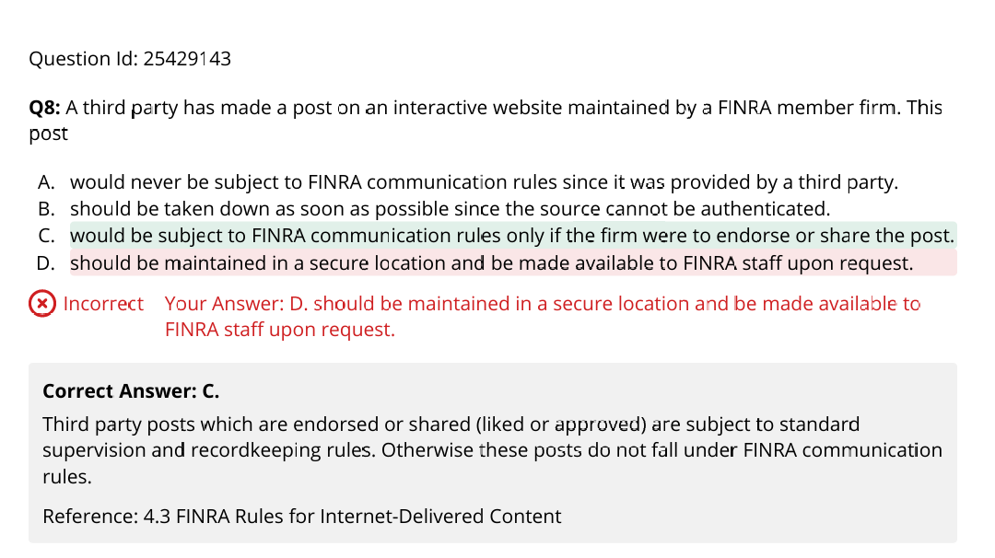
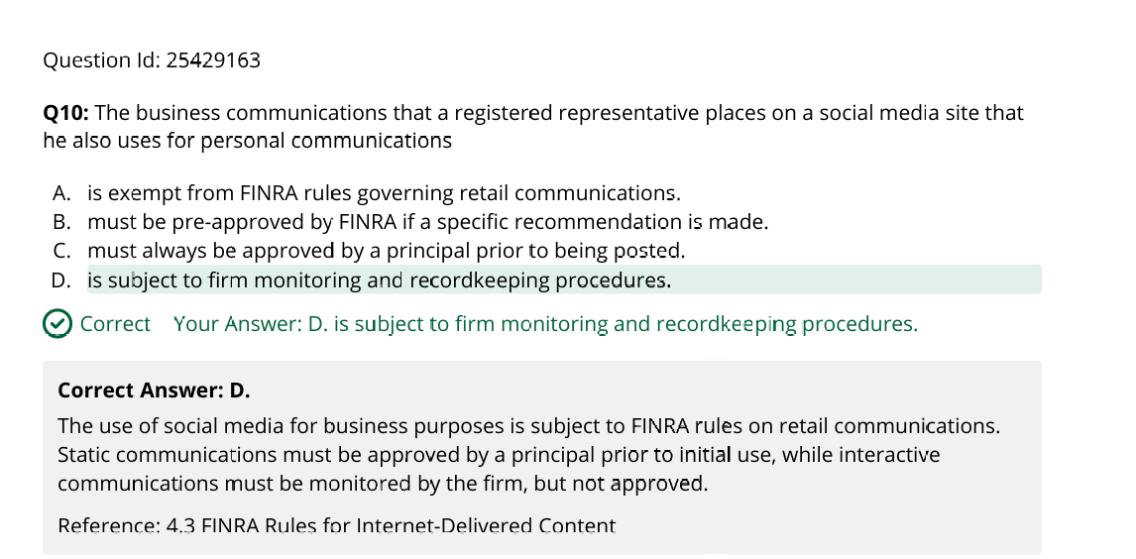
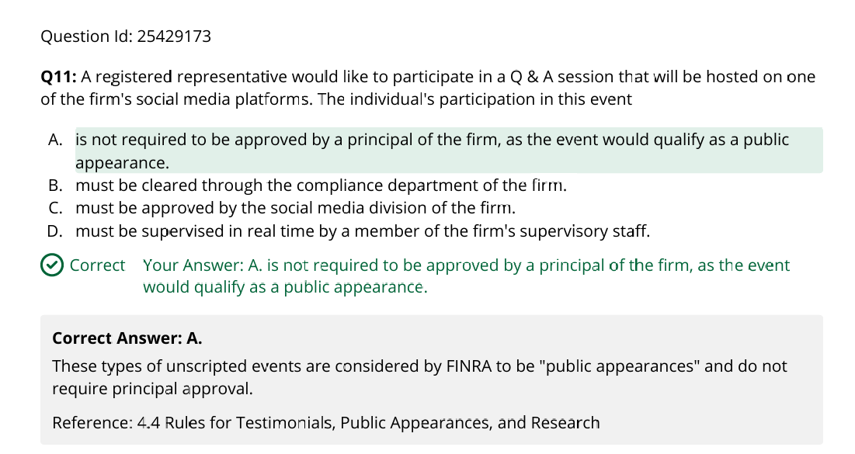
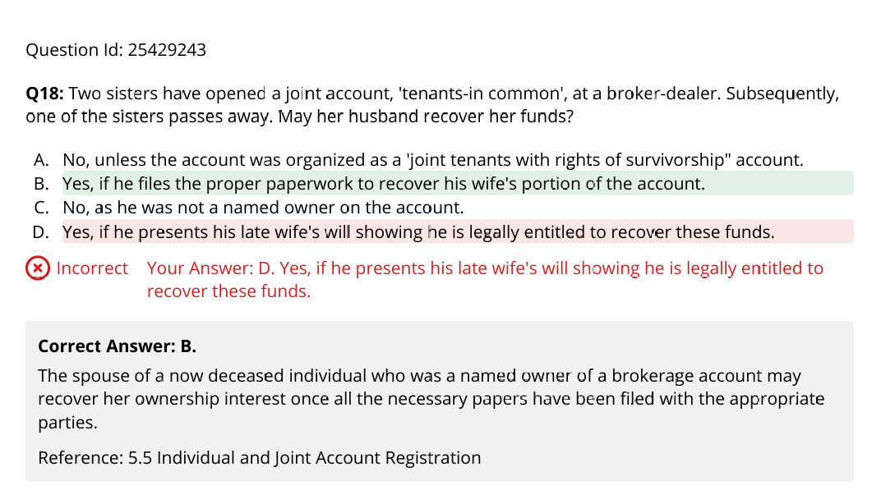
FINRA customer-specific suitability standards do not apply to recommendations made to various institutional customers, such as banks, investment advisors, and insurance companies. Reference: 6.6 FINRA Suitability and Disclosure Standards for Recommendations

When an unexpected positive financial event occurs, it is always prudent to discuss this with your client and to determine if there has been any change in her overall investment goals. Options may have a place in her financial plan, but only a conversation with the client will determine the direction to move。
An HR 10 plan, also known as a Keogh plan, is a tax-deferred retirement plan for self-employed individuals and unincorporated businesses。

Wash sale : 9.4
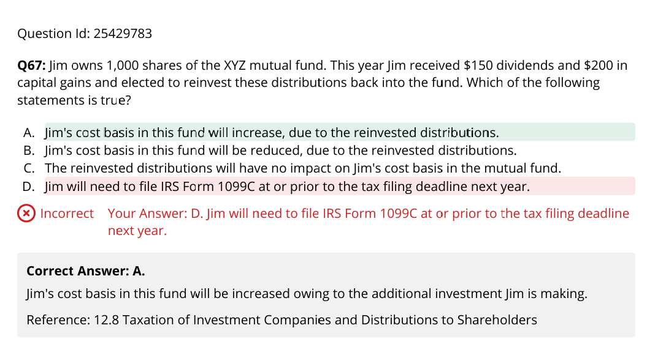

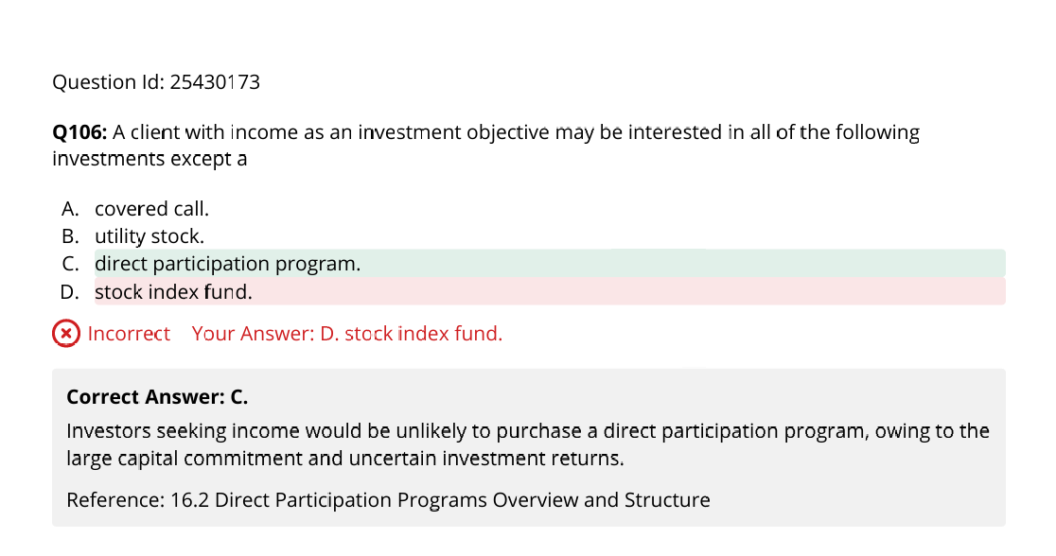
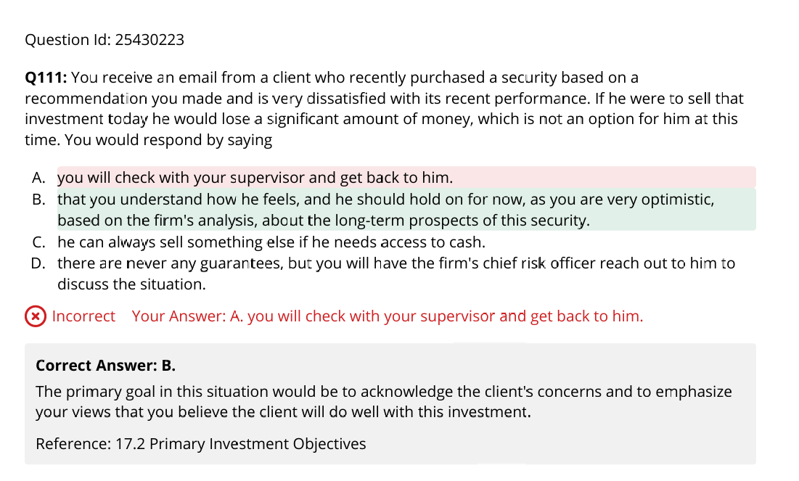
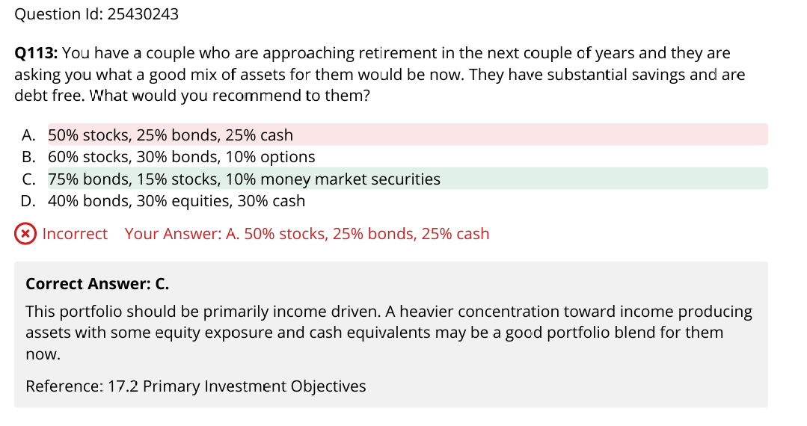
When an RR makes an error in documenting a client order, he/she should notify their supervisor immediately.
In the event an error is made in executing a client order, it is the responsibility of the registered representative to notify their supervisor immediately of the situation.
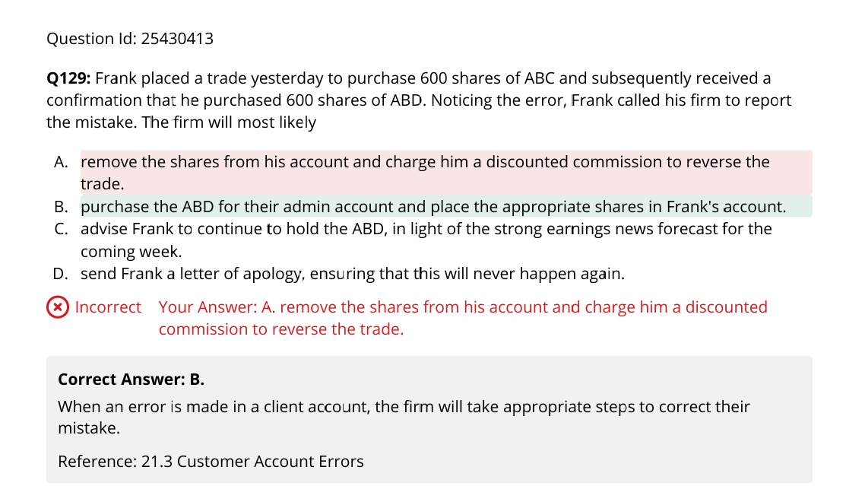
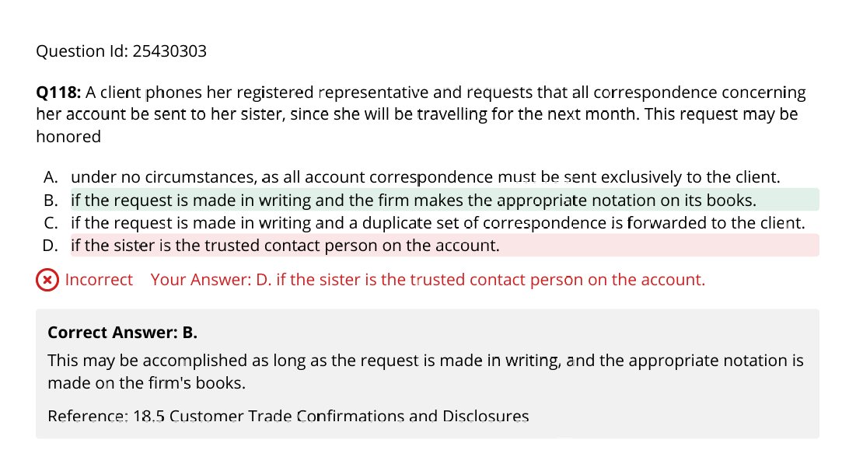

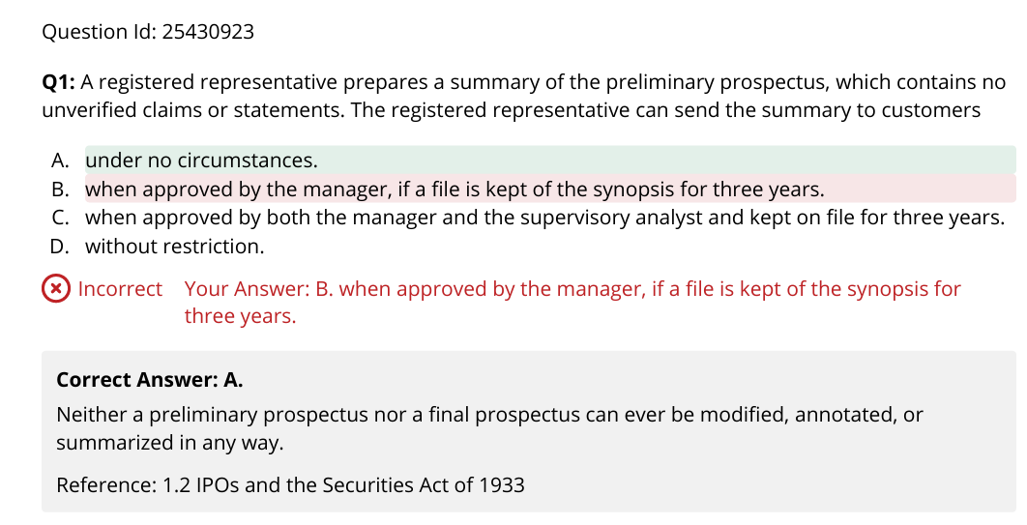
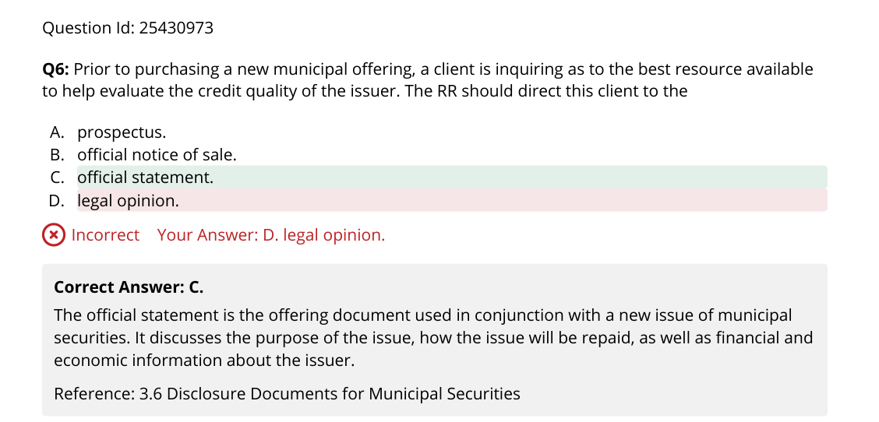
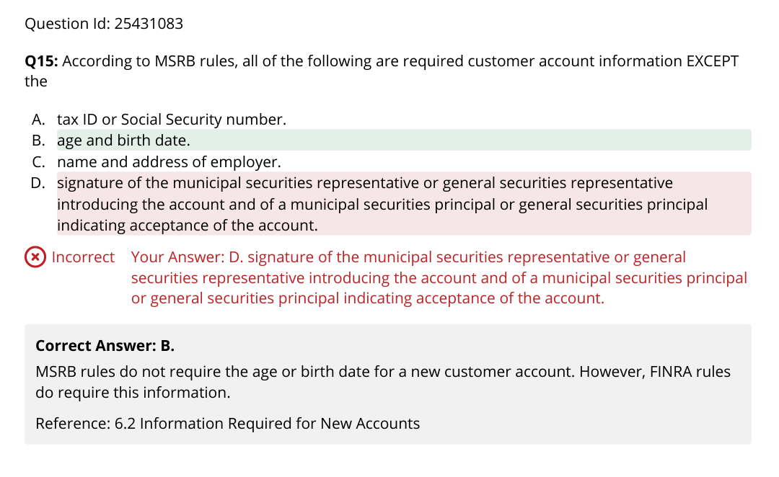
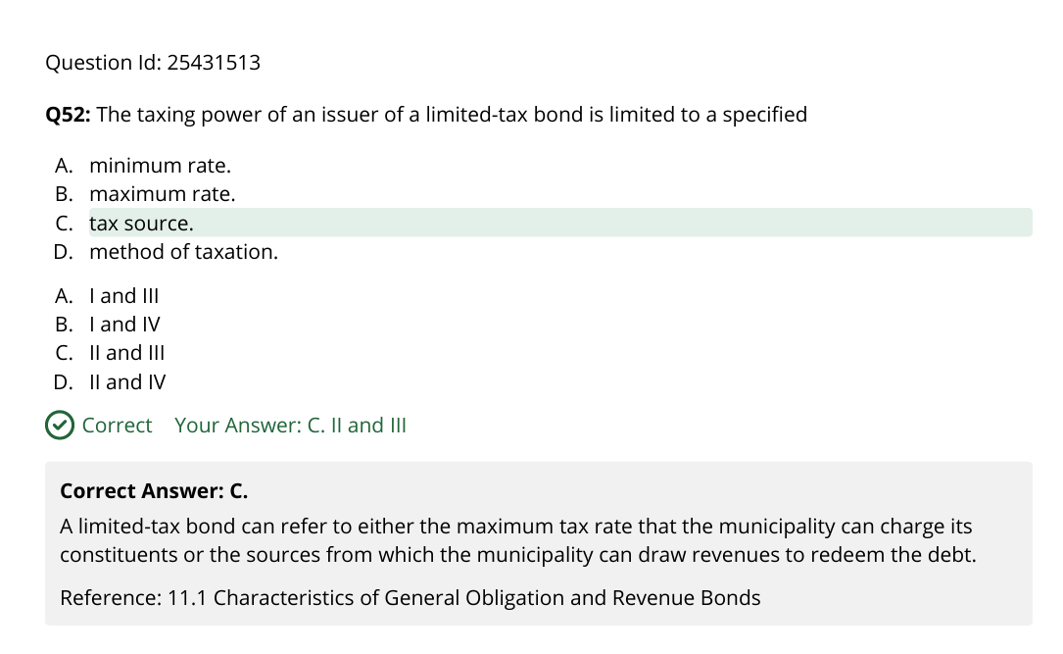
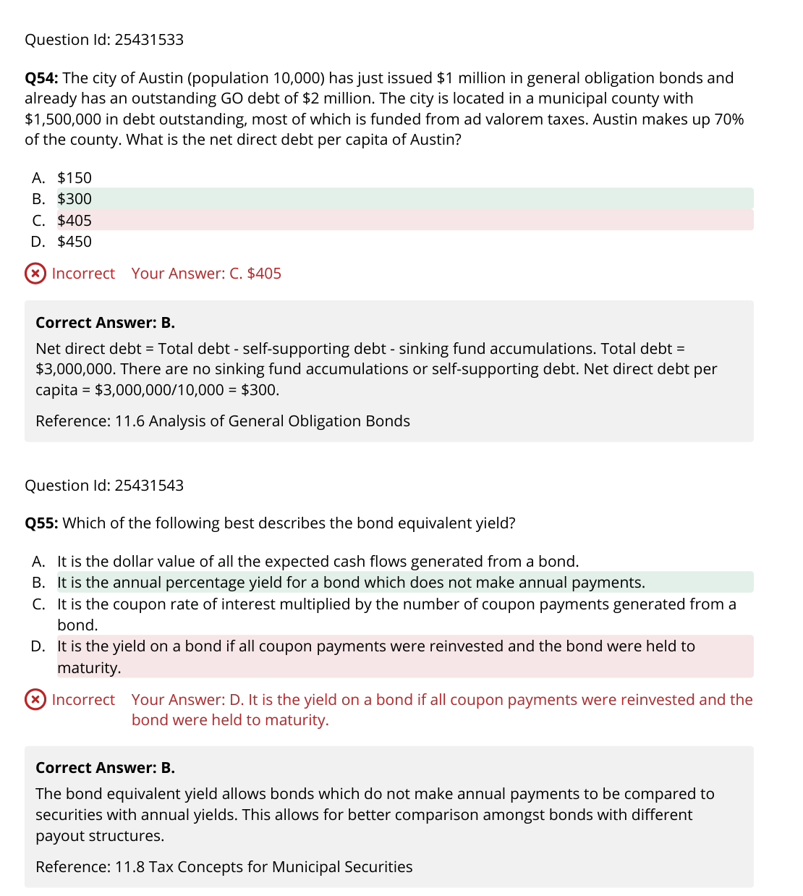
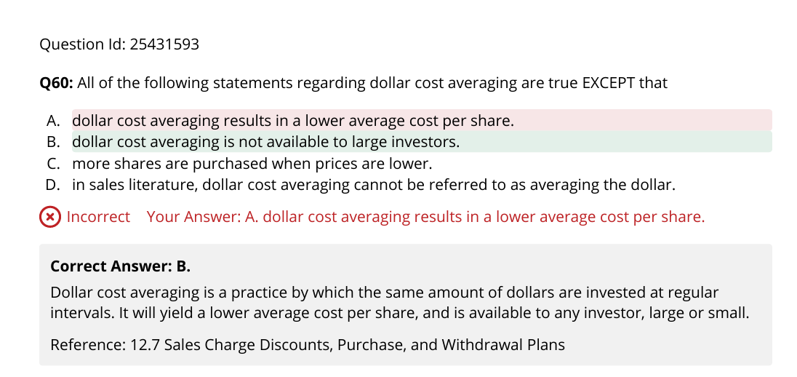
If mk fluctuate and generally trend up dca is good to purchase in lower cost. No effective in continued decline. Avg cost > avg price/share (like TWAP price)
Div, 60 days/90 days around the ex-div (not before)
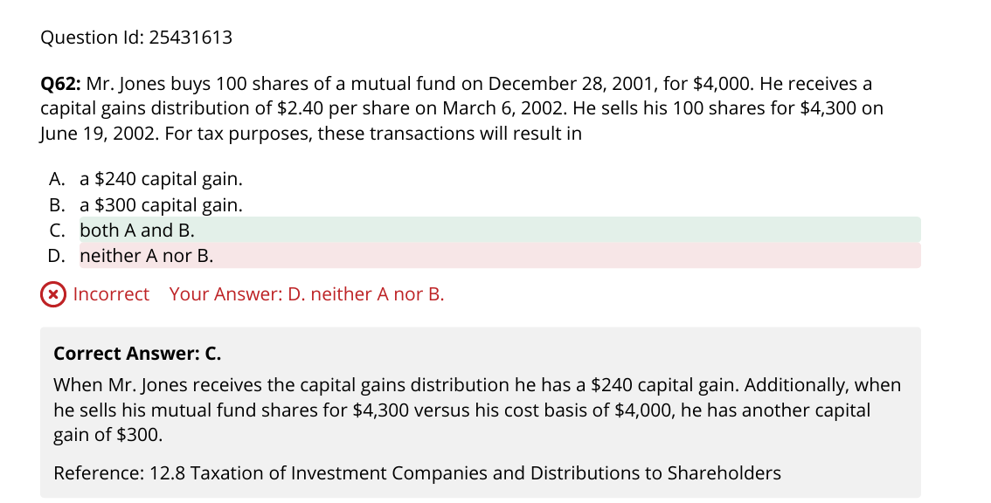
Did not reinvest.
