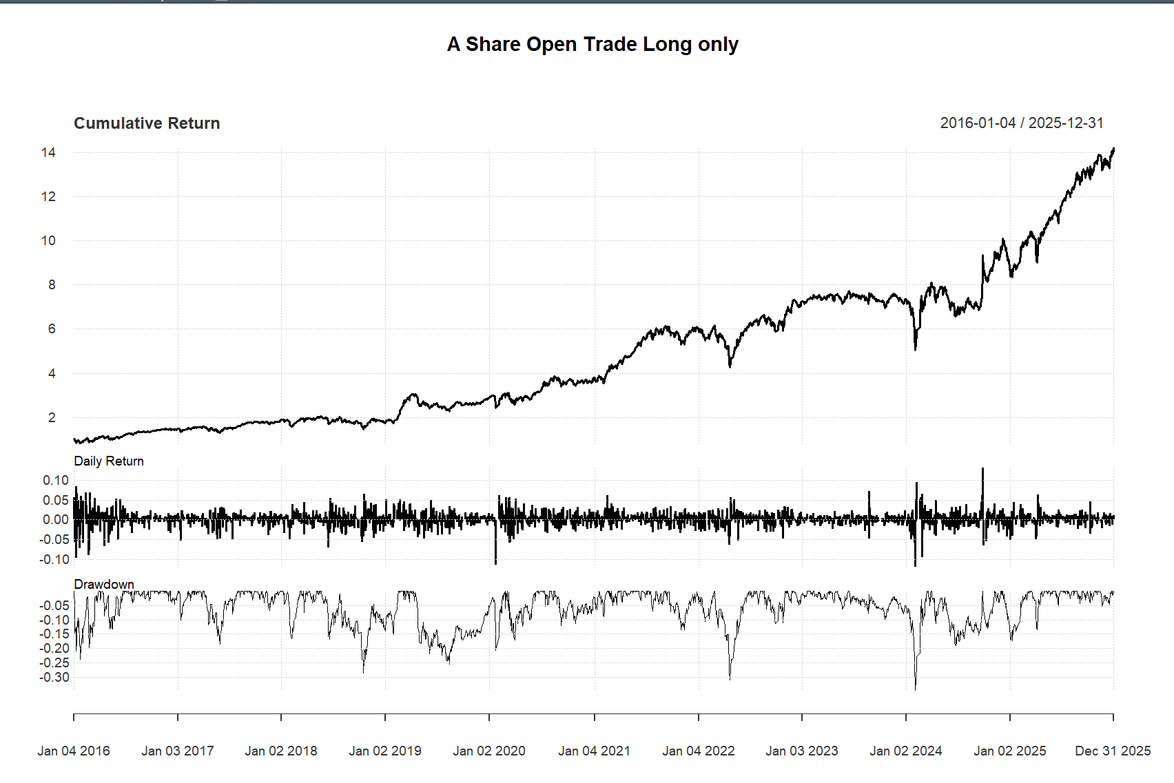
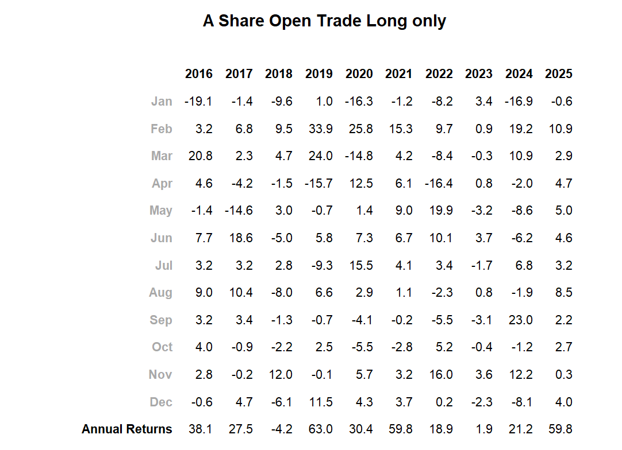
A.Share.Open.Trade.Long.only
Annualized Return 0.3169000
Annualized Std Dev 0.2892000
Annualized Sharpe (Rf=0%) 1.0956000
Max DD 0.3457252
Calmar Ratio 0.9165577
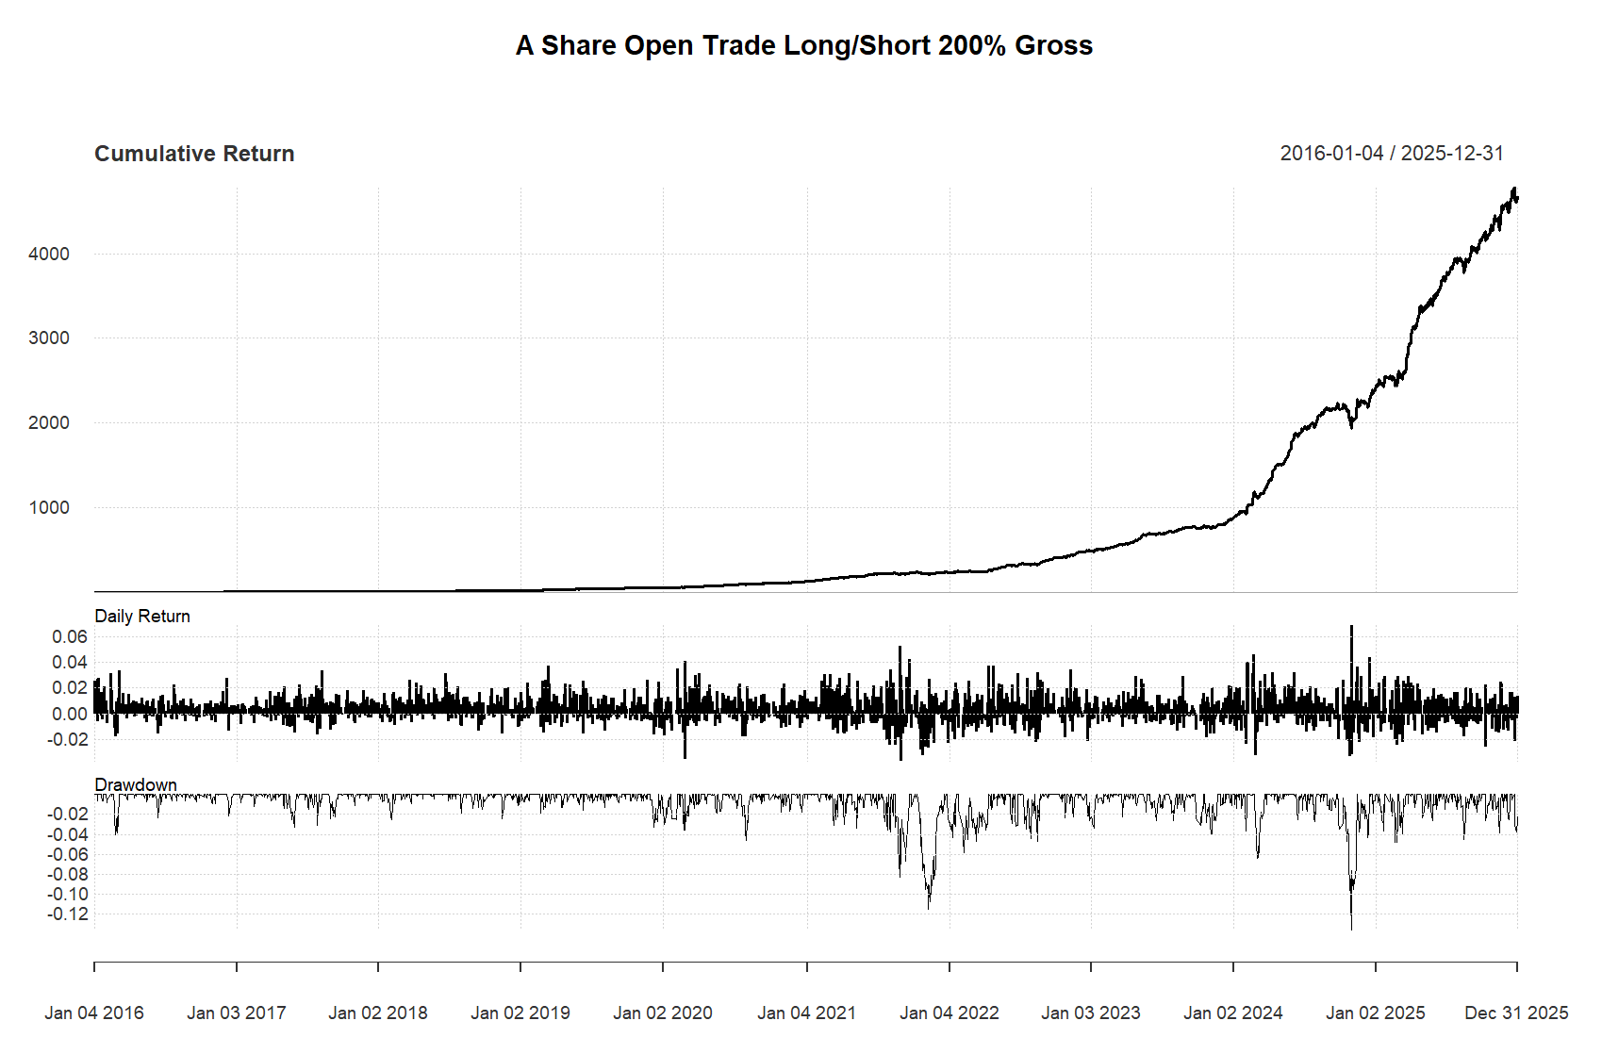

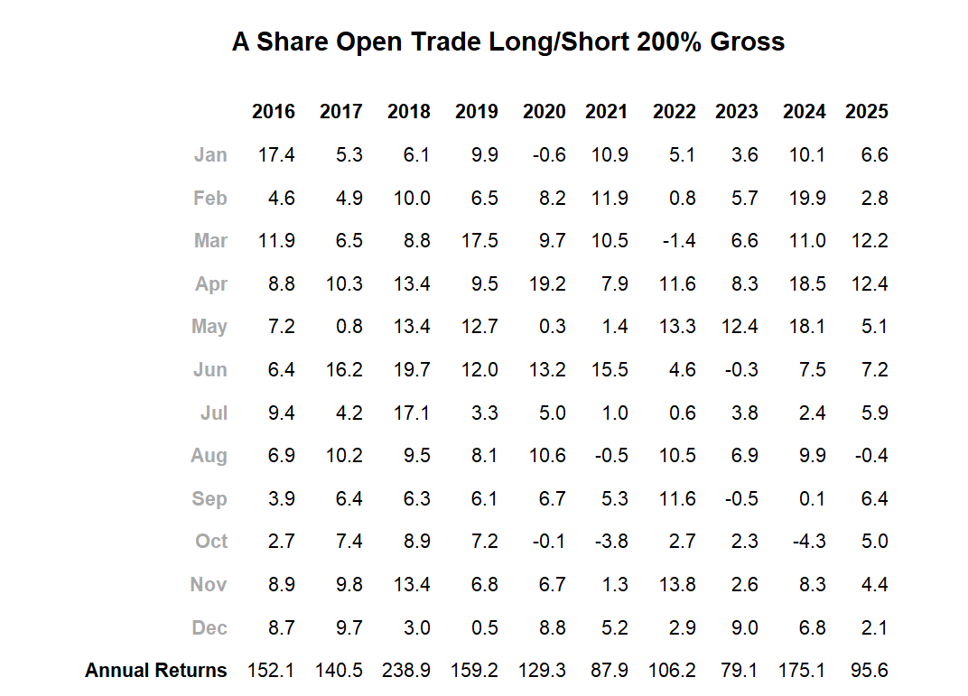
A.Share.Open.Trade.Long.Short.200..Gross
Annualized Return 1.4020000
Annualized Std Dev 0.1564000
Annualized Sharpe (Rf=0%) 8.9673000
Max DD 0.1357765
Calmar Ratio 10.3261320

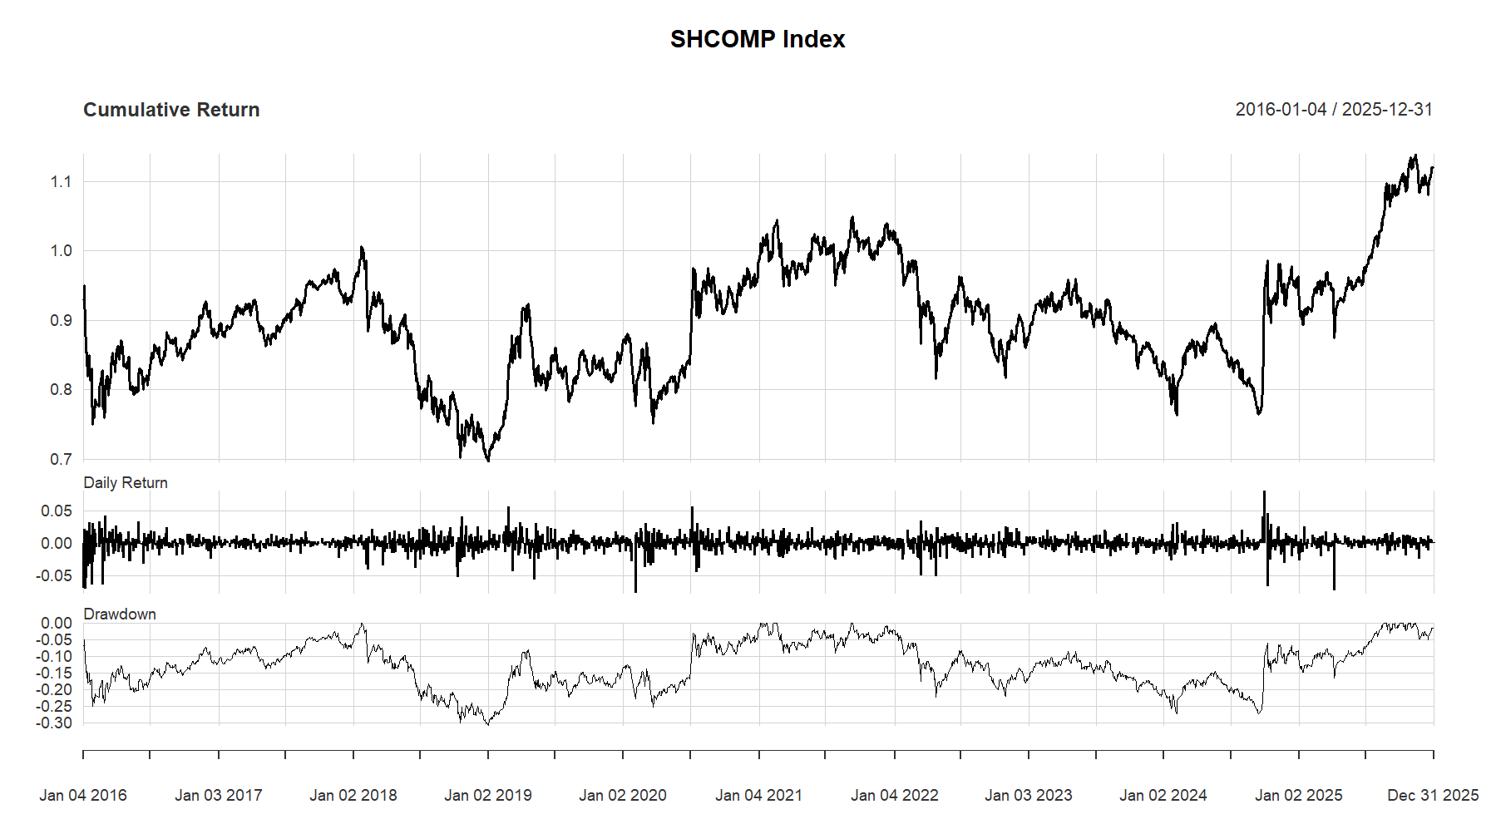
SHCOMP.Index
Annualized Return 1.200000e-02
Annualized Std Dev 1.728000e-01
Annualized Sharpe (Rf=0%) 6.920000e-02
Max DD 3.076593e-01
Calmar Ratio 3.885164e-02

