**Nhân viên: Nguyễn Đức Ngọc Toàn**

**MSNV: 277858**

**PHẦN MỀM VECTOR SIGNAL ANALYSIS**

1. **Chuyển đổi tín hiệu từ định dạng Matlab sang địng dạng VSA**

function convertvsa(waveform,bwpset)

Nfft = bwpset.Nfft;

scs = bwpset.scs;

nAnt = bwpset.NTxant;

waveform = reshape(waveform,[],1);

waveform = repmat(waveform,[8 1]);

InputZoom = uint8(1);

InputCenter = 0;

XDelta = 1/(Nfft*scs);

XDomain = int16(2);

XUnit = 'Sec';

YUnit = 'V';

switch nAnt

case 1

Y = single(waveform);

save('test.mat','InputCenter','InputZoom','XDelta','XDomain','XUnit','YUnit','Y');

case 2

Y1 = single(waveform(1,1));

Y2 = single(waveform(1,2)); save('test.mat','InputCenter','InputZoom','XDelta','XDomain','XUnit','YUnit','Y1','Y2');

case 4

Y1 = single(waveform(1,1));

Y2 = single(waveform(1,2));

Y3 = single(waveform(1,3));

Y4 = single(waveform(1,4)); save('test.mat','InputCenter','InputZoom','XDelta','XDomain','XUnit','YUnit','Y1','Y2','Y3','Y4');

end

end

1. **Kiểm tra tín hiệu kênh PUSCH bằng VSA**
   1. **NTxAnt = 1**

**2.1.1 Case 273RB, QPSK (MCS = 2)**

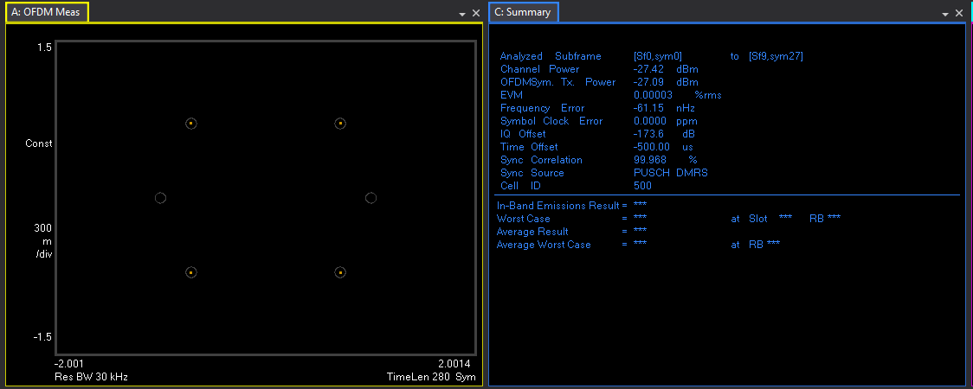

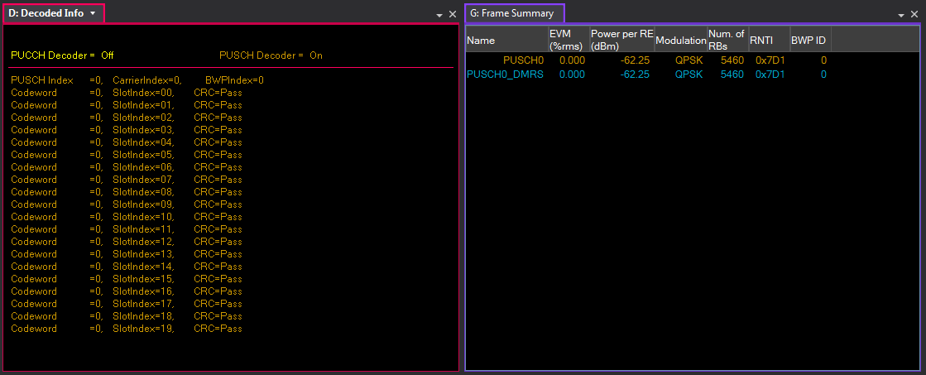

**2.1.2 Case 51RB, 16QAM (MCS = 10)**

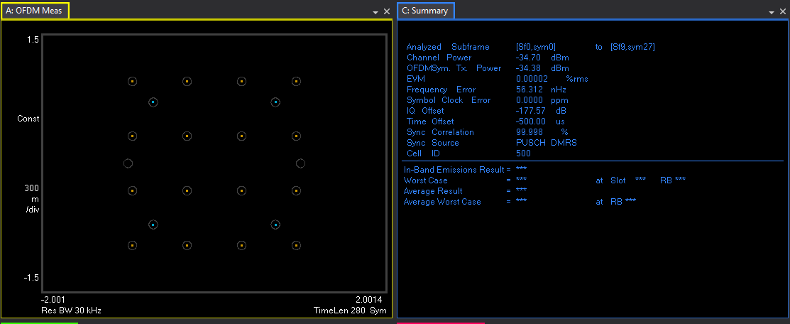

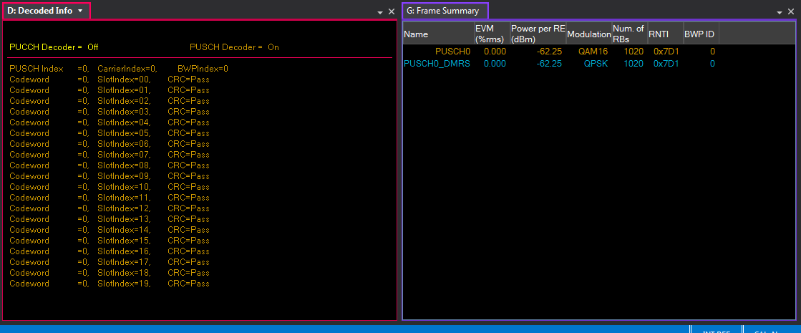

**2.1.3 Case 1RB, 64QAM (MCS = 17)**

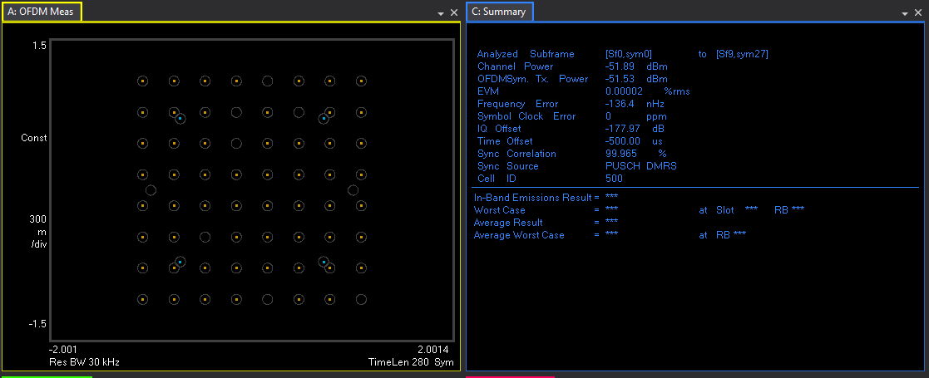

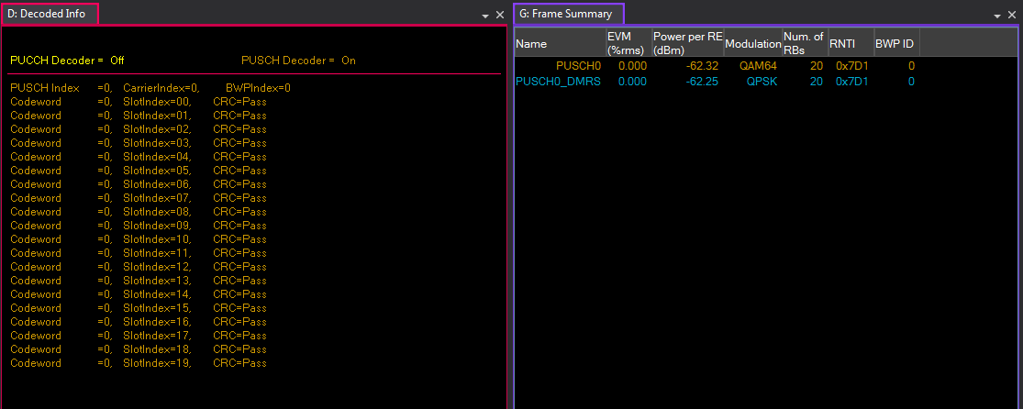

* 1. **NTxAnt = 2**

**2.2.1 Case 273RB, QPSK (MCS = 2), NTPMI = 5**

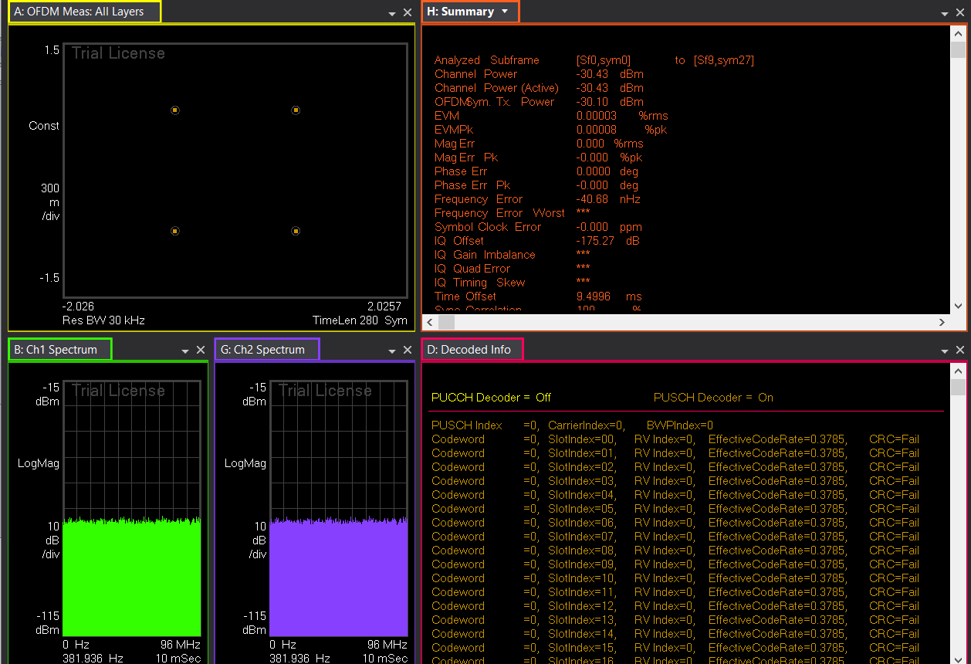

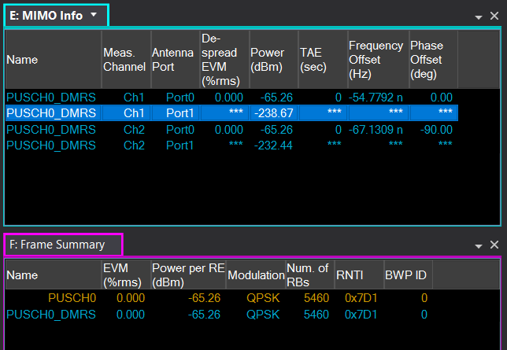

**2.2.2 Case 51RB, 16QAM (MCS = 10), NTPMI = 5**

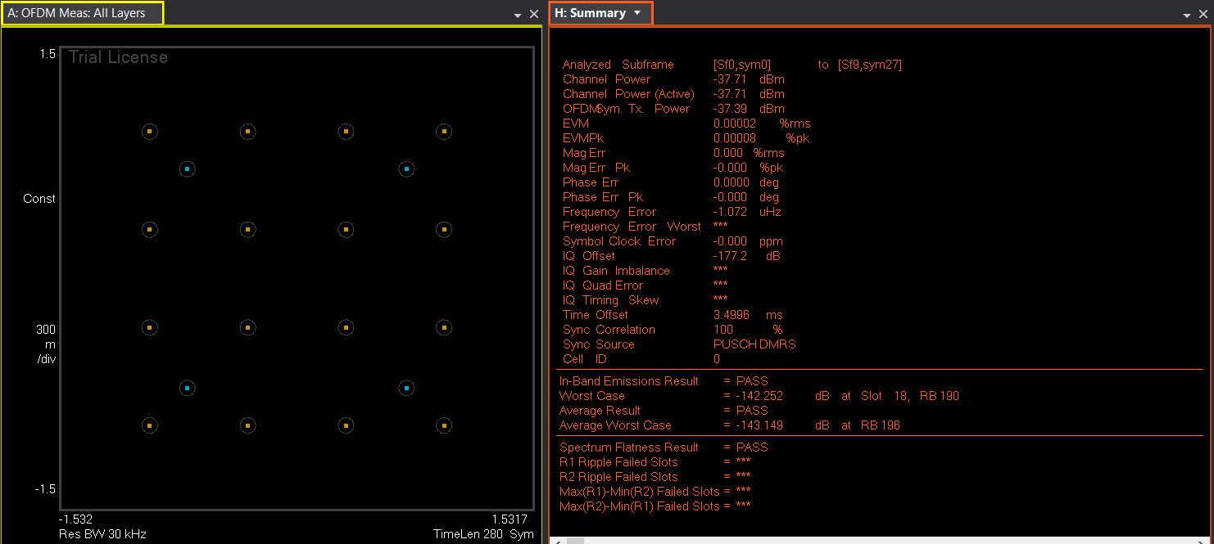

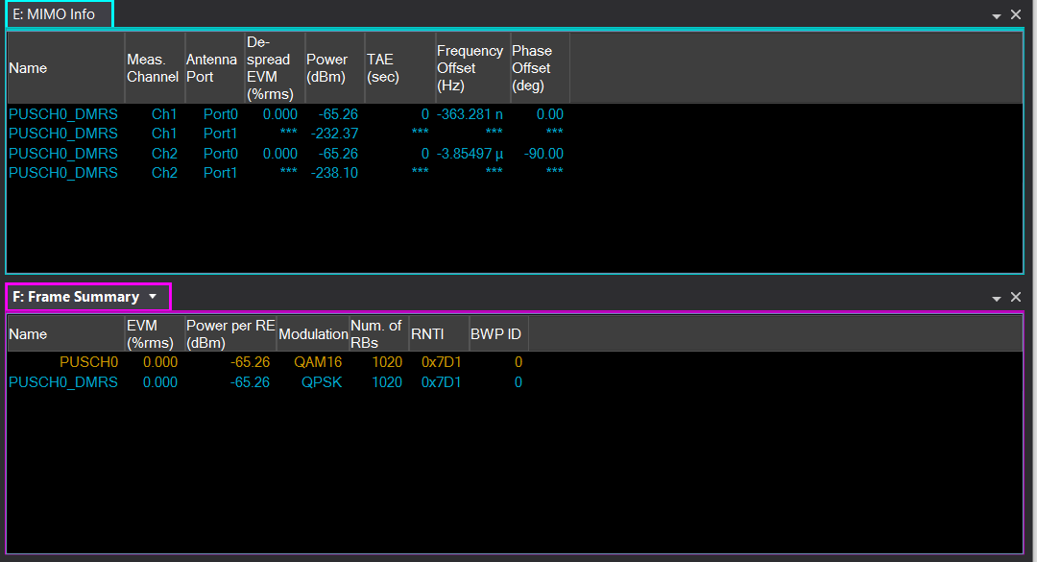

**2.2.2 Case 1RB, 64QAM (MCS = 17), NTPMI = 5**

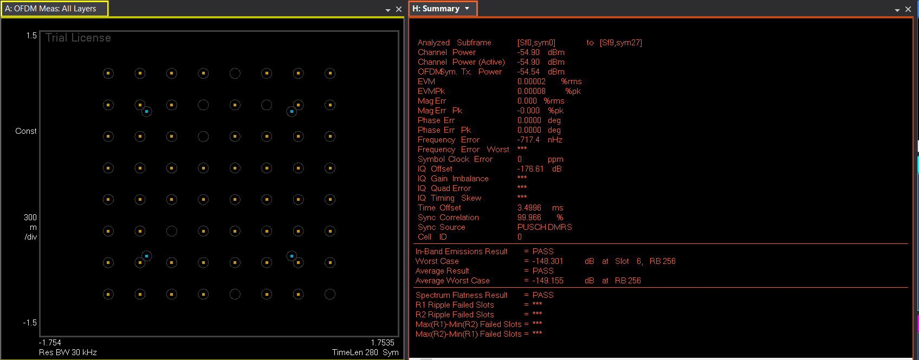

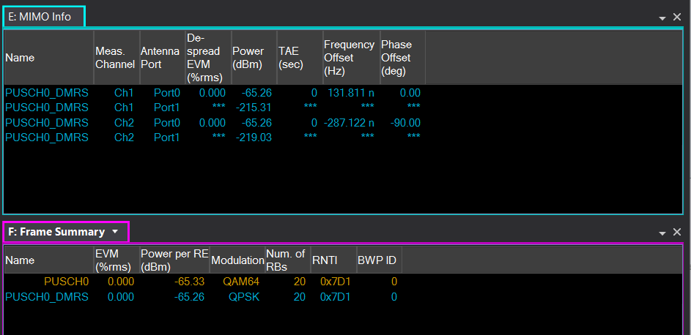

**2.3 NTxAnt = 4**

**2.3.1 Case 273RB, QPSK (MCS = 2), NTPMI = 5**

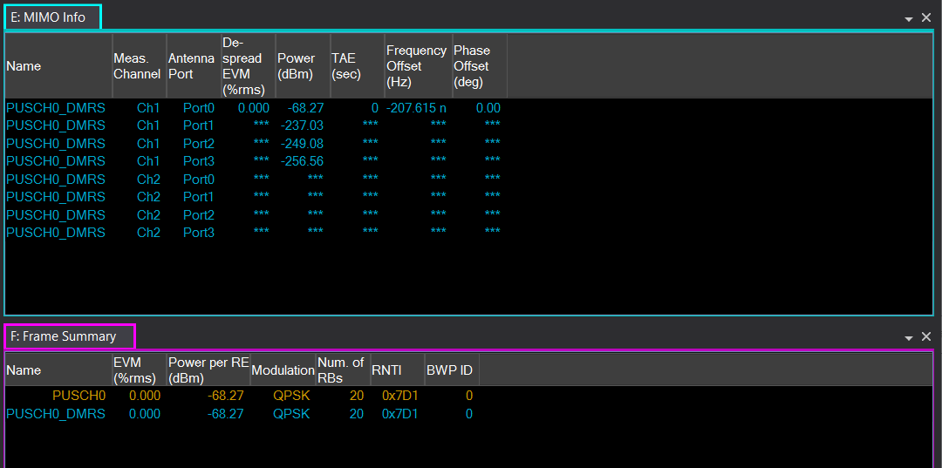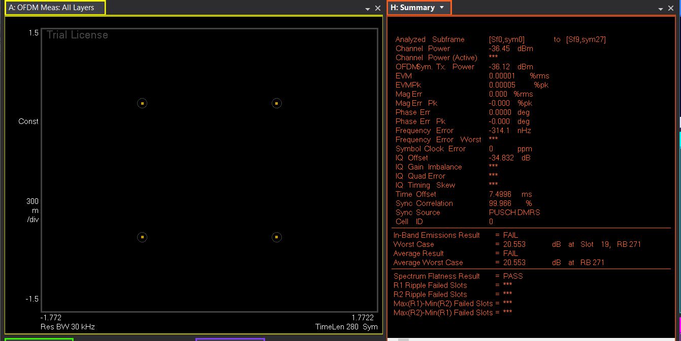

**2.3.2 Case 51RB, 16QAM (MCS = 10), NTPMI = 5**

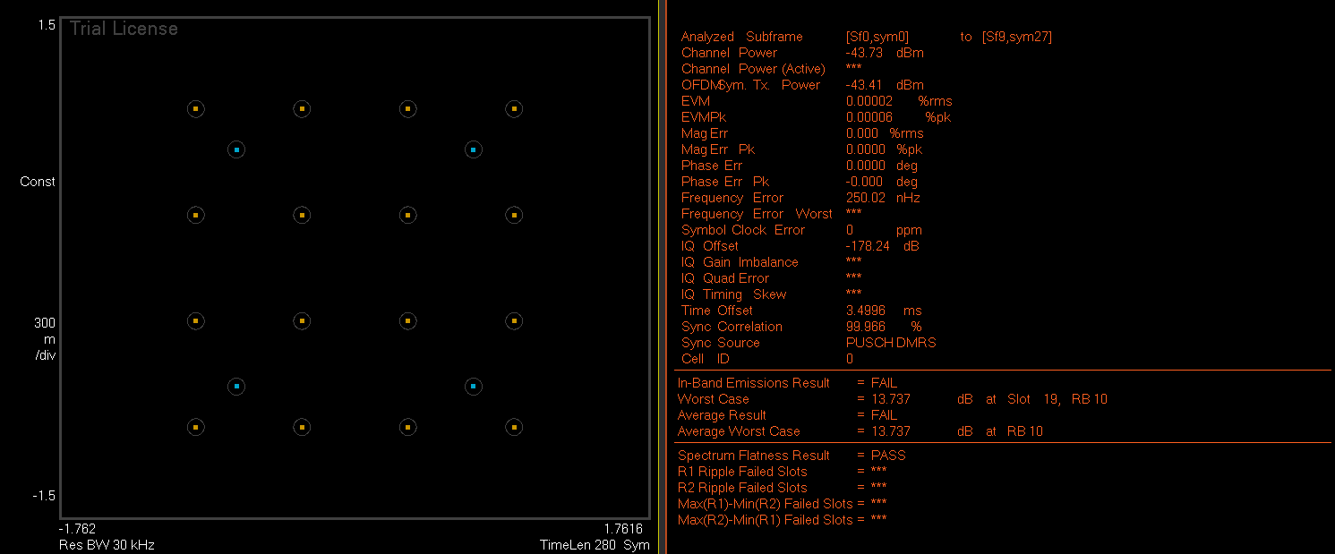

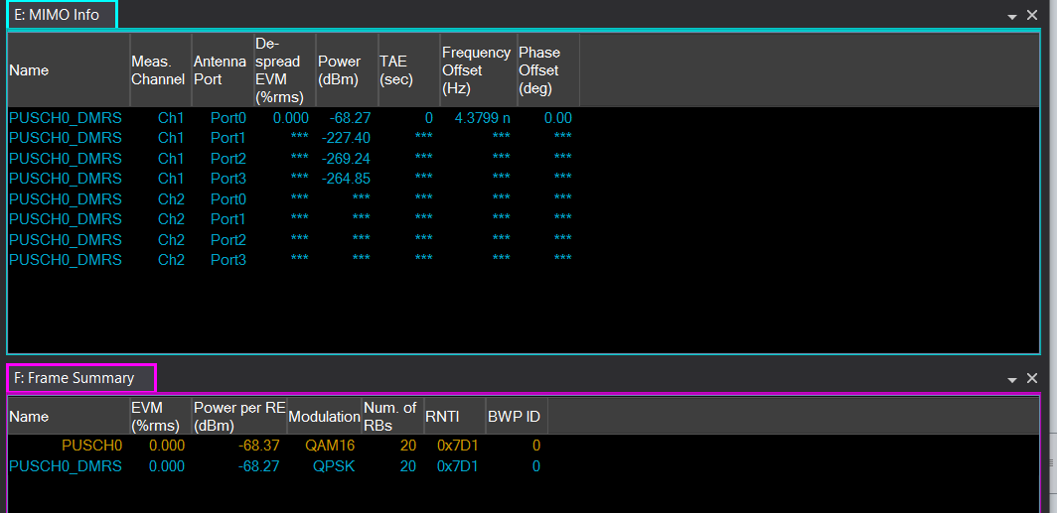

**2.3.2 Case 1RB, 64QAM (MCS = 2), NTPMI = 5**

