Project Document
StarUML Sample
:UCS
Usecase Specification Document


PLASTIC SOFTWARE INCORPORATION
http://www.staruml.com
Document Revision History
Rev# | Date | Affected Section | Author
1

Table of Contents
1. Introduction 7
1.1. Objective 7
1.2. Overall Description 7
2. Use-Case Diagram 8
2.1. AdministratorUsecaseDiagram Diagram 8
2.2. MemberUseCaseDiagram Diagram 8
2.3. ProjectManagerUseCaseDiagram Diagram 9
2.4. TeamLeaderDiagram Diagram 10
2.5. UserRaletetion Diagram 10
3. Actor Specification 12
3.1. Administrator 12
3.1.1. Description 12
3.2. Member 12
3.2.1. Description 12
3.3. ProjectManager 12
3.3.1. Description 12
3.4. TeamLeader 12
3.4.1. Description 12
3.5. User 12
3.5.1. Description 12
4. Use-Case Specification 13
4.1. AccessInformation 13
4.1.1. Description 13
4.1.2. Flow of Events 13
4.1.3. Pre-Conditions 13
4.1.4. Post-Conditions 13
4.2. DocumentInformation 13
4.2.1. Description 13
4.2.2. Flow of Events 13
4.2.3. Pre-Conditions 13
4.2.4. Post-Conditions 13
4.3. MemberAccessInformation 14
4.3.1. Description 14
4.3.2. Flow of Events 14
4.3.3. Pre-Conditions 14
4.3.4. Post-Conditions 14
4.4. MenusInformation 14
4.4.1. Description 14
4.4.2. Flow of Events 14
4.4.3. Pre-Conditions 14
4.4.4. Post-Conditions 14
4.5. ProjectMemberInformation 15
4.5.1. Description 15
4.5.2. Flow of Events 15
4.5.3. Pre-Conditions 15
4.5.4. Post-Conditions 15
4.6. PuginInformation 15
4.6.1. Description 15
4.6.2. Flow of Events 15
4.6.3. Pre-Conditions 15
4.6.4. Post-Conditions 15
4.7. ReportInformation 16
4.7.1. Description 16
4.7.2. Flow of Events 16
4.7.3. Pre-Conditions 16
4.7.4. Post-Conditions 16
4.8. RoleInformation 16
4.8.1. Description 16
4.8.2. Flow of Events 16
4.8.3. Pre-Conditions 16
4.8.4. Post-Conditions 16
4.9. SourceCodeInformation 17
4.9.1. Description 17
4.9.2. Flow of Events 17
4.9.3. Pre-Conditions 17
4.9.4. Post-Conditions 17
4.10. TablesAccessInformation 17
4.10.1. Description 17
4.10.2. Flow of Events 17
4.10.3. Pre-Conditions 17
4.10.4. Post-Conditions 17
4.11. TaskInformation 18
4.11.1. Description 18
4.11.2. Flow of Events 18
4.11.3. Pre-Conditions 18
4.11.4. Post-Conditions 18
4.12. UserInformation 18
4.12.1. Description 18
4.12.2. Flow of Events 18
4.12.3. Pre-Conditions 18
4.12.4. Post-Conditions 18
4.13. processInformation 19
4.13.1. Description 19
4.13.2. Flow of Events 19
4.13.3. Pre-Conditions 19
4.13.4. Post-Conditions 19
4.14. projectInformation 19
4.14.1. Description 19
4.14.2. Flow of Events 19
4.14.3. Pre-Conditions 19
4.14.4. Post-Conditions 19

List of Figure
Figure 1 – Use-Case Diagram of AdministratorUsecaseDiagram 8
Figure 2 – Use-Case Diagram of MemberUseCaseDiagram 9
Figure 3 – Use-Case Diagram of ProjectManagerUseCaseDiagram 9
Figure 4 – Use-Case Diagram of TeamLeaderDiagram 10
Figure 5 – Use-Case Diagram of UserRaletetion 11

Introduction

Objective
This document is Usecase Specification Document generated from UCS template document by StarUML Generator.

Overall Description
This document describes….

Use-Case Diagram

AdministratorUsecaseDiagram Diagram

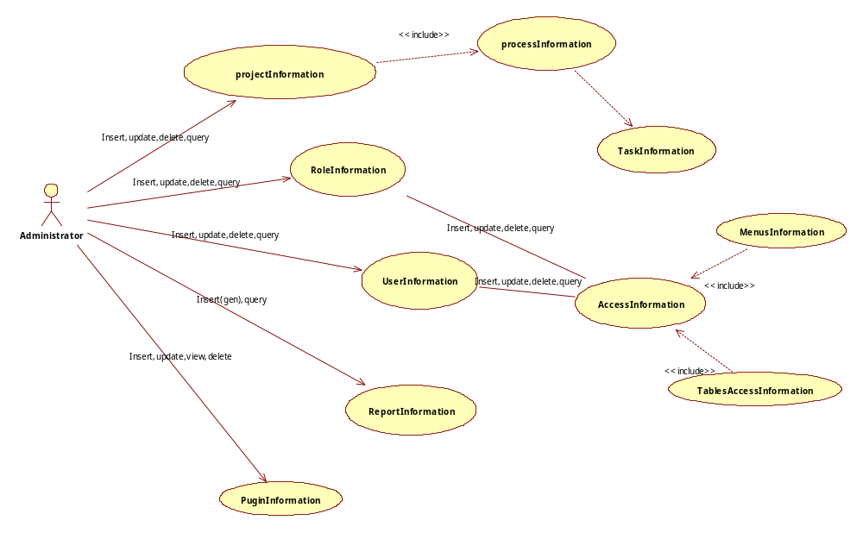
Figure 1 – Use-Case Diagram of AdministratorUsecaseDiagram

MemberUseCaseDiagram Diagram

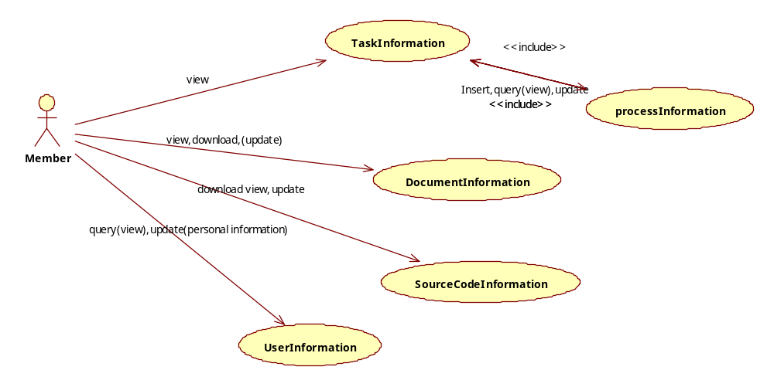
Figure 2 – Use-Case Diagram of MemberUseCaseDiagram

ProjectManagerUseCaseDiagram Diagram

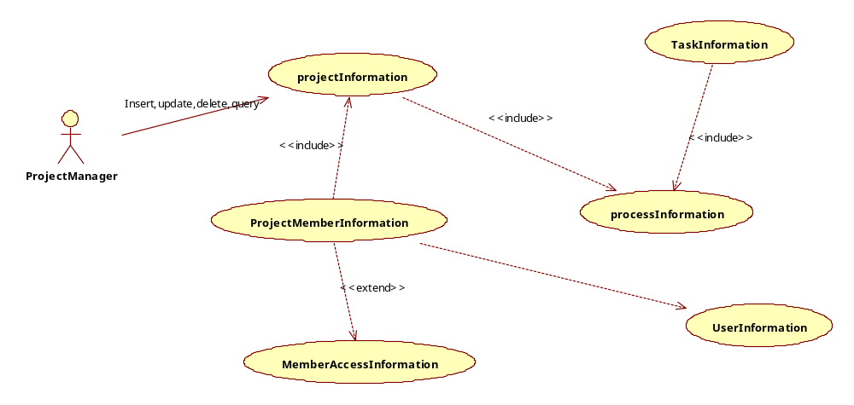
Figure 3 – Use-Case Diagram of ProjectManagerUseCaseDiagram

TeamLeaderDiagram Diagram

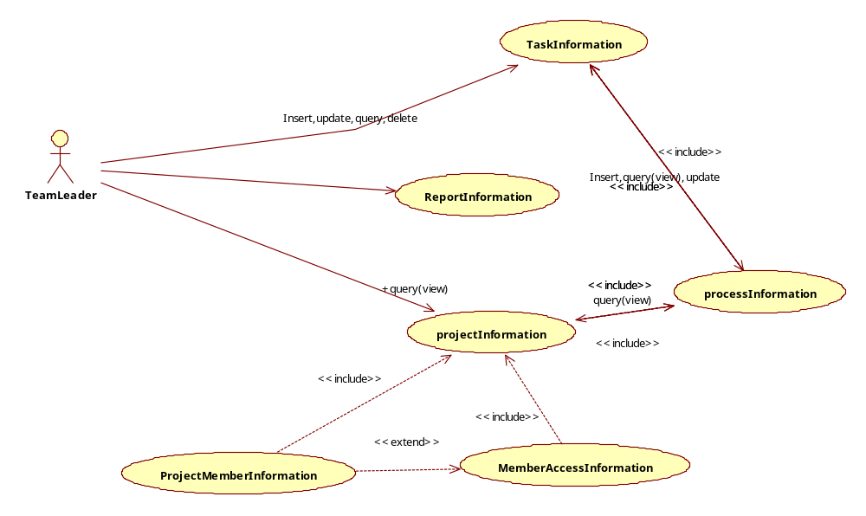
Figure 4 – Use-Case Diagram of TeamLeaderDiagram

UserRaletetion Diagram
参考“分析模块中”UserRaletetion"图的关系
Analysis Model->com.amos.teamserver->entries->UserRaletetion
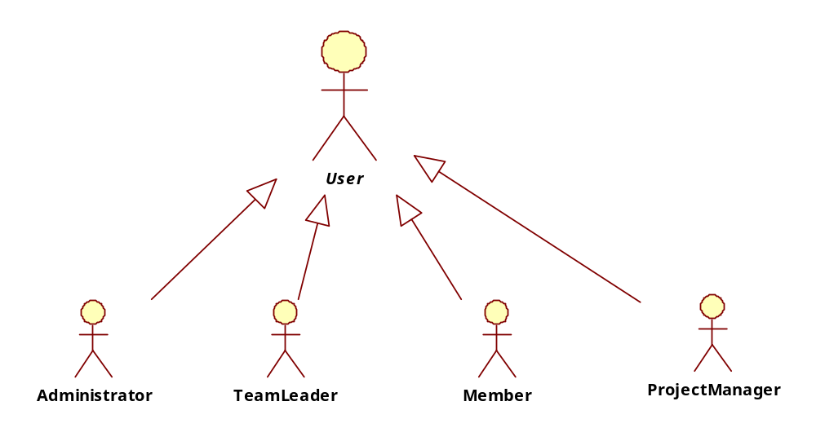
Figure 5 – Use-Case Diagram of UserRaletetion

Actor Specification

Administrator

Description

Member

Description

ProjectManager

Description

TeamLeader

Description

User

Description

Use-Case Specification

AccessInformation

Description

Flow of Events

Basic Flow

Alternative Flow

Pre-Conditions

Post-Conditions

DocumentInformation

Description

Flow of Events

Basic Flow

Alternative Flow

Pre-Conditions

Post-Conditions

MemberAccessInformation

Description

Flow of Events

Basic Flow

Alternative Flow

Pre-Conditions

Post-Conditions

MenusInformation

Description

Flow of Events

Basic Flow

Alternative Flow

Pre-Conditions

Post-Conditions

ProjectMemberInformation

Description

Flow of Events

Basic Flow

Alternative Flow

Pre-Conditions

Post-Conditions

PuginInformation

Description

Flow of Events

Basic Flow

Alternative Flow

Pre-Conditions

Post-Conditions

ReportInformation

Description

Flow of Events

Basic Flow

Alternative Flow

Pre-Conditions

Post-Conditions

RoleInformation

Description

Flow of Events

Basic Flow

Alternative Flow

Pre-Conditions

Post-Conditions

SourceCodeInformation

Description

Flow of Events

Basic Flow

Alternative Flow

Pre-Conditions

Post-Conditions

TablesAccessInformation

Description

Flow of Events

Basic Flow

Alternative Flow

Pre-Conditions

Post-Conditions

TaskInformation

Description

Flow of Events

Basic Flow

Alternative Flow

Pre-Conditions

Post-Conditions

UserInformation

Description

Flow of Events

Basic Flow

Alternative Flow

Pre-Conditions

Post-Conditions

processInformation

Description

Flow of Events

Basic Flow

Alternative Flow

Pre-Conditions

Post-Conditions

projectInformation

Description

Flow of Events

Basic Flow

Alternative Flow

Pre-Conditions

Post-Conditions

Index

Ａ
AccessInformation 13
Administrator 12
AdministratorUsecaseDiagram 8
Ｄ
DocumentInformation 13
Ｍ
Member 12
MemberAccessInformation 14
MemberUseCaseDiagram 8, 9
MenusInformation 14
Ｐ
processInformation 19
projectInformation 19
ProjectManager 12
ProjectManagerUseCaseDiagram 9
ProjectMemberInformation 15
PuginInformation 15
Ｒ
ReportInformation 16
RoleInformation 16
Ｓ
SourceCodeInformation 17
Ｔ
TablesAccessInformation 17
TaskInformation 18
TeamLeader 12
TeamLeaderDiagram 10
Ｕ
User 12
UserInformation 18
UserRaletetion 10, 11

