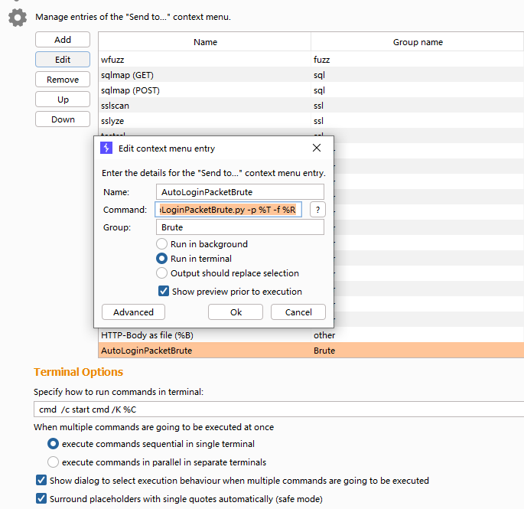

name **AutoLoginPacketBrute**

command **cd C:\Users\WINDOWS\GithubProject\AutoLoginPacketBrute\ && python AutoLoginPacketBrute.py -p %T -f %R**

group **Brute**

勾选 Run in terminal 并保存

