Output:

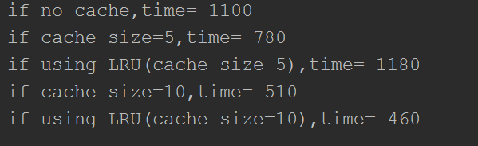

Discussion

A: if there is no cache, the time is 1100 time unit

B: if a small cache is used, there performance is increased by 30%

C: however, when the small cache is combined with LRU, the performance is decreased. There is cache pollution when cache size is very small, the replacement is too frequent, causing useful memory locations to be evicted out of cache

D: doubling the cache, the performance will increase by 50%

F: doubling the cache size and also using LRU, the performance will increase significantly (almost 60% as compared to no cache). The cache hit rate is increased due to larger cache size combined with LRU.