**Implement an AUTOW system to support partients or cripples when using wheelchair automatically**

by

**Leader**: Nguyễn Huy Hoàng- SE141123

Nguyễn Văn Cường- SE130685

Nguyễn Thị Thùy Linh- SE140822

Dương Đình Trung- SE130530

Supervisor: Lê Phú Nguyên

A final year capstone project submitted in partial fulfillment of the requirement

for the Degree of Bachelor of Artificial Intelligent in Computer Science

DEPARTMENT OF ITS

THE FPT UNIVERSITY HO CHI MINH CITY

October, 2022

# Table of contents

ACKNOWLEDGMENTS 4

Definition and Acronyms 7

I. INTRODUCTION 7

**1. Overview** 7

1.1 Project Information 7

1.2 Project team 8

**2. Product Background** 8

**3. Existing Systems** 10

3.1 Wheelchair AUTOW 10

3.2 Wheelchair AUTOW App 11

**4. Business Opportunity** 11

**5. Software product vision** 12

6. **Project Scope & Limitations** 12

6.1 Major Features 12

6.2 Limitations & Exclusions 13

II. PROJECT MANAGEMENT PLAN 13

**1.** **Overview** 13

1.1. WBS & Estimation 13

1.2. Project Objectives 14

1.3. Project Risks 15

**2.** **Management Approach** 16

2.1. Project Process 16

2.2.Quality Management 17

2.3.Trainning plan 18

**3.** **Project Deliverables** 18

**4.** **Responsibility Assignments** 19

**5.** **Project Communications** 20

**6.** **Configuration Management** 20

6.1. Document Management 20

6.2. Source Code Management 21

6.3. Tools & Infrastructures 21

III. Software Requirements Specification 21

**1.** **Product overview** 21

**2.** **User requirements** 21

2.1. Actors 21

2.2. Use case 23

**3.** **Function requirements** 25

3.1. System Functional Overview 25

3.2. Feature 28

**4.** **Non-function requirements** 34

4.1. External Interfaces 34

4.2. Quality Attributes 34

**5.** **Requirement Appendix** 35

5.1. Business Rules 35

5.2. Application Messages List 36

IV. Software Design Description 36

**1. System design** 36

1.1. Overall Description 36

1.2. System Architecture 37

**2. Database design** 39

**3. Detail Design** 39

V. Software Testing Documentation 39

**1. Overall Description** 39

1.1.Test model 39

1.2. Testing Levels 40

1.3. Test type 41

**2.** **Test Plan** 41

2.1 Test Stages 41

2.2 Resources 41

2.3 Test Milestones 42

**3.** **Test case** 43

**4.** **Test repport** 43

VI. Release Package & User Guides 43

**1. Deliverable Package** 43

**2. Installation Guides** 44

**3. User Manual** 44

VII. Appendix 44

# ACKNOWLEDGMENTS

First of all, we would like to express our sincere and deepest gratitude to our supervisor, Mr. Lê Phú Nguyên, for giving us the precious opportunity to participate in this project. He guidance helped us in all the time of research, designing, building, and developing of this thesis. No matter day or night, as long as we have problems, he always ready to support us without complaining, once again we would like to sincerely thank you, Mr. Nguyên. We would like to thank each individual in our group for our enthusiasm, hard-working, dedication and non-stop effort. Sometimes our group fell into a state of deadlock, stress, and fatigue, but luckily, we all tried to overcome them to reach today. Special thanks to Nguyễn Huy Hoàng for being a great leader, always being the one who giving the best effort and always tolerating group members' mistakes. Thank you Nguyễn Văn Cường for your research ability and expertise. Thank you Dương Đình Trung and Nguyễn Thị Thùy Linh for not giving up and always trying to care about the smallest things.Last but not least, we would like to extend our gratitude to our families and friends who have provided emotional and practical support for this project. Thanks for everything all of you give us, we will forever be engraved in our hearts.

ABSTRACT

Remote-controlled AUTOW wheelchair is defined as any mobile device that is

controlled by a means that does not restrict its motion with an origin external to the device. This is usually a radio control device, the cable connecting the remote and the wheelchair AUTOW or Wifi controller.The remote control AUTOW Wheelchair is

always controlled by a human and takes positive action autonomously. It is vital that a vehicle should be capable of proceeding accurately to a target area; maneuvering within that area to fulfill its mission and returning.

In this project we are using wifi wireless technology to control our wheelchair

AUTOW which is a very simple communication system. The remote in this project is an android device which has wifi feature built in. The user has to install an application on his/her mobile and connect wifi in the mobile phone. User can perform various

actions like moving Forward, Backward, move Left and move right using commands that are sent from the android mobile. The wifi is a serial communication medium through which we can connect two devices relessly. Here we have used a wifi module in our the wheelchair AUTOW which gets connected to the phone's wifi, that allows us to communicate and allows to take command over it. The task of controlling the car is done by the Arduino which houses the micro-controller . Arduino has played a major role in the has made it easier to convert digital and analog signal to physical movements. The project is wifi based because it gives us wider range of control and more efficiency. It also gives us the advantage of changing the remote anytime, meaning that we can use any android devices including phones, tablets, computers. Physical barriers like walls, doors, etc. do not effect incontrolling the wheelchair AUTOW.

# Definition and Acronyms

|  |  |
| --- | --- |
| **Acronym** | **Definition** |
| WBS | Work breakdown structure |
| SRS | Software Requirement Specification |
| UI | User Interface |
| GUI | Graphical User Interface |
| SI | Software Interfaces |
| HI | Hardware interface |
| BR | Business Rule |
|  |  |

# I. INTRODUCTION

## **1. Overview**

### 1.1 Project Information

* Project name: **Implement an AUTOW system to support partients or cripples when using wheelchair automatically**
* Project code: **FA22SE37**
* Group name: **GFA22SE46**
* Software type: **Mobile Application, Wheelchair AUTOW**

### 1.2 Project team

#### a. Supervisor

|  |  |  |  |
| --- | --- | --- | --- |
| **Full Name** | **Email** | **Phone Number** | **Title** |
| Lê Phú Nguyên | NguyenLP9@fe.edu.vn | 0787647072 | Lecturer |

#### b. Team Members

|  |  |  |  |
| --- | --- | --- | --- |
| **Full Name** | **Email** | **Phone Number** | **Role** |
| Nguyễn Huy Hoàng | hoangnhse141123@fpt.edu.vn | 0782912970 | Leader |
| Nguyễn Văn Cường | cuongnvse130685@fpt.edu.vn | 0943949578 | Member |
| Nguyễn Thị Thùy Linh | linhnttse140822@fpt.edu.vn | 0333511602 | Member |
| Dương Đình Trung | trungDDse130530@fpt.edu.vn | 0948436424 | Member |

## **2.** **Product Background**

Vietnam is one of the countries with the fastest aging population in the world. People aged 60 and over accounted for 11.9% of the total population in 2019 and by 2050 this number will increase to more than 25%. By 2036, Vietnam will enter a period of population aging. And as there are more and more elderly people, a large number of young people are needed to take care of them and assist them in moving. Since the vast majority of elderly people get older, their mobility also greatly decreases. the move is not as good as before, so it is in need of support from others. For example, currently at domestic and international airports of Vietnam in particular and countries around the world in general, there are quite a few passengers who have difficulty in traveling, they need the assistance of wheelchairs and Relatives or airline staff. To help them move conveniently to the gates or the location of the airport more quickly and easily

But if you want to use a wheelchair, the elderly themselves cannot use it themselves, but must have the support of others in the back to push the wheelchair away, that is with push wheelchairs. With a manual wheelchair, the user has to motive a lot from the waist up to 2 hands. Therefore, it will be very tiring during use. It is difficult to move if the ground is not flat (stairs, slopes…) When the wheels are dirty or wet, their hands will also be dirty. As for electric or motorized wheelchairs, it is quite cumbersome and high cost. Because of seeing the difficulties that the elderly are facing, our team has built and developed an AUTOW wheelchair to help the elderly with poor mobility, walk more easily. and we also optimize the functions on our products so that even older people can use them easily, minimizing the difficulties that occur when using the product. Besides, AUTOW wheelchairs are also designed to be compact, easy to move, not too large in volume, high in payload and low in cost. So that everyone can use it, whether people with a large weight or people with low costs can use it. With the introduction of AUTOW wheelchairs, we want to bring users, especially the elderly, practical values to help their lives get better every day when their mobility is not good anymore.

## **3. Existing Systems**

* Wheelchair AUTOW
* Wheelchair AUTOW app

### 3.1. Wheelchair AUTOW

AUTOW wheelchair is an automatic and intelligent wheelchair. It is used as a tool to support the elderly with limited mobility, helping them move more easily, avoiding being too dependent on others. Although, currently on the market there are many types of wheelchairs to assist the elderly with low mobility such as hand strollers, manual wheelchairs, electric wheelchairs or motorized wheelchairs… But the highlight that AUTOW wheelchairs bring is that is that the user can call his wheelchair from one location to another through the mobile application, for example, the user is in the waiting room and wants to move to the boarding gate, the user will choose two locations Pick up and drop off is the waiting room and boarding gate. The wheelchair will move to the pick-up location and take it to the drop-off location. the wheelchair can move automatically according to the user's will, or the user can also control the vehicle by the control panel, and to ensure the safety of the user, the wheelchair moves at a slow speed equal to normal human speed. The maximum speed is 5km/h..

### 3.2. Wheelchair AUTOW App

The AUTOW Wheelchair App is an app built to assist users in using AUTOW wheelchairs. Here, users who want to use a wheelchair must first set up a map of the moving wheelchair's premises and set up wifi. Then connect the AUTOW wheelchair and mobile app. The mobile app allows users to select pick up and drop off locations. In addition, it also allows users through the mobile application to control the car moving forward, backward, left and right through the control panel on the mobile application. The mobile app will notify you if the battery is running low.

## **4. Business Opportunity**

Currently, the wheelchair product line is not too strange on the market. For elderly people who have difficulty moving or those with limited mobility of their legs, wheelchairs are an extremely important and convenient product. When owning an AUTOW wheelchair, users can move on their own without the help of loved ones. Moving with a wheelchair AUTOW also helps users avoid hand and shoulder diseases... compared to manual wheelchairs. With a simple design that is easy for the elderly to use. And with low cost will be easily accessible to everyone. Because of the above, we believe that AUTOW wheelchairs will develop even more in the future.

## **5.** **Project Scope & Limitations**

The AUTOW wheelchair app is for the elderly and people with limited mobility at the airport. Focus on handling the problem of moving forward, backward, left and right of the AUTOW wheelchair when someone sits on it. Moving from one location to another after bringing the user to the desired location will automatically return to the wheelchair yard. There are two mechanisms for the vehicle to move: automatic control and manual control. Therefore, users of automatic wheelchairs must be able to use smartphones to control wheelchairs through mobile applications..

### 5.1 Major Features

- Book wheelchair AUTOW

- Control the AUTOW wheelchair automatically or manually through the control panel

### 5.2 Limitations & Exclusions

- AUTOW wheelchair cannot carry more than 50kg

- The battery only lasts for 4-5 hours

- Car runs continuously for about 10' (need time to dissipate heat circuit)

- If the weight is too large, turning left and right will be slow

- It is a sample product with many limitations

# II. PROJECT MANAGEMENT PLAN

## **Overview**

### 1.1. WBS & Estimation

|  |  |  |  |
| --- | --- | --- | --- |
| **No** | **WBS Item** | **Complexity** | **Est. Effort** |
| **1** | **Specification** | **30** |  |
| **1.1** | Project Planning. | simple | **2** |
| **1.2** | Project Introduction. | simple | **4** |
| **1.3** | Project Management Plan. | simple | **4** |
| **1.4** | System Requirement Specification. | simple | **20** |
| **2** | **Design** | **20** |  |
| **2.1** | Design User Interfaces (UI) prototypes. | simple | **10** |
| **2.2** | Software Design Document | simple | **10** |
| **3** | **App Mobile** | **100** |  |
| **3.1** | **Control robot’s directions** | 40 |  |
| 3.1.1 | Move forward | simple | **20** |
| 3.1.2 | Move left | simple | **10** |
| 3.1.3 | Move right | simple | **10** |
| **3.2** | **Device connections** | 60 | |
| 3.2.1 | Scan for wifi device | simple | **15** |
| 3.2.2 | Choose device to connect | simple | **15** |
| 3.3 | Show wheelchair AUTOW path | simple | **15** |
| 3.4 | Show real-time video from | simple | **15** |
| **4** | **Wheelchair AUTOW** | **200** |  |
| 4.1 | Connect to mobile app | Medium | **40** |
| 4.2 | Find path from from starting point to points and return | Medium | **40** |
| 4.3 | Receive operator instructions | Medium | **40** |
| 4.4 | Adjust motor speed | Medium | **40** |
| 4.5 | Control dc motor, rudder speed | Medium | **40** |
| **5** | **Testing** | **34** | |
| 5.1 | Test planning for mobile application | Simple | **9** |
| 5.2 | Test planning for wheelchair AUTOW | Simple | **9** |
| 5.5 | Execute tests for mobile application and wheelchair AUTOW | Medium | **16** |
| **6** | **Closing** | 25 | |
| **6.1** | Software User Guide | simple | **10** |
| **6.2** | Final Project Report | simple | **5** |
| **6.3** | Create slide and practice for thesis defence | simple | **10** |
|  | **total** | 409 (person-days) | |

### 1.2. Project Objectives

Timeliness: 40%

Allocated Effort: 4 (members) * 4 (months) * 30 (days/month) = 480 person-days

* Quality

|  |  |  |  |  |  |
| --- | --- | --- | --- | --- | --- |
| **No** | **Testing Stage** | **Test Coverage** | **No. of Defects** | **% of Defect** | **Notes** |
| 1 | Reviewing |  |  |  |  |
| 2 | Unit Test |  |  |  |  |
| 3 | Integration Test |  |  |  |  |
| 4 | System Test |  |  |  |  |
| 5 | Acceptance Test |  |  |  |  |

* Allocated Effort (man-days):

|  |  |  |
| --- | --- | --- |
| **No** | **Stage** | **Man-days** |
| 1 | Define Requirements | 50 |
| 2 | system wheelchair AUTOW & Software Design | 20 |
| 3 | Implementation & Unit Testing | 200 |
| 4 | Integration & System Testing | 50 |
| 5 | Operation & Maintenance | 10 |

* Other objectives:
* All requirements and business rules are confirmed before week 3nd
* By the 10th Week, Core functions must be completed and ready for the test phase
* By the 12th Week, The Complete project must be done and tested
* Reports and documents must be done and reviewed by project members before submission.

### 1.3. Project Risks

|  |  |  |  |  |
| --- | --- | --- | --- | --- |
| **No** | **Risk Description** | **Impact** | **Possibility** | **Response Plans** |
| 1 | Team member drops out | Serious | medium | Reduce scope |
| 2 | Unrealistic project schedule | Serious | High | The team must meet, and everyone needs to review the schedule. |
| 3 | Communication risks | Medium | High | All members must communicate with the team at the same time and avoid private talk. |
| 4 | Conflicts between team members | Medium | High | Creating a meeting to share uncomfortable things. |
| 5 | Poor experience | Medium | Low | All members should support the leader to handle the project process. |
| 6 | Framework technical knowledge | Medium | High | The team should take the time to research the framework. |
| 7 | Not understanding requirements | Medium | medium | Develop a prototype and review this with experts and supervisors. |

## **Management Approach**

### Project Process

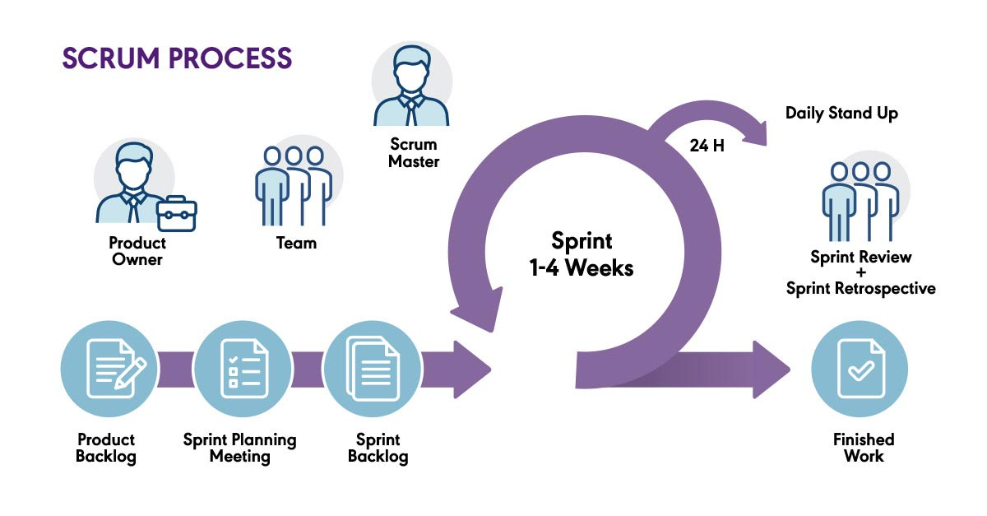

This project uses the Scrum of Agile Software Development Model. We choose this model because of some reasons:

* Scrum is suitable for small or medium size projects as a wheelchair AUTOW System ours
* During project implementation, new ideas and requirements will often occur. Besides, if there is a change in project requirements in the future, it can still be adjusted. Project processes are done by the development team simultaneously, which help everything to be flexible and changeable during the life of the project and even after.
* Scrum helps us have a better overview of the project and reduce risks.

### 2.2.Quality Management

* Defect Prevention
* Requirement Specification Review in each stage of SCRUM model
* Design Review: all team members should participate in review system design, user interface design to avoid misunderstand requirements
* Code Review: cross review between each member to avoid bugs
* Reviewing
* Code Review: cross review between each member to avoid bugs
* Code should be pushed into the developing branch and must be reviewed before merging
* Defects should be documented with details such as priority, time to fix, and their effect on the project.
* Testing
* Team members must do the testing for their features in the development environment before creating pull requests
* Team members must do unit test after developing a function

### 2.3.Trainning plan

|  |  |  |  |
| --- | --- | --- | --- |
| **Training Area** | **Participants** | **When, Duration** | **Waiver Criteria** |
| Java-based mobile app coding convention | LinhNTT, TrungDD | 19/09/2022 - 24/09/2022 | Mandatory |
| Github | All member | 19/09/2022 - 24/09/2022 | Mandatory |
| Arduino coding convention | HoangNH, CuongNV | 26/09/2022 - 01/10/2022 | Mandatory |

## **Project Deliverables**

|  |  |  |  |
| --- | --- | --- | --- |
| No | **Deliverable** | **Due Date** | **Notes** |
| 1 | Project Plan |  | Make project goal plan |
| 2 | Report 1 - Project Introduction Document |  | Project introduction |
| 3 | Report 2 - Project Management Plan Document |  | Project management plan |
| 4 | Report 3 - SRS Document |  | Software requirement specification |
| 5 | Report 4 - Software Design Document |  | Software design document |
| 6 | Report 5 - Software Testing Document |  | Test case document, test documentation |
| 7 | Report 6 - Release Package and User Guides |  | Software user guides |
| 8 | Report 7 - Appendix |  | Final project final |
| 9 | Code line |  | Code, Unit test, System test case |
| 10 | Navigation code |  | Code, Unit test, System test case |
| 11 | Receive wifi signal |  | Code, Unit test, System test case |
| 12 | Set of driving speed |  | Code, Unit test, System test case |
| 13 | Design UI/UX |  | Design UI/UX |
| 14 | Code Back end |  | Code, Unit test, System test case |
| 15 | Code front end |  | Code design screen |
| 16 | Final package |  | Final code package and documents |

## **Responsibility Assignments**

*D - Do; R - Review; S - Support; I - Informed; <blank> - Omitted*

|  |  |  |  |  |
| --- | --- | --- | --- | --- |
| **Responsibility** | **HoangNH** | **CuongNV** | **LinhNTT** | **TrungDD** |
| Project planning & tracking | S | D | R | R |
| Prepare Project Introduction Document | R | R | S | D |
| Prepare SRS Document | S | S | D | S |
| Find robot materials | D | S | S | S |
| Build robot | S | D | S | S |
| Code robot functions | D | S | R | R |
| Frontend mobile | R | R | D | S |
| Backend mobile | R | R | S | D |
| Prepare test cases | S | S | D | S |
| Do testing for robot | D | D | S | S |
| Do testing for mobile | S | S | S | D |

## **Project Communications**

|  |  |  |  |  |
| --- | --- | --- | --- | --- |
| **Communication** | **Who/ Target** | **Purpose** | **When, Frequency** | **Type, Tool, Method(s)** |
| Online | Project team members and Supervisor | -Task reports, Q&A | 1 day/week | Google Meet |
| Online | Project team members | - Discussion  - Working together  - Daily report | 4 day/week | Google Meet |
| Offline | Project team members | - Discussion  - Build robot  - Fix robot if defect  - Test robot functions  - Test robot to mobile app communication | 3 day/week | FPT University |

## **Configuration Management**

### Document Management

Google Drive is used to manage project’s documents.

### Source Code Management

Github is used to manage project’s source code.

### Tools & Infrastructures

|  |  |
| --- | --- |
| **Category** | **Tools / Infrastructure** |
| **Technology** | Python, C/C# |
| **Database** | Firebase |
| **IDEs/Editors** | Pycharm, Arduino IDE |
| **Diagramming** | StarUML, DrawIO |
| **Documentation** | MS Office, Google Docs/Sheets/Slides |
| **Version Control** | Github (Source Codes), Google Drive (Documents) |
| **Deployment server** | Firebase |
| **Project management** | ClickUp (task) |

# III. Software Requirements Specification

## **Product overview**

The wheelchair AUTOW helps user move easily through controlling the wheelchair on the mobile application or automatically to the user's desired location through line recognition during the wheelchair's movement by the camera. Mobile application allows users to track the route on a map.

## **User requirements**

### Actors

|  |  |  |
| --- | --- | --- |
| **No** | **Actor** | **Description** |
| 1 | User | When the user controls the AUTOW wheelchair through the mobile application. Users can send instructions, view a map of pick up and destination locations, and control AUTOW wheelchairs forward, backward, left and right. Besides, users can also view real-time. |
| 2 | Wheelchair AUTOW | On the mobile app, the AUTOW wheelchair is responsible for displaying a notification if the battery is running low |
| 3 | Camera | Camera is responsible for recording images color of the line, and sending them to the android application to process. |
| 4 | Admin | Admin is responsible for setting up wifi to connect AUTOW wheelchair and mobile app together so that through wifi users can use mobile app to control wheelchair AUTOW. Besides, the admin is responsible for installing the path for AUTOW wheelchairs |
|  | Arduino | The Arduino receives instructions from the mobile app and processes them |
|  | App Mobile | The mobile application connects to the AUTOW wheelchair via wifi, receives instructions from the user and send control signals from users to Arduino. |

### Use case

#### **Use Case app mobile**

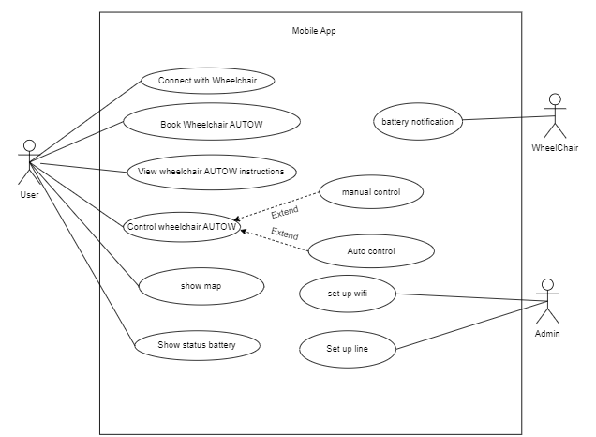

#### **Use case Wheelchair AUTOW**

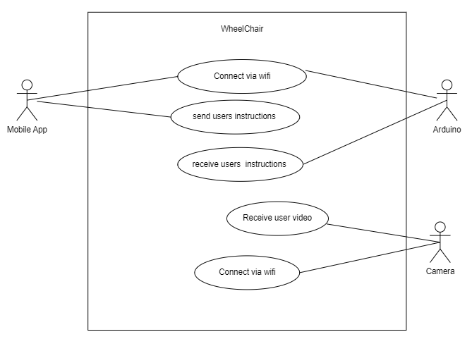

## **Function requirements**

### System Functional Overview

#### **Screens Flow**

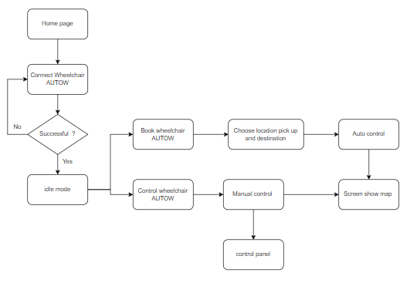

#### **Screen Descriptions**

|  |  |  |  |
| --- | --- | --- | --- |
| **No** | **Feature** | **Screen** | **Description** |
|  | Choose Wheelchair AUTOW to connect | Connect wheelchair AUTOW | show wheelchair AUTOW connected with app mobile |
|  | Choose pick up and  Destination | Book wheelchair AUTOW | Allows the user to choose a location for the AUTOW wheelchair to pick up and drop off the user |
|  | Auto control | Book wheelchair AUTOW | This feature allows the AUTOW wheelchair to run from the pickup location and take the user to their chosen destination |
|  | Manual Control | Control wheelchair AUTOW | Allows the user to choose the method to control the wheelchair AUTOW via app mobile |
|  | Show map | Screen show map | show the location of the wheelchair AUTOW on the map. |
|  | directional | Control panel | Allow operator to control the wheelchair AUTOW in specific directions |

#### **Screen Authorization**

|  |  |
| --- | --- |
| **Screen** | **User** |
| Home page | X |
| Connect wheelchair AUTOW | X |
| Book wheelchair AUTOW | X |
| Control wheelchair AUTOW | X |
| Screen show map | X |
| Control panel | x |
| idle mode | x |

#### **3.1.4 Non-Screen Functions**

|  |  |  |
| --- | --- | --- |
| **No** | **Feature** | **Description** |
| 1 | Connect with wifi | let the mobile app and the AUTOW wheelchair interact with each other |
| 2 | Setup line for wheelchair AUTOW | Spread the line map |

#### **3.1.5.Entity Relationship Diagram(ERD)**

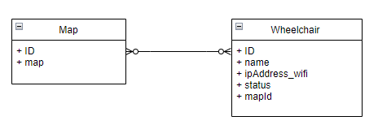

**Entities Description**

|  |  |  |
| --- | --- | --- |
| **No** | **Entity** | **Description** |
| 1 | Wheelchair AUTOW | Information of the wheelchair AUTOW |
| 3 | Map | Map information of the line |

### Feature

#### **3.2.1. Choose Wheelchair AUTOW**

**Function trigger**: this function is trigger when the user clicks "Kết nối " in screen Connect wheelchair AUTOW

**Function description**:

* Actor: user
* Purpose: Show the status of a device whether it is connected or not.
* Interface: Android application.

**Screen layout:**

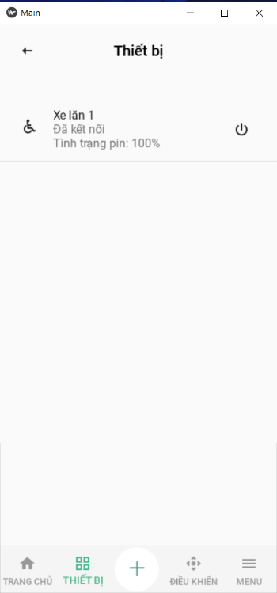

**Function Details:**

After user make select AUTOW wheelchair and click "kết nối"

+ successful connection, the system will move to the screen as shown below

+ if the connection fails, the system will display the message "connection failed"

#### **3.3.2.Choose pick up**

**Function trigger**: this function is triggered when the user chooses the pickup location

**Function description**:

* Actor: user
* Purpose: Allow the user to choose which location the wheelchair AUTOW can pick up
* Interface: Android application.
* Data: pickup location

**Screen layout:**

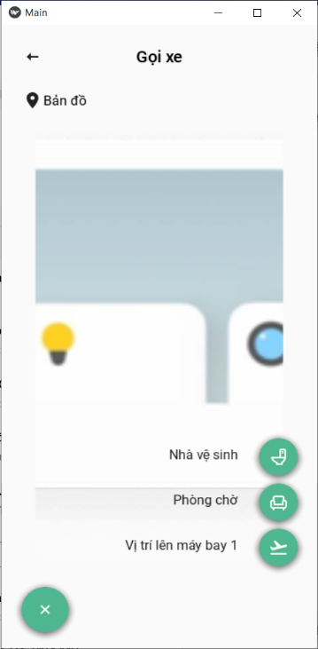

Function Details:

this feature allows user to select pick up location at a location such as waiting room, toilet , etc.

#### **3.3.3. Choose destination**

**Function trigger**: this function is triggered when the user chooses the drop off location on the map.

**Function description:**

* Actor: user
* Purpose: Allow the user to choose which location the wheelchair AUTOW can drop off
* Interface: Android application.
* Data: drop off location

**Screen layout:**

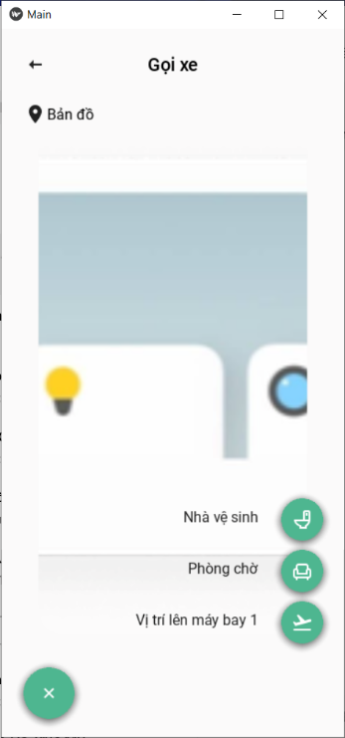

Function Details:

This feature allows the user to choose a drop off location at a location such as waiting room, toilet,...

#### **3.3.4. Manual Control**

**Function trigger**: this function is triggered when the user click "điều hướng" redirects to screen control panel .

**Function description**:

* Actor: user
* Purpose: Allow user to take control of the wheelchair AUTOW by control manual
* Interface: Android application.

**Screen layout:**

Function Details:

#### 3.3.5.Auto Control

**Function trigger**: this function is triggered when the user complete step choose pick-up location and drop-off location on the map

**Function description:**

○ Actor: user

○ Purpose: AUTOW wheelchair will automatically run from pick up location to drop off location according to the available line

○ Interface: Android application.

**Screen layout:**

Function Details:

#### 3.3.7.Show map

**Function trigger:** this function is triggered when the user perform feature Auto control

**Function description:**

○ Actor: user

○ Purpose: show location of wheelchair AUTOW on the line map

○ Interface: Android application.

Screen layout:

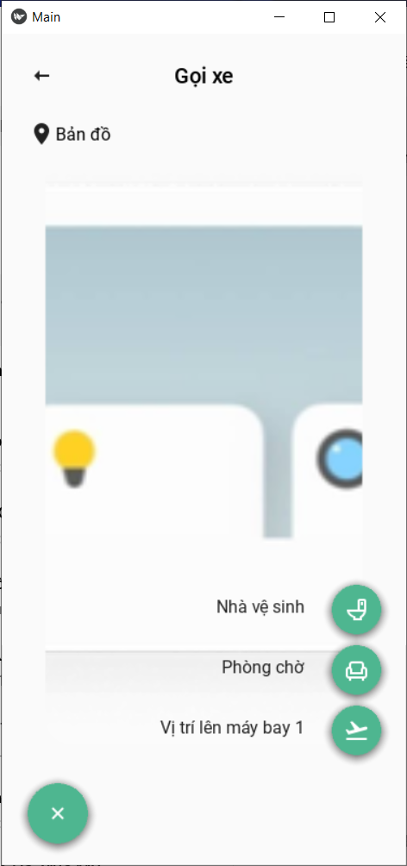

Function Details:

this function displays the travel route of the AUTOW wheelchair from the pick up position to the drop off position

#### 3.3.8.directional

Function trigger: this function is triggered when the user click directional arrows on the Control Panel screen.

Function description:

○ Actor: user

○ Purpose: Allow the user to control the wheelchair AUTOW in specific directions.

○ Interface: Android application.

Screen layout:

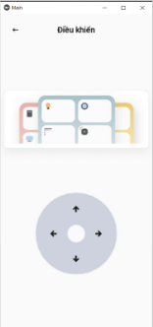

Function Details:

when the user clicks the direction arrow on the control panel screen. the system will receive the request from the user and the wheelchair moves in the right direction that the user wants

## **Non-function requirements**

### External Interfaces

#### **User Interfaces**

UI-1: Language used in the application is Vietnamese.

UI-2: GUI must be simple, friendly.

UI-3: Icons used must be easy to recognize.

UI-4: Wheelchair must depend on battery power, the battery should be fully charged before going out.

UI-5: Difficult to transport if you want to go far.

#### **Software interface**

SI-1: Mobile application: Android, v9.0.

#### **Hardware interface**

HI-1: All devices must have an internet connection. So, there is a certain delay

### Quality Attributes

#### **Usability**

* Mobile applications should be easy to use for most users can easily understand and use.
* Users are not required to have technical knowledge before using.
* AUTOW wheelchairs easily avoid obstacles, turn accurately.
* Relative vehicle speed to ensure safety when users use.

#### **Reliability**

* the wifi connection shall not experience any system major crashes or errors
* System failure is less than 5% and availability of the system is over 80%.
* The wheelchair AUTOW shall respon within fewer than 500 milliseconds from requests of app mobile.

#### **Performance**

* Response time is equal to or less than 10 seconds for each signal from sensor
* Processing time is 10s seconds for each frame

#### **Availability**

* The wifi connection shall be available 100% of the time if in range of 100 meters.
* The wheelchair AUTOWshall respond to user's commands at all times

#### **4.2.5. Security**

* The wifi connection shall not allow any other slave devices to connect to the master and receive data.
* The wifi connection shall use data encryption.

## **Business Rules**

|  |  |
| --- | --- |
| **ID** | **Rule Definition** |
| BR-01 | Set up wifi for wheelchair AUTOW |
| BR-02 | Set up line for wheelchair |
| BR-03 | The app mobile must be accessed wifi |
| BR-04 | The wheelchair AUTOW must follow a line to navigate throughout the journey.(with feature auto control) |
| BR-05 | locatioin pickup and drop are two fixed positions |
| BR-06 | After finishing the journey, the wheelchair AUTOW will move back to the paking |
| BR-07 | The limit carrying weight of the wheelchair AUTOW is 50 kilograms |
| BR-08 | wheelchair AUTOW users must be able to use smartphones |

## **6. Database design**

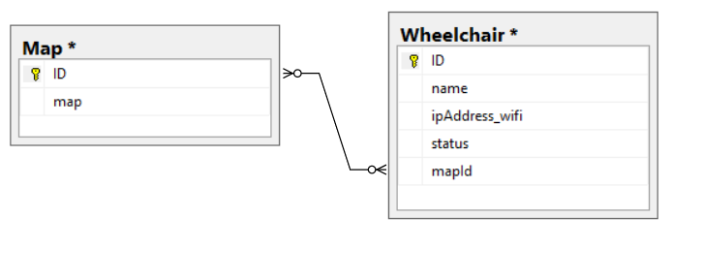

# IV. **MATERIALS AND METHODS**

## 1**. Technology Wifi**

Wi-Fi is uses radio waves for high-speed data transfer over short distances without the need for a wire connection. Wi-Fi works by breaking a signal into pieces and transmitting those fragments over multiple radio frequencies. This technique enables the signal to be transmitted at a lower power per frequency and also allows multiple devices to use the same Wi-Fi transmitter.

## **2. Wifi tobologies**

The WiFi topology is a standard star configuration, shown as picture below. A single base service set is employed with one base station (access point) and multiple end devices. This topology is based on a centralised access point, which controls the membership and access to the network The access point also acts as gateway to any external network

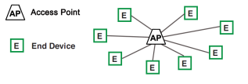

## **3. Design Hardware**

**Hardware**: The hardware portion consists of the following principle parts:

* Arduino UNO: Arduino is an open-source prototyping platform based on easy-to-use hardware and software. Arduino consists of both a physical programmable circuit board and a piece of software, or IDE (Integrated Development Environment) that runs on user's computer, used to write and upload computer code to the physical board.

The Arduino Uno microcontroller board(Fig.3) is based on the ATmega328P. It has 14 digital input/output pins (of which 6 can be used as PWM outputs), 6 analog inputs, a 16 MHz quartz crystal, a USB connection, a power jack, an ICSP header and a reset button. It contains everything needed to support the microcontroller. It can be powered by simply connecting to a computer with a USB cable or with a AC-to-DC adapter or battery to get started.

We have used Arduino because it is an open source device which can be programmed through any operating system like Windows, Mac, Linux, etc. The language used is understandable and easy. Changing of program is also very easy. Various shields and modules that are easily connected to Arduino are available for various purpose like, if we want to connect the Arduino to a network then a Wi-Fi shield is available. For controlling the motor a motor shield is available, and for this project a wifi shile is used.

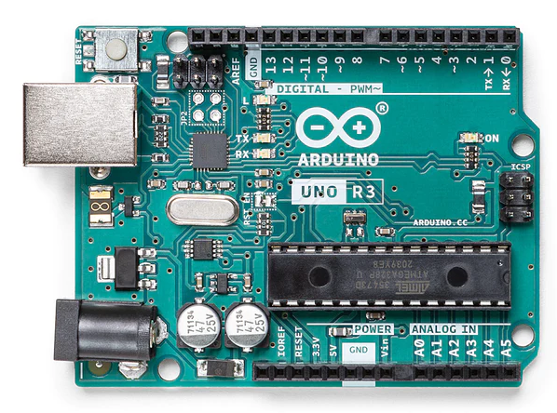

* Cytron Wifi Shield ESP8266
* CC-SMART CCS_SHB12 motor driver

The CCS_SHB12 is a motor driver that allows to control a DC motor about the Velocity, Direction... The Motor is controlled by MOSFETs with 16 Khz switching to optimum performance and noise. 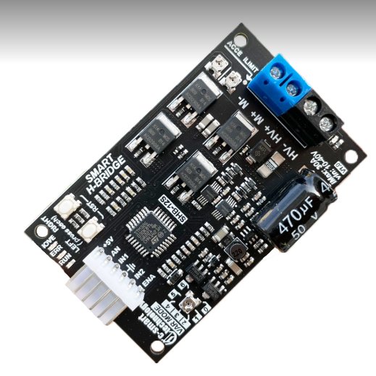

* Motor MY1016z

the motors used are permanent magnets dc motors with gear boxes. Gears reduce the speed of the vehicle but increase its torque. This is called gear reduction. The gear ratio of the engine used is 9,78:1 and runs from 200 to 300 RPM. The setting cluster increases torque and reduces engine speed

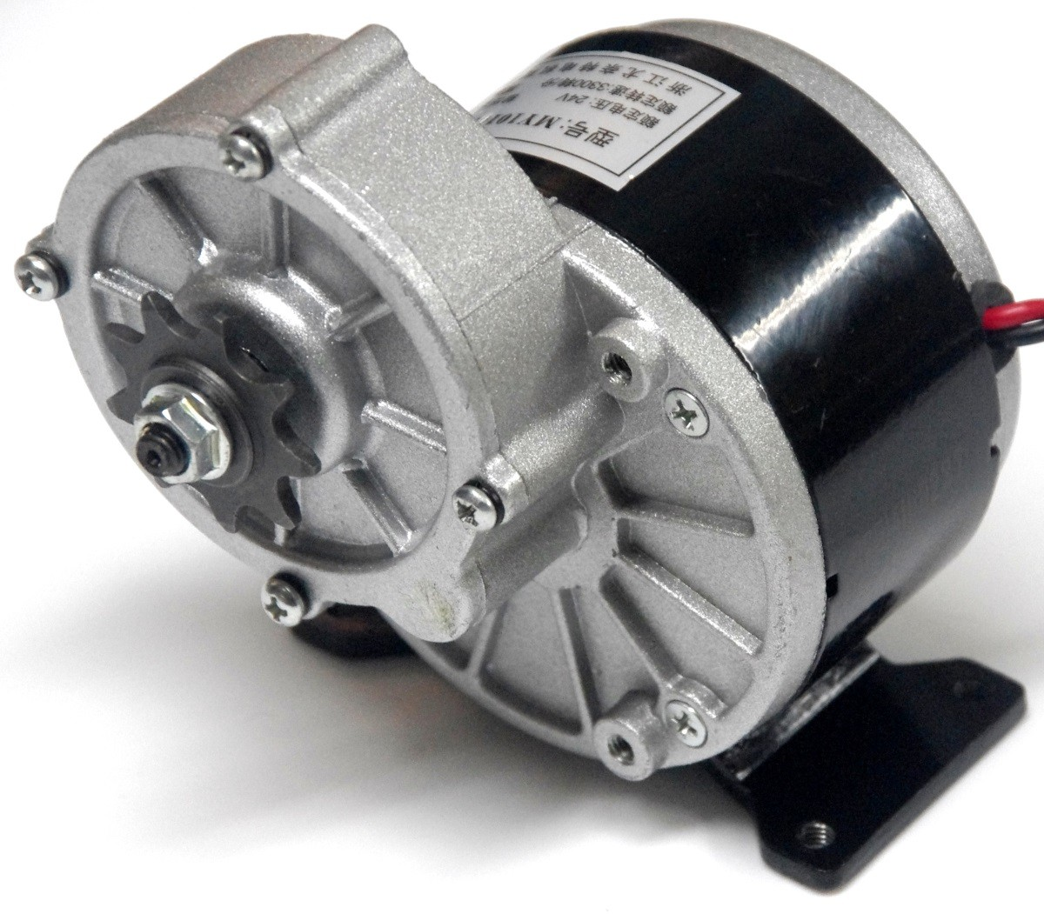

## **4. System Architecture**

#### **1.1.1.** **Design Constraints**

This system should be compiled with following items:

• Network:

* Data transmission over the Internet

• Performance & Reliability:

* The system should process video continuously in real-time and output rate at least one frame per second
* The system should be able to work with multitasking, multithreading to prevent deadlock.

#### **1.1.2. Overall Architecture**

#### **1.1.3. Mobile Application Architecture**

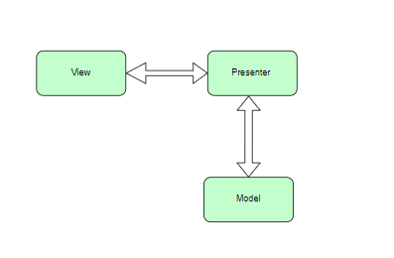

Here, View is the component that the user can directly interact with, send requests. Then Presenter will receive user input through View, process the data with the help of Model. Presenter and View communicate with each other through interfaces. Model is the component that manages the entire database of the application. The Model also contains classes that describe the business logic and define business rules for the data (how the data will be changed and used).

#### **1.1.4. hardwware Architecture**

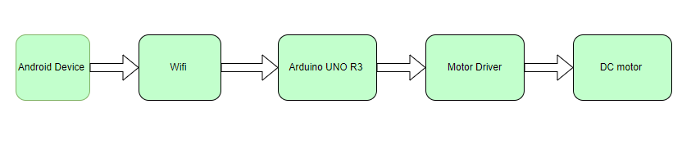

Here, the whole system is divided into five principal blocks viz android device block, wifi block, microcontroller block, the motor driver block And DC motor . The wifi block comprises of the wifi module present in the mobile phone used along with the wifi shile used in our the wheelchair AUTOW. The mobile phone consists of an application that provides us an interface to send characters via wifi which is then received by the wifi shile on the wheelchair AUTOW. The microcontroller then receives the data from the wifi shile and then manipulates the data received into series of digital outputs which run the motor driver section. Two BO motors which run at 330 RPM are used.

# IV. SOFTWARE TESTING DOCUMENTATION

## **1. Overall Description**

### 1.1.Test model

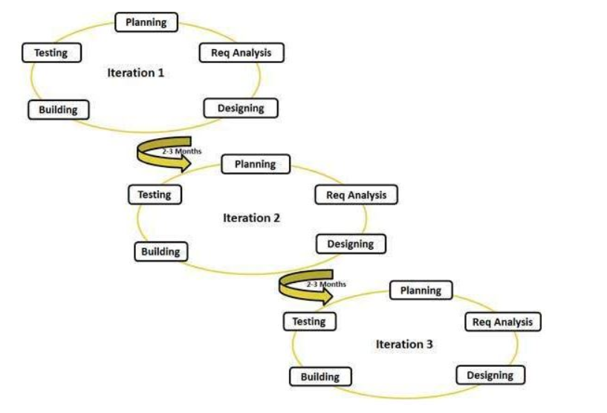

In the planning stage, we apply Agile testing for many purposes.

- Agile testing allows testing to occur concurrently with development activities in iterative releases. As a result, it can quickly adapt to changing requirements.

- Complex issues will be avoided or resolved efficiently as a result of the ability of Agile testing that can make the team collaborate and communicate consistently across team members

### 1.2. Testing Levels

* **Unit testing**

- This is the first stage in software testing

- Helps decouple each part to test and demonstrate that components correctly fulfill the functional requirements in the specification.

- Unit testing is within the scope of White Box Testing

- This level of software testing is usually in charge of the developer to make sure the code they write is correct with the requirements

* **Integration testing**
* This is testing the interaction between the functions in the system and is performed by the Tester
* **System testing**
* This is a test of a finished, fully functionalized system to check that the software system fully meets the functional requirements according to the software requirements specification (SRS). are not.
* The person who performs this level of testing is usually a Tester.
* **Acceptance testing**
* This is the final step in software testing, checking if the system is meeting the needs and expectations of the customer.
* Acceptance testers are usually testing users or clients.

### 1.3. Test type

* Function testing:
* Perform individually testing to verify the functionalities of major features under specific conditions.
* The detailed descriptions of each test case will be described in
* User interface testing :
* Perform testing on UI controls to verify if they work properly according to their desired functionalities.
* Further descriptions of each test case will be described in

## **Test Plan**

### 2.1 Test Stages

|  |  |  |  |  |
| --- | --- | --- | --- | --- |
| **Type of Test** | **Stage of Test** | | | |
| **Unit** | **Integration** | **System** | **Acceptance** |
| Function testing | X | X | X | X |
| User Interface testing |  | X | X | X |

### 2.2 Resources

|  |  |  |
| --- | --- | --- |
| **Worker/Doer** | **Role** | **Specific Responsibilities/Comments** |
| HoangNT | Dev, Tester | Planning, verifying test deliverables  Unit test, integration test, system test |
| LinhNTT | Dev, Tester | Unit test, integration test, system test |
| CuongNV | Dev, Tester | Unit test, integration test, system test |
| TrungDD | Dev, Tester | Unit test, integration test, system test |

### 2.3 Test Milestones

|  |  |  |  |
| --- | --- | --- | --- |
| **Milestone Task** | **Effort (md)** | **Start Date** | **End Date** |
| **Iteration 1: Test planning for**  **wheelchair AUTOW** | 9 | 28/10/2022 | 5/11/2022 |
| Create test plan | 2 | 28/10/2022 | 29/10/2022 |
| Review test plan | 1 | 30/10/2022 | 30/10/2022 |
| Create unit test | 3 | 31/10/2022 | 2/11/2022 |
| Create test case | 3 | 3/11/2022 | 5/11/2022 |
| **Iteration 2: Test planning for mobile application** | 9 | 6/11/2022 | 14/11/2022 |
| Create test plan | 2 | 6/11/2022 | 7/11/2022 |
| Review test plan | 1 | 8/11/2022 | 8/11/2022 |
| Create unit test | 3 | 9/11/2022 | 11/11/2022 |
| Create test case | 3 | 12/11/2022 | 14/11/2022 |
| **Iteration 3: Execute tests for mobile**  **application and wheelchair AUTOW** | 16 | 15/11/2022 | 30/11/2022 |
| Execute test for mobile application | 3 | 15/11/2022 | 17/11/2022 |
| Execute test for wheelchair AUTOW | 7 | 18/11/2022 | 24/11/2022 |
| System test | 4 | 25/11/2022 | 28/11/2022 |
| Acceptance test | 1 | 29/11/2022 | 29/11/2022 |
| Write final report | 1 | 30/11/2022 | 30/11/2022 |

## **Test case**

## **Test repport**

# V. RESULTS

# VI. DISCUSSION

# VII. **CONCLUSIONS**

Arduino is an open source device that has been the brains for many projects. The Arduino has everything the user asked for, including inbuilt converters, vo pins, and more. With the combination of Arduino and wifi Shield, we can control many other things, through our mobile phones. While working on this Project, we learned a lot about Arduino and how it makes it easier for us to convert digital signals into physical movements. Another advantage of Arduino is that once the program is written, we don't need to worry about the program being deleted as long as it is not RESET. Arduino has also surpassed all other microcontrollers because of its efficiency and user-friendly character.

# VIII. **REFERENCES**

<http://www.arduino.cc/>