CW1
(1) Introduction
This report shows the analysis the comprehensive analysis of the infected Cobalt Strike attack system based on the pcap file (traffic logs). The goal is to identify the infected system and how it is being attacked.
Section (2) talks about what tools have been used for the intrusion analysis.
Section (3) describe
Section (4) summarize the whole analysis.
Section (5) shows the reference materials.
(2) Methodology
To reconstruct the sequence of events, I need to know the what, who, when, what, how.

The pcap file contains all the transaction logs. The Wireshark software is capable of finding every detail information about every packets in the infected system by “Follow TCP stream”, or by filtering in the display searching field, or by finding the statistics data.

Before diving into the details, “Zui” software is used to get a general idea of what is happening (it summarize the activities) and how it is happening. To trace how the system got infected, I filtered the alert events. (As shown in Fig1, searching : event_type=="alert" | fuse | sort ts).
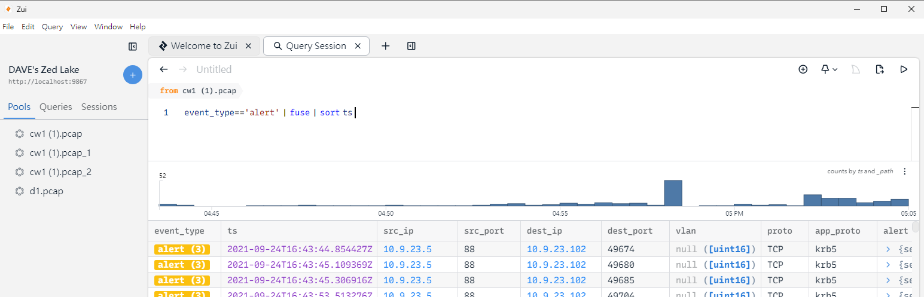
Fig1
As such, in order to view detail information (e.g. MAC address, hostname, domain), click the "Wireshark" button in Zui, and then switch between Zui and Wireshark.

Then, to indicate the infection, I use “VirusTotal” website to check whether IP or URL is malicious. (As Fig 2 below)
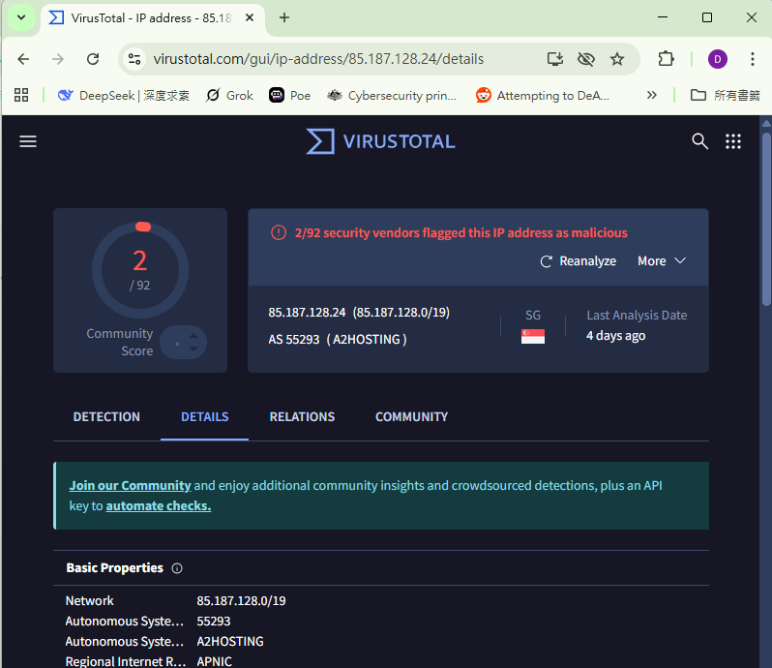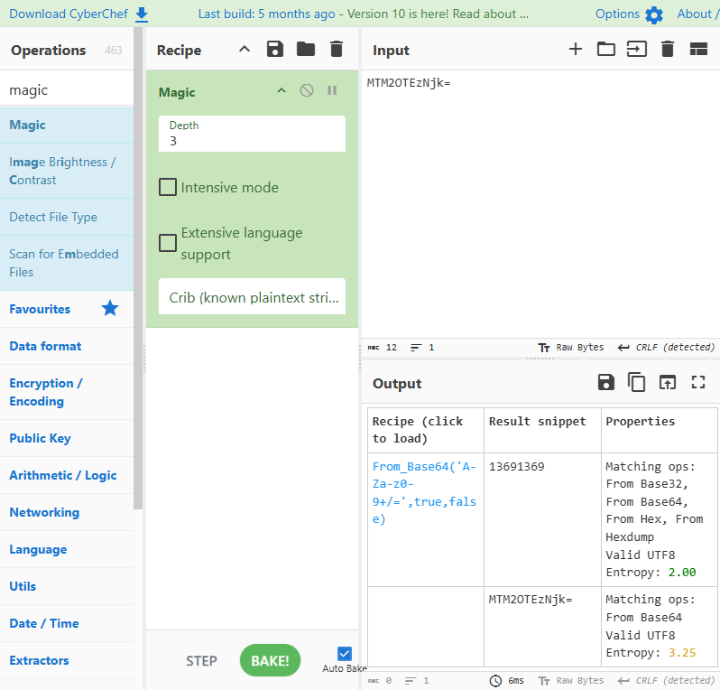
Fig 2 Fig3
Other tools like CyberChef is used to check the information hidden in the “garbled text”. (As Fig3 above)
Windows Terminal is used to check the name of the file located inside the compressed file (As quiz1 question 4).

(3) Results
As using ZUI to filter the alert events, it is found that the IP:10.9.23.102 (the victim) have go to the malicious website and downloaded the malicious file

The roles of this Cobalt Strike attack is as follow:
C2 Server : 185.125.204.174 (Cobalt strike C2), 185.106.96.158(Cobalt
strike C2), 281.91.128.6 (loader C2)
Victim : 10.9.23.102
Spy : 185.125.204.174, 136.232.34.70
Qbot : 85.187.128.24 (Q3)
Zombie : 10.9.23.102
Staging Server : 208.91.128.6
Redirector :

In the initial access state, the initial malicious HTTP connection occur
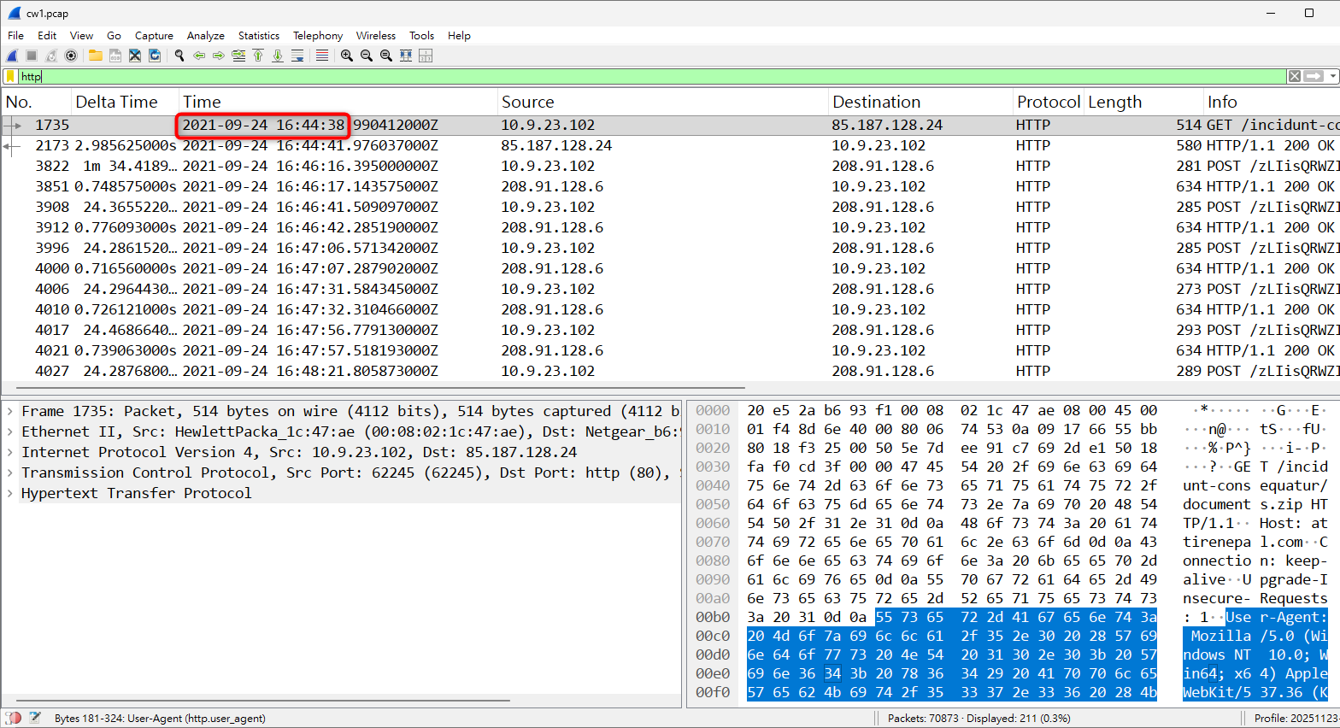
Fig SO_CW1_Q1
(4) Conclusion

(5) References

