**REPORT**

VIETNAM NATIONAL UNIVERSITY

INTERNATIONAL UNIVERSITY – HCM IU

SCHOOL OF BUSINESS

**THE JOURNEY**

**Members:**

* Uong Dinh Chien – ITITIU19008
* Nguyen Van Danh – ITITIU19094
* Tran Nguyen Hoang Hai – ITITIU19115

**CONTENTS**

**Chapter 1. Describe topic**

1.1. Introduction

1.2. Range of research

1.3. Content

1.4. Feature list

1.4.1. Check the finishing.

1.4.2. Control with keyboard

1.4.3. Replay

1.4.4 Create objects

1.5. Target user

**Chapter 2. Screen Flow**

**Chapter 3. Technologies**

**Chapter 4. Class Diagram**

**Chapter 5. Conclude**

**Chapter 6. List of source and appendix**

1. Source Code

2. Contribution

**Chapter 1. Describe Topic**

**1.1 Introduction**

>Instead of play games with good graphics or complicated features, many people nowadays have an interested in game with simple graphics and easy mechanism. Some of them that can call out is Flappy Bird, Among Us or Fall Guy. So in this project, we want to re-create a game which is a minigame of Stardew Valley, the very popular game with pixel graphic,

**1.2 Range of Research**

>Use Eclipse to create an application running on Window PC, with many advantages like the speed of processing data, guaranteed the information's protected and can running in many different versions of Window.

**1.3 Contents**

>Create a game with easy-to-watch graphics, bring back the old memory of user with cowboy content combined with fiction things is monsters. This game also provided many good features to please the player with comfortable.

**1.4 Features list**

1.4.1. Check the finishing.

1.4.2. Control with keyboard

1.4.3. Replay

1.4.4 Create objects

**1.5 Target Users**

>Students, children who has an interested in the shooting game with simple graphic but high difficulty.

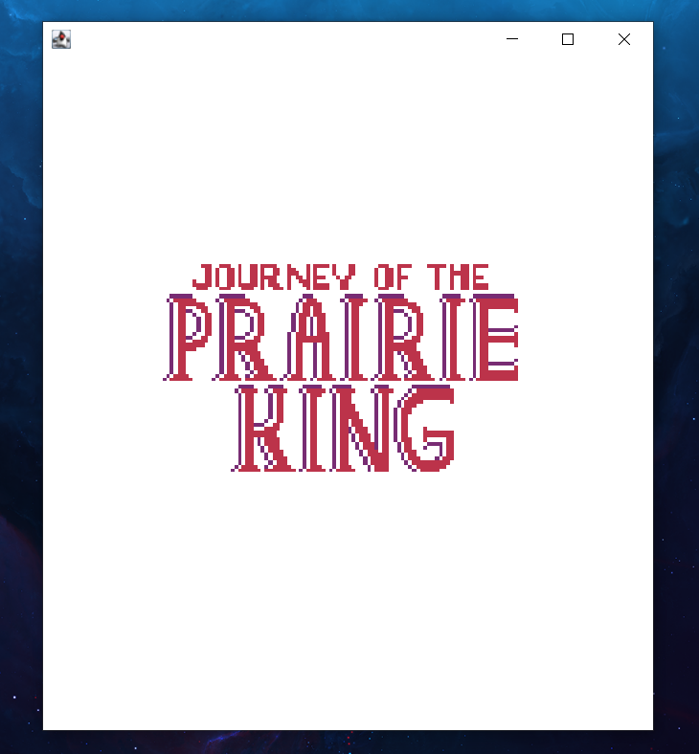**Chapter 2. Screen Flow**

>This is the beginning screen with the full game name.

>Press Enter will make the game start right away.

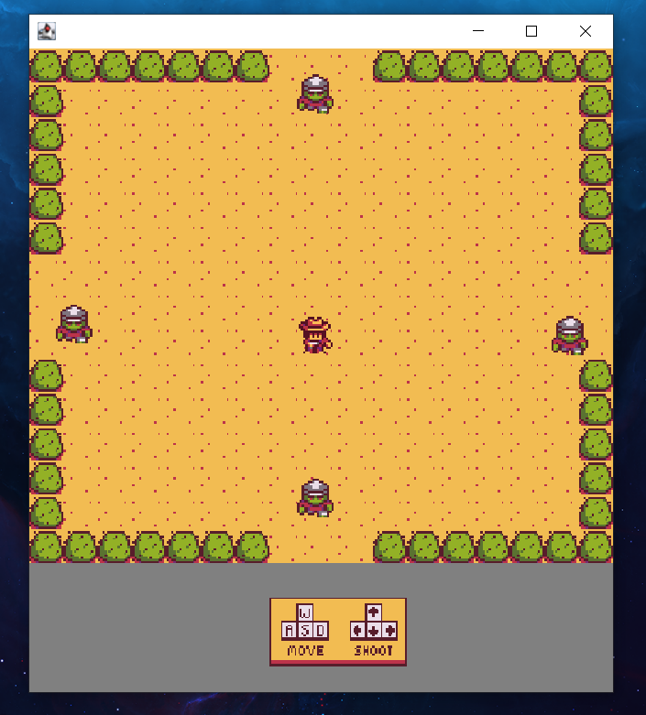

>The player is the one with the cowboy hat in the middle, four other objects is monster. The bush is the wall that cannot go through.

>The game has a mini instruction below the game screen, which provide the input key to control character or make character shoot bullets.

>The monster will chase the player until they die. Once it touches the player, the game will end.

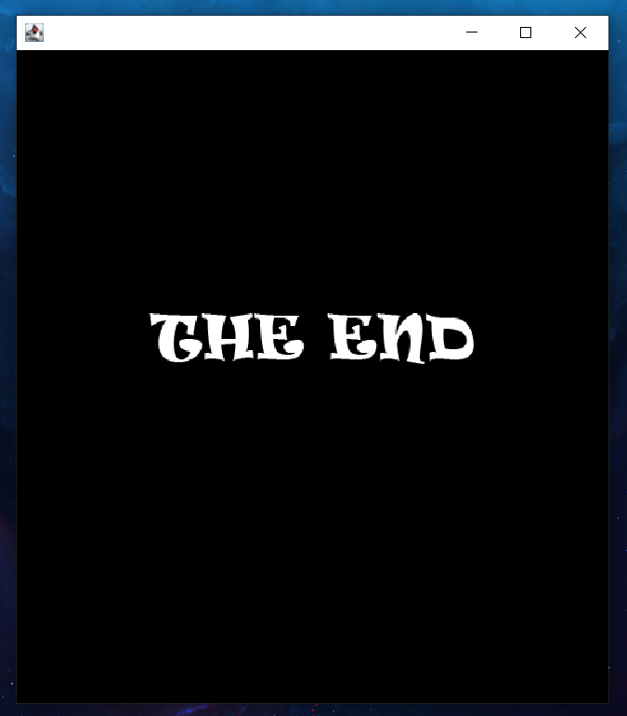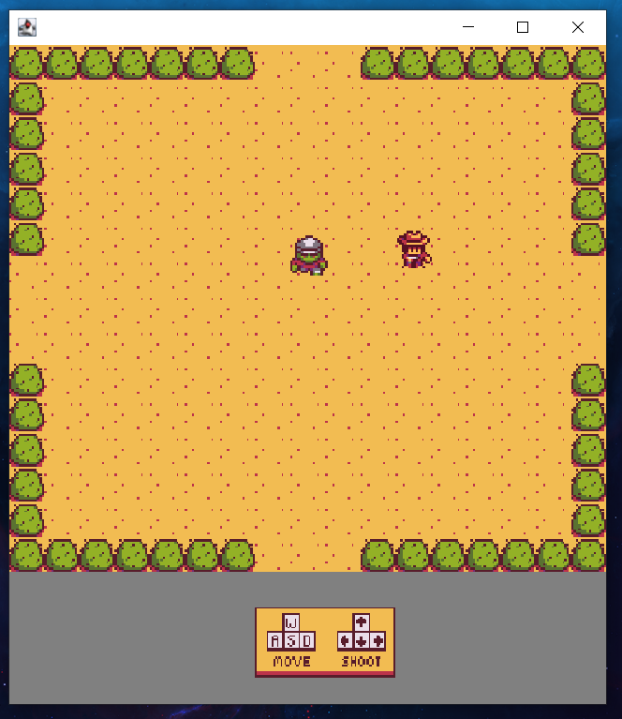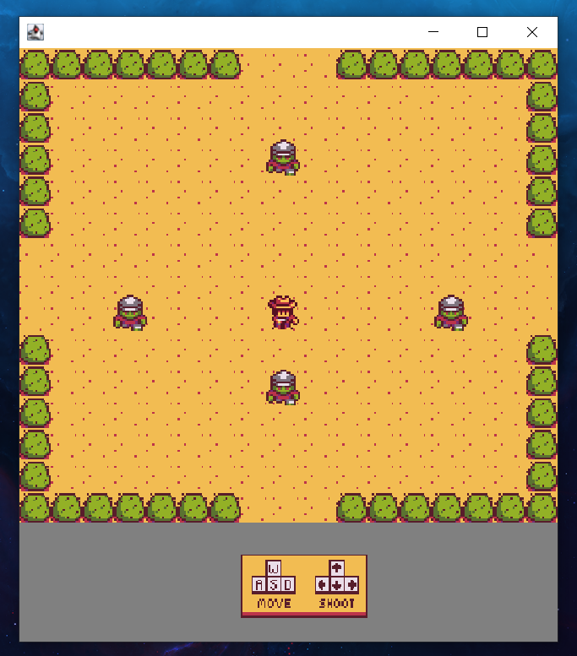

>If player manage to kill all four monsters, the new level will increase and spawn four new monster with faster speed.

>The level will be infinite, so does the difficult. Try your best!

**Chapter 3. Technologies**

**The main classes:**

> GamePanel: Create the display. Update frames continuity.

>InputManager: Control with keyboard.

>GameWorld: Draw objects, handle the children classes.

>ParticularObjectManager: Save and remove data.

>CacheDataLoader: Load data.

>ParticularObject: Hold the variables.

**Chapter 4. Class Diagram**

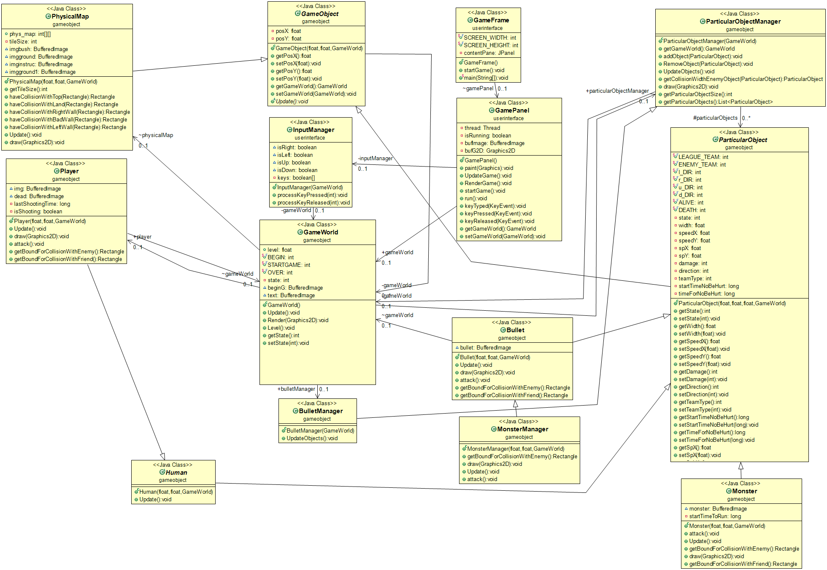

**Chapter 5. Conclude**

**Achievements:**

>Create player, monsters and bullet classes

>Control player and shooting bullets.

>Collision with walls, enemies, bullets and player.

>AI for enemies.

>Replay the game.

**Achievements not yet achieved:**

>The game was not too smooth, still has lag sometimes.

>Hitbox still not completed.

>The collision between enemies.

>Diagonal bullets line has not completed.

>The lack of animation.

**Future features:**

**>**New map.  
>New round.  
>New mode.  
>Create bosses.  
>Create buffs.  
>Add sound.  
>Add pause feature.

**Chapter 6. List of source and appendix**

6.1 Source code:

We learn how to code with this website:

<https://tuhoclaptrinh.cachhoc.net/2017/02/26/bai-mo-dau-lap-trinh-game-di-canh-megaman-tren-java/>

6.2 Contribution

|  |  |
| --- | --- |
| **Name** | **Contribution** |
| Uong Dinh Chien | * Fix bug * Player * Input Manager * Class Diagram |
| Nguyen Van Danh | * Slides * Game Panel * Collision * Physical map |
| Tran Nguyen Hoang Hai | * Report * Presentation * Bullet * Monster |