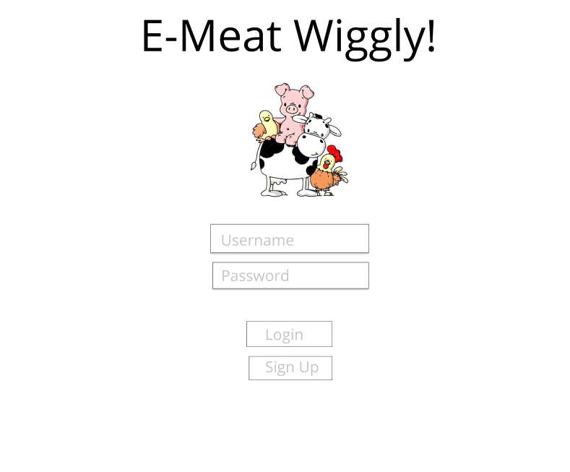 **User Interface Design**

**Figure 2 : Log-in Page**

This page provides the distinction between meat dealers and farmers.

User access to the website by entering their username and password before using the website.

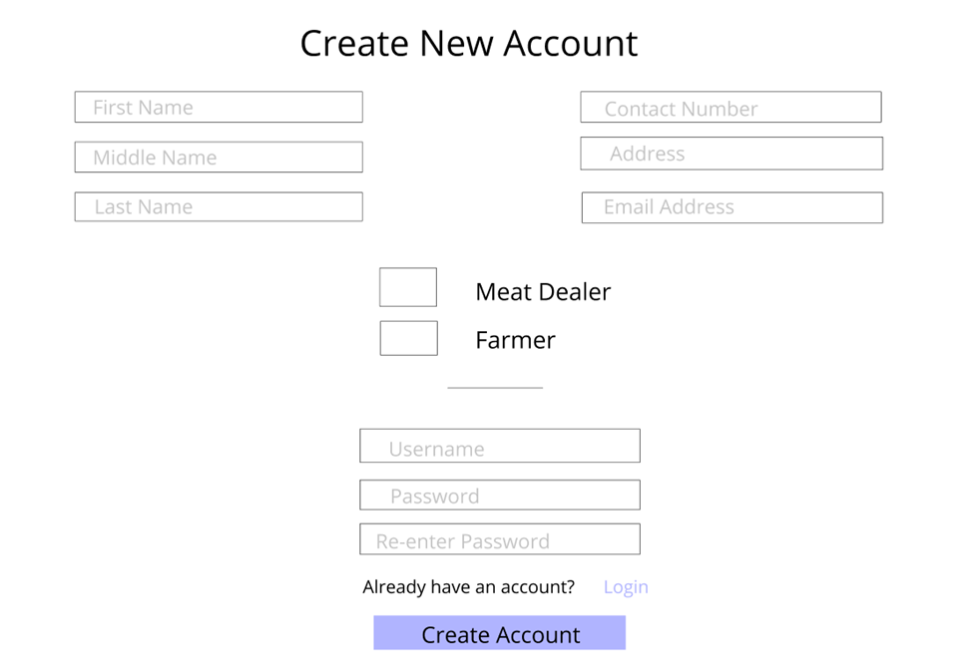

**Figure 3 : Registration**

This page is where the Meat Dealers register before using the system. The system can only be registered by its owners.

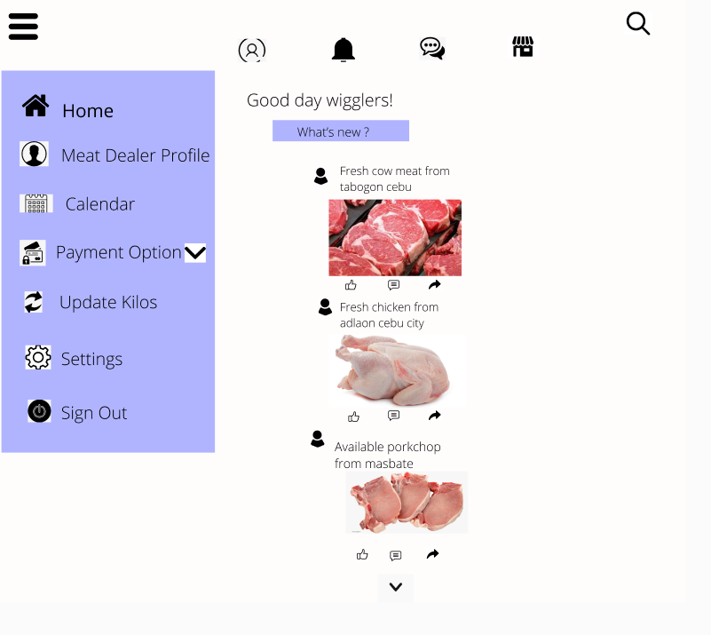

**Figure 4: Homepage**

This page serves as the website's starting – point of a Meat Dealer. It includes a News Feed from various sources, as well as a list of posts from your business partners and farmers that is constantly updated. Interacting to the left side when you click it will directly to the appropriated page.

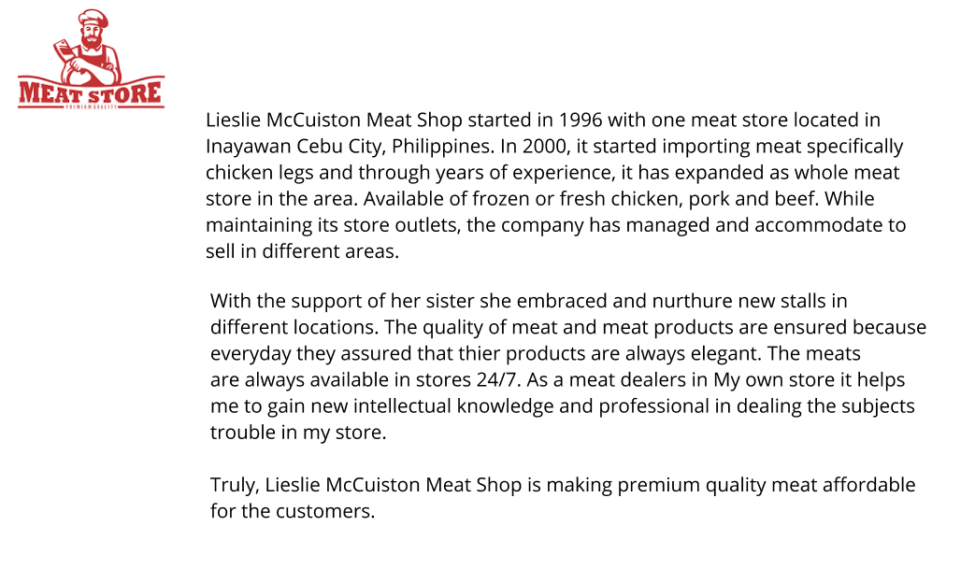

**Figure 5: Meat Dealers Profile**

This page shows that it gives a general idea of what a business is about. How they started and what products would they offer. A list of all the elements that make up a business. It's a brief summary that conveys key information.

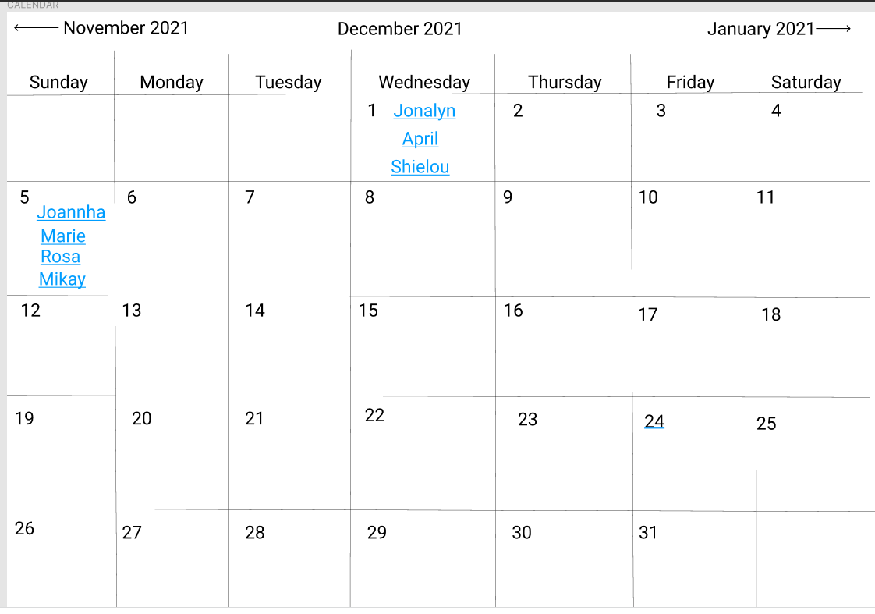

**Figure 6: Calendars**

Both users have the option to check availability and make bookings for certain days or times. The most important phase of a system. It can assist you in maintaining to a strict schedule.

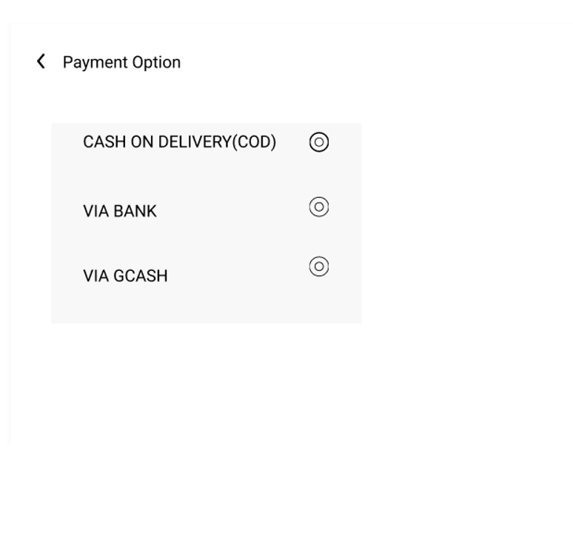

**Figure 7: Payment Option**

Dealers chose what payments should take for. Payment Option is crucial for farmers to minimizes bookkeeping. One of the most convenient payment methods for animal farmers is to transfer funds from the bank account of meat dealers. Cash on Delivery is where the Meat Dealers pay indirect to the farmers. Bank Account and GCash, money can directly put the specific account of the Farmers.

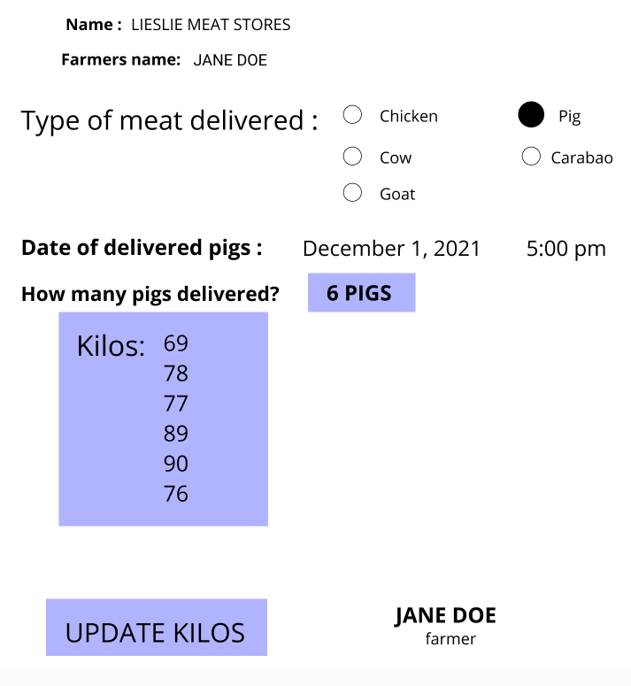

**Figure 8: Update Kilos**

This page is where the meat dealers inputted the kilos of the Pigs that delivered recently. It has the specific date, time, animal farmers name & what kind of meat that they delivered for. Putting kilos in the system can less hassle for the farmers to go the stores.



**Figure 10: Registration Farmers**

This page is where farmers can register their own account. It has a list of fields that the farmers can input their data in registration form.

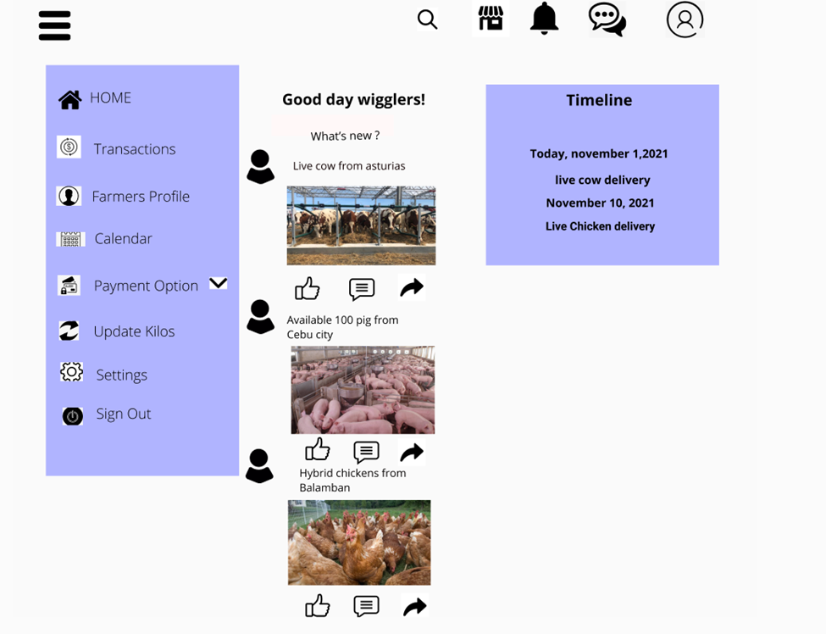

**Figure 10: Homepage Animal Farmers**

This page is only for the Animal Farmers. Frequently the first impression users receive of your website, as well as the first chance of how you might help them. Navigating right side is the Timeline, to remind the farmers before the said scheduled. Farmers can post different various of animals of their own account. The above icons are first is the Notification; it sets as a reminder that before the scheduled it will appear and to remind. The message icon is to have a private conversation and what are the agreement of both of them. Marketplace, they can sell their animals from different dealers.

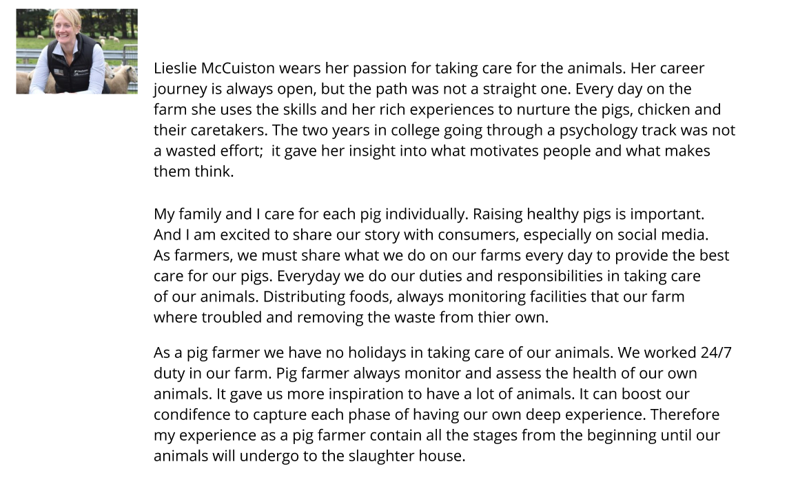

**Figure 11: Farmers Profile**

This page is the Farmers profile. Farmers can share their knowledge doing the animals. They are the key endeavors of their own business. They can inspire people of how hardworking they are. They have adequately presented their work, experiences, responsibility and passion.

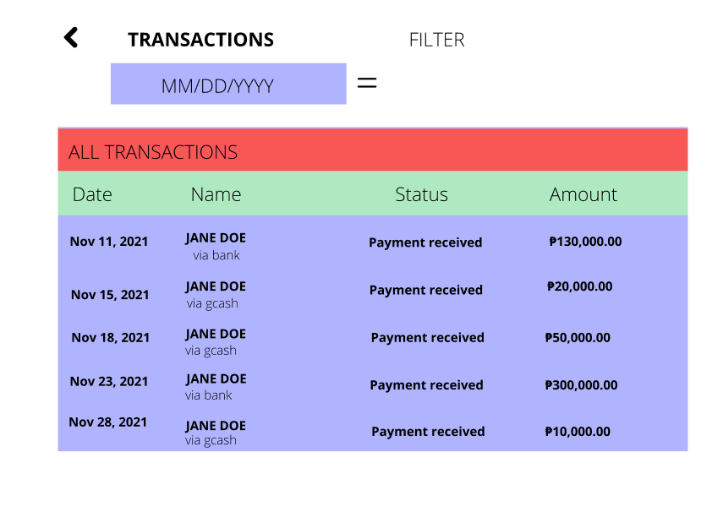

**Figure 12: Transactions**

This page of a website serves a collecting of all the transactions & how much money they receive every month. Farmers can only view transaction as their recorded entry. This page saves into the database the details of transactions used for creation of the reports.



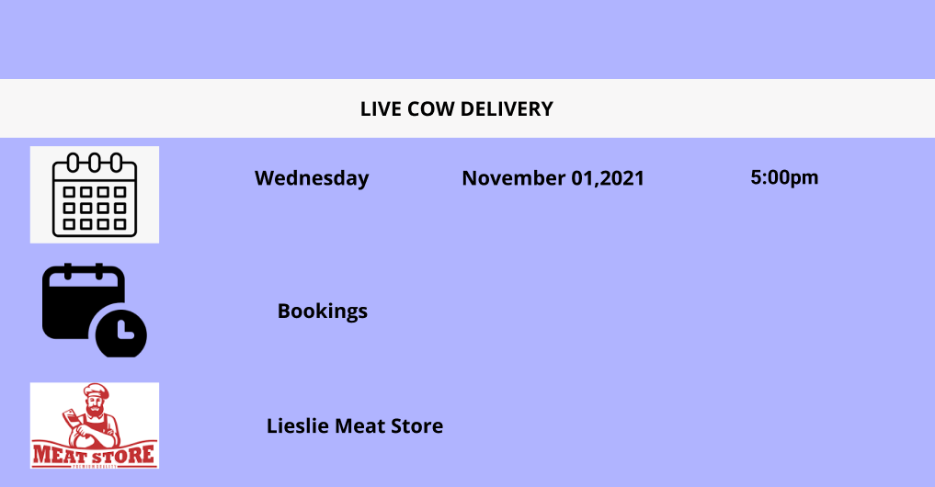

**Figure 13: Calendars**

This page shows that you need to check the availability of booking of your animals. It has the specific names as well as the days. By clicking each one of the names listed it shows that what animals should be book, what date and time, and what store they want to gave the animals. Crucial to check from time to time of the calendars.

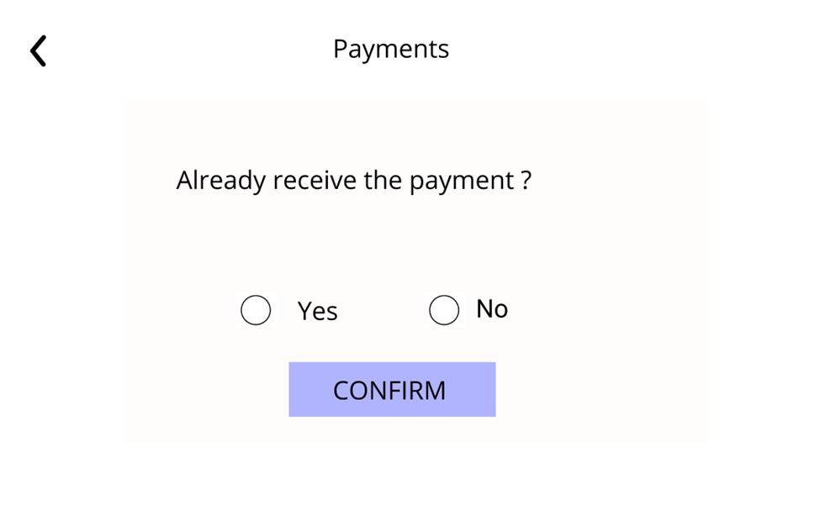

**Figure 15: Payments**

This page is to ask the Farmers if they already received the electronic payments of their Meat Dealers.

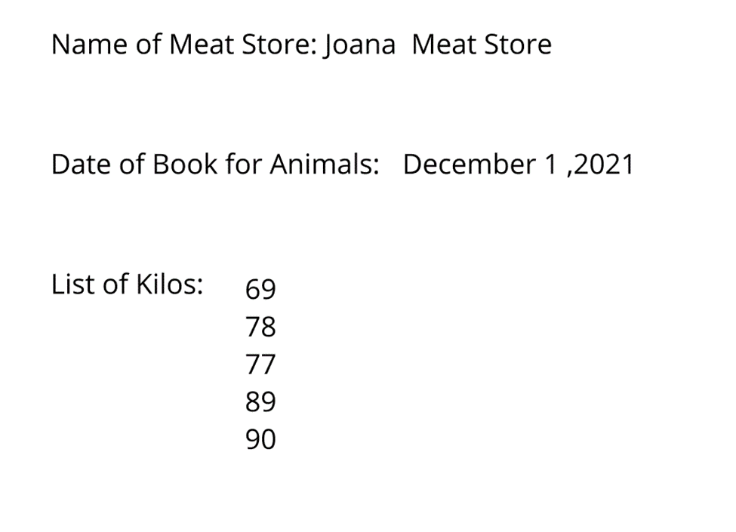

**Figure 16: Kilos**

This page is where the Farmers can view their current kilos they book. It has the specific names of the stores. Easily to find and less hassle.

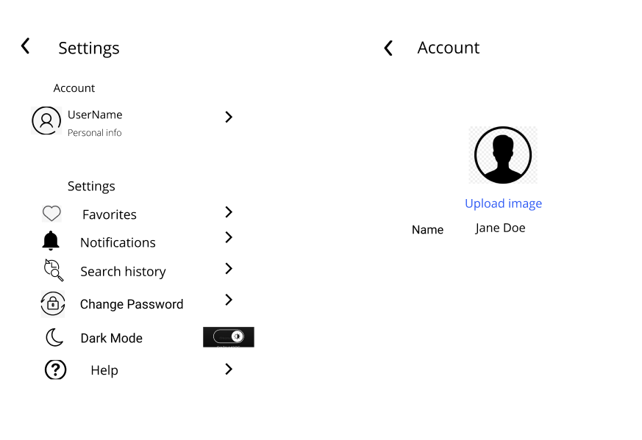

**Figure 17: Settings**

This page is where users can add their profile picture. They can adjust in a software program. It is a section of the device that offers you access to all of the device's preferences.

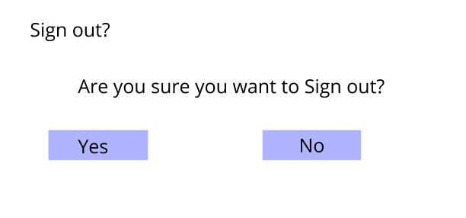

**Figure 18: Sign Out**

This page is where other users will be unable to access the system without first verifying their credentials. It also aids in the protection of the current user's access and the prevention of unauthorized acts during the current login session, making it a crucial aspect of security.

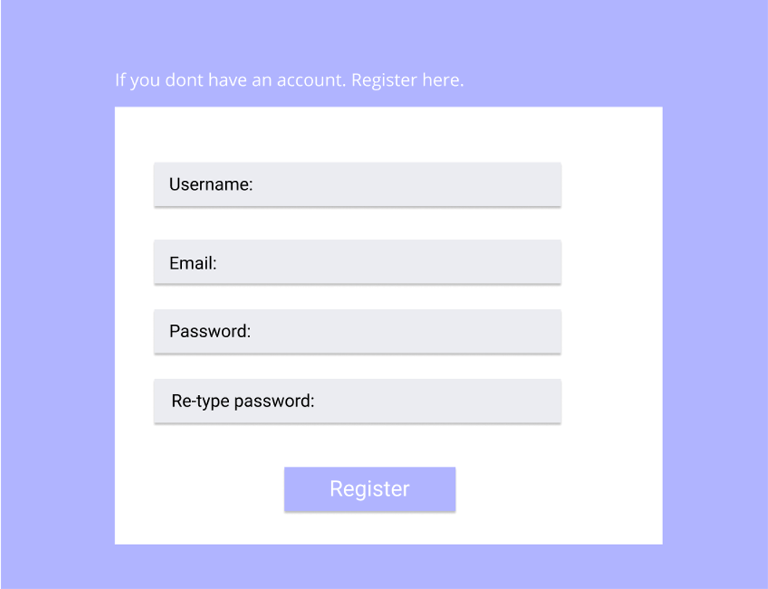

Figure 19: Registration for Admin

This phase is where the Admin want to register his/her account. It is the first step where the information needed.

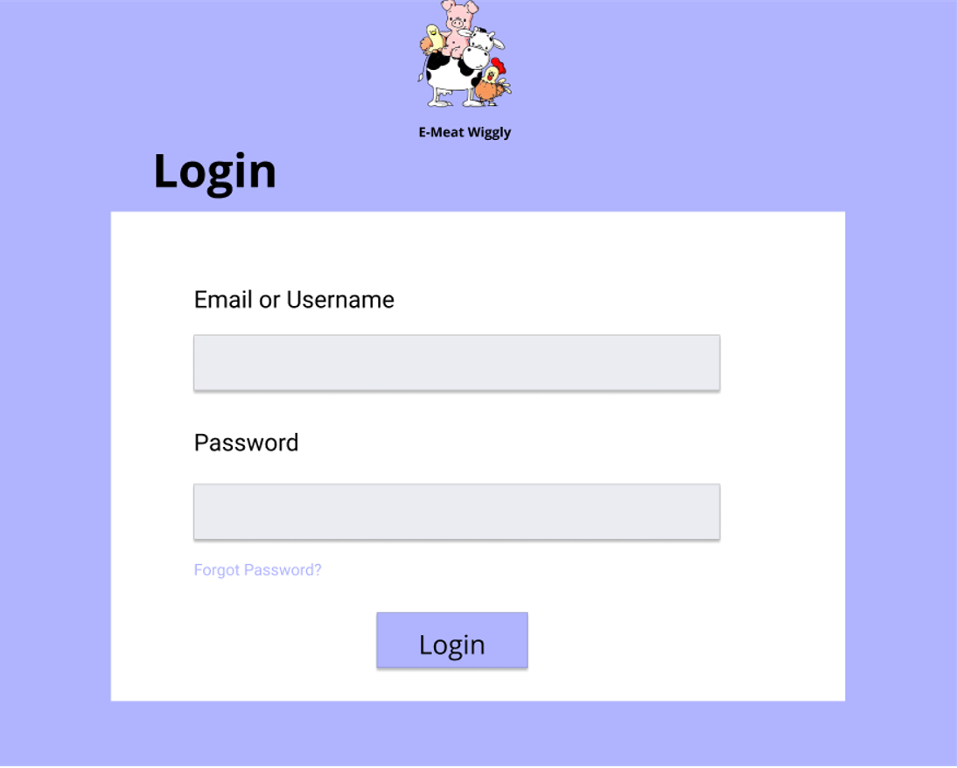

**Figure: 20 Login for Admin**

**This page is where the Admin need to login his/her account. It has username and password. If the Admin cannot remember his/her password he/she will click the forgot password.**

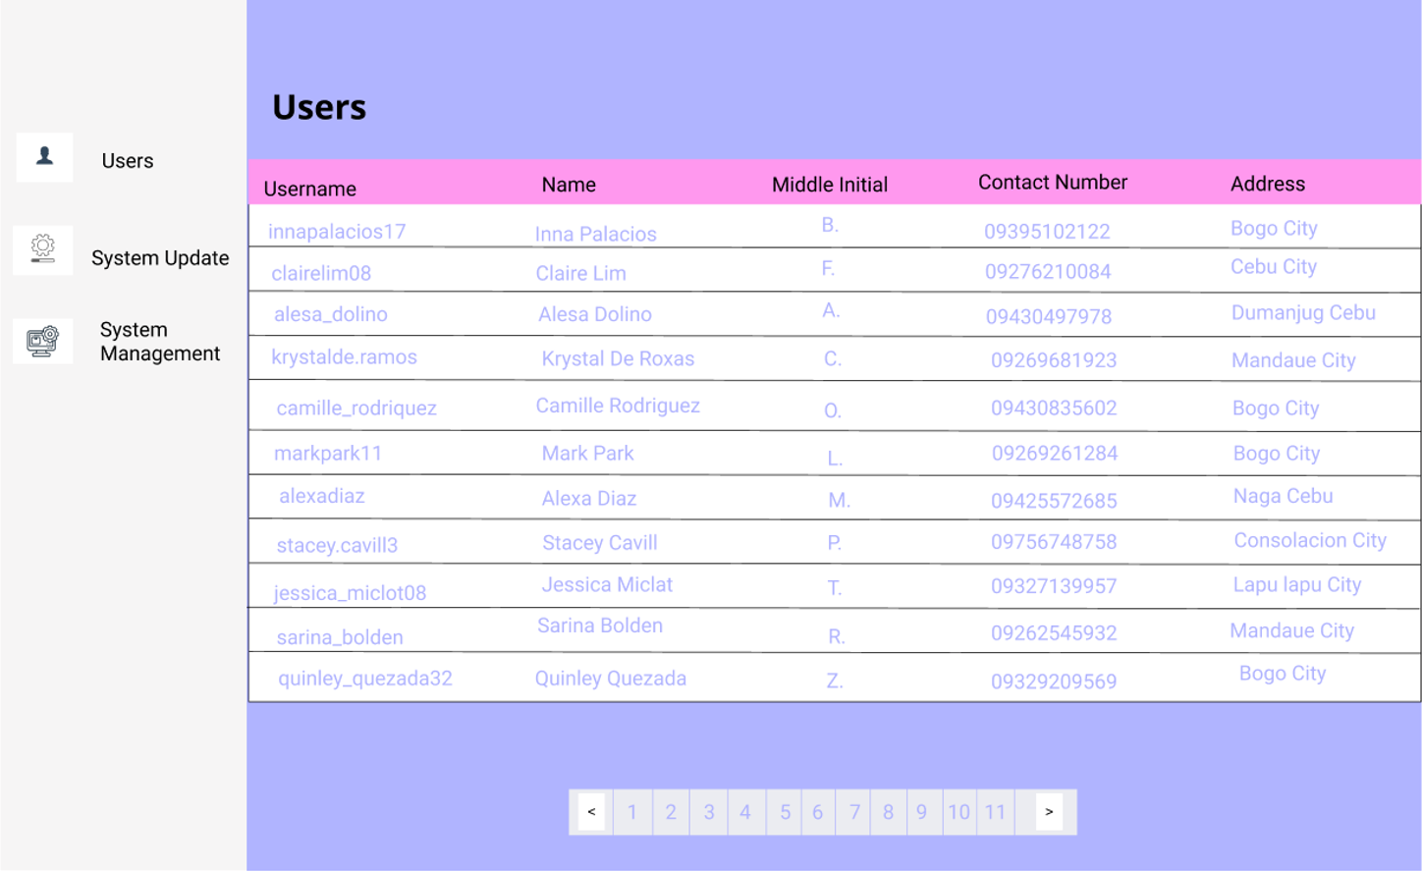

**Figure 21: View Users**

**The Admin can view all the users in the system. Including that the account of the users will be confirm, delete and update.**

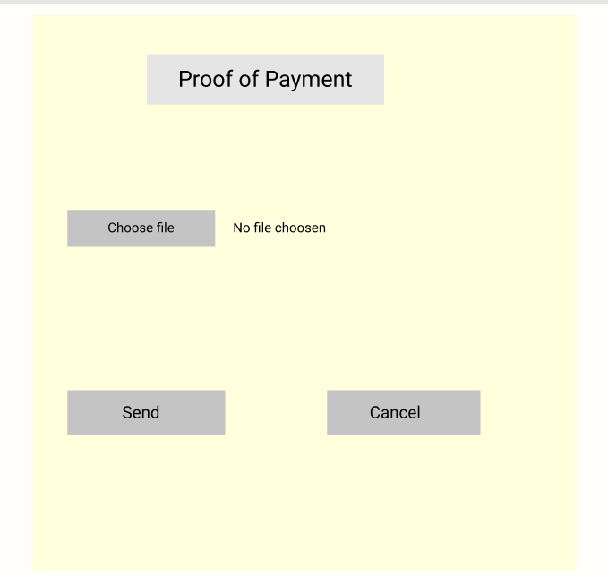

**Figure 22: Upload proof of Payment(subscription fee)**

**This phase is where the Meat Dealers and Animal Farmers upload proof of payment in subscription fee. They send it to the Admin for verify if they paid or not.**

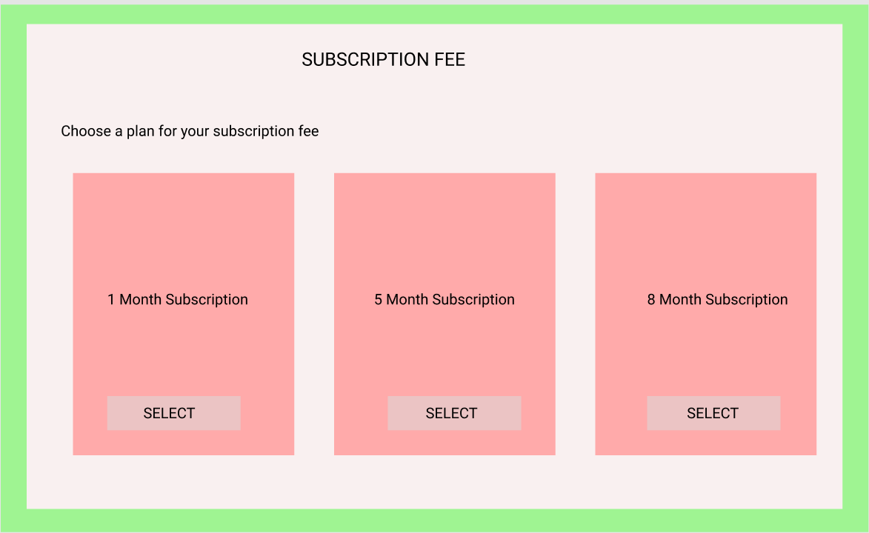

**Figure 23: User-Interface - Subscription page**

**This page is where the Meat dealers and Animal Farmers choose what month would they want to subscribe.**