In below screen adding platelets while search blood type by hospital
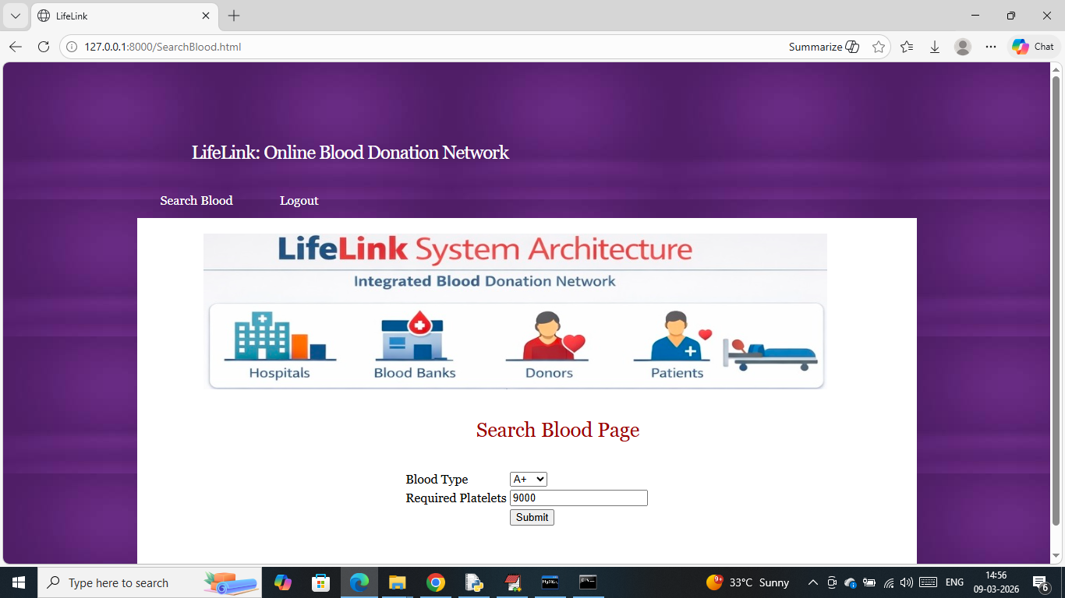
Now press button to get below page
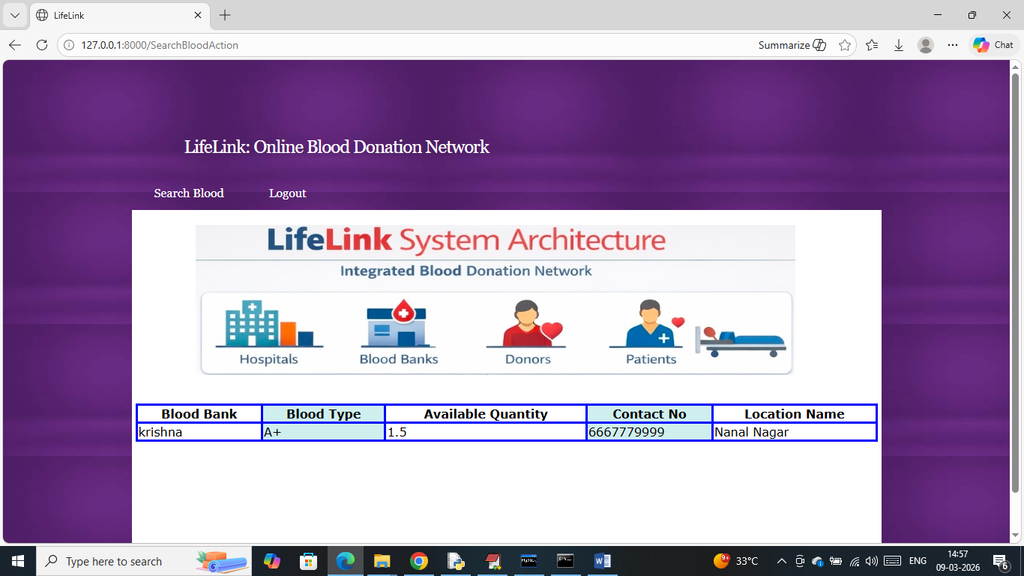
In above screen can get list of blood bank with available blood and in below screen can see email received by donor
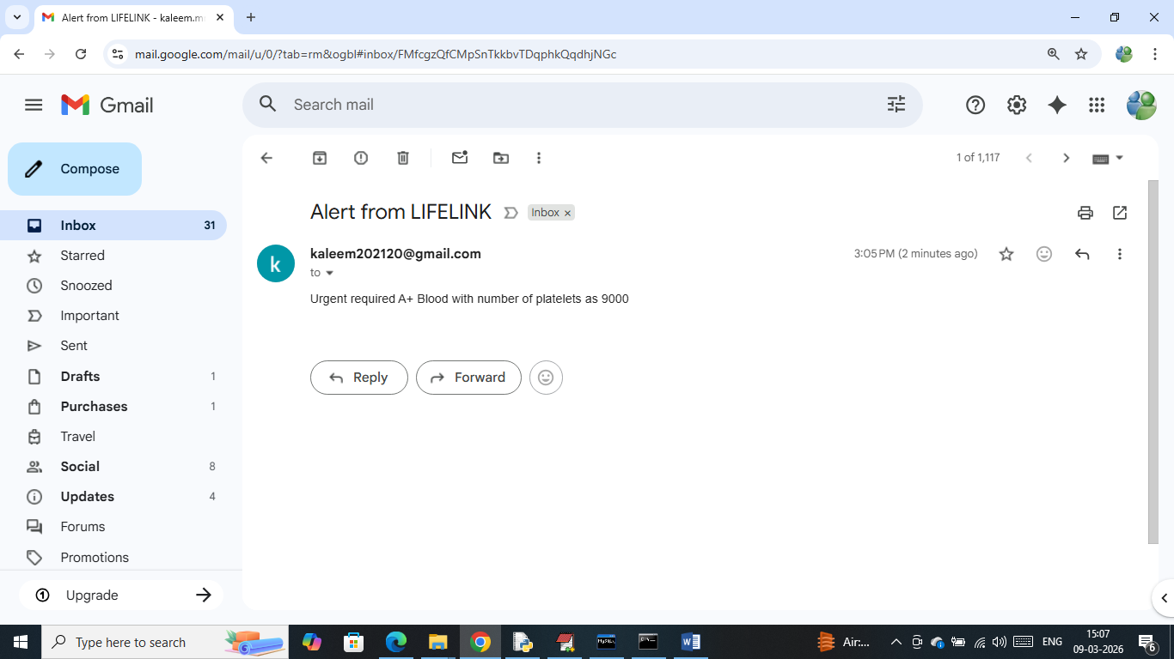
In above screen all donors will received above notifications.
So above are the platelets and email notification modification output

