

Produced and distributed by TLai Enterprises (Media Design Fonts)
http://www.tlai.com
tlai.enterprises@usa.net

AmarilloUSAF- Copyright (c) 1994, 1996, 1998 by Tom C. Lai All Rights Reserved.
Documentation Rev. 980904 - Release 013S-980904

table of contents:

What is Amarillo USAF?
How do I install this font?
How do I use this font?
Registering - How do I do it?
How do I get in touch with TLai Enterprises?
License and other legal information.

What is Amarillo USAF?

Amarillo USAF is an aircraft marking font that duplicates the lettering specification used for current US Air Force aircraft. You can find this style of lettering on US military aircraft dating back to WWII, on both Navy and Army/Air Force planes and helicopters. Some modelers have used it to add N-numbers to reproductions of civilian aircraft. With this font, you can create authentic decals for scale models, make vinyl lettering for movie and television props, and accurately reproduce markings on 3D modeled aircraft (all depending on your level of expertise.) Both Macintosh and PC versions are available. (This 30-day shareware trial version is offered in complete form. If you wish to keep it, please remember to pay your registration fee.)

How do I install this font?

(Win95/98, WinNT)

If you're installing the TrueType version, open up your Control Panel (Start > Settings > Control Panel) and then open up the Fonts folder. You can install by either selecting "Install New Font..." from the File menu, or by dragging the "amarurgt.ttf" file into the Fonts folder. After installing, you may have to restart your current applications for Amarillo USAF to appear. In some cases, you may have to restart Windows.

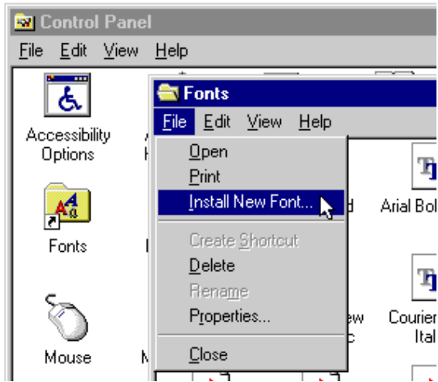

(Win3.1/3.1x)
you're trying to install under Windows 3.1, open up your Control Panel (Main > Control Panel) and then open up the Fonts icon. You can install by clicking the "Add" button.

If you're trying to install the Type 1 version, you must have Adobe Type Manager or an equivalent Postscript interpreter/rasterizer available. To install, please refer to the instructions that came with those utilities regarding installation and font-management.

If you are installing this font on a Chyron or SGI system, please refer to the documentation that came with your font converter/installer.

WARNING: Do not install both Type 1 and TrueType versions of the same font at the same time - this may produce unpredictable results. It is okay to mix Type 1 and TrueType, as long as you don't mix two versions of the same font.

How do I use this font?

Amarillo USAF comes in two formats: Type 1 Postscript, and TrueType. Both of these font formats are vector-based, meaning that you can scale your text to any size without suffering from "jaggies." This is important if you want output at different sizes to look the same.

Type 1 is usually preferred if you plan on outputting your work through a service bureau. If you're working at home, you'll need a Postscript-compatible printer or a software-based rasterizer, like Adobe Type Manager (ATM), or Ghostscript. If you don't have ATM, or choose not to use Postscript, you can use TrueType. TrueType, a different font format created by Apple Computer and Microsoft, is built into all modern versions of the MacOS, and handles rasterization of TrueType fonts at different sizes, just as ATM does with Type 1 fonts.

Once you've installed the format that you wish to use, you should be able to use it in any of your favorite word-processing, design layout, or image-manipulation programs, by selecting AmarilloUSAF-Regular from the font menu. You can scale it in a variety of different sizes, and depending on the features of the program you are using, change the color, spacing, and pitch (angle) of the font to fit your needs.

If you wish to make scale model decals, there is a very good collection of tips concerning types of printers, decal paper, and application techniques available in the rec.models.scale FAQ. A link to the FAQ is available at the USA IPMS site:

http://www.ipmsusa.org

The USA branch of the IPMS (International Plastic Modelers' Society) is also a great place to find out more about modeling in general. In addition to the link to tips and resources, the site also has links to IPMS chapters across the United States, and chapters internationally.

Registering - How do I do it?

Thank you for your choice to keep Amarillo USAF. We hope that you will continue to find this font useful, and suggest that you also take a look at LongBeach USN, a US Navy marking font. You can find more info at http://www.tlai.com.

To register this shareware trial version, follow the directions in the "To Register..." folder that was included in the archive.

· The cost of Amarillo USAF is $12 for a single user license.

· The cost of a network pack license is $50 for up to 5 users.
(A network pack license is required for installs on networked servers and printers.)

To embed the font as vector information in a game or other software, please contact us to arrange licensing.

More information is available in the "To Register..." folder, or online from our site at http://www.tlai.com

How do I get in touch with TLai Enterprises?

Here is our contact information:

INTERNET:

Website:
http://www.tlai.com

E-Mail:
tlai.enterprises@usa.net

US POSTAL: (Allow up to 2 weeks for receipt and reply.)

Tom C. Lai
c/o Kagi
1442-A Walnut Street #392-TB
Berkeley, California, 94709-1405
USA

Correspondence and payment addresses are slightly different! Make sure you send payments to the address given to you by the Registration application ("regausaf.exe".)

Junk e-mail (aka, spam) is not accepted at the above e-mail address. Say no to spammers!

License and other legal information.

By using this software, you accept and agree to the conditions as set forth in this agreement.

YOU CANNOT:

Distribute this product commercially without express written consent of author. Translate or create derivative works based upon this software. Sub-license, sell, rent, lend, or lease any part of the software. Remove, replace, obscure, or alter any documentation or copyright notices contained within the archive or the software itself. Distribute this software in anything other than the original archive. Distribute this software without the original documentation. Reverse engineer, decompile, or disassemble this software.

NOTICE AND DISCLAIMER

Government End Users. The software, documents, and fonts are classified as "Commercial Computer Software" and "Commercial Computer Software Documentation" as used in 48 C.F.R. 12.212 and are provided to the Government under restricted rights. Use, duplication, and disclosure are subject to restrictions as defined in Clause 252.227-7013(c)(1) of the DFARS, Clause 52.227-19(c)(2) of the FAR, or in Clause 18-52.227-86(d) of the NASA Supplement to the FAR as applicable.

Disclaimer of Warranty on Software. You expressly acknowledge and agree that use of the software, documents, and fonts is at your own risk. The software, documentation and fonts are provided AS IS, without warranty of any kind. Both the author and TLai Enterprises disclaims all warranties, express or implied, including without limitation the warranties that the Software is free of defects, noninfringing, merchantable, or fit for a particular purpose.

Limitation of Liability. In no event shall the author or TLai Enterprises be liable for any incidental, special, direct, indirect, or consequential costs or damages due to any cause arising out of the misuse, use or inability to use the software, documentation or fonts, even if the author or TLai Enterprises has been advised or should be aware of the possibility of such costs or damages.

All trademarks mentioned in the above document are the property of their respective owners.

