Levelized cost of heat (LCOH) comparison of electric heat vs natural gas using EU E-PRTR facilities
<some kind of background with Jan Rosenow’s work on decarbonizing industrial heat. Show motivation to decarbonize industrial heat with renewable resources, thermal heat battery and heat pumps vs natural gas baseline.>
By comparing grid electricity with off-grid electricity, we show that the most cost competitive path is off-grid solar with thermal heat battery to supply clean thermal heat for manufacturing processes. The significant decrease in electricity prices shifts heat battery LCOH from 183.2 to 45.5. With off grid electricity prices, all 110 sites have cheaper LCOH with heat battery pathway. With grid electricity prices, 99 of those sites have natural gas as the least cost pathway and 11 of the sites have heat pump as the cheapest pathway, indicating a complete reversal with grid electricity prices.
pathway | Off-grid price | grid price
natural gas | 83.8 | 83.8
heat battery | 45.5 | 183.2
heat pump | 70.8 | 79.3

Inputs – data
- European Pollutant Release and Transfer Register (EPRTR) contain emissions data at the facility level. There is also a large combustion plant (LCP) dataset that has the amount of fuel used at each plant and plants can be linked to individual facility. In total, there are 110 sites with linked LCP and fuel information across Europe and across different manufacturing activities in 2024.
  - Activity 1c is removed because it is activity for thermal power stations and combustible installations which is used to generate electricity. It is not used to for industrial process heat.
  - LCP only includes total rated input above 50 MW (maximum total energy it can burn per second) which is why heat demand might be lower than other published data.
  - When converting LCP fuel to heat demand, I applied a fuel to heat factor (epsilon) because the technology used for each industry has different efficiency factors. This factor is the weighted average of efficiencies and heat usage of the technologies used in each industry detailed in eprtr_epsilon_reference.csv. For example if CHP plants account for a portion of the final output then it have a lower epsilon because only half of the fuel input is used for heat.
- Gas prices were gathered from the Eurostat dataset for large industrial consumers consumption band for 2024. This dataset uses national average, not site-specific prices. Band I3 (mid-large industrial sites) was used for all facilities which might slightly overstate gas costs for the largest industrial facilities. Prices range from 50-81 EUR/MWh LHV. Eurostat reports prices in gross heating value but the energy in water vapor from combustion is not used in process heat so to get the lower heat value (LHV), we applied a 1.1098 factor to get the LHV.
- Grid electricity prices were gathered from the Eurostat nrg_pc_205 dataset for industrial electricity prices for 2024. Same caveat as gas prices where the consumption band might be slightly overestimating costs for electricity. Prices range from 139-218 Euro/MWh
- Off grid electricity prices is the levelized cost of electricity calculated from Bloomberg cost data from PV fixed axis and utility scale battery. Capital, operational cost, cost of capital are pulled from BNEF data by country. 84 sites were directly covered in the BNEF country data, and 26 sites were proxied from peer countries (based on income).
- PVGIS provides solar capacity factor data based on a lat/lon on a fixed axis. The solar capacity factor is how much of the year is solar radiation able to produce electricity.
- Capex and opex of gas boiler, heat battery and heat pump
Technology | capex | source | opex | source
gas boiler | 75 euro/kW_th |  | 1.5% of capex
heat battery | 150 euro/kW_th, 8 hour storage | NREL 2025 | 0.5% of capex | NREL 2025 (Wikoff et al.); Rondo states "essentially no degradation, O&M ~0"
Heat pump | 1200 euro/kWh_th | IRENA 2022 | 2.5% of capex | IRENA 2022 HP report

Outputs
- Map of facilities with feasible solar power and cheaper LCOH than natural gas options
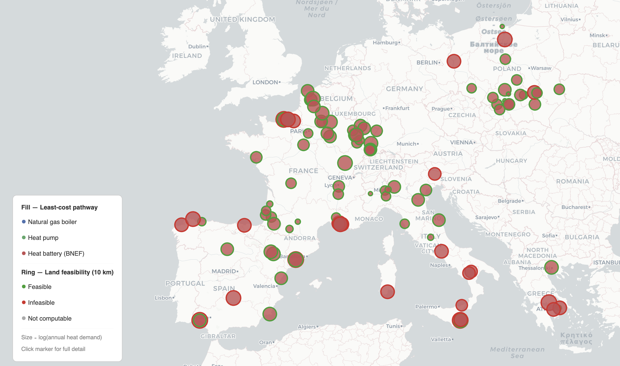
Methodology
- For each facility calculate LCOH.
  - Get the substitutable heat demand from fuel used. Using the amount of energy that is generated by the amount of natural gas, coal, lignite, Other Solid Fuels, Liquid Fuels, Peat, we can get the heat demand.
  - The conversion rate of fuel to heat output is not adjusted. Because the amount of energy is not converted when accounting for end use heat, the final amount might overestimate what the heat demand is.
- LCOH calculations – least cost path
  - Boiler fuel use factor: 0.9
    - 1/0.9 = 1.111
  - Energy component: if gas price = 30.63
    - 1.111 * 30.63 = 34.033
  - Carbon component: add carbon tax
    - Natural gas emission factor: 0.202 tCO_2 per MWh of natural gas (LHV)
    - EU_ETS price for carbon = 60 in 2024
  - Fixed components (capex, opex)
    - CRF = 8% for 20 years
    - 0.85 industrial process capacity factor
  - Sum up these components to get LCOH
- Feasibility
  - Land availability
    - Used grassland, shrubland, cropland and bare
    - Slope > 5°
    - Not protected land
    - 10 km buffer around each site.
  - Solar capacity factor
    - Using the PVGIS API, I collected the kW/kWp for each hour to divided it by 8760 to get the average power
  - Using the solar capacity factor, we calculate the amount of land needed for the heat demand at the site. If land availability meets that amount, then it is feasible to provide for the heat demand at that site.
Assumptions
- Epsilon calculations are based on spread of technology by sector

