Facility-level techno-economic potential of solar-powered industrial heat batteries in European manufacturing [finalize title – keep under 150 characters, avoid punctuation/abbreviations per Nature Energy guide]
Author One¹,*, Author Two¹, Author Three² — [TODO: full author list, affiliations, ORCID iDs]
¹Affiliation one. ²Affiliation two. *Corresponding author: corresponding@author.edu
Abstract
We assess the facility-level cost-effectiveness of collocated solar photovoltaics and industrial heat batteries (IHB) for decarbonizing fossil-fired process heat across European manufacturing. Using Climate TRACE facility data for 2,415 sites in 11 subsectors, we build bottom-up estimates of replaceable (fossil-derived) heat demand, validate them against JRC-IDEES/IndustryHeat-EU country and sector totals, and size solar-plus-storage systems against site-specific solar resource and land availability using a representative-day linear program. Of 2,192 facilities with usable heat and solar data, 1,925 (39% of fleet heat) meet a 90% heat-availability target under a 5 km land screen, at a heat-weighted levelized cost of heat of $82/MWh (median $71/MWh among sites that clear the target). Expanding the land buffer to 15 km raises feasibility to 75% of fleet heat. These results identify which facilities and sectors are structurally suited to solar-plus-IHB decarbonization, and where land, not cost, is the binding constraint.
First-pass draft abstract – refine wording and confirm word count is ≤150 (Nature Energy Article limit).

Motivation
Industrial process heat is a major contributor to global emissions, and industrial decarbonization must be part of the broader effort to reduce them. A substantial literature examines the cost of heat electrification at sector-wide and regional scales, but a facility-level gap remains: little is known about how many individual facilities could cost-effectively and competitively replace gas-boiler heat with electrified alternatives.
[TODO: cite empirical estimates of the cost and emissions-reduction impact of sector/regional heat electrification – flagged in the original draft as “Show some proof”.]
An industrial heat battery (IHB) stores energy as heat, typically using cheap, abundant materials such as silica, ceramics, or graphite. It can absorb renewable electricity during low-cost hours of the day and discharge constant heat as steam for industrial use.

Results

Site screening and candidate classification
The runnable fleet comprises 2,192 facilities with positive replaceable heat and a 2023 PVGIS solar profile. Under 2025 costs and a 5 km land screen, 1,925 sites (39% of fleet heat) meet a 90% availability target. Heat-weighted reliability across all sites is 59%, reflecting land-scarce large plants that serve only part of demand. Heat-weighted LCOH_{served} is about $82/MWh overall and $88/MWh among sites meeting the 90% target. The median among ≥90% sites is about $71/MWh. Expanding the land buffer to 15 km raises heat-weighted reliability to 86% and the ≥90% heat share to 75% (2,148 sites), with heat-weighted LCOH_{served} near $110/MWh (median among ≥90% sites still ~$74/MWh). The higher heat-weighted LCOH at 15 km reflects fuller service of large, storage-intensive high-temperature sites that were curtailed under the tighter land screen — not a uniform rise in unit costs at small sites.
Primary screening outputs are: (i) whether a site meets the 90% availability floor under the land cap; (ii) LCOH_served and its solar/storage split; (iii) optimized solar intensity (MWdc per MWth of flat load) and total thermal storage energy; (iv) heat-pump versus IHB load share; and (v) comparison of LCOH_served with the country CCGT benchmark. Aggregate metrics include fleet and sector replaceable heat, served heat, candidate counts and heat shares at the 90% bar, and distributions of LCOH and reliability (Methods).

Sensitivity analysis
We varied two structural inputs with the largest effect on feasibility and cost: available land (5 km vs. 15 km buffers) and replaceable-heat magnitude (sector-specific low/base/high multipliers). Heat bounds span roughly 388–697 TWh/y fleet-wide (base 522 TWh/y), with the largest relative swing for steam crackers (low = 0.47× the base SEC of 35.9 GJ/t ethylene) and wide ranges for cement, glass, and steel reflecting efficiency and Hotmaps coverage gaps.
Higher assumed heat demand tightens the land constraint: fewer sites, and a smaller share of fleet heat, remain ≥90% feasible (5 km: 49%→38% of heat from low to high; 15 km: 83%→72%). Heat-weighted reliability falls in parallel. Fleet-average LCOH can look slightly lower at higher heat demand, but this is a composition effect rather than a per-site improvement: median LCOH within a site is essentially unchanged as demand rises, because land-rich sites continue to scale served MWh while land-scarce sites lose ≥90% status or serve a smaller share. Median LCOH among sites that still clear 90% stays at roughly $70–74/MWh across heat cases — fleet-average LCOH alone should not be read as evidence that higher heat demand makes every plant cheaper.
Additional sensitivities retained for extension include 2030 technology costs, converter CAPEX on/off, storage-CAPEX learning rates, round-trip efficiency, and stricter land masks (Methods).

Discussion
Several simplifications bound how these results should be interpreted. Heat demand uses sector-average specific energy consumption, process efficiencies, and fossil shares rather than plant-measured fuel use, and temperature-band splits come from sector recipes rather than facility audits, so individual sites — a food and beverage plant, for example — inherit a sector-average high-temperature share that may not describe them exactly. Production and emissions data come from Climate TRACE and related inventories and are best read as a screening-level floor where facility coverage is incomplete, notably for pulp & paper and ceramics & glass (Methods). The flat annual load ignores shift patterns, weekends, and maintenance outages, and land availability is a geospatial screen (slope, protected areas, water) rather than a title, permitting, or grid-interconnection assessment. Technology costs are country-level and stylized rather than EPC quotes understate full project cost and timeline. The representative-day formulation is appropriate for the ≤16 h storage durations modelled here but would need reformulation for seasonal storage, and the CCGT benchmark is an electricity-side gas metric that does not capture site-specific boiler efficiency, fuel contracts, or existing industrial CHP.
Within these bounds, the results indicate that land availability, not technology cost, is the binding constraint at a majority of high-temperature sites: median LCOH among feasible sites is stable at $70–75/MWh across land and demand scenarios, while the feasible heat share moves by a factor of two between the 5 km and 15 km screens. This suggests that siting and land-use policy, alongside continued reduction in storage cost, matter as much as technology cost trajectories for realizing the fleet-wide potential identified here.

Methods

Overview and analytical framework
This study assesses which EU industrial sites could cost-effectively replace fossil-fired process heat with solar-plus-industrial-heat-battery (IHB) systems (Fig. 1). Starting from Climate TRACE open-source facility data for the European Union, we build bottom-up estimates of the heat used in each facility’s manufacturing process. These estimates are validated against country- and sector-level totals from the Joint Research Centre’s Integrated Database of the European Energy System (JRC-IDEES)/IndustryHeat-EU¹, with the exception of the food sector, which is instead fitted to that reference (see ‘Emissions heat estimates’ below). We then use site-specific land availability and solar resource as constraints in a linear-program (LP) optimization that sizes the solar+IHB system and its levelized cost of heat (LCOH) at each site and use the results to identify which facilities and site characteristics are associated with cost-competitive decarbonization.
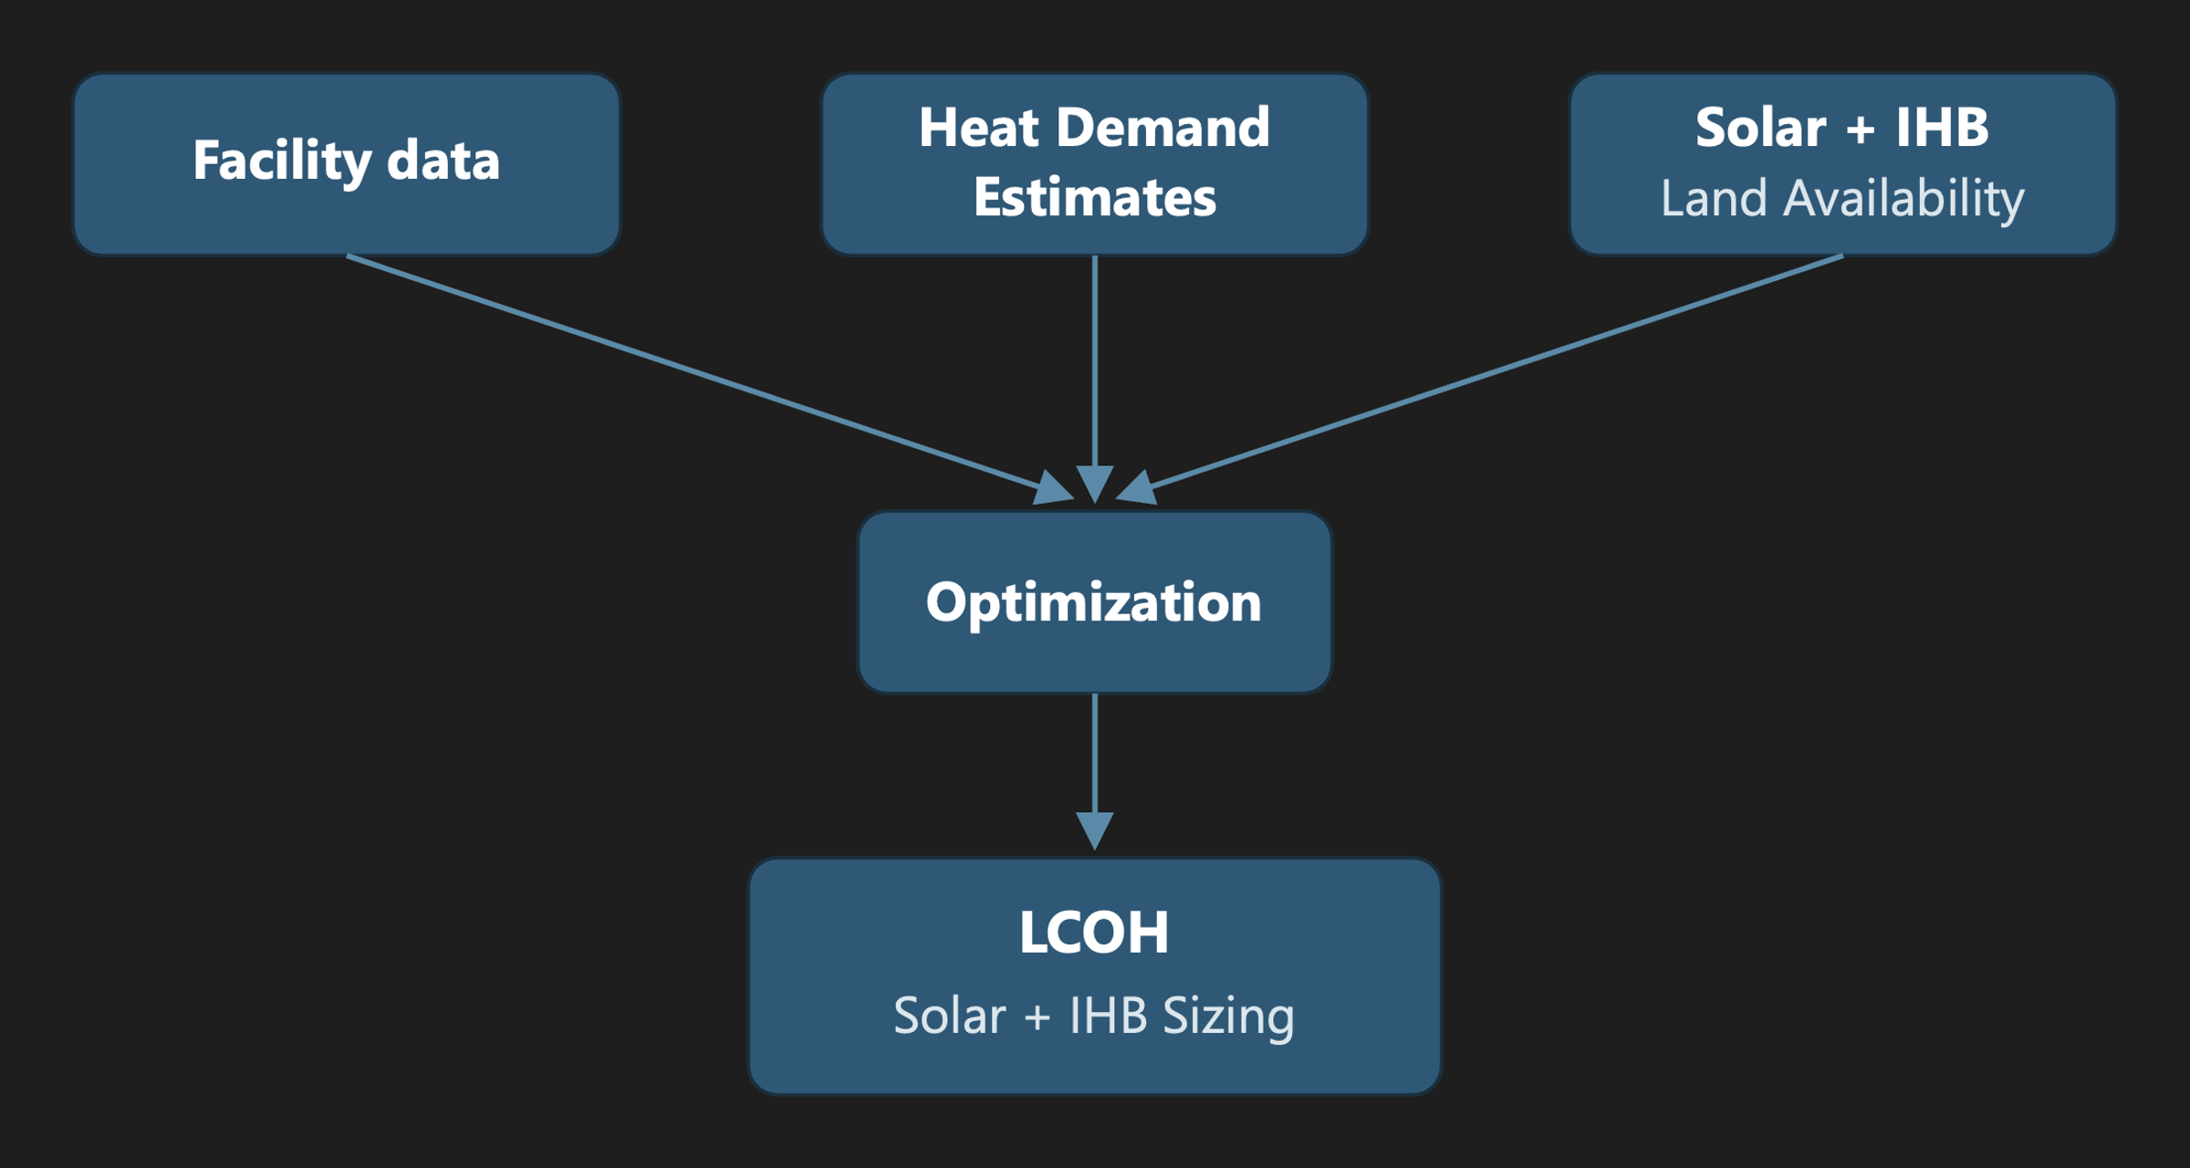
Fig. 1 | Analytical framework. Three independently derived facility-level inputs — heat-demand estimates (‘Replaceable heat demand estimation’), colocated solar resource (‘Solar radiation per facility’), and available land for colocated solar (‘Land availability for colocated solar’) — are combined with facility metadata from Climate TRACE (‘Facility dataset and scope’) and merged into a per-facility optimization (‘LCOH and system sizing’) that returns the sized solar-plus-IHB system and its levelized cost of heat for each site.

Facility dataset and scope
Climate TRACE lists 2,493 facilities in the EU-27 (excluding Malta, which has none) plus the United Kingdom. After removing 78 duplicate records and correcting 4 facility, 2,415 facilities remain. Eleven manufacturing subsectors are covered: food, beverage & tobacco; textiles & apparel; glass; cement; iron & steel; pulp & paper; lime; chemicals; other metals; petrochemical steam cracking; and aluminium. Each facility carries coordinates, annual production output, capacity factor, and annual CO2 emissions, spanning heat temperatures from 100 to 1,500 °C.

Replaceable heat demand estimation
We estimate the useful heat demand that an IHB can serve using a two-tiered approach based on data availability (Table 1). The higher-reliability tier applies sector specific energy consumption (SEC) to facility-level production data²; the lower tier, used only where production data are unavailable, infers fuel use from reported emissions. From useful heat we calculate replaceable heat by applying the fossil share of heat by country and sector³ (‘Fossil share to replaceable heat’, below).
Calculation route | Formulas
SEC route | fuel_energy = production × SEC / 1000  useful_heat = fuel_energy × η_process
Emissions route | fuel_energy = (CO₂e × combustion_share) / emissions_factor  useful_heat = fuel_energy × η_boiler
Replaceable heat | replaceable_heat = useful_heat × fossil_share
Table 1 | Heat-demand calculation routes.

SEC heat estimates
For sectors with per-facility production totals, we apply sector SEC values to obtain useful heat, then apply the fossil share to the SEC-derived value to obtain replaceable heat. Heat-intensity values are taken from Fraunhofer [TODO: cite] and process efficiencies from multiple literature sources (Supplementary Methods, Table S1).

Emissions heat estimates
Two sectors — food and textiles — lack per-facility production data and require the emissions route. In both, combustion emissions account for essentially all reported CO2 (unlike, e.g., cement, where limestone calcination also contributes); we assume a 90%/10% gas/oil fuel blend (EU-reported average) to convert emissions to fuel energy in TJ, then apply a boiler efficiency to obtain useful heat.
Climate TRACE flags high uncertainty in its modelled emissions. Comparing estimated energy need by country against JRC data¹ shows some countries overstated by up to 18× (Portugal) and others understated to 0.4× (Finland); we rescale emissions per country using the ratio of Climate TRACE to JRC totals. Because the food sector is fitted to this reference, it cannot be independently validated by the comparison in ‘Validation of the bottom-up estimate’ below — the rescaling only sets the within-country allocation, and the sector-wide estimate still relies on emissions data. The textile sector is not rescaled, since it already falls within a reasonable range of the reference, but it remains emissions-derived. The heat demand sensitivity analysis builds in the uncertainty of the heat estimates and provide an informed potential range for LCOH.

Fossil share to replaceable heat
Fossil shares are taken from Eurostat, matching NACE activity codes to Climate TRACE sector categories³. Electricity and derived heat are excluded, since useful heat here is combustion-derived, and biomass is excluded because an IHB cannot displace fuel that is burned as an unavoidable part of a process’s chemical feedstock (e.g., black liquor in pulp and paper):
fossil_share = fossil_fuel / (fossil_fuel + biomass_fuel)
Restricting the analysis to the fossil share gives a more realistic accounting of the share of heat generation an IHB can actually displace.

Heat estimate range
Upper and lower heat-estimate bounds, used in the sensitivity analysis (Results), differ by sector for the reasons in Table 2.
Sector | Why low/high differ
Cement / glass / lime | SEC and kiln η ranges
Steel | Scope (4.8 vs. ~7–9 GJ/t; coke/blast furnace in or out)
Steam cracking | 17 vs. 35.9 GJ/t; η ≈ 0.90 uncertain
Food | Country rescale on/off; Climate TRACE allocation
Pulp & paper | Fossil share by country (0.1–1.0) more influential than SEC
Textiles | Emissions-factor / fuel-mix uncertainty (no food-style rescale)
Table 2 | Sources of the low/high heat-estimate range by sector.

Validation of the bottom-up estimate
We compared our bottom-up useful-heat estimates against JRC-IDEES/IndustryHeat-EU useful-energy-demand figures¹ — steam and four non-electric process-heat bands (<100, 100–400, 400–1,000, and >1,000 °C) — at both country and sector level, after matching subsector categories (Supplementary Methods, Table S2).
The bottom-up estimate reproduces the country picture well (Fig. 2): the EU-26 covered-sector total is 556 TWh against a 794 TWh reference (70%), and the largest industrial countries fall in a plausible band (Germany 71%, France 82%, Spain 73%, Italy 58%, Poland 68%, Netherlands 83%). Calculated totals are consistently at or below the reference, consistent with Climate TRACE not covering every facility.
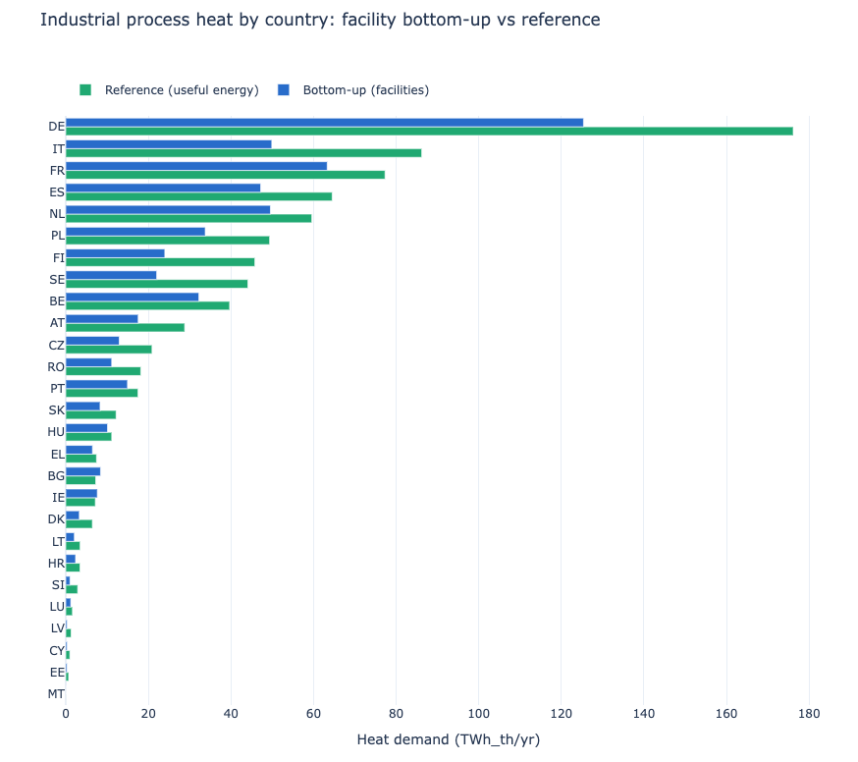
Fig. 2 | Bottom-up versus reference useful process heat, by country. Blue bars: this study’s facility-level bottom-up estimate of industrial process useful heat, aggregated by country (TWh_th/yr). Green bars: the corresponding JRC-IDEES/IndustryHeat-EU reference useful-energy-demand total for the same countries. Countries are the EU-26 (all EU-27 members with Climate TRACE coverage except Malta) plus the United Kingdom, sorted by reference value.
Sector-level totals also match well (Fig. 3), except for pulp & paper and ceramics & glass. For pulp & paper, Climate TRACE lists 79 pulp mills covering 21.8 Mt of the 73.9 Mt EU pulp production, but none of the 716 separate paper & board mills⁴; because the IndustryHeat-EU reference spans the whole pulp-and-paper sector including paper-drying steam, the bottom-up estimate captures only 27% of sector heat. For ceramics & glass, Climate TRACE covers only glass facilities — about 55% of EU glass production (20 of ~37.5 Mt)⁵ — and glass alone matches reasonably; the reference column also bundles ceramics, brick, and refractories, which we do not model.
Editorial note: confirm the ~85% / >1,000 °C figure for the bundled ceramics/brick/refractories share before submission — flagged as unverified in the original draft.
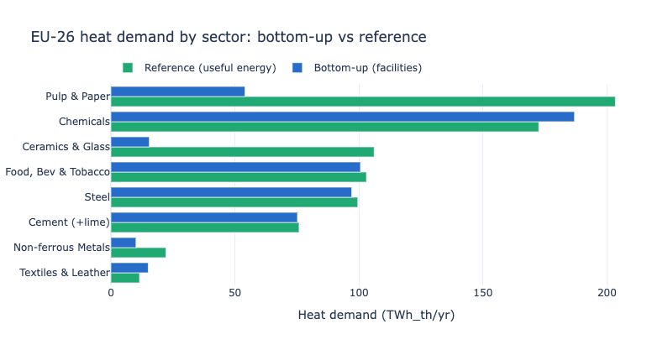
Fig. 3 | Bottom-up versus reference useful process heat, by sector. Blue bars: this study’s facility-level bottom-up estimate of EU-26 industrial process useful heat, aggregated by manufacturing subsector (TWh_th/yr). Green bars: the corresponding JRC-IDEES/IndustryHeat-EU reference useful-energy-demand total for the same eight subsector groupings (Supplementary Methods, Table S2).
Because the food estimate is fitted to the JRC reference (‘Emissions heat estimates’), it cannot be independently validated against it. Textiles retains its emissions-derived level and remains an independent, if emissions-dependent, estimate.

Heat generation and load profile

System configuration
Each facility is modelled as a single on-site solar PV array feeding two independent, temperature-split technology chains (Table 3): an industrial heat pump for loads below 200 °C, and an industrial heat battery for loads above 200 °C, up to ~1,500 °C. Every facility uses whichever chains its temperature profile requires — a food plant almost entirely by heat pumps, a cement plant almost entirely by the resistive battery.
Heat demand band | Technology | COP | Notes
<100 °C | Industrial heat pump (low-temperature) | 2.7
100–200 °C | Industrial heat pump (steam) | 1.8 | Upper limit of the heat-pump pathway (~200 °C)
>200 °C, up to ~1,500 °C | Industrial heat battery | 1.0 | No efficiency multiplier
Table 3 | Heat demand bands, assigned technology, and coefficient of performance (COP).

Flat-load assumption
Heat demand is estimated only at annual resolution (production × SEC × fossil share); no facility-level hourly or seasonal load data are available from Climate TRACE or the underlying benchmarks. We therefore model replaceable heat as a flat, constant hourly load equal to annual replaceable heat divided by 8,760 hours — a deliberate simplification that treats average load as peak load for sizing purposes, with no diurnal or seasonal variation.

Heat demand by temperature and mapping to technology
Each facility’s heat is split across five temperature bands (<100, 100–200, 200–500, 500–1,000, and >1,000 °C) using process recipes from industry benchmarks², each carrying both a heat intensity and a characteristic temperature profile (e.g., cement-clinker calcination falls mostly above 1,000 °C; textile finishing mostly below 200 °C). Technology is assigned band by band: the two sub-200 °C bands to heat pumps, all higher bands to the resistive heat battery. Across the mapped fleet these places roughly one-quarter of replaceable heat (<200 °C) on heat pumps and three-quarters (>200 °C) on the thermal battery, which dominates cost and land requirements.
E_replaceable,b = replaceable_heat_MWh × (heat_band_b / Σ_b heat_band_b)
load_b [MW] = E_replaceable,b / 8760

Solar radiation per facility
Hourly PV output per facility is retrieved from the PVGIS seriescalc API using the PVGIS-ERA5 database for 2023⁶, modelled as a 1 kWp system with tilt equal to site latitude, azimuth due south, and zero system losses. Output is converted to kW/kWp, localized to each site’s time zone, and reindexed to a complete 8,760-hour series (missing hours set to zero); annual yield and capacity factor are derived per facility.
Across the mapped facilities, annual yield has a median of 1,333 and a mean of 1,412 kWh/kWp (range ~900–2,000 kWh/kWp), correlates strongly and negatively with latitude (Pearson r ≈ −0.92), and reproduces the known European solar gradient — brightest across Iberia, Italy, and Greece; dimmest across the Nordics, the UK, and the Baltics (Fig. 4). Representative sites span this range, from Cyprus (~2,049 kWh/kWp) to northern Sweden at 67°N (~967 kWh/kWp).
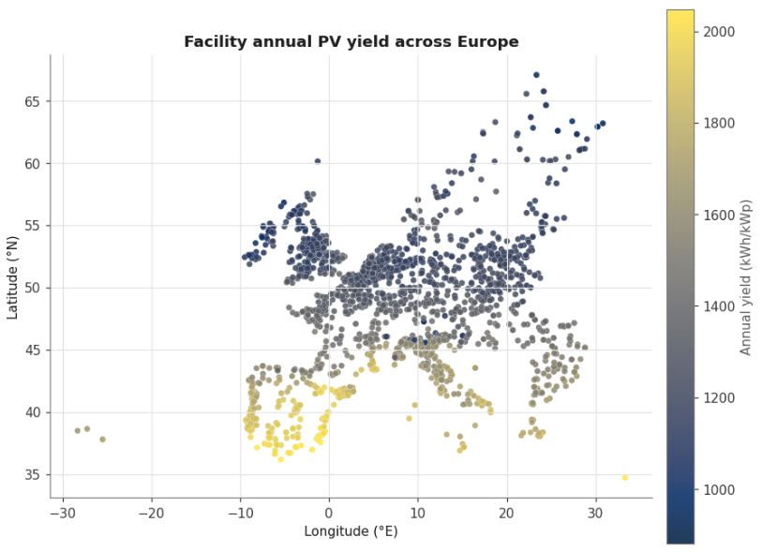
Fig. 4 | Facility-level solar resource across the study area. Each point is one Climate TRACE facility (n = 2,415), positioned by longitude and latitude and colored by annual PV yield (kWh per kWp per year) from the PVGIS-ERA5 database for calendar year 2023, modelled as a 1 kWp system at site-latitude tilt with zero system losses.

Land availability for colocated solar
For each facility we compute developable land for colocated solar within 5 km and 15 km buffers (the latter for sensitivity), using ESA WorldCover land-cover data⁷ via Google Earth Engine zonal statistics⁸. Two exclusions are applied before summing developable area: slope greater than 5°, and WDPA-protected areas⁹ plus a 100 m buffer. Bare ground, cropland, grassland, and shrubland are summed as available land (km²); forest, built-up land, water, wetland, snow/ice, mangroves, and moss/lichen are treated as not developable. Available land caps solar capacity in the optimization; where a 90% reliability target cannot be met within that cap, the model relaxes the floor and reports the reliability actually achievable.
Editorial note: ESA WorldCover’s native product resolution is 10 m, not 30 m as stated in the original draft. Confirm whether a coarser resampling was used for the zonal-statistics step and correct the stated resolution accordingly.
All 2,415 facilities carry land data and average 48.2 km² of developable land per facility within the 5 km buffer (61% of the buffer area); the remainder is masked by slope/protected-area filters or falls outside WorldCover’s coverage. Twenty-six facilities — concentrated in food, beverage & tobacco; textiles & apparel; and pulp & paper — have zero developable land, typically dense or built-up sites with no open ground nearby.

Technology and cost data
Technology costs are assigned at the country level in nominal 2025 US dollars. CAPEX, fixed O&M, WACC, and capital recovery factors (CRF) for fixed-axis solar PV, utility-scale battery storage, and combined-cycle gas turbines (CCGT) are taken from BloombergNEF (BNEF) technology-cost tables¹⁰ (cost year 2025; 2030 values retained for sensitivity); countries without a direct BNEF observation are proxied from income- and region-peer averages, and the UK uses Ireland as its proxy. Solar CAPEX is annualized with the country-specific CRF implied by BNEF’s nominal WACC and a 25-year lifetime; 2025 PV LCOE across study countries is typically ~$35–45/MWh, versus ~$130–140/MWh for CCGT.
For the IHB (thermal storage), we use a 2025 base case of $100/kWh_th CAPEX, 2%/yr fixed O&M, a 25-year lifetime, and a 7% real discount rate. Round-trip efficiency is 92% (split symmetrically on charge/discharge); electric-to-heat conversion efficiency is 98% for ≤200 °C loads and 95% above 200 °C; inverter efficiency is 96.7%. Storage duration is capped at 16 h at the discharge rating, with a minimum 4:1 charge-to-discharge power ratio, and colocated PV density is capped at 50 MWdc/km² of available land.
Heat delivery follows Table 3 (COP 2.7 below 100 °C, 1.8 for 100–200 °C, 1.0 above 200 °C). COP still governs the electricity-to-heat conversion. The country CCGT LCOE from BNEF provides the fossil-heat benchmark for screening comparisons.

LCOH and system sizing
For each facility with positive replaceable heat and a PVGIS profile, we size a collocated solar-plus-storage system with a linear program (HiGHS)¹¹. Replaceable heat is split across temperature bands (above), converted to constant thermal power (MWth) under the flat-load assumption; sub-200 °C bands are served by heat pumps and higher bands by the resistive heat battery.
Because storage is short-duration (≤16 h) and cycles within a day, we reduce the year of hourly solar to 16 representative days by k-means clustering of the 365 daily PVGIS profiles, solve each as a 24-hour block with cyclic state-of-charge, and weight days by cluster membership — shrinking the LP roughly 20× relative to a full 8,760-hour solve, with negligible loss of accuracy for daily-cycling storage.

Decision variables and coupling
Decision variables are shared solar capacity S (MWdc) and, per active band b: charge power P_ch,b, discharge power P_dis,b, storage energy E_b, and hourly charge/discharge/state-of-charge/unserved heat. Available PV output bounds total charge:
Σ_b charge_b,t ≤ S · cf_t
where cf_t is the PVGIS per-kWp capacity factor. Heat charged into band b equals charge_b,t · COP_b · η_ch, with η_ch = η_dis = √RTE (RTE = 92%). Discharge must meet the flat band load up to unserved heat:
discharge_b,t + unserved_b,t = load_b
Storage energy, charge/discharge rates, 16 h discharge duration, and the 4:1 charge:discharge ratio are all bounded as in ‘Technology and cost data’.

Land constraint and reliability
Solar capacity is capped by screened land,
S ≤ A_land · 50 MWdc/km²
using the 5 km buffer as the base case and 15 km in sensitivity. We impose a 90%-of-annual-replaceable-heat availability floor; where infeasible under the land cap, a two-phase solve first maximizes served heat, then minimizes cost at that served level. Unserved heat is unpriced (value of lost load = 0), so reported LCOH reflects only capital and fixed O&M for the renewable system.

Levelized cost of heat
Annualized solar cost is (CAPEX_PV · CRF_country + FOM_PV) · S; annualized storage cost applies the 7%/25-year CRF plus 2%/yr O&M to Σ_b E_b. Converter CAPEX is zero in the primary results. With C_ann as total annualized cost and Q_served the optimized served heat,
LCOH_served = C_ann / Q_served LCOH_total = C_ann / Q_demand
where Q_demand is annual replaceable heat. We report LCOH_served as the primary metric, alongside reliability (Q_served/Q_demand) and whether the 90% floor was met; component shares (solar vs. storage) allocate annualized cost to Q_served. Sites where LCOH_served falls below the country CCGT benchmark, subject to meeting the availability target where land allows, are treated as economically favorable relative to gas-fired heat under these assumptions.

Data availability
[TODO: repository/DOI for the facility-level assessment file (eu_ihb_site_assessment_2024.csv) and derived outputs, per Nature Energy’s data-availability policy.]

Code availability
The analysis pipeline — heat-demand estimation, solar-resource retrieval, land-availability processing, and the multi-band LP optimization — is summarized in Supplementary Methods (pipeline overview).
[TODO: repository URL/DOI, per Nature Energy’s code-availability policy.]

Acknowledgements
[TODO]

Author contributions
[TODO — CRediT-style statement, e.g. “A.B. designed the study; A.B. and C.D. performed the analysis; ...”]

Competing interests
[TODO — required for all Nature Energy content]

References
1. Gjorgievski, V., Cundeva, S., Markovska, N. & Duić, N. IndustryHeat-EU: Harmonized Dataset of Industrial Final and Useful Energy Demand by Temperature Level for EU27 and Member States. Zenodo https://doi.org/10.5281/zenodo.17414346 (2025).
2. Pezzutto, S. et al. Hotmaps Project, D2.3 WP2 Report – Open Data Set for the EU28. www.hotmaps-project.eu (2018).
3. Eurostat. Disaggregated final energy consumption in industry by NACE Rev. 2 activity – quantities [dataset]. [FILL IN dataset code and access date].
4. Confederation of European Paper Industries (CEPI). Key Statistics 2023 – European Pulp & Paper Industry (CEPI, 2024).
5. Glass Alliance Europe. Statistical Report [FILL IN exact edition/year – cited in the draft as “2025–2026”].
6. European Commission Joint Research Centre. PVGIS – Photovoltaic Geographical Information System, PVGIS-ERA5 database [FILL IN access date/version]; https://re.jrc.ec.europa.eu/pvg_tools/en/
7. Zanaga, D. et al. ESA WorldCover 10 m 2021 v200. Zenodo https://doi.org/10.5281/zenodo.7254221 (2022).
8. Gorelick, N. et al. Google Earth Engine: planetary-scale geospatial analysis for everyone. Remote Sens. Environ. 202, 18–27 (2017).
9. UNEP-WCMC & IUCN. Protected Planet: The World Database on Protected Areas (WDPA) [FILL IN access month/year]; www.protectedplanet.net
10. BloombergNEF. [FILL IN exact title of the technology-cost compilation used] (BloombergNEF, 2025).
11. Huangfu, Q. & Hall, J. A. J. Parallelizing the dual revised simplex method. Math. Program. Comput. 10, 119–142 (2018).
12. Madlool, N. A., Saidur, R., Hossain, M. S. & Rahim, N. A. A critical review on energy use and savings in the cement industries. Renew. Sustain. Energy Rev. 15, 2042–2060 (2011).
13. European Commission. Best Available Techniques (BAT) Reference Document for the Production of Cement, Lime and Magnesium Oxide [FILL IN year – draft cites both 2013 and a 2019 revision].
14. Beerkens, R. G. C. & van Limpt, H. A. C. Energy efficiency benchmarking of glass furnaces. Ceram. Eng. Sci. Proc. 23, 93–105 (2008).
15. Schmitz, A., Kamiński, J., Scalet, B. M. & Soria, A. Energy consumption and CO2 emissions of the European glass industry. Energy Policy 39, 142–155 (2011).
16. IEA. Iron and Steel Technology Roadmap: Towards More Sustainable Steelmaking (IEA, 2020).
17. World Steel Association. [FILL IN exact energy-statistics publication/year]; worldsteel.org
18. Ren, T., Patel, M. & Blok, K. [FILL IN exact title]. Energy 31, 425–451 (2006).
19. [FILL IN authors]. Ethylene. In Ullmann’s Encyclopedia of Industrial Chemistry [FILL IN edition/year].
20. European Commission. BAT Reference Document for the Manufacture of Large Volume Inorganic Chemicals (LVIC) [FILL IN year].
21. International Aluminium Institute. [FILL IN exact energy-data publication/year]; international-aluminium.org
22. US Department of Energy. [FILL IN specific industrial steam-boiler efficiency benchmark report/URL].

Supplementary Methods
(Retained here for drafting purposes; would be submitted as a separate Supplementary Information file per Nature Energy guidelines.)

Table S1. Subsector process efficiencies (fuel input to useful heat)
Subsector | Eff. | What it represents | Source
Cement | 0.60 | Kiln pyro-processing first-law efficiency | Madlool et al. [12], 50–60% kiln-system; cross-checked vs. IEA Cement Roadmap (BAT ~3.0 vs. theoretical ~1.8 GJ/t)
Lime | 0.65 | EU mix of shaft (~0.80) + rotary (~0.55) kilns | EU BREF Cement/Lime/MgO [13] (4–5 GJ/t vs. theoretical ~3.2)
Glass | 0.45 | Melting-furnace efficiency (large flue-gas/structural losses) | Beerkens & van Limpt [14]; Schmitz et al. [15] (regenerative melting 40–50%)
Iron & steel | 0.70 | Reheating/sinter furnaces w/ recuperation (65–75%) | IEA Iron & Steel Roadmap [16]; worldsteel energy statistics [17]
Petrochem. steam cracking | 0.90 | Fired heater w/ strong convection recovery | Ren, Patel & Blok [18]; Ullmann’s “Ethylene” [19] — flagged least-certain
Chemicals — ammonia/methanol | 0.90 | Reformers / fired heaters w/ heat recovery | (same class as cracking)
Chemicals — soda ash | 0.85 | Steam-boiler-led | EU BREF LVIC [20]
Aluminium — refinery | 0.85 | Bayer digestion/calcination steam boiler | IAI energy data [21]
Aluminium — smelting | 0.65 | Anode-bake + cast-house fired furnaces | IAI energy data [21]
Pulp & paper | 0.85 | Steam boiler | US DOE typical industrial steam boiler [22]
Food & beverage; textiles | 0.85 | Boiler efficiency (emissions-inversion route) | US DOE typical industrial steam boiler [22]
Editorial note: the cement (0.60) and lime (0.65) efficiencies above come from the SEC route (Madlool et al.; EU BREF) and are noticeably lower than the ε values used for the same processes in the companion E-PRTR/LCP-based reference table for this project (cement ε ≈ 0.75; lime ε ≈ 0.78, from Saad et al. 2026 / LCP BREF). Reconcile which value is authoritative for this paper — or state explicitly why the two data routes (Climate TRACE/SEC vs. E-PRTR/LCP) justify different point estimates for the same physical process — before submission.

Table S2. IndustryHeat-EU subsector mapping to Climate TRACE subsector
Climate TRACE subsector | IndustryHeat-EU column | Grouped label
iron-and-steel | Primary Steel + Secondary Steel | Steel
chemicals | Chemicals | Chemicals
petrochemical-steam-cracking | Chemicals | Chemicals
cement | Cement | Cement (+lime)
lime | Cement (no own column) | Cement (+lime)
glass | Ceramics and Glass | Glass
pulp-and-paper | Pulp and Paper | Pulp & Paper
food-beverage-tobacco | Food, Beverages and Tobacco | Food, Bev. & Tobacco
textiles-leather-apparel | Textiles and Leather | Textiles & Leather
aluminum | Non-ferrous Metals | Non-ferrous Metals
other-metals | Non-ferrous Metals | Non-ferrous Metals

Pipeline overview
Upstream stages (heat demand, solar radiation, land availability) each run independently and write facility-level files; a combine step merges them by facility ID into a single site-assessment file, which the multi-band optimization reads together with country technology costs and hourly solar profiles to produce per-facility LCOH, reliability, and sizing outputs.
UPSTREAM STAGES (run independently, each writes files)

heat_demand/... -> facilities_2024_eu_replaceable.csv
(replaceable_heat_mwh)
solar_radiation/pull_pvgis.py -> hourly_profiles/*.parquet
+ solar summary
land_availability/... (GEE+merge) -> land_availability_by_facility.csv

|
v

COMBINE -- flatblock_optimization/inputs/build_sites_input.py
merges the three above (by source_id) into:
-> outputs/eu_ihb_site_assessment_2024.csv (the single "everything" file)

|
v

OPTIMIZE -- run_multiband_potential.py
(multi-band HP + IHB; also run_ihb_potential.py for single-load TES)
reads sites_csv = outputs/eu_ihb_site_assessment_2024.csv
+ Input/bnef_country_costs.csv (country tech costs)
+ flatblock_optimization/inputs/input_heat_battery_cost.csv
+ solar_radiation/outputs/hourly_profiles/*.parquet (read at runtime)
-> outputs/multiband/<scenario>/by_facility.csv
(LCOH, reliability, sizing; --heat-case low|base|high)

