Facility-level Techno-economic Potential of Electrified Industrial Process Heat in European Manufacturing
Anna Yuen^{1, 2, *}, Amol Phadke²
¹Energy and Resources Group, University of California, Berkeley
²Goldman School of Public Policy, University of California, Berkeley
*Corresponding author. Email: anna_yuen@berkeley.edu

Keywords: Industrial Decarbonization, Heat Pumps, Heat Batteries, Off-Grid Solar PV, Techno-economic analysis

Abstract
Industrial process heat has dominated industrial manufacturing emissions in the EU. Yet, there are readily available non-fossil fueled solutions that can generate process heat. Industrial heat pumps and heat batteries paired with on-site solar PV can be a potential solution to bring power to heat generation quickly. Using 2,192 facility dataset of different manufacturing sectors from Climate TRACE, each facility is modelled with co-located, off-grid solar PV with industrial heat pumps and batteries installed in 2030. Under this modelled configuration, 58.8% of total process heat can be decarbonized using solar PV within a 5km buffer zone around each facility site at an average levelized cost of heat at €55/MWh. After expanding the buffer zone to 15km, the share of possible decarbonized heat increased to 84.4% of process heat at €68/MWh. Each facility is optimized to provide the highest availability under its country’s gas prices. These results show that Southern Europe is ready to decarbonize almost all its industrial process heat. Central Europe (Rhine-Meuse Region), where most of the large, heat intensive sources are located, can decarbonize using on-site solar plus storage but will likely require grid electricity or continued gas use.

1 Introduction
Industrial process heat accounts for three quarters of industrial greenhouse-gas emissions in the European Union (EU) [1] and is an essential part of the climate change mitigation strategy [2]. The majority of industrial process heat demand is concentrated in the iron and steel, chemicals, and non-metallic minerals sectors, which also require the highest process temperatures, typically exceeding 1,000°C [1].
Different technologies are already available to electrify process heat across different temperature heat bands such as heat pumps, industrial heat batteries, electric boilers, and electric arc furnaces. While industrial heat pumps are commercially available and highly efficient, they can only provide heat up to 200°C [3]. Heat batteries/thermal storage is a recent technology that can provide heat up to 1000°C, reaching temperatures needed for iron and steel and the chemical sectors [3]. Renewable generation using solar panels paired with heat pump and heat battery is broadly recognized as a pathway to reduce carbon emissions and increase efficiency [4].
Utilizing renewable generation for electrification allows for the EU to use its own resources and address its vulnerability from dependence on imported fuel [5]. Europe is facing challenges in energy security both due to the reliance on international gas imports and vulnerabilities in grid infrastructure [6]. Diversifying energy sources and utilizing renewable resources can not only relieve the dependence on gas imports and but also allows for quicker decarbonization through electrification to meet EU climate goals. International conflicts such as the Russian war [6] and the closure of the strait of Hormuz threaten the stability of fuel imports and energy costs [7]. Using domestically sourced solar plus storage heat generation, the EU can be better equipped to stabilize and even reduce energy costs.
However, the progress to electrify process heat has been falling behind other sectors [8]. Critical barriers to electrifying industrial heat include high electricity grid prices relative to gas [8] and long lead times to connect to the electricity grid [9], [10]. On-site renewable solutions can decrease reliance on imported gas [11] and avoid the multi-year grid interconnection timeline [12]. With enough land available, solar plus storage systems can provide heat without incurring the cost of expensive transmission infrastructure or long interconnection queue wait times [9].
Prior work analyses industrial decarbonization at a sector level or country level [6], [13] but not at a facility level. While those analyses help identify the need to electrify and decarbonize, they cannot target the specific areas that are the optimal for decarbonizing nor can they quantify the impacts at a regional level. For on-site solar resources, the capacity factor and costs can differ greatly within a country or region. Facility-level bottom-up analysis can tackle those gaps [14] by using site-specific solar capacity factors, land availability, and country adjusted cost of infrastructure. With facility-level resolution, this study identifies specific regions best for heat electrification and quantifies the potential to decarbonize with the solar plus storage solution.
2. Methodology
We generated a facility-level dataset from Climate TRACE in the EU. Climate TRACE provides latitude and longitude, annual production and emissions of each facility. Combining with solar radiation and land availability in a 5km and a 15km radius around each facility, the optimization program calculates the levelized cost of heat (LCOH) at each site. The LCOH is calculated using a mixed-integer optimization framework adapted from [10], which was originally developed to size surplus interconnection capacity for renewable projects. The gas-capped, optimized LCOH at the highest availability is chosen for each site and aggregated to get the total process heat that can be decarbonized using this system and configuration, as illustrated in Figure 1.
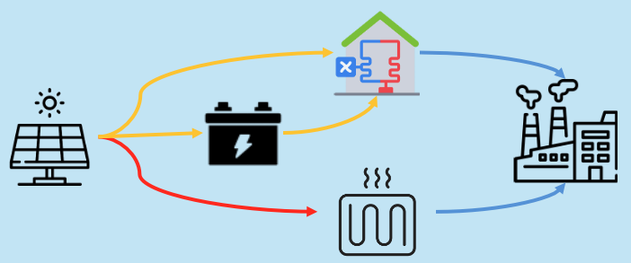
Fig. 1 Modelled system configuration: co-located, off-grid solar PV paired with a heat pump/heat battery and battery storage supplying process heat to the facility

2.1 Facility-level Process Heat Estimate
The replaceable process heat for each facility is the heat generated by fossil fuel that is used in the process of manufacturing a product (steel, food, textile, etc.). Depending on data availability, total annual production or total annual pollution is used to calculate the process heat per sector and country. With total annual production, we apply a specific energy consumption (SEC) factor by sector [15] that defines the energy intensity per ton of good. With emissions total [16], we applied an emissions factor, assuming an EU averaged gas/oil share of 90%/10% [17], to get the total process heat demand. With the total process heat estimate from both SEC and emissions factor, we calculated the replaceable process heat by applying a fossils fuel share [18] to get the useful heat.

The formulas for these two processes are shown in Table 1:
Table 1 Facility-level process heat and replaceable-heat estimation formulas by calculation route
Calculation route | Formulas
SEC route | fuel_energy = production × SEC  useful_heat = fuel_energy × η_process
Emissions route | fuel_energy = (CO₂e × combustion_share) / emissions_factor  useful_heat = fuel_energy × η_boiler
Replaceable heat | replaceable_heat = useful_heat × fossil_share

To validate the heat estimates, we compared against sector and country wide useful heat aggregates and determined it is within +-50% of reference data. (Supplementary graphs and plots).

2.2 Solar Radiation
Solar capacity factor, the amount of solar power output relative to nameplate, is pulled from PVGIS using ERA5 data for 2023. Hourly profiles are pulled for each facility and normalized to 1 kWp. It is then summed over a year and divided by 8760 to get the average solar capacity factor. The tilt is set to the absolute latitude and azimuth is south facing. This factor is applied to the nameplate density (50 MWh/km²) to get the amount of energy at each facility’s location.

2.3 Land Availability
We aggregated the square km of cropland, bare, grass and shrubland around each facility in 5 km and 15km buffer zones using google earth engine and ESA WorldCover v200 (2021) map. We applied a mask for land that is slope <= 5°C and not designated as protected areas with a buffer of 100m from Copernicus digital elevation map. While the ESA WorldCover map has 10-meter resolution, we used the zonal statistics at 30 meters for computation processing speed and to match the resolution of the slope filter.

2.4 Technology Cost Data
All costs are set in 2030-dollar values and assumes that a solar plus storage project to start constructing in 2030. Technologies, both solar and storage, are assumed to have 25-year life. Capital expenditure and fixed operation and maintenance costs of solar panels and utility scale batteries are gathered from BloombergNEF (BNEF) [19] for 2030 by country. Heat pumps costs by temperature band [20] and industrial heat batteries [21] are in 2021 and 2023 dollars respectively. Both are CPI- (Bureau of Labor Statistics, 2025) to 2030 which applies a factor of 1.31 and 1.17 respectively. Country specific costs from BNEF and cost of capital rates (IRENA) are used when direct country costs are available and proxied by peer mean income country groups (HIC, LMIC, etc.) when not available.
To annualize costs across a project’s lifetime, we used this LCOH formula:
Capital costs are annualized using a standard capital recovery factor (CRF) assuming a 25-year technology life and country-specific cost of capital. Total annualized system cost, $C^{ann}$, sums four technology terms — solar, Li-ion battery, industrial heat battery, and heat pump — each following the same general form, illustrated here for solar:

$$C_{solar}^{ann}=\left(CAPEX_{c}^{PV}⋅1000⋅CRF_{c}+FOM_{c}^{PV}\right)S*$$
The Li-ion battery, industrial heat battery, and heat pump terms follow the same functional form using their respective CAPEX and FOM values described above; the full set of annualized cost equations, along with the equivalent LCOH formula for total demand, is provided in the Supplementary Material (Eqs. S1–S6).

$LCOH_{served}=\frac{C_{ann}}{Q_{served}}$},

Where $r_{c}$is country WACC, S*, E*, P* are optimized capacities, $Q_{b }^{*}$is HP thermal capacity sized to served heat in band b, and Qserved=Qdemand-Qunserved. Unserved energy is not costed (VoLL = 0).

2.5 Gas Heat Benchmark
Each LCOH is compared against a gas heat benchmark to get the highest availability of electrified heat generated below the gas heat price. Gas heat prices are gathered from Eurostat’s non-household gas for 2030 (nrg_pc_203) [22]. A general gas boiler efficiency of 0.85 [23] is applied to the gas price.
The EUA carbon tax of €79/tCO₂ is assumed and added to the gas heat cost.
$c_{heat,c}^{gas} = \frac{p_{c}^{gas}}{η} + \frac{p^{EUA} × {EF}_{NG}}{η}$ (1)
with $η = 0.85$ (boiler efficiency), $p^{EUA} = 79 EUR/tCO₂$ (EUA carbon price assumption), and ${EF}_{NG} = 0.202 tCO₂/{MWh}_{fuel}$ (gas CO₂ emission factor).
2.6 Optimization – System Sizing
To get the optimized system size to minimize cost, we sized the co-located solar panels with heat pump or heat battery solution using a linear program (HiGHS). Both of those solutions will pipe heat into the industrial facility. The linear program is defined as follows.
Objective
$$min \frac{1}{Q^{dem}} (c_{S} S + c_{E}^{Li} E^{Li} + c_{P}^{Li} P_{dis}^{Li} +$$
$Σ_{b∈B(IHB)} [c_{in}P_{b}^{ch} + c_{out}P_{b}^{dis} + c_{E}E_{b}])$ (2)
Sets and parameters
$c ∈ \{1,…,K\}$: days in the year. $t ∈ \{1,…,H\}$: hours (H = 24), with t − 1 ≡ H when t = 1. $b_{∈ B(HP)}$: heat-pump bands (COP > 1), covering <100°C and 100–200°C. $b_{∈ B(IHB)}$: industrial-heat-battery bands (COP ≤ 1), covering ≥200°C. Round-trip efficiencies enter as $η^{Li} = \sqrt{{RTE}^{Li}} and η^{IHB} = \sqrt{{RTE}^{IHB}}$, with ${RTE}^{Li} = 0.90, {RTE}^{IHB} = 0.95$, and maximum Li-ion duration $h^{max} = 16 h$.
Subject to
- Solar capacity is capped by available land at a fixed density of 50 MWdc/km².
- Li-ion battery energy is limited to a 16-hour maximum discharge duration.
- At each hour, solar generation is allocated across heat-pump demand, Li-ion charging, and industrial-heat-battery charging.
- Heat-pump output (COP-adjusted, including battery-buffered supply) matches each band's flat thermal load.
- Industrial-heat-battery output and state-of-charge evolve hour to hour based on charging and discharging, net of round-trip efficiency losses.
- Annual unserved heat is capped at (1−α) of demand, enforcing the target availability level α.
All capacities and dispatch variables are non-negative.
The model is solved as a facility-level linear program (HiGHS) over 2023 PVGIS hourly profiles. Shared solar capacity feeds heat-pump bands (below 200°C, buffered by a Li-ion battery) and industrial-heat-battery bands (at or above 200°C, resistively charged into a thermal store).
Utilizing the hourly solar profiles and the flat-load heat demand, we optimized for availability level at 90%. If that site does not meet 90% availability below gas heat benchmark, then optimization will be run at the next highest decile availability until it is below gas heat benchmark. After sizing the solar panels and batteries for both the 5km and 15km radius, the total availability for each plant is averaged and aggregated to get the total amount of heat decarbonized and the heat weighted LCOH at the two buffer zones.
3 Results
Table 2 Share of replaceable process heat served and levelized cost of heat (LCOH) at 5 km and 15 km buffer zones
 | 5 km | 15 km
Served (highest served under gas prices) | 58.8%  (307 TWh) | 84.4%  (441 TWh)
LCOH (highest served under gas prices) | €55 | €62
Served  (max savings vs €93) | 53.2%  (278 TWh) | 72.1%  (377 TWh)
LCOH  (max savings vs €93) | €41 | €42

3.1 Total heat % served and LCOH
The aggregate replaceable heat demand served is analyzed in two ways: maximizing savings and maximizing heat demand. To maximize savings, a facility should aim for availability up to the maximum savings points. The remaining can be met with grid electricity or gas. To maximize heat demand served, a facility could overbuild solar panels while still being under gas prices resulting in a lower marginal benefit but is still gas competitive. Table 2 summarizes both framings at the 5 km and 15 km buffer zones.
Figure 2 shows the average LCOH vs availability curve that can be used to observe the maximum saving point vs the gas-cap point.
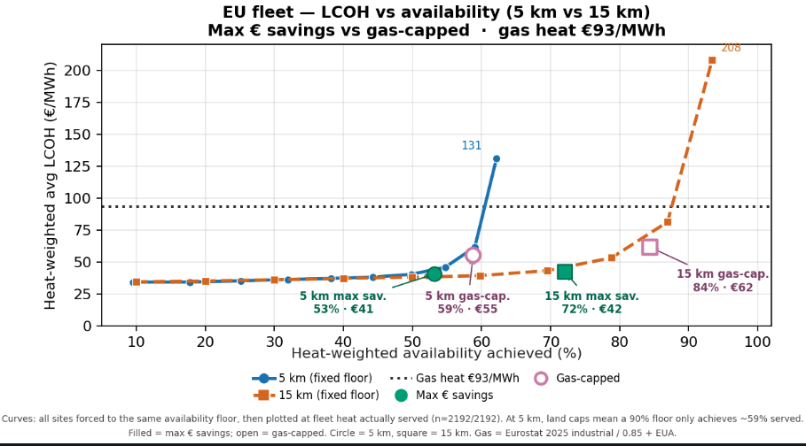
Fig. 2 EU fleet-average LCOH vs. availability achieved at 5 km and 15 km land buffer zones, relative to the €93/MWh gas-heat benchmark

3.2 High temperature sector comparison
Steam cracking, iron & steel sector have very large sites and have more heat intense processes (> 500°C) resulting in much higher heat loads. These sectors require more hybrid solutions: increased land availability, utilizing grid electricity, co-firing with gas plants.
By increasing buffer zone around each site, over 80% of heat can be served in both sectors under gas prices. Grid electricity or gas plants are still needed to provide for the last 10-30% of demand.
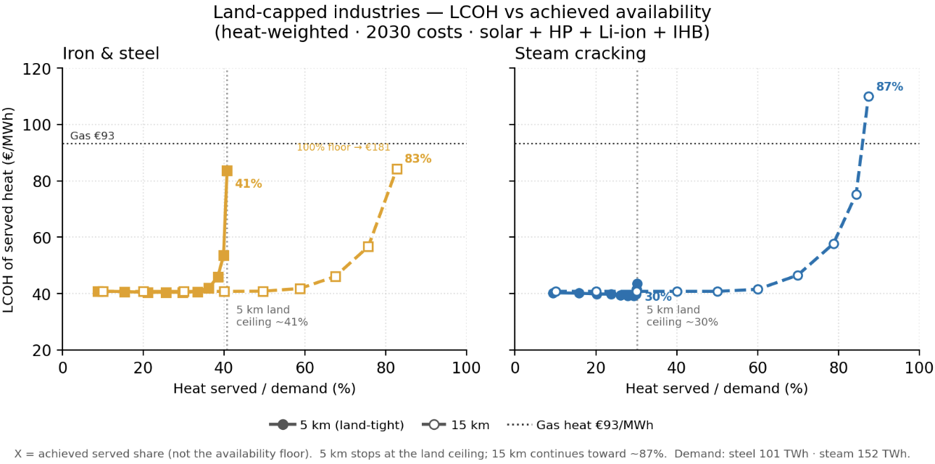
Fig. 3 LCOH vs. heat availability achieved for land-capped high-temperature industries at 5 km and 15 km buffer zones: (a) Iron & steel, (b) Steam cracking

3.3 Country-level comparison
Germany, the Netherlands, and France have very large process-heat demand. With a ~15 km land buffer, a large majority can be served below country gas. At 5 km, Germany and the Netherlands remain more land constrained. Southern Europe (Greece, Spain, Italy, Portugal) is the strongest fit: Sites tend to be smaller, with better solar yield. ~95% of demand served at LCOH roughly 70–75% of country gas cost.
For high-temperature processes, this solution can decarbonize a high share of replaceable heat (~80% for steel and steam cracking at 15 km), even if not 100% everywhere. By meeting heat on-site with solar + storage, this package can reduce reliance on gas boilers and incremental electric load on the local grid, potentially easing upgrades and gas exposure, and offers a deployable path to cheaper cleaner heat.
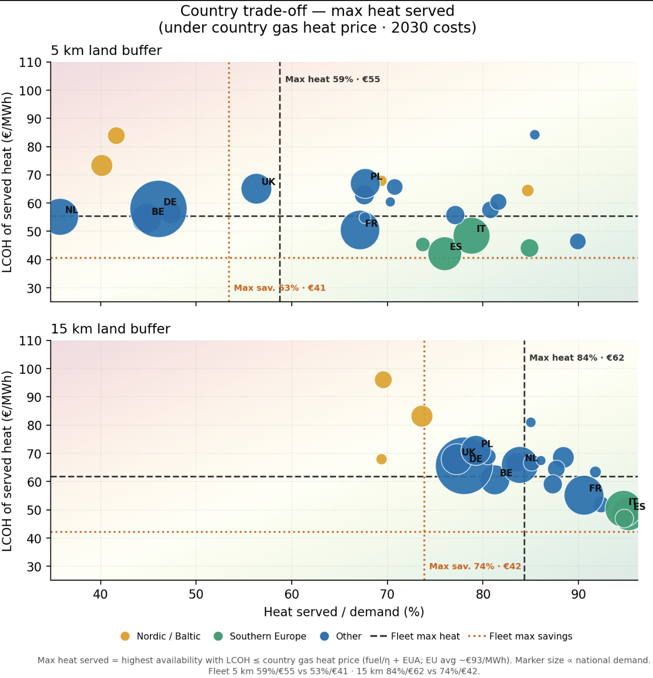
Fig. 4 Country-level LCOH of served heat vs. share of heat demand served, gas-capped at €93/MWh: (a) 5 km land buffer, (b) 15 km land buffer

3.4 Facility specific analysis for solar radiation impacts
Where land is comparable, solar resource drives how much PV overbuild high-temperature sites need. Two high temperature steel plants, Linz in Austria and Taranto in Italy, have similar temperature needs (900°C) and heat demand (5 TWh). Taranto has 20% solar capacity factor while Linz has 15%. Both have enough land available at 15km to meet 90% of their heat demand, but Linz need to overbuild 15x of their load while Taranto would only need to build 5.3x their load. Higher-irradiance sites can hit high-T reliability with less overbuild and much lower LCOH. Table 3 summarizes the comparison.
Table 3 Solar overbuild, capacity, land use, and LCOH for two high-temperature steel sites at 15 km buffer zone (90% availability)
 | Solar / load | PV built | Land used | LCOH
Taranto | 5.3× | 3.0 GW | 32% | €33
Linz | 15.0× | 8.5 GW | 80% | €85
3.5 Impacts of land constraint
For large sites with high temperature processes, there are concentrated areas where the land resources just cannot provide most of the energy at 5 km buffer zone. The major shortfall areas are in the Rhine-Meuse region where steel and
steam cracking facilities are. These sites typically have ~8–50 km²/TWh land and ~12–14% solar capacity factor. Most sites at 5 km can meet enough energy at 15 km. Expanding to 15km allows all sites, except for 3, to reach over 50% availability.

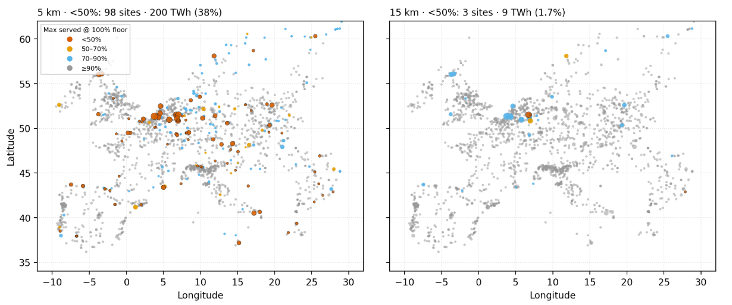
Fig. 5 Facility-level heat availability achieved by land-constraint category: (a) 5 km buffer zone, (b) 15 km buffer zone

4 Discussion
4.1 Motivation for off-grid renewable solution
One of the major roadblocks of electrification is the impacts to the electricity grid infrastructure. The high energy demand of even small or low-temperature industrial sites can cause outages in peak hours. With on-site renewable site, there is enough availability served such that industrial sites can use those resources during both non-peak and peak hours. This would reduce the need to upgrade grid infrastructure to meet peak hours and reduce cost and time to electrify heat generation. With even 5km of buffer zone, the 58% of total heat demand in the EU can be met with solar + heat pump/heat battery at a cost below natural gas fuel costs with carbon tax. This solar + storage solution does not require the whole system to be decarbonized for cost and emissions reductions. Before meeting the highest heat decarbonize target below gas, facilities can build up to the max savings points to get a considerable amount of energy for their facilities. This study highlights the high potential of utilizing solar plus storage resources to meet most of the industrial heat demand through rigorously modelled technoeconomic analysis.
4.2 Trade-off between solar resource and land availability
Solar capacity factors interact with land available that makes the cost considerations different for each site. The decision to maximize cost savings versus maximize heat demand served depends on how much solar panel overbuilding might be enough to justify the cost and benefit at each site. Other decisions such as feasibility of connecting to the grid and prices of grid electricity can play a significant factor in how a facility approach its decarbonization timeline. In the Rhine-Meuse region, where high temperature and large industrial facilities are located and available land resource is low, the regional regulation and electricity prices might help with decarbonization by enabling cheaper electricity prices to meet the total heat demand with grid electricity.
Germany has implemented state subsidized electricity prices that would help support electrification efforts. (almost 50% of electricity prices) [24]. Even with cost competitive grid electricity, the impacts on the distribution and transmission grid might prevent electrification from being approved or delay the electrification. The affordability of solar panels and storage is rapidly decreasing costs, and this could be a pathway to quicker and sooner decarbonization.
4.3 Limitation
Heat demand estimations are based on literature sector energy consumption factors and emissions factors, not based on individual facility’s generation. These estimates are calculated based on EU published figures and averages by sector. They are validated by sector and country aggregated figures but may deviate from reference individual facilities significantly. With more precise data on combustion plants and fuel types of each facility, the modeled heat generation and LCOH can be better fitted per facility using the same process in this study.
This study does not account for the land acquisition process as there is not enough data to systematically incorporate into this study. Only remote sensing categorized data were used to screen available land. Each facility would need to evaluate the land acquisition process to accommodate the land needed for solar panels.
5 Conclusion
This study shows that the on-site solar and storage system can decarbonize most of the replaceable industrial process heat in the EU at costs below the natural gas benchmark. Within a 5km buffer zone, 59% of replaceable heat demand can be served at an average levelized cost of €55/MWh. That rate can be increased to 86% at €62/MWh with a 15km buffer zone. Southern European facilities tend to have stronger solar resource and less heat intense industrial facilities which allows them to serve almost their entire replaceable heat demand. The large, land-constrained, high-temperature sites are concentrated in the Rhine-Meuse region which will require hybrid solutions with either grid electricity or gas use to meet all its needs. Because this pathway is cost-competitive without requiring full decarbonization of the electricity grid, it offers industrial facilities a deployable, near-term solution to reduce emissions and lower exposure to gas price volatility.
6 References
[1] Matthias Rehfeldt, Simon Bußmann, Tobias Fleiter, and Jeffrey Rissman, “Direct electrification of industrial process heat. An assessment of technologies, potentials and future prospects for the EU,” Fraunhofer ISI, 2024. Accessed: Jul. 27, 2026. [Online]. Available: https://energyinnovation.org/wp-content/uploads/Direct-electrification-of-industrial-process-heat.-An-assessment-of-technologies-potentials-and-future-prospects-for-the-EU.pdf
[2] S. Madeddu et al., “The CO2 reduction potential for the European industry via direct electrification of heat supply (power-to-heat),” Environ. Res. Lett., vol. 15, no. 12, p. 124004, Nov. 2020, doi: 10.1088/1748-9326/abbd02.
[3] “Executive summary – Renewables for Industry – Analysis,” IEA. Accessed: Aug. 10, 2026. [Online]. Available: https://www.iea.org/reports/renewables-for-industry/executive-summary
[4] H. M. Wikoff, D. Garfield, S. Hwang, M. M. Ribo, M. Ruth, and S. B. Reese, “Benchmarking thermal energy storage cost for industrial process heat,” Applied Energy, vol. 402, p. 126873, Dec. 2025, doi: 10.1016/j.apenergy.2025.126873.
[5] A. Lal, M. Tavoni, N. Preuss, and F. You, “Aligning EU energy security and climate mitigation through targeted transition strategies,” Nat Commun, vol. 17, no. 1, p. 875, Jan. 2026, doi: 10.1038/s41467-025-67595-7.
[6] J. Rosenow and S. Oxenaar, “Opportunities for heat electrification and energy efficiency in European industry”.
[7] “The Strait of Hormuz: Security Developments and Impacts on Oil, Gas, and Other Commodities.” Accessed: Aug. 10, 2026. [Online]. Available: https://www.congress.gov/crs-product/R45281
[8] J. Rosenow, C. Arpagaus, S. Lechtenböhmer, S. Oxenaar, and E. Pusceddu, “The heat is on: Policy solutions for industrial electrification,” Energy Research & Social Science, vol. 127, p. 104227, Sep. 2025, doi: 10.1016/j.erss.2025.104227.
[9] J. Dominguez, U. Paliwal, and A. Phadke, “U.S. Can Cost-Effectively Supply One Third of Industrial Heat Demand Using Off-Grid Electric Thermal Storage and Heat Pumps”.
[10] E. Chojkiewicz, A. Manocha, U. Paliwal, D. Callaway, and A. Phadke, “Utilizing Noncoincident Needs to Site Data Centers with Solar+Storage at Existing Gas Plants”.
[11] M. Baselovic, “A credible gas endgame for Europe,” Strategic Perspectives. Accessed: Aug. 10, 2026. [Online]. Available: https://strategicperspectives.eu/a-credible-gas-endgame-for-europe-electrification-and-regional-partnerships/
[12] “Crossed wires꞉ Grid capacity could block EU energy security,” Ember. Accessed: Aug. 10, 2026. [Online]. Available: https://ember-energy.org/latest-insights/crossed-wires-grid-capacity-could-block-eu-energy-security
[13] “The business case for electrifying industrial heat,” Agora Industry, Agora Energiewende, Fraunhofer ISI, ECCO Think Tank and Reform Institu. Accessed: Jul. 22, 2026. [Online]. Available: https://www.agora-industry.org/fileadmin/Projekte/2023/2023-36_IND_Electrification_low_heat/A-IND_396_The_business_case_for_electrifying_industrial_heat_WEB.pdf
[14] M. Neuwirth, T. Fleiter, and R. Hofmann, “Modelling the transformation of energy-intensive industries based on site-specific investment decisions,” Sci Rep, vol. 14, no. 1, p. 30552, Dec. 2024, doi: 10.1038/s41598-024-78881-7.
[15] S. Pezzutto et al., “Hotmaps project, D2.3 WP2 report – open data set for the EU28,” EURAC, e-think, TUW, Fraunhofer ISI, 2018. [Online]. Available: https://www.hotmaps-project.eu/wp-content/uploads/2018/03/D2.3-Hotmaps_for-upload_revised-final_.pdf
[16] Gomez, Dario and Watterson, John D., “STATIONARY COMBUSTION.” Accessed: Jul. 31, 2026. [Online]. Available: https://www.ipcc-nggip.iges.or.jp/public/2006gl/pdf/2_Volume2/V2_2_Ch2_Stationary_Combustion.pdf
[17] Eurostat, “Disaggregated final energy consumption in industry by NACE Rev. 2 activity - quantities (nrg_d_indq).” 2024. [Online]. Available: https://europa.eu
[18] “[nrg_d_indq_n] Disaggregated final energy consumption in industry by NACE Rev. 2 activity - quantities.” Accessed: Jul. 16, 2026. [Online]. Available: https://ec.europa.eu/eurostat/databrowser/view/nrg_d_indq_n/default/table?lang=en
[19] “BloombergNEF,” BloombergNEF. Accessed: Aug. 03, 2026. [Online]. Available: https://about.bnef.com/
[20] J. Rissman, “Decarbonizing Low-Temperature Industrial Heat in the U.S.”.
[21] J. Rissman and E. Gimon, “Industrial Thermal Batteries”.
[22] Eurostat, “Gas prices for industrial consumers - bi-annual data (from 2007 onwards).” Eurostat, 2026. doi: 10.2908/NRG_PC_203.
[23] “Technology factsheet natural gas boiler industry.” Accessed: Aug. 03, 2026. [Online]. Available: https://energy.nl/wp-content/uploads/technology-factsheets-natural-gas-boiler-industry-7.pdf
[24] S. Wiedemann, “The industrial electricity price - cost relief with new requirements and verification obligations,” KPMG-Law. Accessed: Aug. 06, 2026. [Online]. Available: https://kpmg-law.de/en/the-industrial-electricity-price-cost-relief-with-new-requirements-and-verification-obligations/

3.1 Figures
Graphics may be full colour but make sure that they are appropriate for print (black and white) and online (colour) publication. Coloured line graphs should use dotted or dashed lines, or shapes to distinguish them apart in print. Examples of graphs in acceptable formats are given in Fig 1. Each figure should be explicitly referred to in numerical order and should be embedded within the text at the appropriate point. A maximum of four subfigures are allowed per figure.

a

b

3.1.1 Figure Captions: two examples of figure captions in an acceptable format for Fig 1.are given below:

Fig. 1 (a) Sample graph with pink (dotted), blue (solid) and black (dashed) lines, (b) Sample graph with black (diamond), black (triangle) and black (square) markers
or
Figure 1 Sample graph
(a) Subfigure 1
(b) Subfigure 2

Figure captions must be below the figure, in 10pt font and should ideally consist of one sentence. If a figure has subfigures, all subfigures should also have a caption and should be identified by letters, e.g. (a), (b), (c), (d) as shown above.

3.2 Tables
Tables should be formatted as shown in the example below with no column lines, unless these are essential for clarifying the content of the table. Row lines can be used to distinguish the column headings from the content of the table.

Table 1 Example table

Column heading | Column heading two | Column heading three
Row 1 | Row 1 | Row 1
Row 2 | Row 2 | Row 2
3.2.1 Table Captions: tables must be numbered and cited within the text in strict numerical order. Table captions must be above the table and in 10 pt font.

3.3 Mathematical equations
- Equations should fit into a two-column print format and be single spaced.
- When writing mathematics, avoid confusion between characters that could be mistaken for one another, e.g. the letter 'l' and the number one.
- Vectors and matrices should be in bold italic and variables in italic.
- If your paper contains superscripts or subscripts, take special care to ensure that the positioning of the characters is unambiguous.
- Exponential expressions should be written using superscript notation, i.e. 5x10³ not 5E03.
- A multiplication symbol should be used, not a dot.
- Refer to equations using round brackets e.g. (1)

3.4 Units

- Use SI (MKS) units only and avoid spelling the unit in full instead of using the shortened notation e.g. use kJ not kilo Joules.
- If for any reason you must use mixed units, the units used for each quantity in an equation must be stated.
- Place a zero before decimal points: “0.10” do not put “.10.”

4 Conclusion
Submissions should always include the following sections: an abstract; an introduction; a conclusion and a references section. If any of the above sections are not included the paper may be asked to add the relevant section or be rejected.
5 Acknowledgements
Acknowledgements should be placed after the conclusion and before the references section. Details of grants, financial aid and other special assistance should be noted.
6 References
6.1 Referencing Style
You should number your references sequentially throughout the text, and each reference should be individually numbered and enclosed in square brackets (e.g. [1]).
If the number of authors on a reference is greater than three list the first three authors followed by et al.
Ensure that all references in the Reference list are cited in the text and vice versa. Failure to do so may cause delays in the publishing of your paper, should you be accepted.
Ensure that you provide as much information as possible to allow the reader to locate the article concerned. This is particularly important for articles appearing in conferences, workshops and books that may not appear in journal databases.
Do not include references for papers that have been submitted and not accepted for publication. Papers that have been accepted for publication are allowed as long as all information is provided.
Provide all author name(s) and initials, title of the paper, date published, title of the journal or book, volume number, editors (if any), and finally the page range. For books and conferences, the town of publication and publisher (in parentheses) should also be given.
Example References
6.2 Referencing Examples
Journal articles
[5] Smith, T., Jones, M.: 'The title of the paper', IET Syst. Biol., 2007, 1, (2), pp. 1–7
[6] Borwn, L., Thomas, H., James, C., et al.:'The title of the paper, IET Communications, 2012, 6, (5), pp 125-138

Conference Paper
[7] Jones, L., Brown, D.: 'The title of the conference paper'. Proc. Int. Conf. Systems Biology, Stockholm, Sweden, May 2006, pp. 1–7

Book, book chapter and manual
[8] Hodges, A., Smith, N.: 'The title of the book chapter', in Brown, S. (Ed.): 'Handbook of Systems Biology' (IEE Press, 2004, 1st edn.), pp. 1–7
[9] Harrison, E.A., and Abbott, C.: 'The title of the book' (XYZ Press, 2005, 2nd edn. 2006)

Patent
[11] Brown, F.: 'The title of the patent (if available)'. British Patent 123456, July 2004

Report
[10] IET., 'Report Title' (Publisher, 2013), pp. 1-5
[12] Smith, D., Hodges, J.: British Patent Application 98765, 1925

Standard
[14] BS1234: 'The title of the standard', 2006

Thesis
[13] Abbott, N.L.: 'The title of the thesis'. PhD thesis, XYZ University, 2005

Websites
[1] ‘Author Guide - IET Research Journals’, http://digital-library.theiet.org/journals/author-guide, accessed 27 November 2014
[2] ‘Research journal length policy’, http://digital-library.theiet.org/files/research_journals_length_policy.pdf, accessed 27 November 2014
[3] ‘ORCID: Connecting research and researchers’, http://orcid.org/, accessed 3 December 2014
[4] ‘Fundref’, http://www.crossref.org/fundref/, accessed 4 December 2014

Additional Information

I) Submission Specification for Conference Papers
This ‘Submission Specification for Conference Papers’ document provides instructions for the submission of Conference Papers for publication on the IET Digital Platform.

This document is to be used in conjunction with the ‘Manuscript-template.docx’.
The Conference Paper is to be prepared in MS Word format and then printed to PDF.

1. Submission requirements
Conference papers must satisfy the following requirements:

1.1 Manuscript Submission

1.1.1 Originality: Is the work scientifically rigorous, accurate and novel? Does the work contain significant additional material to that already published? Has its value been demonstrated?

1.1.2 Plagiarism: All conference papers submitted to the IET for publication must record original work which has not been published previously. Any alleged cases of plagiarism will be dealt with according to the ‘IET Policy in Relation to Plagiarism, Infringement of Copyright and Infringement of Moral Rights and Submission to Multiple Publications’.

1.1.3 Multiple submissions: The IET does not permit manuscripts included in its conference proceedings to be simultaneously under review for another conference or publication.
Once a case of multiple submissions has been established, the paper/s in question will be immediately declined for publication by the IET.

1.1.4 Relevance: Is the material appropriate to the scope of the conference to which it is submitted?

1.1.5 Clarity: Is the English clear and well written? Poorly written English may obscure the scientific merit of your paper. Are the ideas expressed clearly and concisely? Are the concepts understandable?

2. Post-print Policy

2.1.1 The author may post post-prints of their conference papers published by the IET on repositories, servers and websites of any sort, provided that these servers are operated by the author's institution or the funding body contributing to the research. To comply with funding requirements, authors may also deposit their conference papers in repositories (or mirror sites) designated by the funding body.

The conditions attached to this are as follows:

2.1.2 Access to such servers is not for commercial use and does not depend on payment of access, subscription, or membership fees.

2.1.3 The following wording clearly appears on the front page of the post-print:

"This paper is a post-print of a paper submitted to and accepted for publication in Conference Proceedings of conference title and is subject to Institution of Engineering and Technology Copyright. The copy of record is available at IET Digital Library"

2.1.4 The post-print must be the author's version and not the IET version/PDF.

2.1.5 The post-print must not be posted prior to publication of the paper by the IET and when posted any preprint version should be removed.

3.1 Copyright

3.1.1 An author submitting a paper should ensure that he or she has the right to publish the paper and that it contains nothing defamatory. The IET will assume that all co-authors have agreed to the submission of any paper received.

3.1.2 Your conference paper must be accompanied by a signed licence to publish.

3.1.3 Copyright: Unless the paper is either "United Kingdom Crown copyright" or "a work of the US Government and in the Public Domain", the copyright remain with the author(s).

3.1.4 Right to publish: An author submitting a paper should ensure that he or she has the right to publish the paper and that it contains nothing defamatory. The IET will assume that all co-authors have agreed to the submission of any paper received.

4.1 Permissions to Reproduce

4.1.1 All authors must secure permission from the copyright holder for reproducing previously published text, figures and tables. The source of the reproduced material must be given in full and the words 'Reproduced by permission of .....' included with the illustration.

II) PDF format requirement

All PDFs shall be set as follows:

Version: Adobe PDF Version 1.5-1.8 (Acrobat 5-8)

Fonts: All fonts must be 'embedded subset'.

Document Properties:

Title: Full title of the paper.
Authors: All contributing author names to be included.
Subject: Full conference name and abbreviation.
Keywords: Keywords as set in the paper at Item 2, Keywords.

III) IET Digital Library and Inspec Indexing requirements

Papers that will be submitted for publication on the IET Digital Library, and subsequent indexing in Inspec, IEEE Xplore and EI Compendex, must be submitted in the following format:

All PDFs must be in the format as specified as stated in Paragraph 2 above (PDF format requirement).

