Facility-level techno-economic potential of solar-powered industrial heat batteries in European manufacturing [finalize title – keep under 150 characters, avoid punctuation/abbreviations per Nature Energy guide]
Author One¹,*, Author Two¹, Author Three² — [TODO: full author list, affiliations, ORCID iDs]
¹Affiliation one. ²Affiliation two. *Corresponding author: corresponding@author.edu
Abstract
We assess co-located solar photovoltaics with temperature-specific electrification—heat pumps buffered by lithium-ion storage below 200 °C and industrial heat batteries above—for fossil process heat across European manufacturing, applying 2030 technology costs to a 2024 heat inventory. From Climate TRACE data for 2,415 sites, we estimate replaceable heat, validate against IndustryHeat-EU, and size systems with a representative-day linear program under site solar resource and land limits. Of 2,192 runnable sites, 1,925 (40% of fleet heat) meet 90% availability within 5 km at a heat-weighted LCOH of $72/MWh (median $58/MWh); a 15 km land buffer raises feasible heat to 75%. About 71% of 5 km ≥90% heat is below a country gas-boiler benchmark (28% of fleet heat). Land, not cost, remains the binding constraint for hard-to-abate heat.
First-pass draft abstract – refine wording and confirm word count is ≤150 (Nature Energy Article limit).

Motivation
Industrial process heat remains a major source of greenhouse-gas emissions in the European Union, and deep decarbonization of manufacturing therefore requires options that displace fossil fuel use at scale. Eurostat data for 2021 indicate that the EU consumed on the order of 1,100 TWh of fossil fuels for industrial heat—about 60% of industrial heat and roughly 44% of industrial final energy. The Union also remains highly exposed to imported fuels: more than half of energy supply is imported, with oil and petroleum products accounting for a large share of that import dependence. The 2022 energy crisis, when gas prices rose sharply amid geopolitical disruption, illustrated how that dependence translates into price volatility and security risk for energy-intensive industry.
Electrification paired with renewable generation is widely recognized as a pathway to reduce fossil import dependence while cutting combustion emissions. A substantial body of work has assessed the costs and potentials of industrial heat electrification at sector and regional scales [TODO: cite sector/regional electrification studies, including Rosenow and related assessments]. What remains less quantified is the facility-level question: how many individual plants could cost-competitively replace gas-boiler heat with electrified alternatives under local renewable supply and land constraints.
Retail and wholesale electricity prices are often the binding economic barrier to electrifying process heat when heat is supplied from the grid. At the same time, large incremental electrical loads can trigger distribution upgrades, transformer replacements and interconnection studies whose costs and lead times are material for plant operators. Dedicated on-site (or near-site) solar generation with short-duration storage offers a way to deliver renewable electricity to heat conversion without relying on grid electricity tariffs or waiting for network reinforcement.
This study therefore evaluates, at Climate TRACE manufacturing facilities across the EU, whether co-located solar photovoltaics plus storage can supply a high fraction of replaceable fossil process heat at costs competitive with a country gas-boiler benchmark. We map temperature-resolved heat to heat pumps (below 200 °C) and industrial heat batteries (at and above 200 °C), size systems under explicit land screens, and report reliability and levelized cost of heat under 2030 technology costs.
[TODO: add short quantitative citations for the cost and emissions-reduction impact of sector- and region-scale heat electrification to anchor the facility-level gap.]

Heat Pumps and Industrial Heat Batteries

Industrial Heat Process Solutions
Process-specific electric technologies are already commercial in parts of heavy industry—for example electric arc furnaces in steelmaking and electric kilns in some mineral processes—but cross-sector electricity-to-heat pathways that can serve steam and process heat across many manufacturing branches have been less examined at the individual facility. Here we assess the potential for, and barriers to, deploying industrial heat pumps and industrial heat batteries alongside co-located solar across EU manufacturing sectors.
In the optimization, heat below 200 °C is served by industrial heat pumps powered by on-site solar and a shared lithium-ion battery; heat at or above 200 °C is served by an industrial heat battery (resistive charge into a thermal store) charged directly from solar. Heat-pump coefficients of performance are 2.7 below 100 °C and 1.8 between 100 and 200 °C, so each unit of renewable electricity yields more than one unit of useful low-temperature heat. Temperature-band assignment is process-aware where possible (for example name-matched food processes and glass types) so that high-temperature storage is not spread artificially across heat-pump-only sites.
An industrial heat battery stores energy as high-temperature heat in dense, durable materials (for example ceramics or refractory media). It charges from renewable electricity when solar output is available and discharges a near-constant thermal load suitable for continuous industrial duty. Relative to the heat-pump pathway, the industrial heat battery trades a COP of one for the ability to reach furnace- and kiln-relevant temperatures that vapour-compression heat pumps cannot serve.
The two architectures therefore match temperature to technology: lithium-ion storage buffers electrical input to heat pumps for sub-200 °C loads, whereas industrial heat batteries provide both storage and heat delivery for higher-temperature loads from a shared solar array. Levelized costs include solar, storage and heat-pump equipment capital and fixed O&M (Methods); they do not include grid interconnection or distribution upgrade costs that on-site supply is intended to avoid.

Results

Key findings
Across 2,192 EU sites with solar profiles, base-case replaceable fossil process heat is 522 TWh/y (2024 heat inventory). With co-located land within 5 km and 2030 technology costs, 39% of that heat meets a 90% availability target (88% of sites), at a heat-weighted LCOH of ≈ $72/MWh among ≥90% sites (median ≈ $58/MWh). Expanding the land buffer to 15 km raises the share of high-temperature heat (≥200 °C) meeting 90% from 25% to 67%, unlocking ≈ 160 TWh/y.
We compare LCOH_served to a country gas-boiler heat cost equal to the industrial gas price divided by boiler efficiency 0.85, plus EUA carbon at €79/tCO₂ (Methods). Country values span ≈ €61–122/MWh_th (≈ $66–132/MWh at EURUSD = 1.08; fleet heat-weighted mean ≈ $84/MWh), in line with a published fossil gas-boiler LCOH of ≈ €86/MWh_th in 2030. Under these 2030 costs, ≈ 71% of heat that meets 90% under the 5 km screen (≈ 147 TWh/y; ≈ 73% of those sites) has LCOH_served below this country benchmark—about 28% of all fleet replaceable heat. Including heat-pump equipment cost lowers the below-gas share by a few percentage points relative to a solar-plus-storage-only cost boundary, without changing which sites meet the 90% availability floor.

Fleet outcomes under the base land screen
The runnable fleet comprises 2,192 facilities with positive replaceable heat and a 2023 PVGIS solar profile. Under 2030 costs (BNEF 2030 country solar and lithium-ion battery CAPEX; Energy Innovation industrial heat-battery CAPEX inflated to 2030 dollars; industrial heat-pump CAPEX/FOM similarly expressed in 2030 dollars and annualized at country BNEF capital-recovery factors) and a 5 km land screen, 1,925 sites (88% of facilities but only 40% of fleet heat) meet a 90% availability target. Heat-weighted reliability across all sites is 59%: of all replaceable heat, about three-fifths is served under the optimized systems. The gap between the high site-success rate and the lower heat-weighted share reflects concentration of unmet demand at large, land-scarce plants. Among ≥90% sites, heat-weighted LCOH_served is ≈ $72/MWh (median ≈ $58/MWh); component shares are dominated by solar, with heat pumps, lithium-ion and industrial heat batteries each contributing a smaller slice of annualized cost.
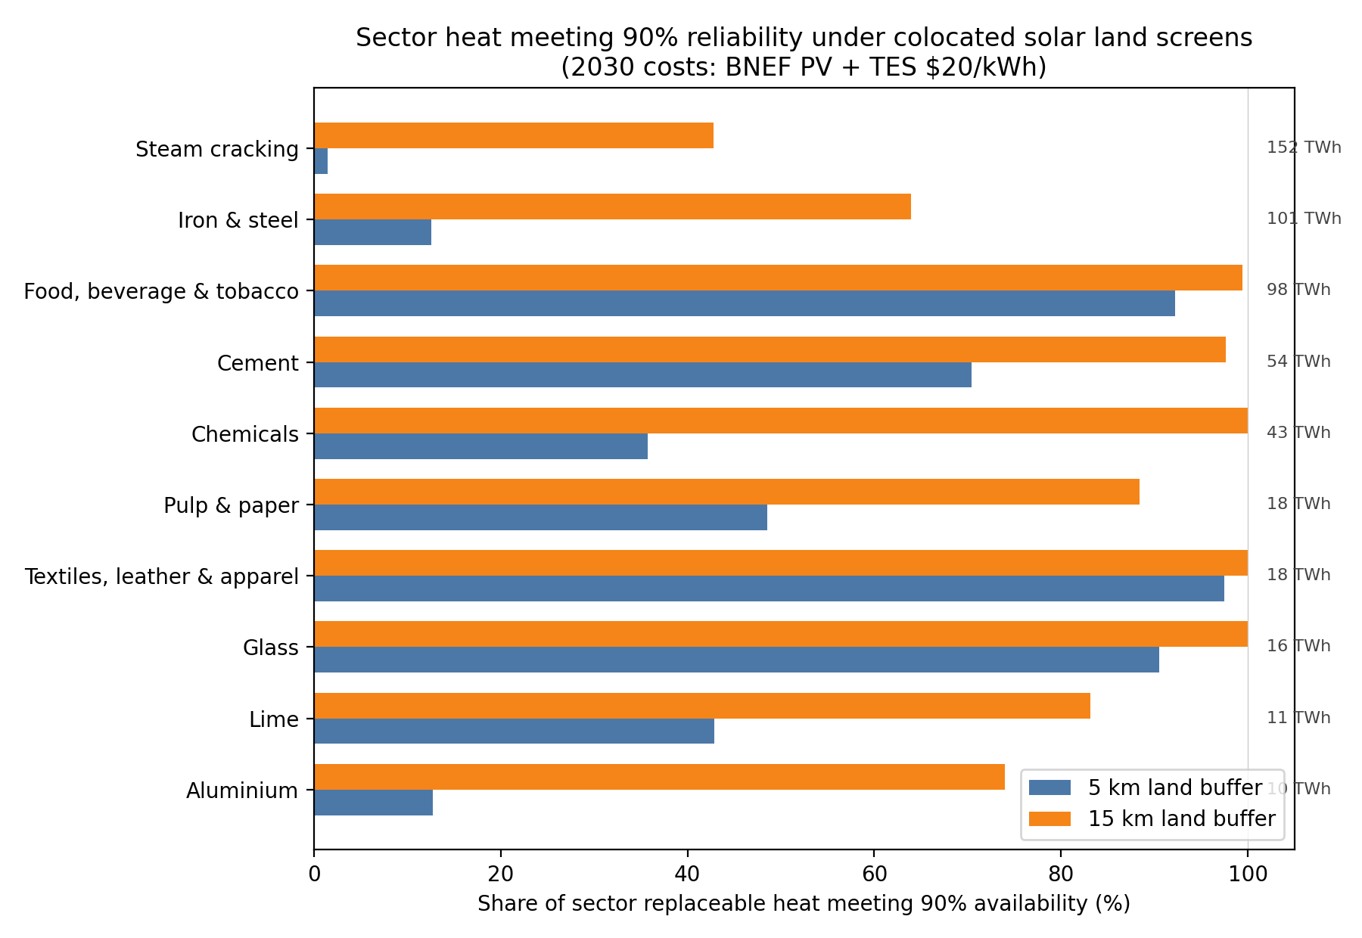
Fig. 5 | Share of sector replaceable heat meeting 90% availability under 5 km and 15 km co-located solar land screens (solar-plus-storage; 2030 costs). Bar length is heat-weighted feasibility, not site count; labels at right show sector replaceable heat (TWh/y, base case).
Cost-effective reliability concentrates in low-temperature, heat-pump-served heat. Among sites meeting 90% availability, food–beverage–tobacco and textiles–leather–apparel account for much of the lowest-cost quartile, with heat-weighted heat-pump load shares near 80–90% and temperature profiles dominated by bands below 200 °C. Southern European sites (Italy, Spain, Portugal, Greece and neighboring Mediterranean countries) that clear the 90% floor have annual solar capacity factors of about 18–21% (heat-weighted ≈ 20%), versus ≈ 16% across all ≥90% sites. By contrast, sites that fail the 90% floor are overwhelmingly high-temperature, land-binding and lower solar capacity factor. About 91% of failed heat is ≥200 °C, heat-weighted reliability on those sites is only ≈ 38%, and nearly all failed heat is at the solar land cap. Steam crackers, primary steel, and large chemicals dominate failed heat. Glass and much of cement more often clear 90% where land allows, but at higher LCOH because they rely on resistive IHB without a heat-pump COP benefit.

Land availability unlocks high-temperature heat
Of the fleet’s ≈ 383 TWh/y of high-temperature replaceable heat (≥200 °C), only 25% (≈ 96 TWh/y) sits at sites that meet 90% availability under the 5 km screen. Expanding developable land to a 15 km buffer, a proxy for shared or nearby solar rather than strictly on-site siting, raises that share to 67% (≈ 255 TWh/y). In other words, relaxing the land limit unlocks an additional ≈ 160 TWh/y of high-temperature heat (42% of fleet high-T heat) that was previously infeasible at 90% reliability. The unlocked tranche is itself high-T dominated (≈ 87% of its heat) and arrives at a heat-weighted LCOH_served of ≈ $95/MWh under 2030 costs. Low-temperature heat is already largely feasible at 5 km (79% of LT heat ≥90%) and nearly complete at 15 km (97%).
The same pattern appears when sites are grouped by hard-to-abate manufacturing sectors (steam cracking, iron and steel, cement, lime, glass, chemicals, aluminium). Hard-industry heat meeting 90% rises from 23% under the 5 km screen to 67% at 15 km. Sector shifts are large where plants are big and land-scarce: steam-cracker heat from 1.5% to 43%, iron and steel from 13% to 64%, while cement moves from already-high coverage to near-complete. About 170 TWh/y of hard-industry heat is unlocked only when the land radius expands, at a heat-weighted LCOH of roughly $87–95/MWh among newly feasible and already-feasible hard sites under 2030 costs — higher than food and textile economics, but competitive with fossil heat once gas and carbon costs are included (fleet heat-weighted gas-boiler benchmark ≈ $84/MWh, near the published ≈ €86/MWh_th fossil gas-boiler LCOH for 2030²⁴; Methods). A residual ≈ 128 TWh/y of high-T heat (33% of fleet high-T) still fails 90% even at 15 km, almost entirely at sites that remain land-capped: these are the true residual core under the present technology and cost assumptions, not evidence that high-T solar-plus-IHB is intrinsically uneconomic.
Heat-demand bounds (sector low/base/high; fleet ≈ 388–697 TWh/y) mainly change how often the land constraint binds. We treat heat-demand sensitivity as a robustness check on inventory uncertainty, not as the primary lever for hard-industry feasibility. From low to high heat under the 5 km screen, the ≥90% heat share moves from 49% to 38%; under 15 km, from 83% to 72%. Within-site LCOH is essentially unchanged when demand is scaled — fleet-average LCOH shifts are composition effects. The primary Results use 2030 technology costs applied to the 2024 heat inventory; 2025 costs raise heat-weighted LCOH among ≥90% sites to ≈ $87/MWh (5 km) and ≈ $106/MWh (15 km) without changing feasible heat shares. Additional sensitivities retained for extension include storage-CAPEX learning pathways, round-trip efficiency, and stricter land masks (Methods).

Discussion
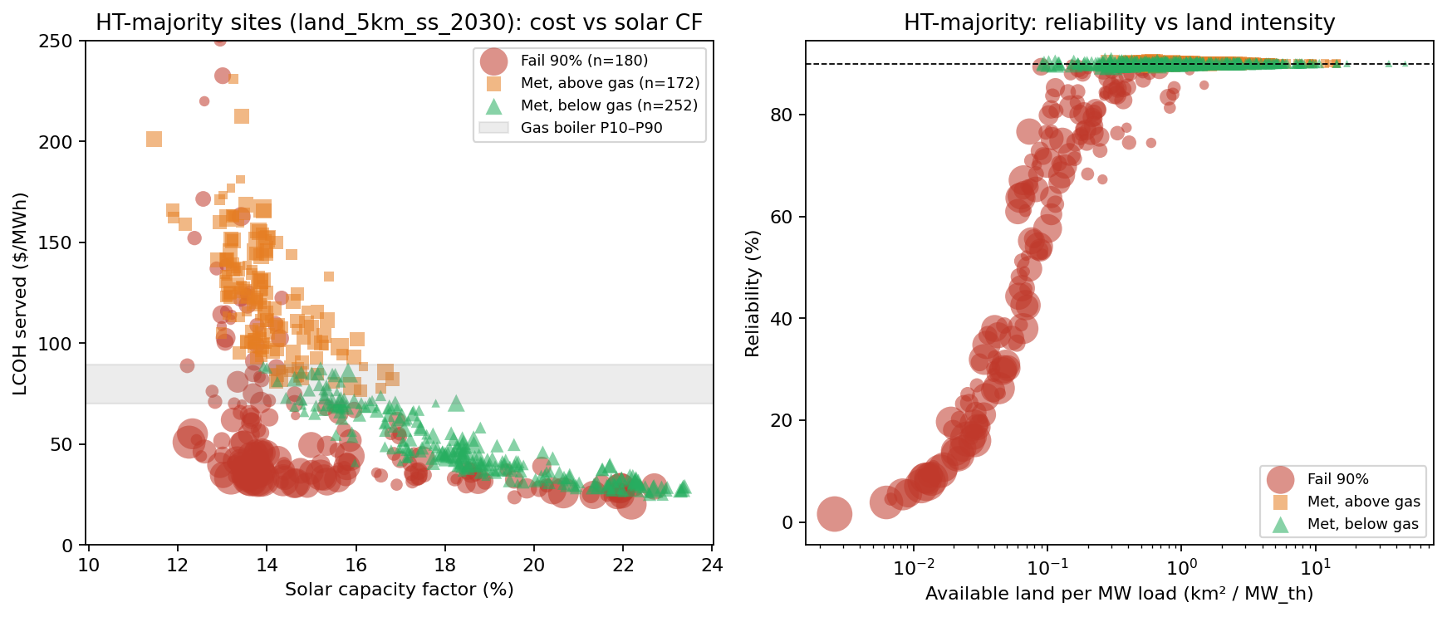
Fig. 6 | High-temperature–majority sites under the 5 km land screen (2030 costs). Left: LCOH_served versus annual solar capacity factor, with the country gas-boiler cost band (P10–P90). Right: reliability versus available land per unit thermal load; the dashed line marks the 90% availability target. Marker colour indicates whether the site meets 90% and whether LCOH_served is below the country gas-boiler benchmark.
The central implication is that hard-to-decarbonize industrial heat is often land-constrained rather than cost-prohibitive under solar-plus-battery systems. Where land within 5 km already supports full reliability, high-temperature and hard-industry sites that clear the 90% floor do so at heat-weighted LCOH_served near $70–100/MWh under 2030 costs (including heat-pump equipment). Where land is scarce, the same technologies cannot meet a high availability target, not because storage or solar are intrinsically too expensive, but because the optimized array hits the land cap first. Expanding the siting radius to 15 km more than doubles the high-temperature heat that achieves 90% reliability (25% → 67% of fleet high-T heat) and nearly triples hard-industry heat coverage (23% → 67%), at roughly $87–95/MWh for unlocked hard heat. Easy-to-serve low-temperature sites in sunny southern Europe remain the cheapest, but they should not define the headline for hard industries: the relevant claim is that a large share of high-T heat becomes fully reliable at mid-range industrial heat costs once nearby land is allowed.
Geography reinforces the solar-resource side of this story without overturning the land mechanism. Southern Mediterranean facilities that meet 90% combine high-capacity factors (≈ 18–21%) with predominantly low-temperature loads. Northern and coastal heavy-industry clusters combine poorer solar with large continuous high-T demand and limited developable land in the immediate buffer. Port crackers and integrated mills are among the hardest cases, whereas inland southern food and textile plants are among the easiest. Policy levers that expand usable land for co-located or nearby solar (shared industrial parks, agrivoltaic or brownfield preferences, coordination across neighboring parcels) therefore move the feasible frontier for hard heat as much as further declines in module or storage CAPEX.
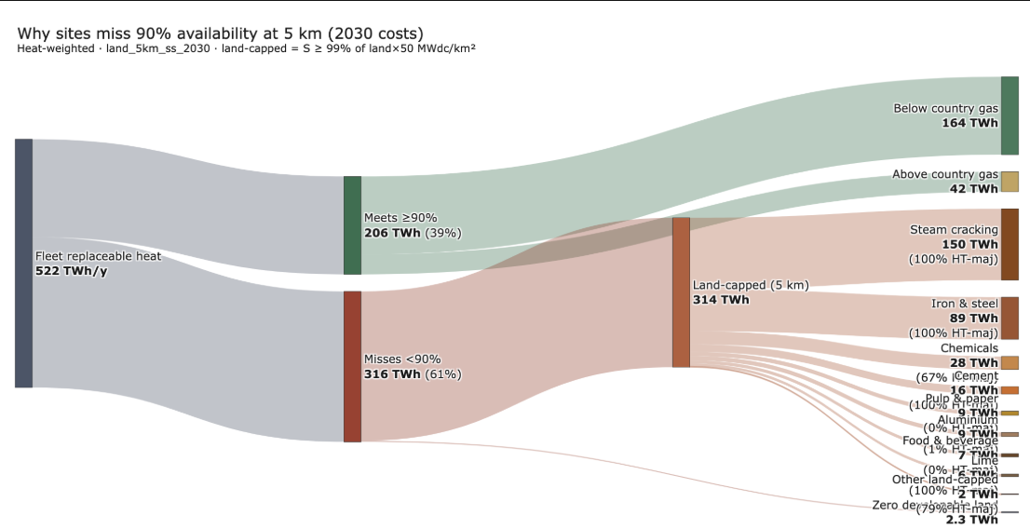
The land sensitivity is the result that carries the narrative. Heat-demand bounds mainly confirm that inventory uncertainty does not erase the cost finding for sites that remain feasible. The heat-weighted average cost can rise when land is relaxed precisely because more heat at higher temperature sites is served, a feature of successful unlock, not a deterioration of easy-site economics.

Limitations
Several simplifications bound how these results should be interpreted. Heat demand uses sector-average specific energy consumption, process efficiencies, and fossil shares rather than plant-measured fuel use, and temperature-band splits come from sector recipes rather than facility audits, so individual sites inherit sector-average band shares that may not describe them exactly. Production and emissions data come from Climate TRACE and related inventories and are best read as a screening-level estimate where facility coverage is incomplete, notably for pulp & paper and ceramics & glass (Methods). The flat annual load ignores shift patterns, weekends, and maintenance outages, and land availability is a geospatial screen (slope, protected areas, water) rather than a title, permitting, or grid-interconnection assessment. The 15 km case relaxes siting but is not unlimited land; a residual third of high-T heat remains land-capped even then. Technology costs are country-level and stylized rather than EPC quotes. The representative-day formulation is appropriate for the ≤16 h storage durations modelled here but would need reformulation for seasonal storage, and any claim of cost-effectiveness relative to fossil heat depends on the gas-and-carbon benchmark adopted for comparison.
Within these bounds, land availability is the binding constraint at most hard sites. Median LCOH among feasible sites is about $46–48/MWh under 2030 costs across the 5 km and 15 km screens, while the feasible share of high-temperature heat moves from one-quarter to two-thirds between those screens. Siting and land-use policy, alongside continued reduction in storage cost, therefore matter as much as technology cost trajectories for realizing the fleet-wide potential identified here.

Methods

Overview and analytical framework
This study assesses which EU industrial sites could cost-effectively replace fossil-fired process heat with solar-plus-industrial-heat-battery (IHB) systems (Fig. 1). Starting from Climate TRACE open-source facility data for the European Union, we build bottom-up estimates of the heat used in each facility’s manufacturing process. These estimates are validated against country- and sector-level totals from the Joint Research Centre’s Integrated Database of the European Energy System (JRC-IDEES)/IndustryHeat-EU¹, with the exception of the food sector, which is instead fitted to that reference (see ‘Emissions heat estimates’ below). We then use site-specific land availability and solar resource as constraints in a linear-program (LP) optimization that sizes the solar+IHB system and its levelized cost of heat (LCOH) at each site and use the results to identify which facilities and site characteristics are associated with cost-competitive decarbonization.
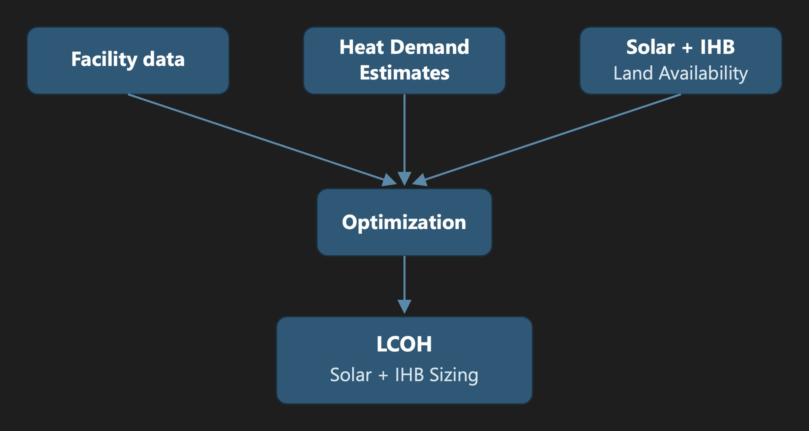
Fig. 1 | Analytical framework. Three independently derived facility-level inputs — heat-demand estimates (‘Replaceable heat demand estimation’), colocated solar resource (‘Solar radiation per facility’), and available land for colocated solar (‘Land availability for colocated solar’) — are combined with facility metadata from Climate TRACE (‘Facility dataset and scope’) and merged into a per-facility optimization (‘LCOH and system sizing’) that returns the sized solar-plus-IHB system and its levelized cost of heat for each site.

Facility dataset and scope
Climate TRACE lists 2,493 facilities in the EU-27 (excluding Malta, which has none) plus the United Kingdom. After removing 78 duplicate records and correcting 4 facility, 2,415 facilities remain. Eleven manufacturing subsectors are covered: food, beverage & tobacco; textiles & apparel; glass; cement; iron & steel; pulp & paper; lime; chemicals; other metals; petrochemical steam cracking; and aluminium. Each facility carries coordinates, annual production output, capacity factor, and annual CO2 emissions, spanning heat temperatures from 100 to 1,500 °C.

Replaceable heat demand estimation
We estimate the useful heat demand that an IHB can serve using a two-tiered approach based on data availability (Table 1). The higher-reliability tier applies sector specific energy consumption (SEC) to facility-level production data²; the lower tier, used only where production data are unavailable, infers fuel use from reported emissions. From useful heat we calculate replaceable heat by applying the fossil share of heat by country and sector³ (‘Fossil share to replaceable heat’, below).
Calculation route | Formulas
SEC route | fuel_energy = production × SEC  useful_heat = fuel_energy × η_process
Emissions route | fuel_energy = (CO₂e × combustion_share) / emissions_factor  useful_heat = fuel_energy × η_boiler
Replaceable heat | replaceable_heat = useful_heat × fossil_share
Table 1 | Heat-demand calculation routes.

SEC heat estimates
For sectors with per-facility production totals, we apply sector SEC values to obtain useful heat, then apply the fossil share to the SEC-derived value to obtain replaceable heat. Heat-intensity values are taken from Fraunhofer [TODO: cite] and process efficiencies from multiple literature sources (Supplementary Methods, Table S1).

Emissions heat estimates
Two sectors — food and textiles — lack per-facility production data and require the emissions route. In both, combustion emissions account for essentially all reported CO2 (unlike, e.g., cement, where limestone calcination also contributes); we assume a 90%/10% gas/oil fuel blend (EU-reported average) to convert emissions to fuel energy in TJ, then apply a boiler efficiency to obtain useful heat.
Climate TRACE flags high uncertainty in its modelled emissions. Comparing estimated energy need by country against JRC data¹ shows some countries overstated by up to 18× (Portugal) and others understated to 0.4× (Finland); we rescale emissions per country using the ratio of Climate TRACE to JRC totals. Because the food sector is fitted to this reference, it cannot be independently validated by the comparison in ‘Validation of the bottom-up estimate’ below — the rescaling only sets the within-country allocation, and the sector-wide estimate still relies on emissions data. The textile sector is not rescaled, since it already falls within a reasonable range of the reference, but it remains emissions-derived. The heat demand sensitivity analysis builds in the uncertainty of the heat estimates and provide an informed potential range for LCOH.

Fossil share to replaceable heat
Fossil shares are taken from Eurostat, matching NACE activity codes to Climate TRACE sector categories³. Electricity and derived heat are excluded, since useful heat here is combustion-derived, and biomass is excluded because an IHB cannot displace fuel that is burned as an unavoidable part of a process’s chemical feedstock (e.g., black liquor in pulp and paper):
fossil_share = fossil_fuel / (fossil_fuel + biomass_fuel)
Restricting the analysis to the fossil share gives a more realistic accounting of the share of heat generation an IHB can actually displace.

Heat estimate range
Heat estimates for each sector uses sector wide production and emissions factors. Due to the range of heat estimation, there is uncertainty baked into the heat demand used in the LCOH calculations. To counter that uncertainty, we tested different heat estimate ranges, adjusting for upper and lower limits of SEC or emission factors or efficiencies.
heat_low = base × low_factor
heat_high = base × high_factor
Upper and lower heat-estimate bounds, used in the sensitivity analysis (Results), differ by sector for the reasons in Table 2.
Sector | Base calculation | Low × | High × | Logic
Cement | production × 2.8 GJ/t × η 0.60 × fossil share (SEC ≈ 3.5 GJ/t clinker × 0.77 clinker/cement; η = Madlool kiln first-law, top of 50–60%) | 0.85 | 1.60 | Low: η = 0.50 instead of 0.60 → 0.50/0.60 ≈ 0.85 (same SEC).  High: METHODS ≈ 65 TWh vs Hotmaps/benchmark ≈ 104 TWh → ratio 1.60.
Lime | production × 4.5 GJ/t × η 0.65 × fossil share (EU average SEC; η = shaft ~0.80 / rotary ~0.55 mix) | 0.80 | 1.50 | Span published SEC 3.6–7.5 GJ/t (EuLA/BREF) and kiln-type η (≈ −20% to +50% around base).
Glass | production × 6.5 GJ/t × η 0.45 × fossil share (EU melting + working; furnace η mid of 40–50%) | 0.85 | 2.00 | Low: η toward high-efficiency end of 40–50%.  High: METHODS vs Hotmaps ratio ≈ 2.7; capped at 2.0.
Iron and steel | production × route SEC × η 0.70 × fossil share (BF/BOF SEC 4.8 GJ/t = sinter + rolling only; coke/BF excluded; EAF fuel 2.5 GJ/t) | 0.90 | 1.55 | Low: lean on final-consumption SEC floor.  High: raise toward ~7.5 GJ/t; METHODS vs benchmark ≈ 1.55.
Steam cracking | ethylene × 35.9 GJ/t × η 0.90 × fossil share (total furnace duty: external + byproduct fuel-gas) | 0.47 | 1.00 | Low: external-fuel-only 17 GJ/t / 35.9 ≈ 0.47.  High = base: full duty required for electrification.
Chemicals | product SEC × η × fossil share (e.g. ammonia fuel-only 9 GJ/t × 0.90; soda ash 10 GJ/t × 0.85) | 0.85 | 1.40 | Low: SEC/η lean  High: METHODS vs Hotmaps ≈ 1.40.
Pulp and paper | production × 10.5 GJ/t × η 0.85 × country fossil share | 0.70 | 1.15 | Low: higher biomass / lower fossil share (0.1–1.0 by country).  High: SEC + fossil-share upside (+15%).
Food, beverage, tobacco | fuel_TJ = CO₂e / 58.2  useful = fuel_TJ × 0.85; then × country scale to IndustryHeat-EU | 0.85 | 1.40 | Assumed sensitivity ranges that represent uncertainty in emission factor, fuel mix and within country allocation.
Textiles, leather, apparel | Same emissions inversion as food (EF 58.2, boiler η 0.85), no country rescale | 0.85 | 1.20 | Assumed sensitivity ranges that represent uncertainty in emission factor, fuel mix and within country allocation.
Aluminium | production × alumina/Al SEC × η × fossil share (e.g. Bayer ~11 GJ/t alumina × 0.85) | 0.90 | 1.15 | METHODS vs Hotmaps ≈ 1.11; tight band.
Table 2 | Sources of the low/high heat-estimate range by sector.
General production×SEC form: useful_heat = production × SEC × η × fossil_share.

Validation of the bottom-up estimate
We compared our bottom-up useful-heat estimates against JRC-IDEES/IndustryHeat-EU useful-energy-demand figures¹ — steam and four non-electric process-heat bands (<100, 100–400, 400–1,000, and >1,000 °C) — at both country and sector level, after matching subsector categories (Supplementary Methods, Table S2).
The bottom-up estimate reproduces the country picture well (Fig. 2): the EU-26 covered-sector total is 556 TWh against a 794 TWh reference (70%), and the largest industrial countries fall in a plausible band (Germany 71%, France 82%, Spain 73%, Italy 58%, Poland 68%, Netherlands 83%). Calculated totals are consistently at or below the reference, consistent with Climate TRACE not covering every facility.
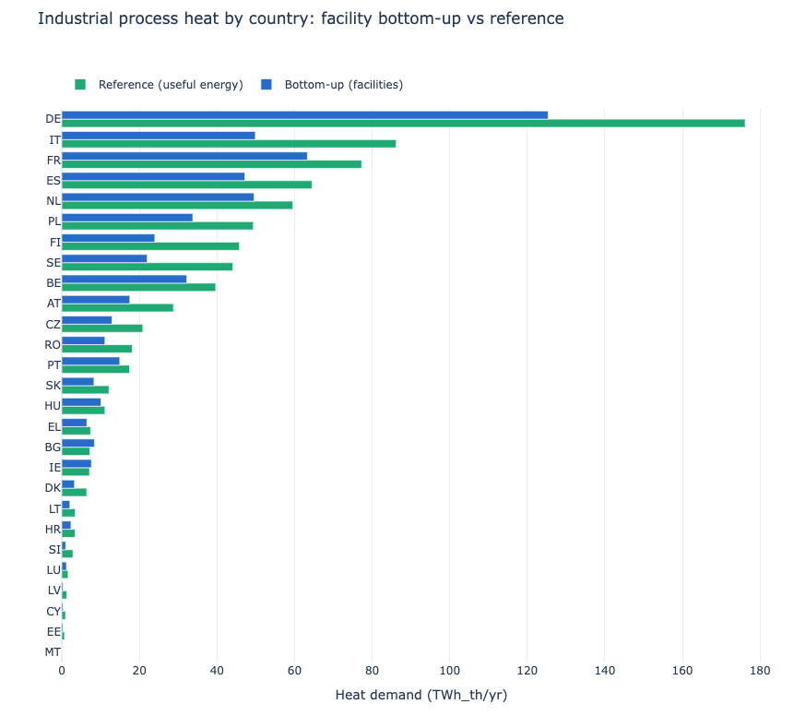
Fig. 2 | Bottom-up versus reference useful process heat, by country. Blue bars: this study’s facility-level bottom-up estimate of industrial process useful heat, aggregated by country (TWh_th/yr). Green bars: the corresponding JRC-IDEES/IndustryHeat-EU reference useful-energy-demand total for the same countries. Countries are the EU-26 (all EU-27 members with Climate TRACE coverage except Malta) plus the United Kingdom, sorted by reference value.
Sector-level totals also match well (Fig. 3), except for pulp & paper and ceramics & glass. For pulp & paper, Climate TRACE lists 79 pulp mills covering 21.8 Mt of the 73.9 Mt EU pulp production, but none of the 716 separate paper & board mills⁴; because the IndustryHeat-EU reference spans the whole pulp-and-paper sector including paper-drying steam, the bottom-up estimate captures only 27% of sector heat. For ceramics & glass, Climate TRACE covers only glass facilities — about 55% of EU glass production (20 of ~37.5 Mt)⁵ — and glass alone matches reasonably; the reference column also bundles ceramics, brick, and refractories, which we do not model.
Editorial note: confirm the ~85% / >1,000 °C figure for the bundled ceramics/brick/refractories share before submission — flagged as unverified in the original draft.
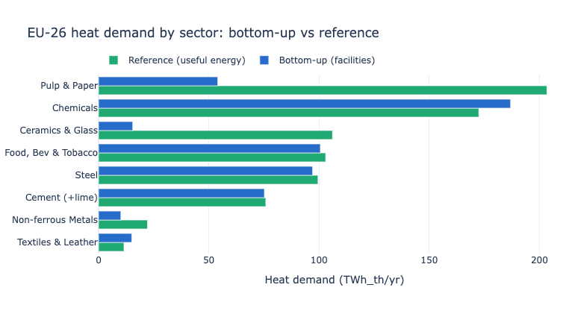
Fig. 3 | Bottom-up versus reference useful process heat, by sector. Blue bars: this study’s facility-level bottom-up estimate of EU-26 industrial process useful heat, aggregated by manufacturing subsector (TWh_th/yr). Green bars: the corresponding JRC-IDEES/IndustryHeat-EU reference useful-energy-demand total for the same eight subsector groupings (Supplementary Methods, Table S2).
Because the food estimate is fitted to the JRC reference (‘Emissions heat estimates’), it cannot be independently validated against it. Textiles retains its emissions-derived level and remains an independent, if emissions-dependent, estimate.

Heat generation and load profile

System configuration
Each facility is modelled as a single on-site solar PV array feeding two independent, temperature-split technology chains (Table 3): an industrial heat pump for loads below 200 °C, and an industrial heat battery for loads above 200 °C, up to ~1,500 °C. Every facility uses whichever chains its temperature profile requires. For example, a food plant’s heat demand is almost entirely supplied by heat pumps, a cement plant almost entirely by the resistive battery.
Heat demand band | Technology | COP | Notes
<100 °C | Industrial heat pump (low-temperature) | 2.7
100–200 °C | Industrial heat pump (steam) | 1.8 | Upper limit of the heat-pump pathway (~200 °C)
>200 °C, up to ~1,500 °C | Industrial heat battery | 1.0 | No efficiency multiplier
Table 3 | Heat demand bands, assigned technology, and coefficient of performance (COP).

Flat-load assumption
Heat demand is estimated only at annual resolution (production × SEC × fossil share or CO2 emissions × combustion share × emission factor). The heat profiles from Hotmaps are nearly flat and would not change the time demand onto solar hours. We therefore model replaceable heat as a flat, constant hourly load equal to annual replaceable heat divided by 8,760 hours. This deliberate simplification treats average load as peak load for sizing purposes, with no diurnal or seasonal variation.

Heat demand by temperature and mapping to technology
Each facility’s heat is split across five temperature bands (<100, 100–200, 200–500, 500–1,000, and >1,000 °C) using process recipes from industry fuel-SEC and band-share benchmarks (IndustryHeat / Hotmaps process data). For most manufacturing subsectors the Climate TRACE source type maps directly to a benchmark recipe (for example clinker calcination for cement, sinter plus rolling for BF–BOF steel, ethylene for steam cracking).
Where Climate TRACE types are generic, we assign a Hotmaps process from facility names before applying band shares. Food, beverage and tobacco sites are matched with multilingual keywords to Sugar, Dairy, Brewing, Meat processing, Bread & bakery or Starch. Sugar and bakery plants carry a high-temperature share and therefore receive industrial heat-battery capacity; dairy, brewing, meat and starch loads remain below 200 °C and are heat-pump served. Sites that do not match any keyword default to Dairy (heat-pump only), rather than an equal-weight blend of all food processes, so unmatched plants are not assigned sugar- or bakery-like high-temperature demand. Glass works are name-matched to container, flat, fibre or other glass when possible, otherwise an EU product mix; lehr and annealing heat is folded into the melt band so glass is modelled as industrial-heat-battery only. Textiles and pulp and paper are treated as sub-200 °C steam loads (heat-pump only). Dual heat-pump and industrial-heat-battery equipment at one site is reserved for genuine co-located low- and high-temperature unit operations (notably alumina refining and soda ash, and name-matched sugar or bakery plants).
Technology follows the band: the two sub-200 °C bands to heat pumps with shared lithium-ion storage, and all higher bands to the industrial heat battery. Across the mapped fleet these placements concentrate heat-pump duty in food, textiles and paper, and industrial heat-battery duty in cement, lime, glass melt, steel finishing, chemicals and steam cracking.
Heat demand uses Hotmaps / IndustryHeat temperature demand bins (<100, 100–200, 200–500, 500–1,000 and >1,000 °C)—the buckets that split each facility’s annual process heat by temperature. Heat-pump CAPEX instead follows Rissman’s commercial product classes ($700/kW_th for roughly 80–100 °C; $870/kW_th for roughly 100–180 °C). We reconcile the two by mapping the nearer Rissman cost class onto each Hotmaps demand bin: the 80–100 °C costs to demand below 100 °C, and the 100–180 °C costs to the full 100–200 °C demand bin. The heat-pump versus industrial-heat-battery technology boundary stays at 200 °C to match the demand bins (and Rissman’s own heat-demand framing under/over 200 °C); loads at or above 200 °C fall outside the heat-pump cost tables and are served by the industrial heat battery. Heat between 180 and 200 °C is not separately resolved in the benchmarks; under a uniform split of the 100–200 °C bin only a few percent of fleet heat would change technology class.
E_replaceable,b = replaceable_heat_MWh × (heat_band_b / Σ_b heat_band_b)
load_b [MW] = E_replaceable,b / 8760

Solar radiation per facility
Hourly PV output per facility is retrieved from the PVGIS seriescalc API using the PVGIS-ERA5 database for 2023⁶, modelled as a 1 kWp system with tilt equal to site latitude, azimuth due south, and zero system losses. Output is converted to kW/kWp, localized to each site’s time zone, and reindexed to a complete 8,760-hour series (missing hours set to zero); annual yield and capacity factor are derived per facility.
Across the mapped facilities, annual yield has a median of 1,333 and a mean of 1,412 kWh/kWp (range ~900–2,000 kWh/kWp), correlates strongly and negatively with latitude (Pearson r ≈ −0.92), and reproduces the known European solar gradient — brightest across Iberia, Italy, and Greece; dimmest across the Nordics, the UK, and the Baltics (Fig. 4). Representative sites span this range, from Cyprus (~2,049 kWh/kWp) to northern Sweden at 67°N (~967 kWh/kWp).
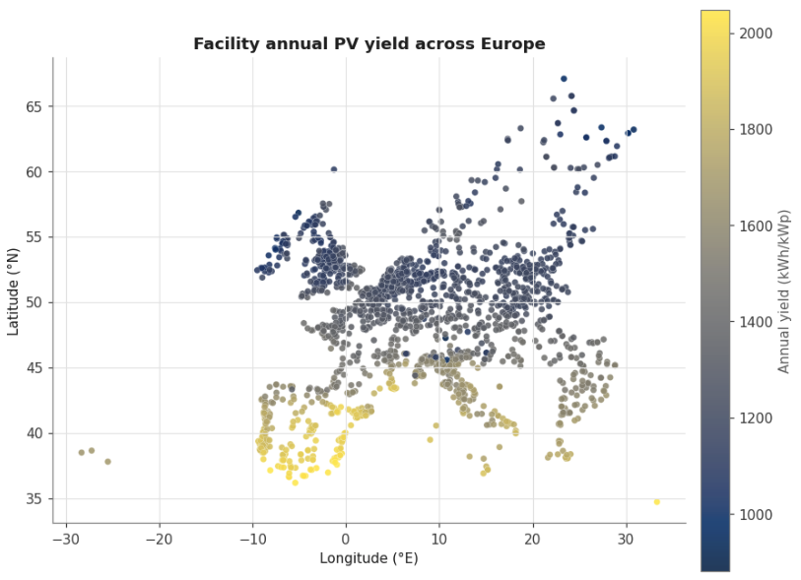
Fig. 4 | Facility-level solar resource across the study area. Each point is one Climate TRACE facility (n = 2,415), positioned by longitude and latitude and colored by annual PV yield (kWh per kWp per year) from the PVGIS-ERA5 database for calendar year 2023, modelled as a 1 kWp system at site-latitude tilt with zero system losses.

Land availability for colocated solar
For each facility we compute developable land for colocated solar within 5 km and 15 km buffers (the latter for sensitivity), using ESA WorldCover land-cover data⁷ via Google Earth Engine zonal statistics⁸. Two exclusions are applied before summing developable area: slope greater than 5°, and WDPA-protected areas⁹ plus a 100 m buffer. Bare ground, cropland, grassland, and shrubland are summed as available land (km²); forest, built-up land, water, wetland, snow/ice, mangroves, and moss/lichen are treated as not developable. Available land caps solar capacity in the optimization; where a 90% reliability target cannot be met within that cap, the model relaxes the floor and reports the reliability achievable.
All 2,415 facilities carry land data and average 48.2 km² of developable land per facility within the 5 km buffer (61% of the buffer area). The remainder is masked by slope/protected-area filters or falls outside WorldCover’s coverage. Twenty-six facilities, concentrated in food, beverage & tobacco, textiles & apparelm and pulp & paper, have zero developable land, typically dense or built-up sites with no open ground nearby.

Technology and cost data
Technology costs are assigned at the country level in US dollars for the chosen project-start year. The primary Results use 2030 BNEF tables for fixed-axis solar PV and utility-scale four-hour lithium-ion batteries; countries without a direct observation are proxied from income- and region-peer averages, and the UK uses Ireland as its proxy. Solar and lithium-ion CAPEX are annualized with the country-specific capital-recovery factor (CRF) implied by BNEF. Industrial heat-pump CAPEX and fixed O&M (Rissman / Agora–FutureCamp–Wuppertal basis: $700 and $870 per kW_th with $12 and $18 per kW_th-yr FOM in 2021 dollars for the ~80–100 °C and ~100–180 °C product classes, mapped onto Hotmaps demand bins <100 °C and 100–200 °C as above) and Energy Innovation industrial heat-battery CAPEX ($100/kW-in, $300/kW-out, $5/kWh in 2023 dollars) are converted to constant 2030 dollars with US CPI-U (plus 2%/yr beyond the latest observed annual index) before the same country CRF is applied. Heat-pump thermal capacity in the cost accounting is sized to served heat.
For the industrial heat battery, round-trip efficiency is 95%. Storage duration is capped at 16 h at the discharge rating, and co-located PV density is capped at 50 MWdc/km² of available land. Lithium-ion round-trip efficiency is 90%. Legacy thermal-store screening assumptions ($20/kWh_th with a fixed 7% discount rate) are retained only as sensitivity context; primary Results use the Energy Innovation power-and-energy CAPEX structure above.
Heat delivery follows Table 3 (COP 2.7 below 100 °C, 1.8 for 100–200 °C, 1.0 above 200 °C). COP still governs the electricity-to-heat conversion. The country CCGT LCOE from BNEF provides a fossil-generation screening benchmark. For Results cost-effectiveness claims we use a country gas-boiler heat cost constructed from industrial end-user gas prices by country (project cost tables; Eurostat nrg_pc_203 is the natural primary statistical source for an equivalent series), divided by boiler efficiency 0.85²², plus EUA carbon at €79/tCO₂, converted at EURUSD = 1.08 (≈ €61–122/MWh_th across study countries; fleet heat-weighted ≈ $84/MWh). As a published comparator, Reform Institute reports a fossil gas-boiler LCOH of ≈ €86.3/MWh_th in 2030 (≈ €90.9–104.7/MWh_th over 2035–2050; Annex 3, Table 18) in the Poland scenarios compiled by Agora Industry & Agora Energiewende²³,²⁴. Agora’s Germany comparison (Table 2; Fig. 10) reports gas and CO₂ price scenarios used to compute technology LCOHs, including the 2024 gas-plus-CO₂ parameter of €80.6/MWh, rather than a single EU-wide gas-boiler LCOH figure²³.

LCOH and system sizing
For each facility with positive replaceable heat and a PVGIS profile, we size a co-located solar-plus-storage system with a linear program (HiGHS). Replaceable heat is split across temperature bands, converted to constant thermal power (MW_th) under a flat-load assumption, and served by heat pumps with shared lithium-ion storage below 200 °C or by the industrial heat battery at higher temperatures. The objective is lexicographic: meet a 90% annual availability floor when land allows (otherwise maximize served heat), then minimize annualized system cost at that serve level.
Because storage is short-duration (≤16 h) and cycles within a day, we reduce the year of hourly solar to 16 representative days by k-means clustering of the 365 daily PVGIS profiles, solve each as a 24-hour block with cyclic state-of-charge, and weight days by cluster membership—shrinking the LP relative to a full 8,760-hour solve with limited loss of accuracy for daily-cycling storage.
Component | CAPEX | Fixed OPEX | Annualized (avg) | Year | Notes
Solar PV (fixed-axis) | $427/kW | $10.4/kW-yr | ~$41k/MW-yr | 2030 | CAPEX×CRF + FOM; CRF ≈ 7.1%
Li-ion (BNEF 4h utility) | $727/kW system → $182/kWh | $7.1/kW-yr on discharge power | Energy: ~$13k/MWh-yr; FOM: ~$7k/MW-yr | 2030 | CAPEX on energy only; FOM on power only
IHB charge (in) | $100/kW | 0% of CAPEX | ~$7.1k/MW-yr | 2023 | Rissman & Gimon, Energy Innovation, July 2023
IHB discharge (out) | $300/kW | 0% | ~$21k/MW-yr | 2023 | Same
IHB storage | $5/kWh | 0% | ~$0.36k/MWh-yr | 2023 | Same; RTE 95% confirmed in source
Heat pump (<100°C) | $700/kW | $12/kW-yr | ~$62k/MW-yr | 2021 | Rissman (2022 report), German cost basis via Agora/FutureCamp/Wuppertal
Heat pump (100°C–200°C) | $870/kW | $18/kW-yr | ~$80k/MW-yr | 2021 | Same source

Decision variables and coupling
Decision variables are shared solar capacity S (MW_dc); shared lithium-ion energy and discharge power for heat-pump bands; and, per industrial heat-battery band, charge power, discharge power and storage energy, together with hourly charge, discharge, state-of-charge and unserved heat. Available PV output bounds the sum of heat-pump direct use, lithium-ion charging and industrial heat-battery charging:
Σ_b charge_b,t ≤ S · cf_t
where cf_t is the PVGIS per-kWp capacity factor. For heat-pump bands, solar or battery electricity is converted to heat at the band COP. For industrial heat-battery bands, charge and discharge obey a 95% round-trip efficiency (symmetric square-root factors on charge and discharge). Discharge plus unserved heat equals the flat band load:
discharge_b,t + unserved_b,t = load_b
Lithium-ion and industrial heat-battery energy and power ratings, and the 16 h discharge duration cap, are bounded as in ‘Technology and cost data’.

Land constraint and reliability
Solar capacity is capped by screened land,
S ≤ A_land · 50 MWdc/km²
using the 5 km buffer as the base case and 15 km in sensitivity. We impose a 90%-of-annual-replaceable-heat availability floor. If a facility is infeasible under the land cap, a two-phase solve first maximizes served heat, then minimizes cost at that served level. Unserved heat is unpriced (value of lost load = 0), so reported LCOH reflects annualized capital and fixed O&M for solar, storage and heat-pump equipment.

Levelized cost of heat
Annualized solar cost is (CAPEX_PV · CRF_country + FOM_PV) · S. Lithium-ion costs charge energy CAPEX (implied $/kWh from the four-hour BNEF system price) at the country CRF and fixed O&M on discharge power. Industrial heat-battery costs annualize charge-power, discharge-power and energy CAPEX at the country CRF. Heat-pump costs annualize temperature-band CAPEX plus absolute FOM on served thermal capacity. With C_ann as total annualized cost and Q_served the optimized served heat,
LCOH_served = C_ann / Q_served LCOH_total = C_ann / Q_demand
where Q_demand is annual replaceable heat. We report LCOH_served as the primary metric, alongside reliability (Q_served/Q_demand) and whether the 90% floor was met; component shares allocate annualized solar, heat-pump, lithium-ion and industrial heat-battery cost to Q_served. Sites where LCOH_served falls below the country gas-boiler benchmark and the availability target is met (where land allows) are treated as economically favourable relative to gas-fired heat under these assumptions.

Data availability
[TODO: repository/DOI for the facility-level assessment file (eu_ihb_site_assessment_2024.csv) and derived outputs, per Nature Energy’s data-availability policy.]

Code availability
The analysis pipeline — heat-demand estimation, solar-resource retrieval, land-availability processing, and the multi-band LP optimization — is summarized in Supplementary Methods (pipeline overview).
[TODO: repository URL/DOI, per Nature Energy’s code-availability policy.]

Acknowledgements
[TODO]

Author contributions
[TODO — CRediT-style statement, e.g. “A.B. designed the study; A.B. and C.D. performed the analysis; ...”]

Competing interests
[TODO — required for all Nature Energy content]

References
1. Gjorgievski, V., Cundeva, S., Markovska, N. & Duić, N. IndustryHeat-EU: Harmonized Dataset of Industrial Final and Useful Energy Demand by Temperature Level for EU27 and Member States. Zenodo https://doi.org/10.5281/zenodo.17414346 (2025).
2. Pezzutto, S. et al. Hotmaps Project, D2.3 WP2 Report – Open Data Set for the EU28. www.hotmaps-project.eu (2018).
3. Eurostat. Disaggregated final energy consumption in industry by NACE Rev. 2 activity – quantities [dataset]. [FILL IN dataset code and access date].
4. Confederation of European Paper Industries (CEPI). Key Statistics 2023 – European Pulp & Paper Industry (CEPI, 2024).
5. Glass Alliance Europe. Statistical Report [FILL IN exact edition/year – cited in the draft as “2025–2026”].
6. European Commission Joint Research Centre. PVGIS – Photovoltaic Geographical Information System, PVGIS-ERA5 database [FILL IN access date/version]; https://re.jrc.ec.europa.eu/pvg_tools/en/
7. Zanaga, D. et al. ESA WorldCover 10 m 2021 v200. Zenodo https://doi.org/10.5281/zenodo.7254221 (2022).
8. Gorelick, N. et al. Google Earth Engine: planetary-scale geospatial analysis for everyone. Remote Sens. Environ. 202, 18–27 (2017).
9. UNEP-WCMC & IUCN. Protected Planet: The World Database on Protected Areas (WDPA) [FILL IN access month/year]; www.protectedplanet.net
10. BloombergNEF. [FILL IN exact title of the technology-cost compilation used] (BloombergNEF, 2025).
11. Huangfu, Q. & Hall, J. A. J. Parallelizing the dual revised simplex method. Math. Program. Comput. 10, 119–142 (2018).
12. Madlool, N. A., Saidur, R., Hossain, M. S. & Rahim, N. A. A critical review on energy use and savings in the cement industries. Renew. Sustain. Energy Rev. 15, 2042–2060 (2011).
13. European Commission. Best Available Techniques (BAT) Reference Document for the Production of Cement, Lime and Magnesium Oxide [FILL IN year – draft cites both 2013 and a 2019 revision].
14. Beerkens, R. G. C. & van Limpt, H. A. C. Energy efficiency benchmarking of glass furnaces. Ceram. Eng. Sci. Proc. 23, 93–105 (2008).
15. Schmitz, A., Kamiński, J., Scalet, B. M. & Soria, A. Energy consumption and CO2 emissions of the European glass industry. Energy Policy 39, 142–155 (2011).
16. IEA. Iron and Steel Technology Roadmap: Towards More Sustainable Steelmaking (IEA, 2020).
17. World Steel Association. [FILL IN exact energy-statistics publication/year]; worldsteel.org
18. Ren, T., Patel, M. & Blok, K. [FILL IN exact title]. Energy 31, 425–451 (2006).
19. [FILL IN authors]. Ethylene. In Ullmann’s Encyclopedia of Industrial Chemistry [FILL IN edition/year].
20. European Commission. BAT Reference Document for the Manufacture of Large Volume Inorganic Chemicals (LVIC) [FILL IN year].
21. International Aluminium Institute. [FILL IN exact energy-data publication/year]; international-aluminium.org
22. US Department of Energy. [FILL IN specific industrial steam-boiler efficiency benchmark report/URL].
23. Agora Industry & Agora Energiewende. The business case for electrifying industrial heat (Agora Industry / Agora Energiewende, 2025); https://www.agora-industry.org/fileadmin/Projekte/2023/2023-36_IND_Electrification_low_heat/A-IND_396_The_business_case_for_electrifying_industrial_heat_WEB.pdf. Table 2 and Fig. 10 (Germany/Fraunhofer ISI): gas and CO₂ price scenarios and technology LCOH comparison. Annex 3 / Poland chapter reproduces Reform Institute heat-cost tables including fossil gas-boiler LCOH.
24. Reform Institute. Clean industrial heat: Electrification scenarios for selected sectors (Reform Institute, 2025); https://ireform.eu/en/our-projects/clean-industrial-heat-electrification-scenarios-for-selected-sectors-reform-institute-report/. Fossil gas-boiler LCOH ≈ €86.3/MWh_th in 2030 (Table 18 in Agora Industry & Agora Energiewende 2025, Annex 3); operating cost alone ≈ €85.1/MWh_th in 2030 (Table 17).

Supplementary Methods
(Retained here for drafting purposes; would be submitted as a separate Supplementary Information file per Nature Energy guidelines.)

Table S1. Subsector process efficiencies (fuel input to useful heat)
Subsector | Eff. | What it represents | Source
Cement | 0.60 | Kiln pyro-processing first-law efficiency | Madlool et al. [12], 50–60% kiln-system; cross-checked vs. IEA Cement Roadmap (BAT ~3.0 vs. theoretical ~1.8 GJ/t)
Lime | 0.65 | EU mix of shaft (~0.80) + rotary (~0.55) kilns | EU BREF Cement/Lime/MgO [13] (4–5 GJ/t vs. theoretical ~3.2)
Glass | 0.45 | Melting-furnace efficiency (large flue-gas/structural losses) | Beerkens & van Limpt [14]; Schmitz et al. [15] (regenerative melting 40–50%)
Iron & steel | 0.70 | Reheating/sinter furnaces w/ recuperation (65–75%) | IEA Iron & Steel Roadmap [16]; worldsteel energy statistics [17]
Petrochem. steam cracking | 0.90 | Fired heater w/ strong convection recovery | Ren, Patel & Blok [18]; Ullmann’s “Ethylene” [19] — flagged least-certain
Chemicals — ammonia/methanol | 0.90 | Reformers / fired heaters w/ heat recovery | (same class as cracking)
Chemicals — soda ash | 0.85 | Steam-boiler-led | EU BREF LVIC [20]
Aluminium — refinery | 0.85 | Bayer digestion/calcination steam boiler | IAI energy data [21]
Aluminium — smelting | 0.65 | Anode-bake + cast-house fired furnaces | IAI energy data [21]
Pulp & paper | 0.85 | Steam boiler | US DOE typical industrial steam boiler [22]
Food & beverage; textiles | 0.85 | Boiler efficiency (emissions-inversion route) | US DOE typical industrial steam boiler [22]
Editorial note: the cement (0.60) and lime (0.65) efficiencies above come from the SEC route (Madlool et al.; EU BREF) and are noticeably lower than the ε values used for the same processes in the companion E-PRTR/LCP-based reference table for this project (cement ε ≈ 0.75; lime ε ≈ 0.78, from Saad et al. 2026 / LCP BREF). Reconcile which value is authoritative for this paper — or state explicitly why the two data routes (Climate TRACE/SEC vs. E-PRTR/LCP) justify different point estimates for the same physical process — before submission.

Table S2. IndustryHeat-EU subsector mapping to Climate TRACE subsector
Climate TRACE subsector | IndustryHeat-EU column | Grouped label
iron-and-steel | Primary Steel + Secondary Steel | Steel
chemicals | Chemicals | Chemicals
petrochemical-steam-cracking | Chemicals | Chemicals
cement | Cement | Cement (+lime)
lime | Cement (no own column) | Cement (+lime)
glass | Ceramics and Glass | Glass
pulp-and-paper | Pulp and Paper | Pulp & Paper
food-beverage-tobacco | Food, Beverages and Tobacco | Food, Bev. & Tobacco
textiles-leather-apparel | Textiles and Leather | Textiles & Leather
aluminum | Non-ferrous Metals | Non-ferrous Metals
other-metals | Non-ferrous Metals | Non-ferrous Metals

Pipeline overview
Upstream stages (heat demand, solar radiation, land availability) each run independently and write facility-level files; a combine step merges them by facility ID into a single site-assessment file, which the multi-band optimization reads together with country technology costs and hourly solar profiles to produce per-facility LCOH, reliability, and sizing outputs.
UPSTREAM STAGES (run independently, each writes files)

heat_demand/... -> facilities_2024_eu_replaceable.csv
(replaceable_heat_mwh)
solar_radiation/pull_pvgis.py -> hourly_profiles/*.parquet
+ solar summary
land_availability/... (GEE+merge) -> land_availability_by_facility.csv

|
v

COMBINE -- flatblock_optimization/inputs/build_sites_input.py
merges the three above (by source_id) into:
-> outputs/eu_ihb_site_assessment_2024.csv (the single "everything" file)

|
v

OPTIMIZE -- run_multiband_potential.py
(multi-band HP + IHB; also run_ihb_potential.py for single-load TES)
reads sites_csv = outputs/eu_ihb_site_assessment_2024.csv
+ Input/bnef_country_costs.csv (country tech costs)
+ flatblock_optimization/inputs/input_heat_battery_cost.csv
+ solar_radiation/outputs/hourly_profiles/*.parquet (read at runtime)
-> outputs/multiband/<scenario>/by_facility.csv
(LCOH, reliability, sizing; --heat-case low|base|high)

“Decarbonizing Industrial Heat to Face Climate Change | Arthur D. Little,” February 28, 2024, https://www.adlittle.com/cz-en/insights/report/decarbonizing-industrial-heat-face-climate-change.
“Shedding Light on Energy in the EU: Share of Energy Products in Total Energy Available,” Shedding Light on Energy in the EU: Share of Energy Products in Total Energy Available, accessed July 23, 2026, https://ec.europa.eu/eurostat/cache/interactive-publications/energy/2025/01/index.html?lang=en&simple=true.
Rosenow, J. Europe on the way to net zero: What challenges and opportunities? PLOS Climate 1, e0000058- (2022).
Prepared Simon Pezzutto et al., D2.3 WP2 Report – Open Data Set for the EU28, n.d.
Jeffrey Rissman and Eric Gimon, Industrial Thermal Batteries, n.d.
Jeffrey Rissman, Decarbonizing Low-Temperature Industrial Heat in the U.S., n.d.

