FACILITY-LEVEL TECHNO-ECONOMIC POTENTIAL OF ELECTRIFIED INDUSTRIAL PROCESS HEAT IN EUROPEAN MANUFACTURING
Anna Yuen^{1, *}, Emilia Chojikiewicz¹, Amol Phadke²
¹Energy and Resources Group, University of California, Berkeley, United States
¹Energy and Resources Group, University of California, Berkeley, United States
²Goldman School of Public Policy, University of California, Berkeley, United States
*Corresponding author. Email: anna_yuen@berkeley.edu

Keywords: INDUSTRIAL DECARBONISATION, HEAT PUMPS, HEAT BATTERIES, OFF-GRID SOLAR PV, TECHNO-ECONOMIC ANALYSIS

Abstract
Industrial process heat dominates manufacturing emissions in the EU. Roughly 75% of energy used for industrial process heat is powered by fossil fuels. Yet, there are readily available solutions that can continuously generate process heat. Industrial heat pumps and thermal energy storage solutions paired with on-site solar PV can be a solution to bring power to heat generation quickly and cost competitively with natural gas. Using a dataset of 2,192 facilities of different manufacturing sectors from Climate TRACE, each facility is modelled with co-located, off-grid solar PV with industrial heat pumps and batteries installed in 2030. Under this modelled configuration, 59% of fossil-fuelled process heat can be decarbonized using solar PV within a 5 km buffer zone around each facility site at an average levelised cost of heat of €55/MWh. After expanding the buffer zone to 15 km, the share of possible decarbonized heat rises to 84% of process heat at €62/MWh against an EU average gas-heat cost of €93/MWh. Each facility is optimized to provide the highest availability and highest savings under its country's gas costs. These results show that Southern Europe can cost-competitively decarbonize over 95% of its heat demand. Central Europe (Rhine-Meuse Region), where most of the large, heat intensive sources are located, can decarbonize over 70% of its heat demand using on-site solar plus storage.

Introduction
- Problem: Fossil fuel makes up ~75% of industrial process heat in EU in 2019.
- Technology: heat pumps and electrified thermal energy storage
  - Heat pumps are commercially ready, and electrified thermal energy storage (ETES) is rapid advancing
  - Explain how heat pumps (COP) and ETES work
- Current barriers:
  - High electricity prices: Average industrial electricity prices are €162/MWh, €77/MWh more than average glass prices with carbon tax.
    - Total Industrial Bill = Commodity Energy + Network/Capacity Fees + Taxes/Levies + Grid Service Fees
    - Commodity energy: what you get from energy market
    - Network/Capacity Fees: what you pay to the TSOs (state owned grid infra). Most impacted by high congestion windows.
    - Taxes/Levies: carbon tax
    - Grid Service Fees: machinery to manage reactive energy
    - Mostly volumetric costs dominate bill
    - High exposure to wholesale prices
    - Non-firm supply is commonly enforced.
    - Recently Germany had a 5-cent cap per kWh to subsidize their industrial energy use
  - Long interconnection queues: variable. Ranges from 3 years in Southern Europe and 5-10 years in Netherlands and Germany (big industrial manufacturing hubs)
  - Gas dependence and energy security: Russia-Ukraine war, Strait of Hormuz. International conflicts that increase gas prices by 125-150%.
- Context for off-grid energy system
  - Land permits: can take 12-24 months to get approved. Member states must map suitable land by 21 May 2025. They also would need EIA Directive
  - France and Italy do not allow solar farms on cropland or limit the amount of PV.
  - Process (2-5 years):
    - securing the land (lease 25-30 years)
    - rezone or plan for rezone with approval for public and municipal approval
    - Environmental review
    - Building permit and connection route. Solar farms need private line/heat pipe to plant which would require easements, road and river crossings.
- Literature review:
  - Off grid/collocated renewable heat studies (Dominguez, et al. (IECC))
  - Saad has worked on facility level heat demand in the US. McMillan has done facility-level technical potential of alternative thermal sources to meet industrial heat demand in the US using GHGRP data.
  - Markussen did a TEA of technologies for decarbonizing low & medium temperature industrial heat but not for solar + TES systems.
  - Table to compare scope: facility level, spatial resolution, technologies, off-grid, hourly dispatch, country-specific costs and benchmark
    - Our study contains high fidelity modeling
- Gap and contribution
  - First facility level assessment of off-grid solar + heat pump + ETES for EU process heat
  - Co-optimized for site-specific hourly solar, land availability, country specific costs and WACC
  - Comparison of max savings and max heat
  - Spatial analysis of regions

Results
- Max saving and Max heat comparisons: Majority of heat can be decarbonized at below LCOH
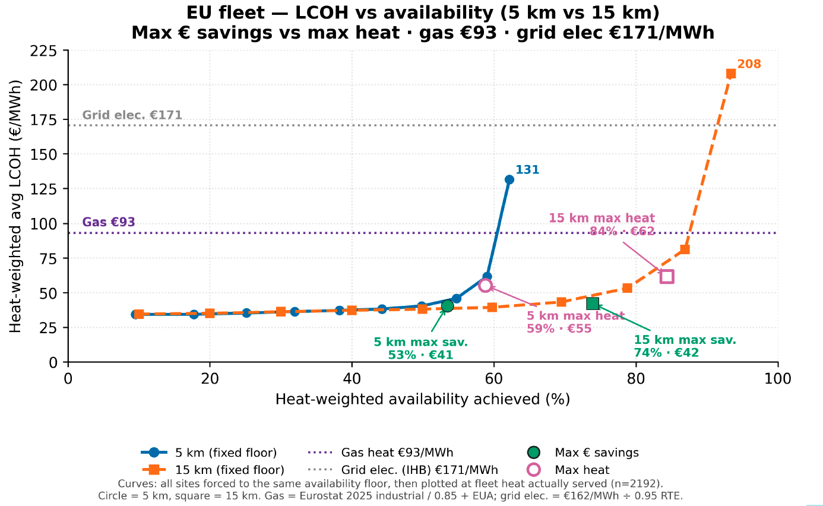
- Regional analysis
  - Heavy industrial customers (Germany, Netherlands) can have around 2/3rd of their heat demand supplied through this solution
  - Southern Europe is already able to meet their heat demand.
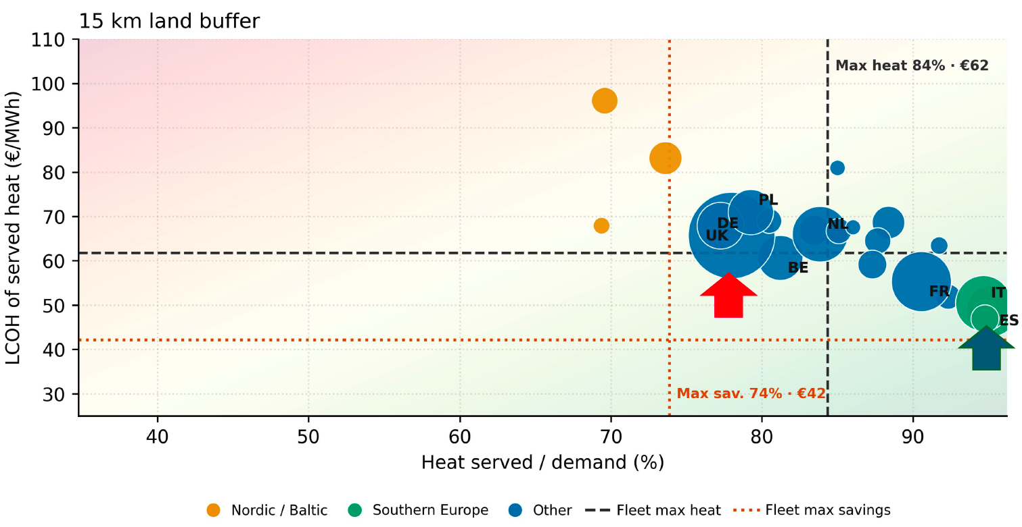
- Analysis by industry: food & beverage, iron & steel, chemical, etc. with temperature bands
- Solar resource vs land constraint

Sensitivity and uncertainty analysis
- Heat demand
- Carbon tax
- Capex of prices
- Land availability
- Weather variability

Discussion
- Flat load assumption
- Heat demand data
- Land acquisition process

Methods
- Dive deeper into land availability reasoning

