FACILITY-LEVEL TECHNO-ECONOMIC POTENTIAL OF ELECTRIFIED INDUSTRIAL PROCESS HEAT IN EUROPEAN MANUFACTURING
Anna Yuen^{1, 2 *}, Amol Phadke²
¹Energy and Resources Group, University of California, Berkeley, United States
²Goldman School of Public Policy, University of California, Berkeley, United States
*Corresponding author. Email: anna_yuen@berkeley.edu

Keywords: INDUSTRIAL DECARBONISATION, HEAT PUMPS, HEAT BATTERIES, OFF-GRID SOLAR PV, TECHNO-ECONOMIC ANALYSIS

Abstract
Industrial process heat dominates manufacturing emissions in the EU. Yet, there are readily available solutions that can continuously generate process heat. Industrial heat pumps and heat batteries paired with on-site solar PV can be a solution to bring power to heat generation quickly and cost competitively with natural gas. Using a dataset of 2,192 facilities of different manufacturing sectors from Climate TRACE, each facility is modelled with co-located, off-grid solar PV with industrial heat pumps and batteries installed in 2030. Under this modelled configuration, 58.8% of fossil-fuelled process heat can be decarbonised using solar PV within a 5 km buffer zone around each facility site at an average levelised cost of heat of €55/MWh. After expanding the buffer zone to 15 km, the share of possible decarbonised heat rises to 84.4% of process heat at €62/MWh against an EU average gas-heat cost of €93/MWh. Each facility is optimised to provide the highest availability and highest savings under its country's gas costs. These results show that Southern Europe can cost-competitively decarbonise over 95% of its heat demand. Central Europe (Rhine-Meuse Region), where most of the large, heat intensive sources are located, can decarbonise over 70% of its heat demand using on-site solar plus storage.

1 Introduction
Industrial process heat accounts for three quarters of industrial greenhouse-gas emissions in the European Union (EU) [1] and is an essential part of the climate change mitigation strategy [2]. The majority of industrial process heat demand is concentrated in the iron and steel, chemicals, and non-metallic minerals sectors, which also require the highest process temperatures, typically exceeding 1,000°C [1].
Different technologies are already available to electrify process heat across different temperature heat bands such as heat pumps, industrial heat batteries, electric boilers, and electric arc furnaces. While industrial heat pumps are commercially available and highly efficient, they can only provide heat up to 200°C [3]. Heat batteries (thermal storage) are a recent technology that are specified to provide heat up to 1500°C, reaching temperatures needed for hard to abate industries such as iron and steel and the chemical sectors [4]. Renewable generation using solar panels paired with heat pump and heat battery is a potential pathway to reduce carbon emissions and increase efficiency [5]. These technologies can generate replaceable process heat, heat that is generated with fossil fuel.
Europe is facing challenges in energy security due to the reliance on international gas imports [6]. Diversifying energy sources and utilising renewable resources can not only reduce dependence on gas imports but also allow for quicker decarbonisation through electrification to meet EU climate goals.
However, the progress to electrify process heat has been falling behind other sectors [7]. Critical barriers to electrifying industrial heat include high electricity grid prices relative to gas [7] and long lead times to connect to the electricity grid [9], [10]. Off-grid renewable solutions can decrease reliance on imported gas [10] and avoid the multi-year grid interconnection timeline [11]. With enough land available, solar plus storage systems can provide heat without incurring the cost of expensive transmission infrastructure or long interconnection queue wait times [8].
Prior work analyses industrial decarbonisation at a sector level or country level [6], [12]. Facility level analysis has been conducted but not for co-located off-grid solar plus storage in the EU with country specific costs and gas benchmarks [9], [14]. For on-site solar resources, the capacity factor and costs can differ greatly within a country or region. Facility-level bottom-up analysis can tackle those gaps [13] by using site-specific solar capacity factors, land availability, and country adjusted cost of infrastructure. With facility-level resolution, this study analyses 2,192 EU facility with 5 and 15km land buffers to determine levelised cost of heat (LCOH) at each facility and quantifies the potential to decarbonise with the solar plus storage solution that is below the gas LCOH.
2 Methodology
We generated a facility-level dataset from Climate TRACE in the EU and optimised for different heat demand targets to determine total energy demand served. Climate TRACE provides latitude and longitude, annual production and emissions of each facility. Combining facility level information with solar radiation and land availability data, the optimisation program calculates the levelised cost of heat (LCOH) at each site. The LCOH is calculated using an optimisation framework adapted from [9], which was originally developed to size surplus interconnection capacity for renewable projects. The gas-capped, optimised LCOH at the highest availability is chosen for each site and aggregated to get the total process heat that can be decarbonised using this system and configuration, as illustrated in Figure 1.
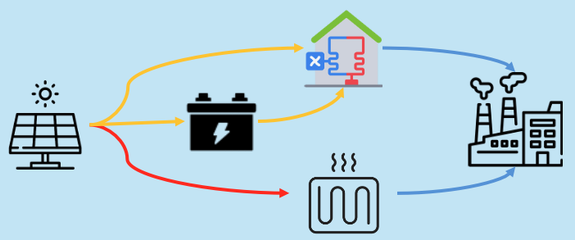
Fig. 1 Modelled system configuration: co-located, off-grid solar PV paired with a heat pump/heat battery and battery storage supplying process heat to the facility

2.1 Facility-level Process Heat Estimate
The replaceable process heat for each facility is the heat generated by fossil fuel that is used in the process of manufacturing a product (steel, food, textile, etc.). Depending on data availability, total annual production or total annual emissions is used to calculate the amount of process heat per sector and country. With total annual production, we apply a specific energy consumption (SEC) factor by sector [14] that defines the energy intensity per tonne of product. With emissions total [15], we applied an emissions factor, assuming an EU averaged gas/oil share of 90%/10% [16], to get the total process heat demand. With the total process heat estimate from both SEC and emissions factor, we calculated the replaceable process heat by applying a fossil-fuel share [17] to the useful heat.
Table 1: Facility-level process heat and replaceable-heat estimation formulas by calculation route
Calculation route | Formulas
SEC route | fuel_energy = production × SEC  useful_heat = fuel_energy × η_process
Emissions route | fuel_energy = (CO₂e × combustion_share) / emissions_factor  useful_heat = fuel_energy × η_boiler
Replaceable heat | replaceable_heat=useful_heat × fossil_share
To validate the heat estimates, we compared against sector and country wide useful heat aggregates and determined it is within +-50% of reference data [18].
2.2 Solar Radiation
Solar capacity factor, the amount of solar power output relative to nameplate, is pulled from PVGIS using ERA5 data for 2023. Hourly profiles are pulled for each facility and normalised to 1 kWp. It is then summed over a year and divided by 8760 to get the average solar capacity factor. The tilt is set to the absolute latitude and azimuth is south facing.
2.3 Land Availability
We aggregated the square km of cropland, bare, grass and shrubland around each facility in 5 km and 15 km buffer zones using Google Earth Engine and ESA WorldCover v200 (2021) map. A nameplate power density of 50 MWdc/km² is assumed, which caps the solar capacity that can be installed on the eligible land at each site.
2.4 Technology Cost Data
All costs are set in 2030-dollar values and assumes construction start in 2030. Technologies, both solar and storage, are assumed to have 25-year life. Capital expenditure and fixed operation and maintenance costs of solar panels and utility scale batteries are gathered from BloombergNEF (BNEF) [19] for 2030 by country. Heat pump costs by temperature band [20] and industrial heat batteries [21] are in 2021 and 2023 dollars respectively. Both are CPI-inflated to 2030 which applies a factor of 1.31 and 1.17 respectively. Country specific costs from BNEF and cost of capital rates [22] are used when direct country costs are available and proxied by peer mean income country groups (HIC, LMIC, etc.) when not available. All monetary results are reported in euros at a fixed EUR/USD rate of 1.08.
Capital costs are annualised using a standard capital recovery factor (CRF) assuming a 25-year technology life and country-specific cost of capital. Total annualised system cost, $C^{ann}$, sums four technology terms (solar, Li-ion battery, industrial heat battery, and heat pump). The Li-ion battery, industrial heat battery, and heat pump terms follow the same functional form using their respective CAPEX and FOM values described above.
Each follows the same general form, illustrated here for solar:

$C_{solar}^{ann}=\left(CAPEX_{c}^{PV}⋅1000⋅CRF_{c}+FOM_{c}^{PV}\right)S*$ $LCOH_{served}=\frac{C_{ann}}{Q_{served}}$},
Where $r_{c}$is country WACC, S*, E*, P* are optimised capacities, $Q_{b }^{*}$is HP thermal capacity sized to served heat in band b, and Q_{served}=Q_{demand}-Q_{unserved}. Unserved energy is not costed (VoLL = 0).
2.5 Gas Heat Benchmark
Each LCOH is compared against a gas heat benchmark to get the highest availability of electrified heat generated below the gas heat price. Gas heat prices are gathered from Eurostat’s non-household gas for 2025 (nrg_pc_203) [23]. A general gas boiler efficiency of 0.85 [24] is applied to the gas price. Each facility is capped at its own country’s gas price. The LCOH of gas only accounts for the operation cost and not the capital cost because this study assumes the gas boiler had already been installed. The EUA carbon tax of €79/tCO₂ is assumed and added to the gas heat cost. Technology costs are expressed in 2030 dollars, whereas the gas benchmark uses 2025 Eurostat prices. Even at high availability levels, the LCOH for solar plus storage comes below the 2025 gas benchmark.
$c_{heat,c}^{gas} = \frac{p_{c}^{gas}}{η} + \frac{p^{EUA} × {EF}_{NG}}{η}$ (1)
with $η = 0.85$ (boiler efficiency), $p^{EUA} = 79 EUR/tCO₂$ (EUA carbon price assumption), and ${EF}_{NG} = 0.202 tCO₂/{MWh}_{fuel}$ (gas CO₂ emission factor).
2.6 Optimisation – System Sizing
To get the system size for minimal cost, we sized the co-located solar panels with heat pump or heat battery solution using a linear program (HiGHS). Both of those solutions will pipe heat into the industrial facility. The linear program is defined as follows.
Objective
$$min \frac{1}{Q^{dem}} (c_{S} S + c_{E}^{Li} E^{Li} + c_{P}^{Li} P_{dis}^{Li} +$$
$Σ_{b∈B(IHB)} [c_{in}P_{b}^{ch} + c_{out}P_{b}^{dis} + c_{E}E_{b}])$ (2)
Sets and parameters
$c ∈ \{1,…,K\}$: days in the year. $t ∈ \{1,…,H\}$: hours (H = 24), with t − 1 ≡ H when t = 1. $b_{∈ B(HP)}$: heat-pump bands (COP > 1), covering <100°C and 100–200°C. $b_{∈ B(IHB)}$: industrial-heat-battery bands (COP ≤ 1), covering ≥200°C. Round-trip efficiencies enter as $η^{Li} = \sqrt{{RTE}^{Li}} and η^{IHB} = \sqrt{{RTE}^{IHB}}$, with ${RTE}^{Li} = 0.90, {RTE}^{IHB} = 0.95$, and maximum Li-ion duration $h^{max} = 16 h$.
Subject to
- Solar capacity is capped by available land at a fixed density of 50 MWdc/km².
- Li-ion battery energy is limited to a 16-hour maximum discharge duration.
- At each hour, solar generation is allocated across heat-pump demand, Li-ion charging, and industrial-heat-battery charging.
- Heat-pump output (COP-adjusted, including battery-buffered supply) matches each band's flat thermal load.
- Industrial-heat-battery output and state-of-charge evolve hour to hour based on charging and discharging, net of round-trip efficiency losses.
- Annual unserved heat is capped at (1−α) of demand, enforcing the target availability level α.
All capacities and dispatch variables are non-negative.
The model is solved as a facility-level linear program (HiGHS) over 2023 PVGIS hourly profiles. Shared solar capacity feeds heat-pump bands (below 200°C, buffered by a Li-ion battery) and industrial-heat-battery bands (at or above 200°C, resistively charged into a thermal store).
Utilising the hourly solar profiles and the flat-load heat demand, we optimised for availability level at 90%. on 16 representative days, obtained by k-means clustering of the 365 daily solar profiles weighted by cluster size. Optimisation is run at every decile (10%, 20%, … 100%). At 10% availability, the optimization is run to minimize the cost of solar plus storage to provide 10%. After sizing the solar panels and batteries for both the 5 km and 15 km radius, served heat is summed across facilities and expressed as a share of total replaceable heat, with fleet LCOH weighted by served heat.
3 Results
Table 2: Share of replaceable process heat served and levelised cost of heat (LCOH) at 5 km and 15 km buffer zones
 | 5 km | 15 km
Served (highest served under gas prices) | 58.8%  (307 TWh) | 84.4%  (441 TWh)
LCOH (highest served under gas prices) | €55 | €62
Served  (max savings vs €93) | 53.4%  (278 TWh) | 73.9%  (377 TWh)
LCOH  (max savings vs €93) | €41 | €42
At 5 km, 59% of replaceable heat is below country gas at €55/MWh, expanding to 15 km reaches 84% at €62/MWh. Stopping at max savings leaves more money on the table but only 53% and 74% of heat for 5 km and 15 km buffer zones respectively. The LCOH at 90% for solar plus storage is still almost €100 under the grid electricity LCOH.
3.1 Total heat % served and LCOH
The aggregate replaceable heat demand served is analysed in two ways: maximising savings and maximising heat demand. To maximise savings, a facility should aim for availability up to the maximum savings points. The remaining can be met with grid electricity or gas. To maximise heat demand served, a facility could overbuild solar panels while still being under gas prices resulting in a lower marginal benefit but is still gas competitive. Table 2 summarises both framings at the 5 km and 15 km buffer zones.
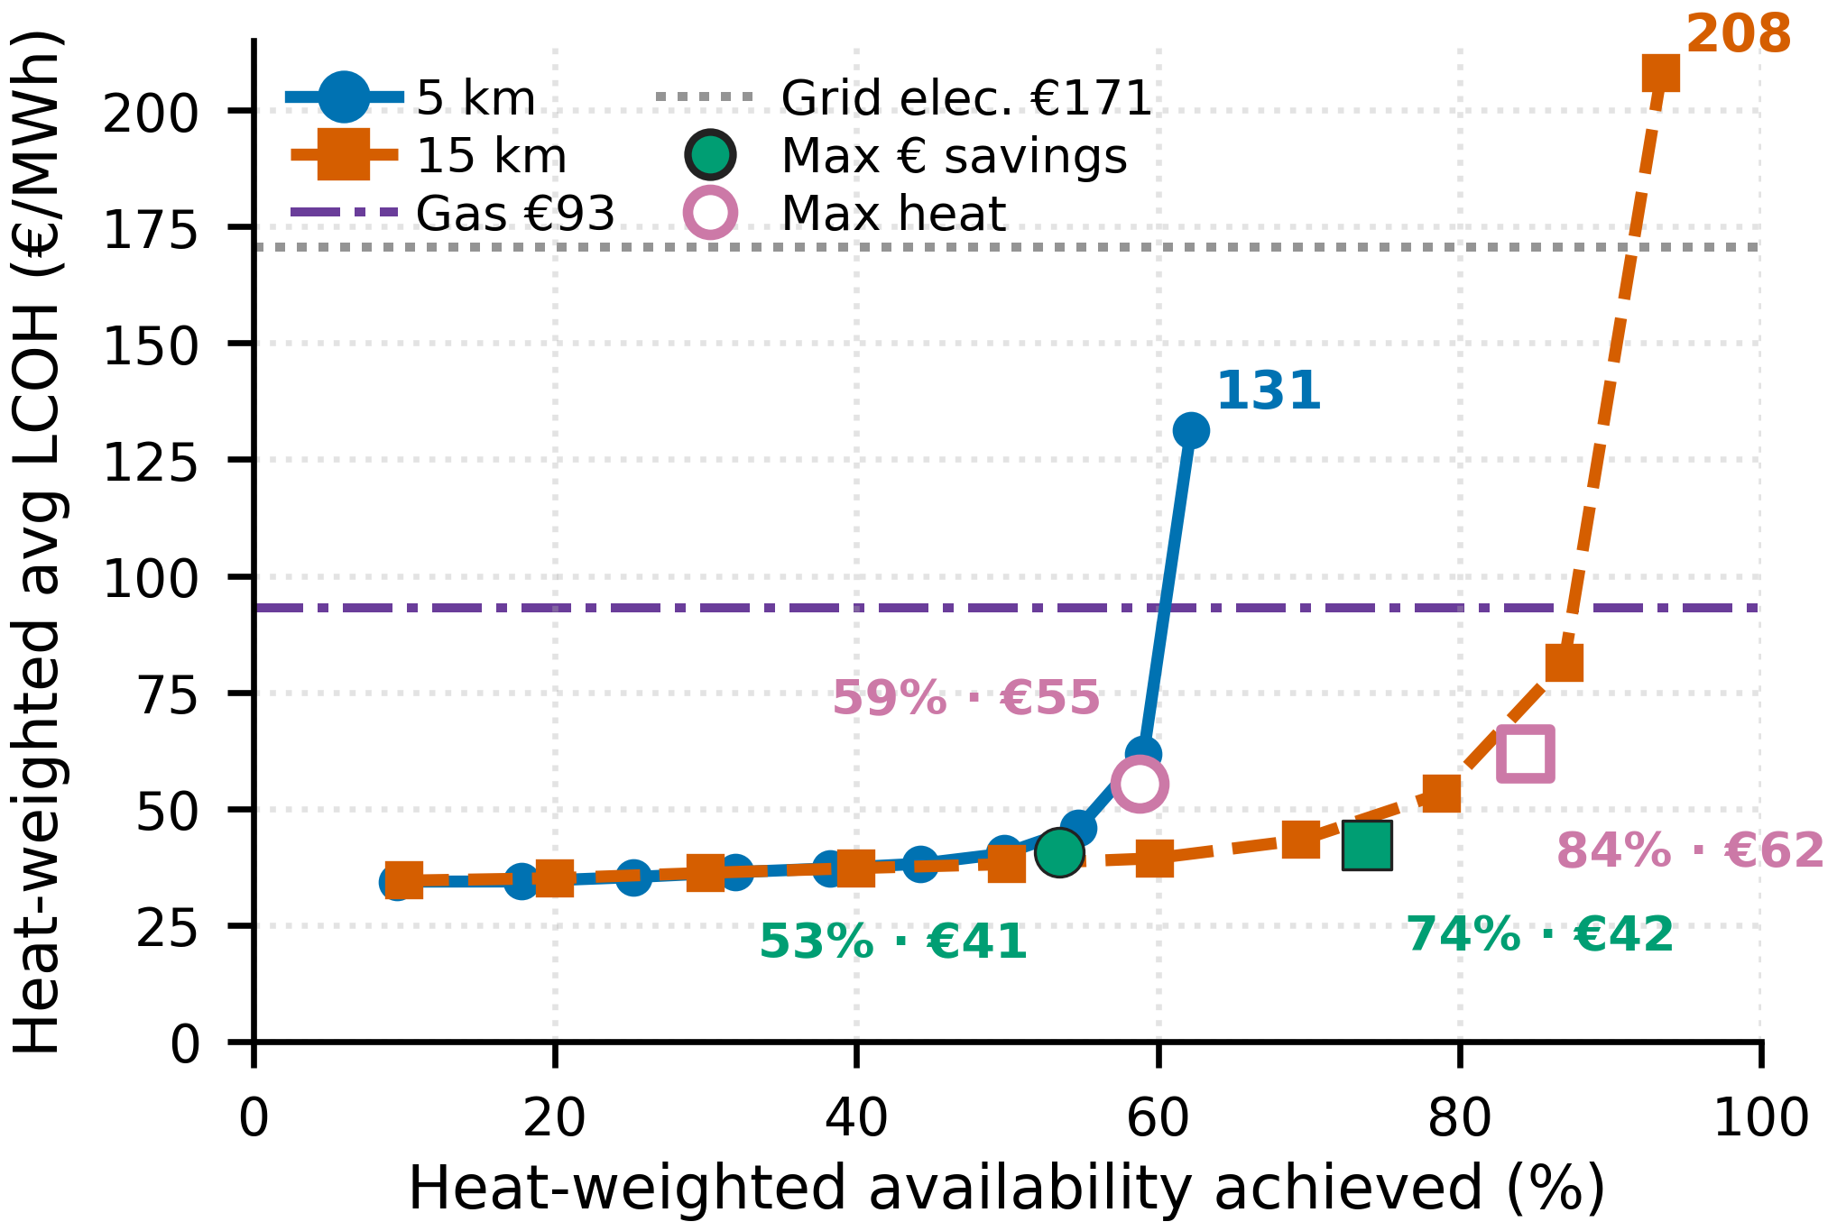
Fig. 2: EU fleet-average LCOH vs. availability achieved at 5 km and 15 km land buffer zones, relative to the €93/MWh gas-heat and €171/MWh grid-electricity benchmarks.

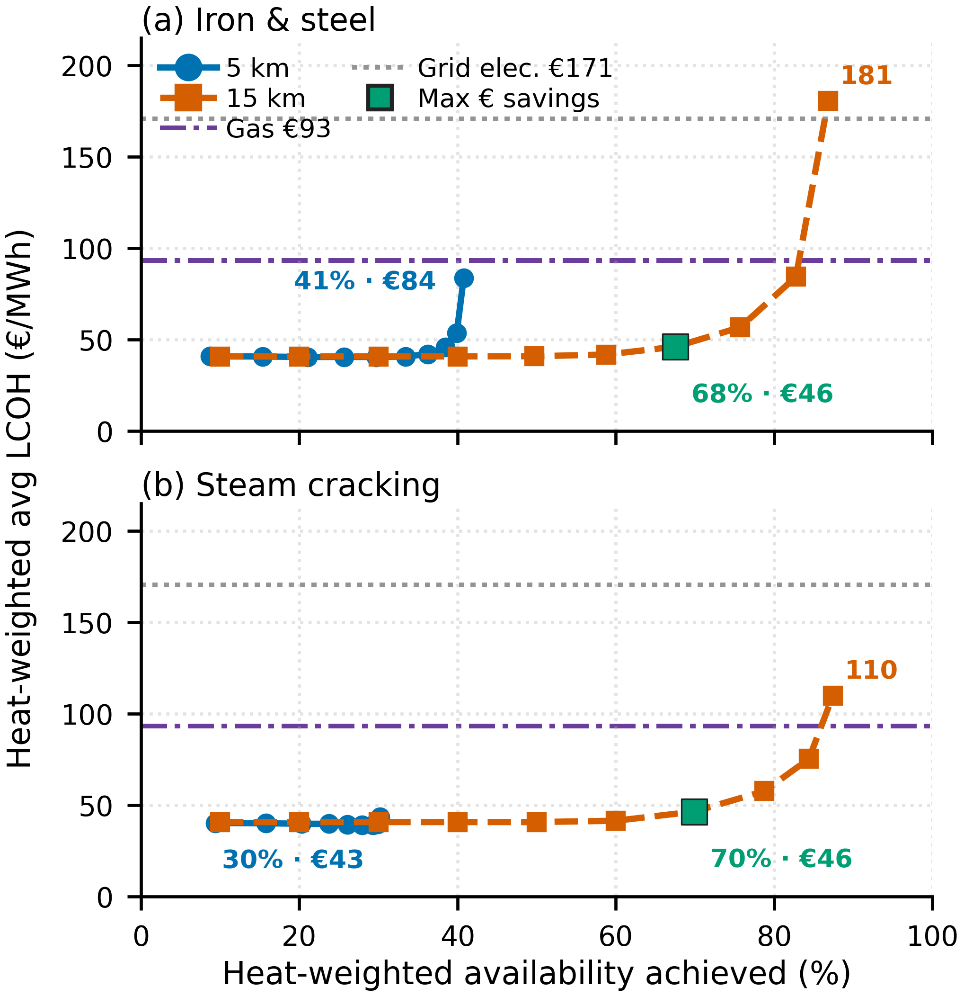
Fig. 3: LCOH vs. availability for land-capped industries at 5 km and 15 km: (a) iron and steel, (b) steam cracking. Lines: gas €93/MWh, grid electricity €171/MWh

3.2 High temperature sector comparison
Steam cracking and iron and steel sector have very large sites and have more heat intense processes (> 500°C) resulting in much higher heat loads. These sectors require more hybrid solutions: increased land availability, utilising grid electricity, co-firing with gas plants. By increasing buffer zone around each site, over 80% of heat can be served in both sectors under gas prices. Increasing buffer zones from 5 km to 15km, availability for steel increases from 40% to 80%, for steam, from 30% to 80%. Grid electricity or gas plants are still needed to provide for the last 10-30% of demand at 15 km buffer zones.
3.3 Country-level comparison
Germany, the Netherlands, and France have very large process-heat demand. With a ~15 km land buffer, a large majority can be served below country gas. At 5 km, Germany and the Netherlands remain more land constrained. Southern Europe (Greece, Spain, Italy, Portugal) is the strongest fit. Those sites tend to be smaller, with better solar yield. ~95% of demand served at LCOH roughly 70–75% of country gas cost.

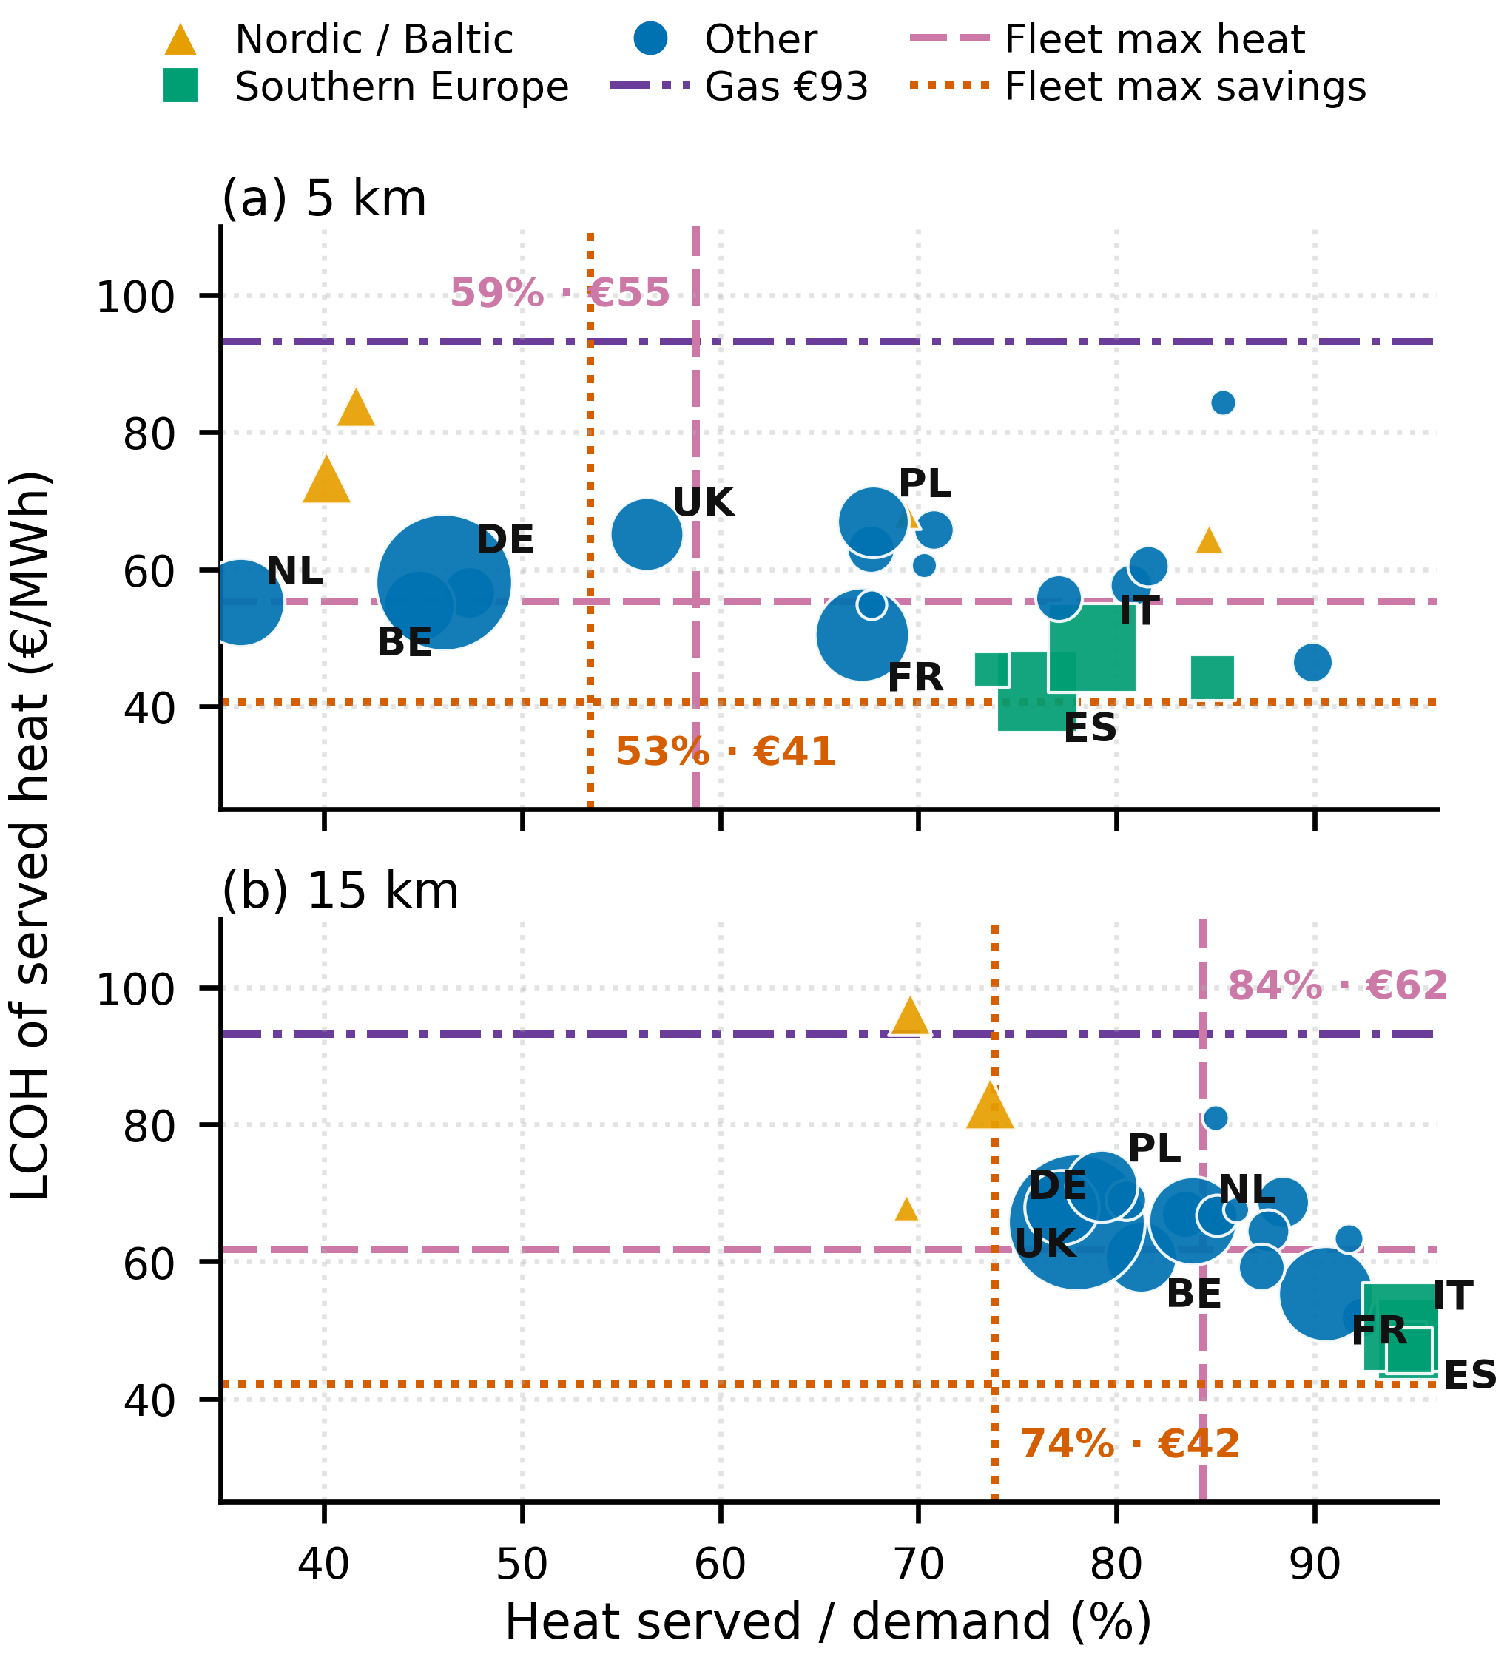
Fig. 4: Country-level LCOH vs. heat served at each country’s gas-heat price, relative to €93/MWh: (a) 5 km, (b) 15 km

3.4 Facility specific analysis for solar radiation impacts
Where land is comparable, solar resource drives how much PV overbuild high-temperature sites need. Two high temperature steel plants, Linz in Austria and Taranto in Italy, have similar temperature needs (900°C) and heat demand (5 TWh). Taranto has 20% solar capacity factor while Linz has 15%. Both have enough land available at 15 km to meet 90% of their heat demand, but Linz needs to overbuild 15x load while Taranto would only need to build 5.3x their load. Higher-irradiance sites can hit high-T reliability with less overbuild and much lower LCOH. Table 3 summarises the comparison.
Table 3: Solar overbuild, capacity, land use, and LCOH for two high-temperature steel sites at 15 km buffer zone (90% availability)
 | Solar/load | PV built | Land used | LCOH
Taranto | 5.3× | 3.0 GW | 32% | €33
Linz | 15.0× | 8.5 GW | 80% | €85

3.5 Impacts of land constraint
For large sites with high temperature processes, there are concentrated areas where the land resources just cannot provide most of the energy at 5 km buffer zone. The major shortfall areas are in the Rhine-Meuse region where steel and steam cracking facilities are. These sites typically have ~8–50 km²/TWh land and ~12–14% solar capacity factor. Most sites that miss 50% at 5 km recover at 15 km. Expanding to 15 km allows all sites, except for 3, to reach over 50% availability.
4 Discussion
4.1 Motivation for off-grid renewable solution
One of the major roadblocks to industrial electrification is the cost and delay to connecting to electricity grid infrastructure. However, with on-site renewable site, there is enough availability served such that industrial sites can use those resources. This study examines how much heat generation can be served on-site without connecting to grid infrastructure and how much that would cost. With even 5 km of buffer zone, 58.8% of replaceable heat demand in the EU can be met with solar + heat pump/heat battery at a cost below natural gas fuel costs with carbon tax. This solar + storage solution does not require the whole system to be decarbonized, nor a new interconnection, for meaningful cost and emissions reductions. Facilities that cannot reach high availability on-site can still build to the maximum-savings point (53% of fleet heat at 5 km) and meet the remainder with gas or grid electricity.
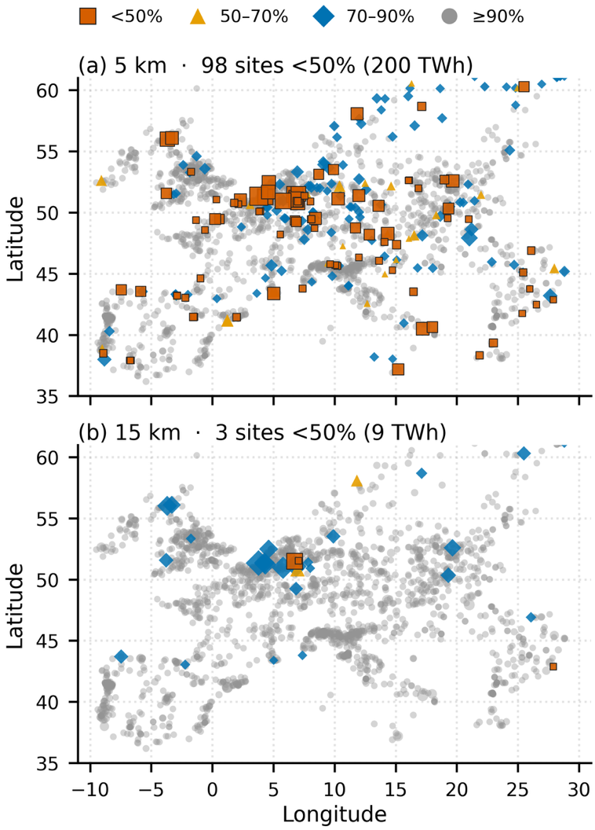
Fig. 5: Facility-level heat availability achieved by land-constraint category: (a) 5 km buffer zone, (b) 15 km buffer zone
4.2 Trade-off between solar resource and land availability
The interaction between solar radiance and land availability makes the cost considerations different for each site. The decision to maximise cost savings versus maximise heat demand served depends on how much solar panel overbuilding might be enough to justify the cost and benefit at each site. Where land is comparable, solar resource sets the overbuild. The Linz and Taranto steel plants have similar heat demand (~5 TWh) and both can meet 90% availability at 15 km, but Linz (15% capacity factor) needs 15× load versus 5.3× at Taranto (21%). Those sites are the natural candidates for a hybrid remainder: gas, or grid electricity where industrial tariffs fall. In the Rhine-Meuse region, where high temperature and large industrial facilities are clustered. Land is the binding constraint. Regional regulation and electricity prices might help with decarbonisation by enabling cheaper electricity prices to meet part of the heat demand with grid electricity. Some countries in the EU have begun changing electricity prices for industrial customers. Germany has implemented state subsidised electricity prices that would help support electrification efforts [25]. Even with cost competitive grid electricity, the impacts on the distribution and transmission grid might prevent electrification from being approved or delay the electrification. With the cost of solar panels and storage falling rapidly, this could be a pathway to quicker and sooner decarbonisation.
4.3 Limitations
Heat demand estimations are based on literature sector energy consumption factors and emissions factors, not based on individual facility’s generation. These estimates are calculated based on EU published figures and averages by sector. They are validated by sector and country aggregated figures but may deviate from reference individual facilities significantly. With more precise data on combustion plants and fuel types of each facility, the modelled heat generation and LCOH can be better fitted per facility using the same process in this study.
This study does not account for the land acquisition process as there is not enough data to systematically incorporate into this study. Only remote sensing categorised data were used to screen available land. Each facility would need to evaluate the land acquisition process to accommodate the land needed for solar panels.
5 Conclusion
On-site solar with heat pumps and heat batteries can serve most replaceable EU industrial process heat at costs below the 2025 gas-heat benchmark. Within a 5 km buffer zone, 58.8% of replaceable heat demand can be served at an average levelised cost of €55/MWh. That rate can be increased to 84.4% at €62/MWh with a 15 km buffer zone. Southern European facilities tend to have stronger solar resource and less heat intense industrial facilities which allows them to serve almost their entire replaceable heat demand. The large, land-constrained, high-temperature sites are concentrated in the Rhine-Meuse region which will require hybrid solutions with either grid electricity or gas use to meet all its needs. Because this pathway is cost-competitive without requiring full decarbonisation of the heat demand or a new interconnection, it offers industrial facilities a deployable, near-term solution to reduce emissions and lower exposure to gas price volatility.
6 References
1 Matthias Rehfeldt, Simon Bußmann, Tobias Fleiter, Jeffrey Rissman: ‘Direct electrification of industrial process heat. An assessment of technologies, potentials and future prospects for the EU’ (Fraunhofer ISI, 2024)
2 Madeddu, S., Ueckerdt, F., Pehl, M., et al.: ‘The CO2 reduction potential for the European industry via direct electrification of heat supply (power-to-heat)’Environ. Res. Lett., 2020, 15, (12), p. 124004.
3 {Citation}‘Executive summary – Renewables for Industry – Analysis’, https://www.iea.org/reports/renewables-for-industry/executive-summary, accessed August 2026
4 ‘How It Works - Rondo Energy’, https://www.rondo.com/how-it-works, accessed July 2026
5 Wikoff, H.M., Garfield, D., Hwang, S., Ribo, M.M., Ruth, M., Reese, S.B.: ‘Benchmarking thermal energy storage cost for industrial process heat’Applied Energy, 2025, 402, p. 126873.
6 Rosenow, J., Oxenaar, S.: ‘Opportunities for heat electrification and energy efficiency in European industry’Nature Reviews Clean Technology, 2025, 1, (10), pp. 671–672.
7 Rosenow, J., Arpagaus, C., Lechtenböhmer, S., Oxenaar, S., Pusceddu, E.: ‘The heat is on: Policy solutions for industrial electrification’Energy Research & Social Science, 2025, 127, p. 104227.
8 Dominguez, J., Paliwal, U., Phadke, A.: ‘U.S. Can Cost-Effectively Supply One Third of Industrial Heat Demand Using Off-Grid Electric Thermal Storage and Heat Pumps’2026.
9 Chojkiewicz, E., Manocha, A., Paliwal, U., Callaway, D., Phadke, A.: ‘Utilizing Noncoincident Needs to Site Data Centers with Solar+Storage at Existing Gas Plants’2026.
10 Baselovic, M.: ‘A credible gas endgame for Europe’, https://strategicperspectives.eu/a-credible-gas-endgame-for-europe-electrification-and-regional-partnerships/, accessed August 2026
11 ‘Crossed wires꞉ Grid capacity could block EU energy security’, https://ember-energy.org/latest-insights/crossed-wires-grid-capacity-could-block-eu-energy-security, accessed August 2026
12 ‘The business case for electrifying industrial heat’ (Agora Industry, Agora Energiewende, Fraunhofer ISI, ECCO Think Tank and Reform Institu, 2026)
13 Neuwirth, M., Fleiter, T., Hofmann, R.: ‘Modelling the transformation of energy-intensive industries based on site-specific investment decisions’Sci Rep, 2024, 14, (1), p. 30552.
14 Pezzutto, S., Zambotti, S., Croce, S., et al.: ‘Hotmaps project, D2.3 WP2 report – open data set for the EU28’ (EURAC, e-think, TUW, Fraunhofer ISI, 2018)
15 Gomez, Dario, Watterson, John D.: ‘STATIONARY COMBUSTION’, https://www.ipcc-nggip.iges.or.jp/public/2006gl/pdf/2_Volume2/V2_2_Ch2_Stationary_Combustion.pdf, accessed July 2026
16 Eurostat: ‘Disaggregated final energy consumption in industry by NACE Rev. 2 activity - quantities (nrg_d_indq)’ (2024)
17 ‘[nrg_d_indq_n] Disaggregated final energy consumption in industry by NACE Rev. 2 activity - quantities’, https://ec.europa.eu/eurostat/databrowser/view/nrg_d_indq_n/default/table?lang=en, accessed July 2026
18 BloombergNEF: ‘2H 2024 LCOE Data Viewer: country-level solar PV and utility-scale 4 h battery costs, 2030’ (2024)
19 Rissman, J.: ‘Decarbonizing Low-Temperature Industrial Heat in the U.S.’2020.
20 Rissman, J., Gimon, E.: ‘Thermal Batteries: Decarbonizing U.S. Industry While Supporting A High-Renewables Grid’2023.
21 IRENA: ‘Renewable Power Generation Costs in 2024’ (2025)
22 Eurostat: ‘Gas prices for industrial consumers - bi-annual data (from 2007 onwards)’ (Eurostat, 2026)
23 ‘Technology factsheet natural gas boiler industry’, https://energy.nl/wp-content/uploads/technology-factsheets-natural-gas-boiler-industry-7.pdf, accessed August 2026
24 Wiedemann, S.: ‘The industrial electricity price - cost relief with new requirements and verification obligations’, https://kpmg-law.de/en/the-industrial-electricity-price-cost-relief-with-new-requirements-and-verification-obligations/, accessed August 2026

