Motivation
Industrial heat is a dominant player in global emissions and industrial decarbonization needs to be part of the solution reduce emissions impacts.
There is substantial literature examining the cost of heat electrification at a sector wide and regional wide analysis. (Show some proof of what the impact in cost and emissions reduction). But there is a gap in facility level analysis and analysis on how many facilities would be able to cost effectively and competitively with gas boiler.
Industrial heat battery is a battery that stores energy as heat often using cheap abundant materials such as silica, ceramics or graphite. This storage technology can take renewable electricity during cheap hours of the day and discharge constant heat as steam for industrial purposes.

Methods — outline

2.1 Overview and analytical framework
The goal of this research is to assess which EU industrial sites could cost-effectively replace fossil powered heat with solar + industrial heat battery (IHB) systems. To screen facility candidates, we started with climate trace open-source data of facilities in the European Union. The main methodology starts with bottom-up estimates of heat used in the manufacturing process. These bottom-up estimates are validated by country and sector level totals from Joint Research Centre's Integrated Database of the European Energy System (JRC-IDEES)/IndustryHeat-EU (Gjorgievski et al., 2025) to verify that useful heat is within acceptable range. The bottom-up, top-down verified, approach to heat estimates addresses the facility-level industrial decarbonization analysis gap that is missing in current literature. This method provides assurance that the bottom-up estimates are reasonable.
To complete the cost calculations, we gathered the land availability and solar capacity and put them as constraints in the flatblock optimization modeling. We used optimization methods to gather the optimal sizing of solar+IHB system the LCOH per site. With the LCOH calculated, facilities are analyzed to see which facilities are feasible and cost effective against gas generated heat and what characteristics would make these specific sites successful.
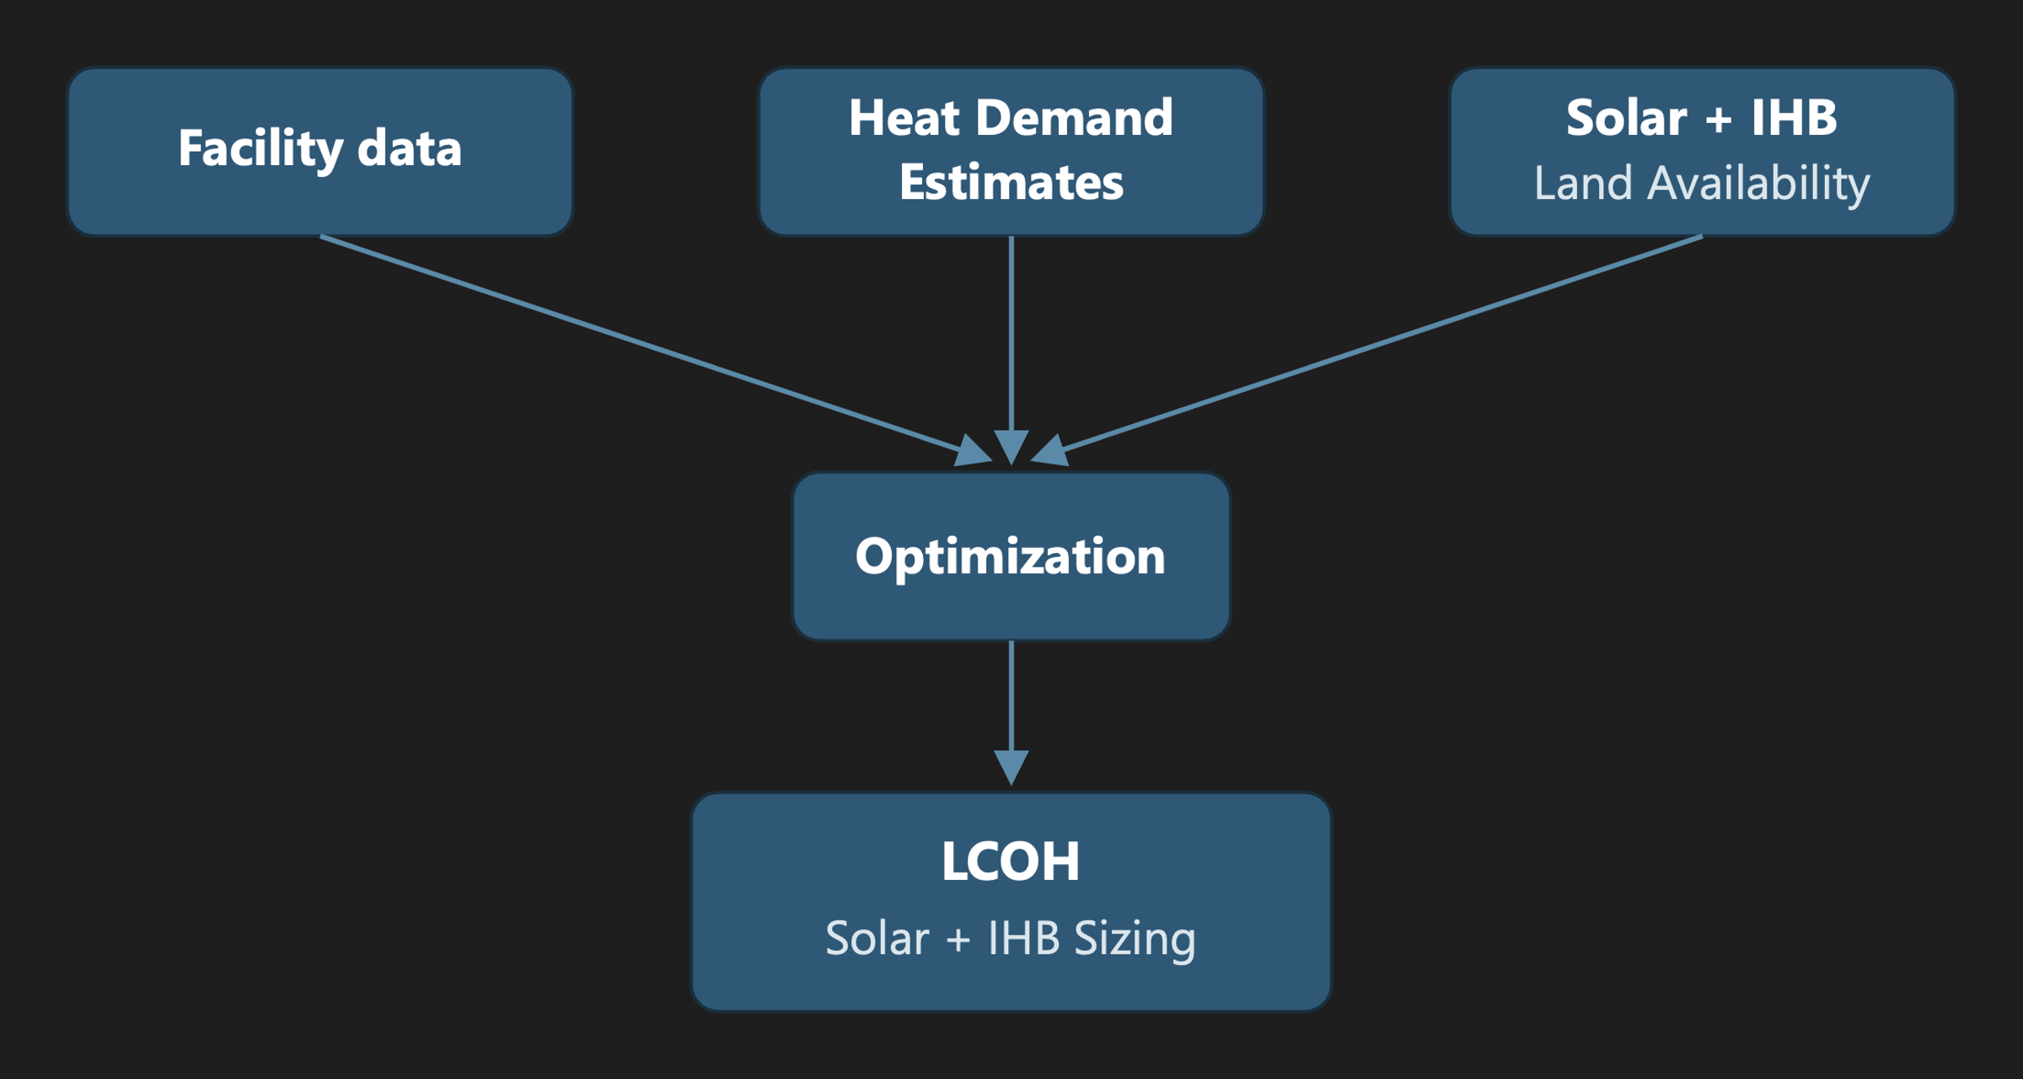

2.2 Facility dataset and scope
Climate Trace has 2,493 in EU-27 (excluding Malta, no facilities) plus the United Kingdom. After filtering out duplicate sites and correcting invalid data, there are 2,415 facilities used in this study. There are 11 subsectors for manufacturing analysis: food & beverage & tobacco, textiles & apparel, glass, cement, iron & steel, pulp & paper, lime, chemicals, other metals, petrochemical steam cracking, aluminum. For each facility, there are coordinates, annual production output, capacity factor, annual emissions in CO2. These facilities utilize heat temperatures from 100°C to 1500°C which could be decarbonized with heat pump or IHB.

2.3 Replaceable heat demand estimation
For each subsector, we gathered the useful heat demand that IHB can serve based on the specific energy consumption(Pezzutto et al., n.d.) and process efficiencies (Appendix 1). From useful heat, we calculated the replaceable heat by applying fossil share for heat by country and sector(Disaggregated Final Energy Consumption in Industry by NACE Rev. 2 Activity - Quantities, n.d.). The useful heat calculation is used for validation against JRC annual heat data, and the replaceable heat is the portion of heat used that is generated by fossil fuels which can be decarbonized by IHB.
Calculation route | Formulas
SEC route | fuel_energy = production × SEC/1000  useful_heat = fuel_energy * η_process
Emissions route | fuel_energy = (CO₂e × combustion_share) / emissions_factor  useful_heat = fuel_energy × η_boiler
Replaceable Calculations | replaceable_heat = useful_heat × fossil_share
The production data for each sector varies and we developed a 3-tiered system to calculate the heat demand based on the best available data. The more reliable tier uses climate trace production data with SEC. The lower tier uses emissions to calculated useful heat.

2.3.1 SEC Heat Estimates
For sectors that provide production annual totals per facility, we applied the SEC value to get the useful heat amount and applied the fossil share with the SEC value to get the replaceable heat. Heat-intensity table with selected values and sources are taken from Fraunhofer and noted in the references. The process efficiencies are gathered from different trusted sources and applied to the fuel energy to get the useful heat.

2.3.2 Emissions heat estimates
For sectors that do not provide production amounts per facility, we used emissions to get the heat demand estimates. There are only two sectors that uses emissions to get the heat demand: food and textiles. In food and textile sector, the combustion emissions are entirely from fuel combustion unlike sectors such as cement which releases emissions from limestone calcination, not fuel. From the combustion emissions, we used an assumed gas/oil blend (EU reported mix of 90% gas/10% oil) to get the TJ of fuel and applied a boiler efficiency to get the useful heat.
Climate Trace have flagged the high uncertainty of the modeled estimates of emissions. When comparing the estimated energy need of different countries with JRC data(Gjorgievski et al., 2025), there are countries that are 18x overstated (Portugal) but also countries that are 0.4x (Finland) understated. To minimize the over/understatement, we use the ratio of Climate Trace emissions to JRC data per country and rescaled the emissions based on the ratio. It is important to note that food sector, and food sector alone is fitted to the validation data and therefore cannot be validated. However, this method still provides a reasonable sector-wide analysis for the food and beverages sector. The textile sector does not need to rescale since it is within a reasonable range of the validation data but still relies on emissions data.

2.3.3 Fossil Share to replaceable heat
Fossil shares are taken from Eurostat data, matching NACE activity with Climate Trace sector categories and getting the fossil percentage per sector. Electricity and derived heat excluded because useful heat is combustion derived. IHB cannot replace heat produced by byproducts such as biomass in pulp and paper because biomass will still be burned as part of the chemical feedstock need to manufacture pulp and paper. Taking only the fossil share gives a more realistic accounting of what types of heat generation can be replaced by IHB.
fossil_share = fossil_fuel / (fossil_fuel + biomass_fuel)

2.4 Validation of the bottom-up estimate
We compared industrial process heat from our calculated bottom-up figures with the reference figures from JRC-IDEES/IndustrialHeatEU. From this dataset, we used the useful energy demand dataset which is the amount of energy that is used in the process. Specifically, we pulled the steam, non-electric process heat <100°C, non-electric process heat 100–400°C, non-electric process heat 400–1000°C, and non-electric process heat >1000°C at the country level and at the sector level to compare with our useful heat estimates. We matched the IndustrialHeatEU subsectors categories to the Climate Trace sector categories, which is shown in the appendix.
Overall, the facility bottom-up reproduces the country picture well. The EU-26 covered-sector total is 556 TWh vs 794 TWh reference (70%), and the largest industrial countries all land in a plausible band: DE 71%, FR 82%, ES 73%, IT 58%, PL 68%, NL 83%. The calculated totals are slightly under the reference totals which is explainable because Climate Trace does not account for all the facilities. Overall, the calculated totals do not go over 50% of the reference useful energy.
The sector-level totals also match the reference well except for pulp & paper and ceramics & glass. For pulp & paper, Climate TRACE lists 79 pulp mills covering 21.8 Mt of the 73.9 Mt EU pulp production (CEPI, 2023), but none of the 716 separate paper & board mills (CEPI, 2023). Because the IndustryHeat-EU reference spans the whole pulp-and-paper sector, pulp and paper-drying steam, the bottom-up captures 27% of its heat, the shortfall being the uncovered paper sector. For ceramics & glass, Climate TRACE lists only glass facilities, covering ~55% of EU glass production 20 of ~37.5 Mt (GAE STATISTICAL REPORT 2025-2026, n.d.). Glass itself matches reasonably. The reference column also bundles ceramics, brick and refractories which is ~85% of its heat, mostly >1000 °C kiln firing, that we do not model. (check and verify this last statement)
Because each country's food total is fitted to the JRC reference, the food estimate cannot be independently validated against it. The emissions data only set the within-country allocation. Textiles keeps its emissions-derived level and so remains an independent (if emissions-dependent) estimate.
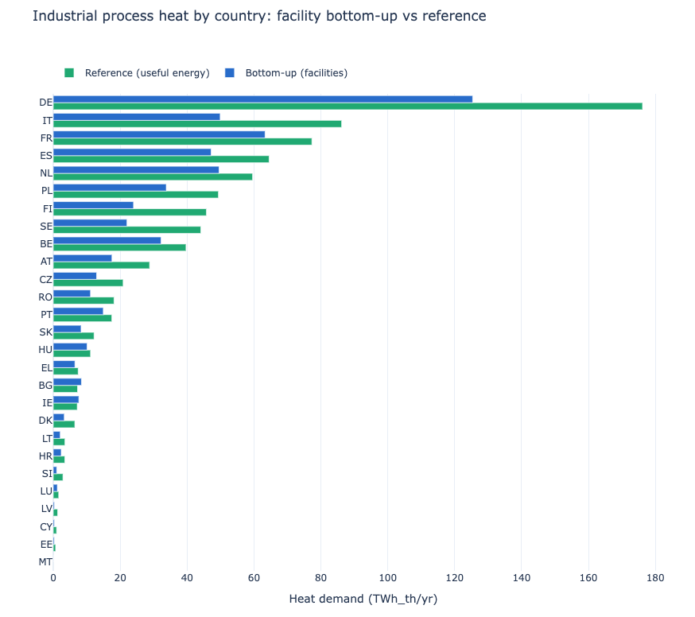
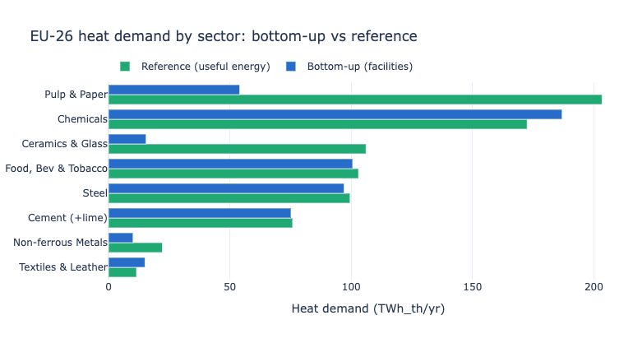

2.5 Heat load profile
Flat hourly load assumption, its derivation from annual aggregation, and its stated limitations (no diurnal/seasonal shape). Carry improved profiles into sensitivity.

2.6 Solar resource
PVGIS series calc, ERA5, 2023, 1 kWp, tilt = |lat|, 0% losses; UTC→local handling. Summary metrics (annual yield, capacity factor) and the observed range.

2.7 Land availability for colocated solar
GEE zonal statistics; 5 km point buffer (15 km reserved for sensitivity); ESA WorldCover at 30 m.
Suitability mask: slope > 5° (SRTM + Copernicus DEM above 60°N), WDPA + 100 m buffer.
Available land = bare/sparse + cropland; exclusions. Screening-metric caveats.
Land availability is a cap in the optimization. If the full load with 90% reliability and land cap doesn’t solve, then the floor is dropped, unserved is penalized and achieved reliability percentage is given.

2.8 Technology and cost data
Country-level Bloomberg inputs (solar LCOE, IHB/storage, CCGT). Specify vintage, currency, discount rate, project lifetime, IHB round-trip efficiency — all currently TODOs and required for a methods section.

2.9 LCOH and system sizing (the biggest gap — currently unwritten)
Solar array + IHB sizing algorithm (hourly matching of flat load to PVGIS output; storage sizing logic).
LCOH equation for the renewable path; LCOH equation for the CCGT baseline.
Land constraint binding vs. non-binding.
Optimization constraints: list it out.

3. Analysis

3.1 Site screening and candidate classification
Decision criteria (solar+IHB LCOH < CCGT LCOH; minimum land / yield thresholds).
Aggregate outputs: replaceable heat, candidate count/share, LCOH-delta distribution, emissions reduction.

3.2 Sensitivity analysis
One-at-a-time (and combined) variation: HEAT ESTIMATE, fossil share, heat intensity, tech costs, IHB efficiency, solar year, land classification, capacity factor. Output format (tornado / site-count curves).

3.3 Limitations
Sector-average intensity & fossil share; flat-load assumption; point-buffer land screening; country-level (not site-level) costs; Climate TRACE coverage bias (floor estimate).

Appendix
- Subsector Process Efficiencies (fuel input to useful heat)
Subsector | eff | What it represents | Source
Cement | 0.60 | Kiln pyroprocessing first-law eff | Madlool et al. 2011 (Renew. Sustain. Energy Rev. 15:2042), 50–60% kiln-system; cross-checked vs IEA Cement Roadmap (BAT ~3.0 vs theoretical ~1.8 GJ/t)
Lime | 0.65 | EU mix of shaft (~0.80) + rotary (~0.55) kilns | EU BREF Cement/Lime/MgO (4–5 GJ/t vs theoretical ~3.2)
Glass | 0.45 | Melting-furnace eff (large flue-gas/structural losses) | Beerkens 2008 (glass-furnace energy benchmarking); Schmitz et al. 2011 (regenerative melting 40–50%)
Iron & steel | 0.70 | Reheating/sinter furnaces w/ recuperation (65–75%) | IEA Iron & Steel Roadmap; worldsteel energy statistics
Petrochem steam cracking | 0.90 | Fired heater w/ strong convection recovery | Ren, Patel & Blok 2006 (Energy 31:425); Ullmann's "Ethylene" — flagged least-certain
Chemicals — ammonia/methanol | 0.90 | Reformers / fired heaters w/ heat recovery | (same class as cracking)
Chemicals — soda ash | 0.85 | Steam-boiler-led | EU BREF LVIC
Aluminium — refinery | 0.85 | Bayer digestion/calcination steam boiler | IAI energy data
Aluminium — smelting | 0.65 | Anode-bake + cast-house fired furnaces | IAI energy data
Pulp & paper | 0.85 | Steam boiler | US DOE typical industrial steam boiler
Food & beverage, Textiles | 0.85 | Boiler efficiency (emissions-inversion route) | US DOE typical industrial steam boiler

- IndustryHeat-EU subsector mapping with Climate Trace subsector
Climate TRACE subsector | IndustryHeat-EU column | Grouped label in notebooks
iron-and-steel | Primary Steel + Secondary Steel | Steel
chemicals | Chemicals | Chemicals
petrochemical-steam-cracking | Chemicals | Chemicals
cement | Cement | Cement (+lime)
lime | Cement (no own column) | Cement (+lime)
glass | Ceramics and Glass | Glass
pulp-and-paper | Pulp and Paper | Pulp & Paper
food-beverage-tobacco | Food, Beverages and Tobacco | Food, Bev & Tobacco
textiles-leather-apparel | Textiles and Leather | Textiles & Leather
aluminum | Non-ferrous Metals | Non-ferrous Metals
other-metals | Non-ferrous Metals | Non-ferrous Metals

Except for the food sector which is fitted to the JRC-IDEES/IndustryHeat-EU data.
Climate trace facilities dataset is deduplicated for sites with the same name + coordinates + identical capacity/heat and reviewed manually with sourced reasons. Overall, there were 78 duplications removed and 4 facility data updated.

