

HONG KONG INSTITUTE OF VOCATIONAL EDUCATION

DEPARTMENT OF ENGINEERING

Higher Diploma in Computer and Electronic Engineering

Module Lab Report: Telecommunication Technology (EEE3460)

Title: *Lab 1 Digital modulation for QPSK*

|  |  |  |  |  |  |
| --- | --- | --- | --- | --- | --- |
| Name /  Programme Code /  Class | Student No. | Report  (50%) | Performance  (Demo in class)  (50%) | Participation  (weighting factor [f] for Performance) | Total  (100%) |
|  |  |  |  | f= 1 if no late  f=0.8 if late < 30min  f=0.5 if late > 30 min  f=0 if absent |  |

1. Demo the **Exercise(s)** to the teacher; (50%)

Result[1]: Successful / Partially successful / unsuccessful / not demonstrated at all

**1.1 Introduction (2.5%)**

**1.2 Objective (2.5%)**

**2. Results for QPSK:**

**2.1 List of equipment/parts/components (2.5%)**

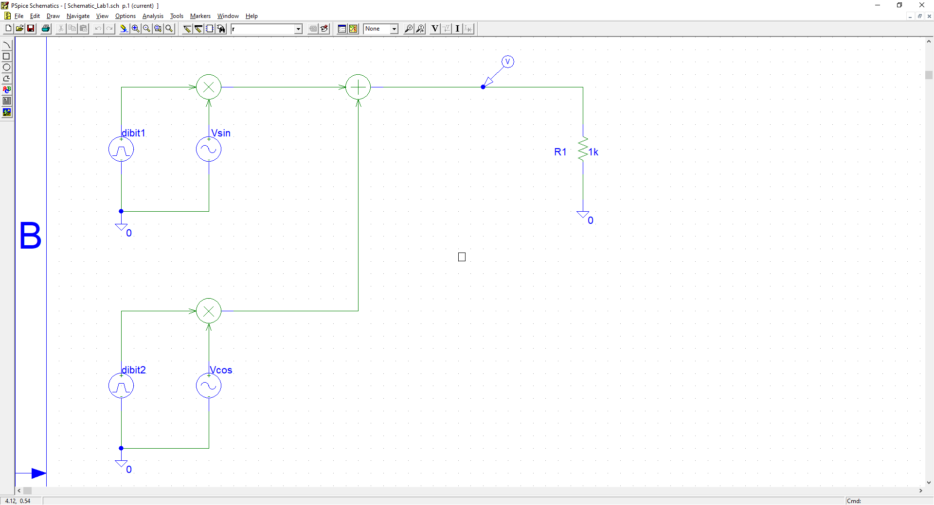

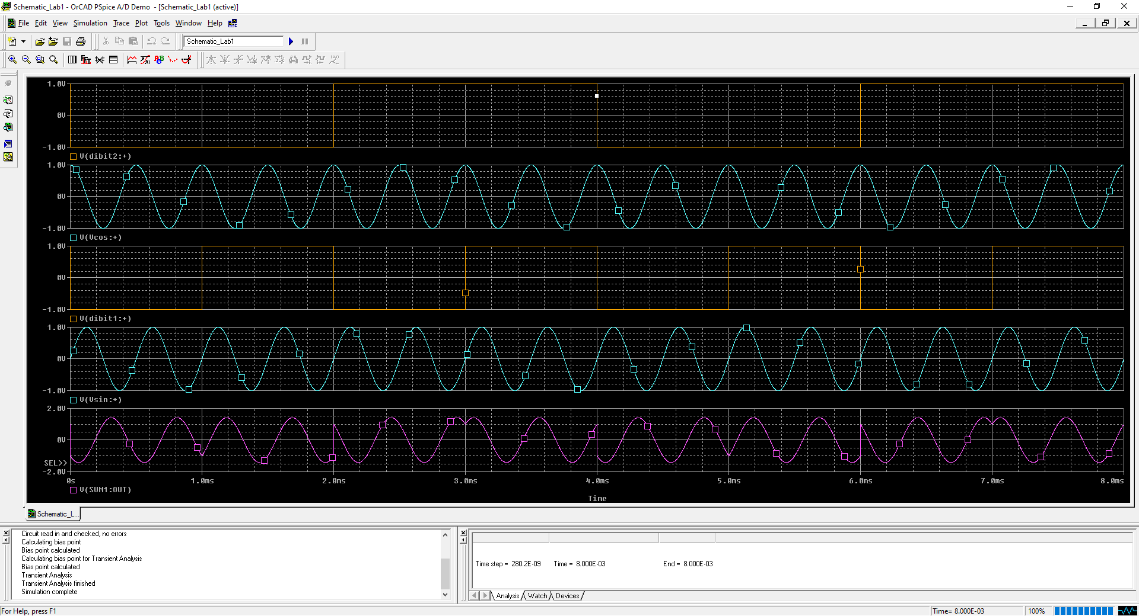**2.2 Procedure and Results: (17.5%)**

**2.3 Conclusion (5%)**

**3. Discussion (17.5%)**

**4. References: (2.5%)**

1. Delete where applicable