

HONG KONG INSTITUTE OF VOCATIONAL EDUCATION

DEPARTMENT OF ENGINEERING

Higher Diploma in Computer and Electronic Engineering

Module Lab Report: Telecommunication Technology (EEE3460)

Title: *Lab 1 Digital modulation for QPSK*

|  |  |  |  |  |  |
| --- | --- | --- | --- | --- | --- |
| Name /  Programme Code /  Class | Student No. | Report  (50%) | Performance  (Demo in class)  (50%) | Participation  (weighting factor [f] for Performance) | Total  (100%) |
| Yeung Wing  EG114403-1B | 230251805 |  |  | f= 1 if no late  f=0.8 if late < 30min  f=0.5 if late > 30 min  f=0 if absent |  |

1. Demo the **Exercise(s)** to the teacher; (50%)

Result[1]: Successful / Partially successful / unsuccessful / not demonstrated at all

Content

1.1 Introduction (2.5%) 3

• Digital Modulation: 3

• Phase Shift Keying (PSK): 4

• Quadrature Phase Shift Keying (QPSK): 4

1.2 Objective (2.5%) 5

2. Results for QPSK: 5

2.1 List of equipment/parts/components (2.5%) 5

2.2 Procedure and Results: (17.5%) 5

2.3 Conclusion (5%) 7

3. Discussion (17.5%) 8

4. References: (2.5%) 10

# 1.1 Introduction (2.5%)

* Digital Modulation:
  + Modulation (demodulation) maps (retrieves) the digital information into (from) an analog waveform appropriate for transmission over the channel.
  + Generally involve translating (recovering) the baseband digital information to (from) a bandpass analog signal at a carrier frequency that is very high compared to the baseband frequency.

For Examples: ASK, FSK, QPSK, 16QAM

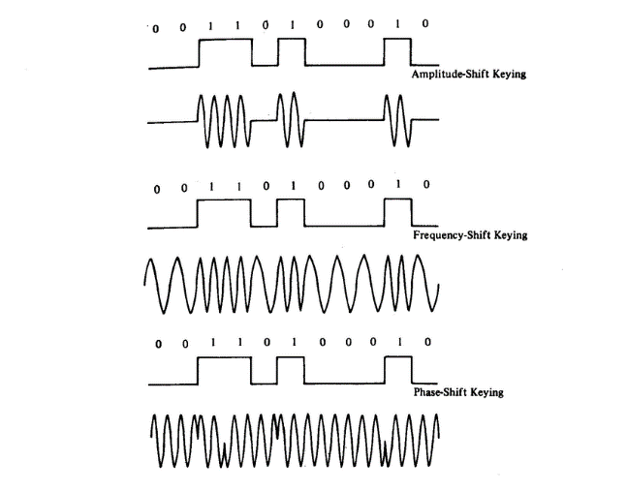

* Phase Shift Keying (PSK):

PSK is a form of phase modulation where the modulating waveform is a digital data stream. In PSK, the transmitted signal has constant amplitude and frequency but its phase, with respect to a reference, is directly related to the value of a binary data signal. There are several schemes that can be used to accomplish PSK. The simplest method uses only two signal phases: 0 degrees and 180 degrees. The digital signal is broken up timewise into individual bits (binary digits). The state of each bit is determined according to the state of the preceding bit. If the phase of the wave does not change, then the signal state stays the same (low or high). If the phase of the wave changes by 180 degrees -- that is, if the phase reverses -- then the signal state changes (from low to high, or from high to low). Because there are two possible wave phases, this form of PSK is sometimes called BPSK (Binary Phase Shift Keying). For a two-level binary signal, the phase shift can be made equal to 180 degrees, that is a phase shift of plus and minus 90 degrees from the reference.

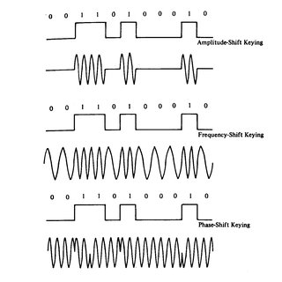

* Quadrature Phase Shift Keying (QPSK):

QPSK is an extension of the simple PSK method of keying. In QPSK, the signal can take up one of four possible phase angles, mutually in quadrature, each corresponding to a particular data input condition. Consider NRZ(Non-return to zero) formatted data in which each word is divided into bit pairs (or dibits) instead of individual bits. QPSK offers twice as many data bits per carrier phase change than Binary Phase Shift Keying (BPSK), hence it finds wide application in high-speed carrier-modulated data transmission systems. This means that the bandwidth required for any given data transfer rate will be approximately halved for QPSK as compared with BPSK. The typical possible phase angles are +/-45 degrees and +/-135 degrees; each phase shift can represent two signal elements. The simplest method of generation of the bit pairs is to store two bits, read off the combination and generate the required carrier phase shift and then store the next two bits, etc.

|  |  |
| --- | --- |
|  | undefined |
| Understanding Quadrature Phase Shift Keying (QPSK) Modulation - Technical  Articles |

# 1.2 Objective (2.5%)

Investigate the design of the digital modulation of QPSK by creating a schematic in PSpice.

# 2. Results for QPSK:

## 2.1 List of equipment/parts/components (2.5%)

Dibit_I (dibit1) is ***VPULSE***: V1=1, V2=-1, TR=0, TF=0, PW=1m, PER=2m.

Dibit_Q (dibit2) is ***VPULSE***: V1=1, V2=-1, TR=0, TF=0, PW=2m, PER=4m.

Vsin is ***VSIN***: VOFF=0, FREQ=2000, TD=0, DF=0, PHASE=0, VAMPL=1.

Vcos is ***VSIN***: VOFF=0, FREQ=2000, TD=0, DF=0, PHASE=90, VAMPL=1.

MULT is the ***multiple block***.

SUM is the ***summing block***.

GND_ANALOG is the ground.

## 2.2 Procedure and Results: (17.5%)

|  |
| --- |
| 一張含有 文字, 螢幕擷取畫面, 陳列, 圖表 的圖片  自動產生的描述  Fig1 |
| 一張含有 文字, 螢幕擷取畫面, 陳列, 軟體 的圖片  自動產生的描述  Fig2 |
| Fig3 |
| Fig4 |
| 一張含有 螢幕擷取畫面, 鮮豔, space, 行 的圖片  自動產生的描述  Fig5 |

## 2.3 Conclusion (5%)

Using the schematic in Fig 1, we run a simulation and generate the remaining figure, the result of which is shown in Fig 2. Fig 3 and Fig4 shows how the PSK of dibit1 and dibit2 was produced. Lastly, the Fig5 shows the result of how the QPSK is finally done.

# 3. Discussion (17.5%)

|  |  |
| --- | --- |
|  |  |
| In the condition of the dibit is positive voltage, the wave remains the same.  In the condition of the dibit is negative voltage, the wave is inverted. | |

|  |
| --- |
| 一張含有 螢幕擷取畫面, 鮮豔, space, 行 的圖片  自動產生的描述  After summing the results together, the QPSK produced. |

|  |  |
| --- | --- |
|  | * In the condition of dibit2 is negative voltage (-1V),   + dibit1 is negative voltage (-1v): [00]   start and end around -1v perform a cosine wave   * + dibit1 is positive voltage (+1v): [01]   start and end around -1v perform a sine wave |
|  | * In the condition of dibit2 is positive voltage (+1V),   + dibit1 is negative voltage (-1v): [10]   start and end around +1v perform a cosine wave   * + dibit1 is positive voltage (+1v): [11]   start and end around +1v and perform a sine wave |

# 4. References: (2.5%)

* [The Hong Kong Polytechnic University - Department of Electronic and Information Engineering - Communication Laboratory - Phase Shift Keying (PSK) & Quadrature Phase Shift Keying (QPSK)] (<https://www.eie.polyu.edu.hk/~em/dtss04pdf/psk.pdf>)
* [Digital Signal Processing - Scientific Figure on ResearchGate] (<https://www.researchgate.net/figure/Digital-modulation-schemes-ASK-FSK-and-PSK_fig3_303471153>)
* [ELEC 7073 Digital Communications III, Dept. of E.E.E., HKU] (<https://www.eee.hku.hk/~sdma/elec7073/Part3-Digital%20Modulation_small.pdf>)
* [EEE3460 CH3 Digital Modulation and Demodulation v1] (<https://moodle2324.vtc.edu.hk/mod/resource/view.php?id=739109>)

1. Delete where applicable