Lab X: Setting up the Python IDE

Objectives
- To download and install Anaconda package manager.
- To launch Jupyter Notebook – a Python Integrated Development Environment (IDE).

Equipment
- A Windows 10 PC with Internet connection

Procedures

Part 1. Downloading and Installing Anaconda

  - Browse to the link:

https://www.anaconda.com/products/individual

  - Download the Anaconda Installer for 64-bit Windows for Python 3.9:


  - Run the installer and proceed with default settings. This may take several minutes.
Part 2. Launching Jupyter Notebook

  - Launch ‘Anaconda Navigator’.

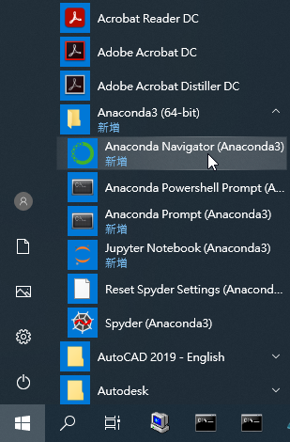
2.2 Create a new environment. Click “Environments” and click “Create”.
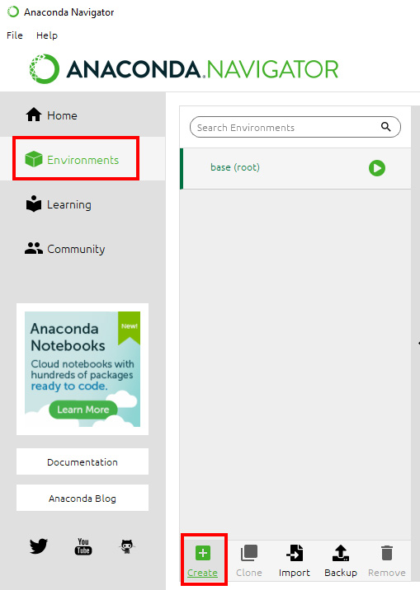
In the “Name”, type “EEE4463”. Click “Create” button.
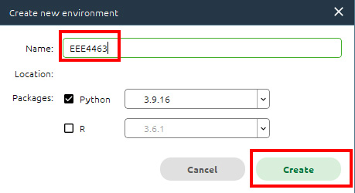

This will take a while to create a new environment. If it is successfully done, you will see a new environment named “EEE4463” as follows.
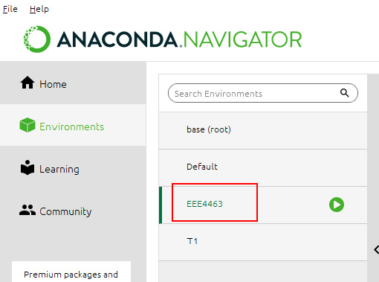

2.3 On the right, select “Not installed” in the drop-list. Type “pandas” in the search box on the right as follows. Check the checkbox next to “pandas”. Click “Apply” button at the bottom right as follows. This installs the Pandas library in the environment.
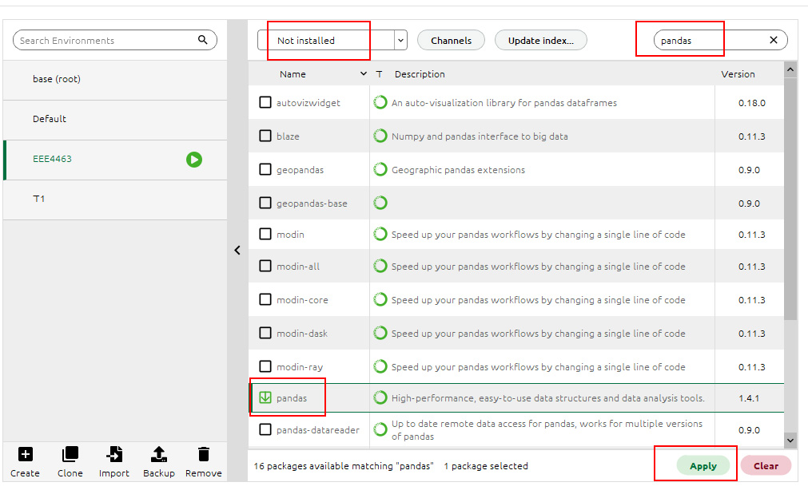

Similarly, install libraries “matplotlib”, “seaborn” and “scikit-learn”.

  - Install Jupyter Notebook and Spyder.
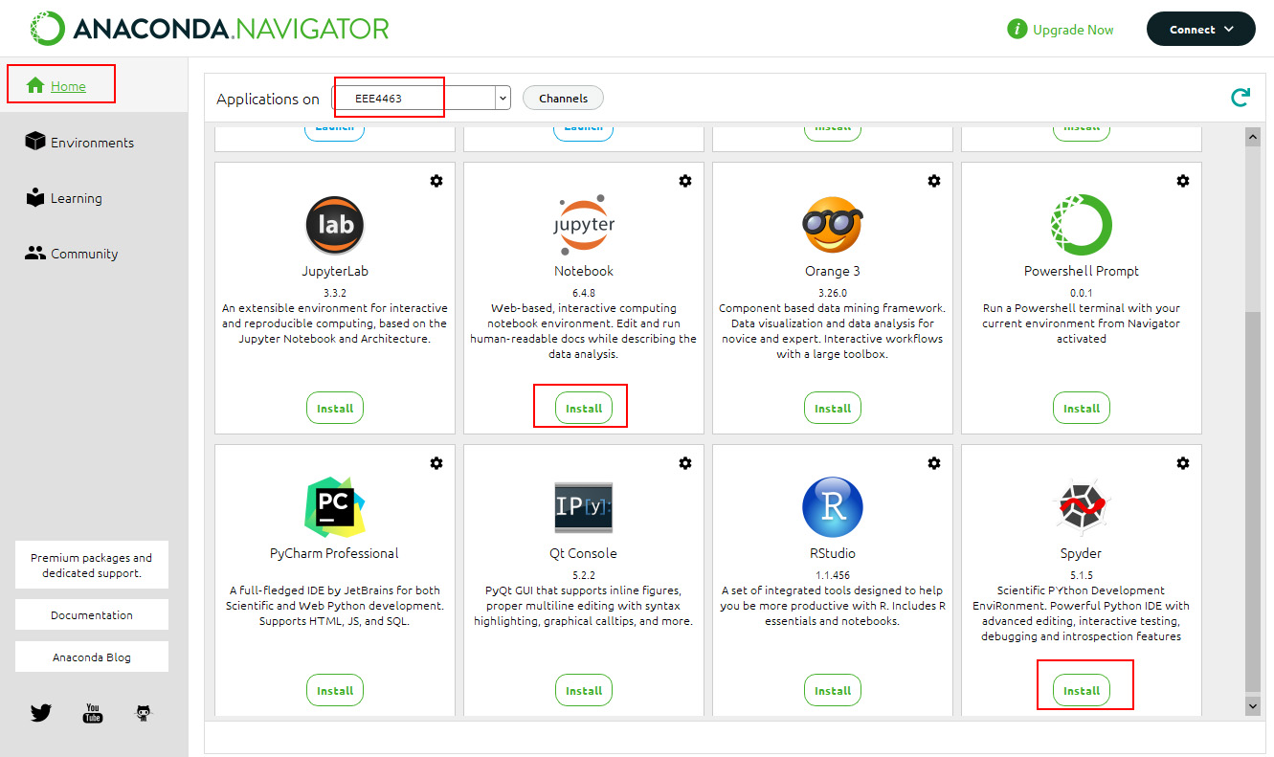

  - Launch Jupyter Notebook.
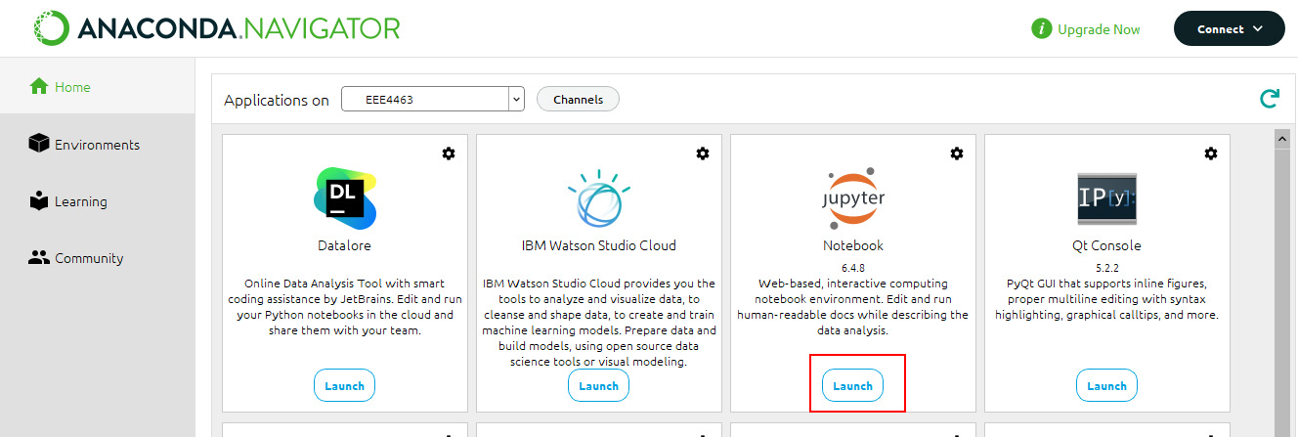

2.6 A browser will be launched and shows the entries in your home folder, usually something like ‘C:\Users\username’.

2.7 Browse to locate the Jupyter Notebook file ‘pandas_intro.ipynb’. Ask the lecturer if you don’t have it.

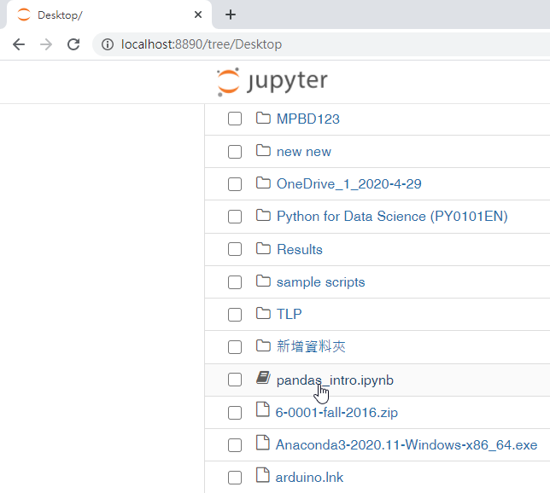

  - Click on the filename to open it.

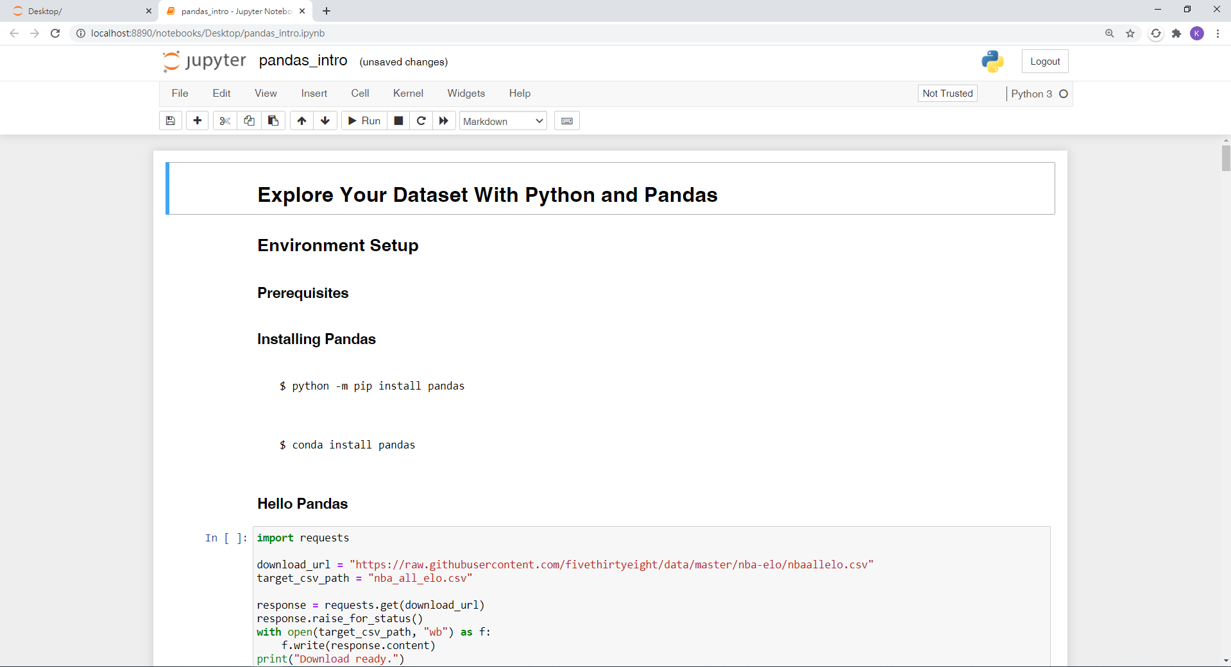

2.9 Click on the ‘Restart the kernel, then re-run the whole notebook’ button to run the whole notebook.

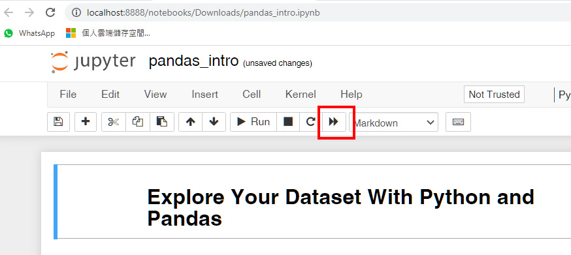

2.11 Confirm by clicking on the ‘Restart and Run All Cells’ button.

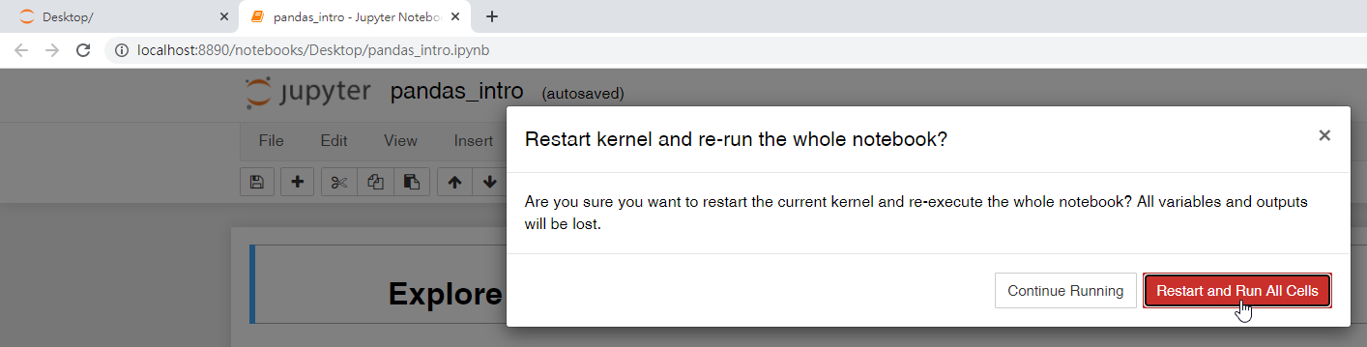

2.12 If everything is fine, you’ll find two newly-generated graphs at the bottom of the notebook.

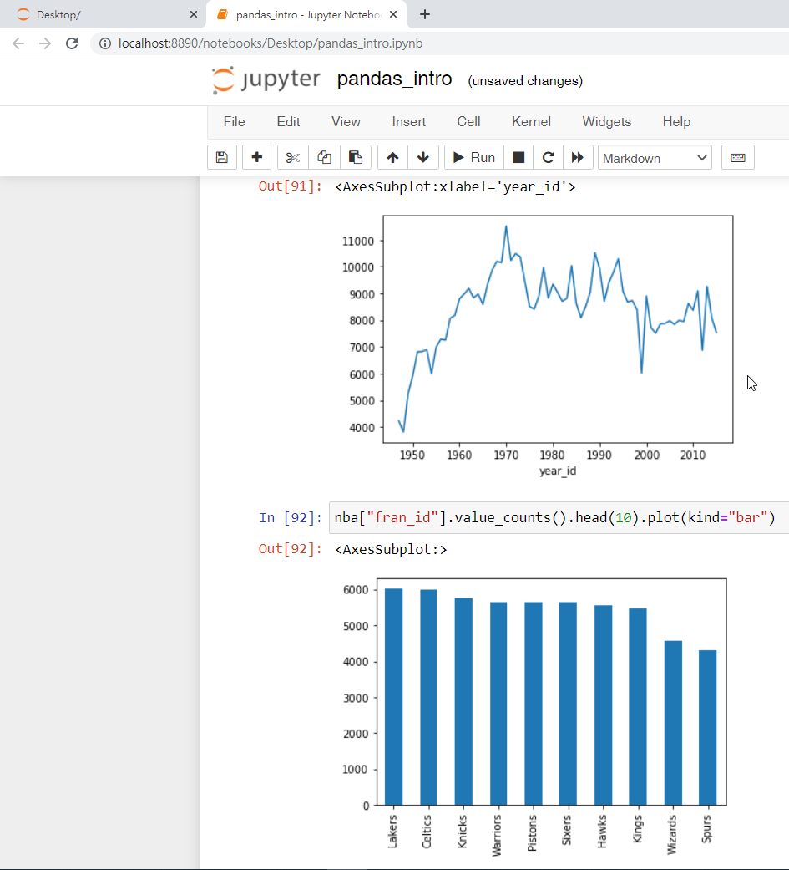

1/19/2023

