S.G. Winikoff, M. Kohli, S.B. Iyengar

EEB Foundations 2014

**Soil Fungus Knockout and Plant Performance**

**INTRODUCTION**

**Winnie**

* **Topic Sentence:** One of the most important factors controlling plant productivity is the availability of nutrients (XXXX). However, we do not know the extent to which soil fungal communities might directly compete for resources with plants, negatively impact plants via pathogenic relationships, or influence the availability of soil nutrients to plants.
  + Diagram

**+**

**+**

**+ / -**

**Inorganic Nutrients**

**Plant Productivity**

**Soil Fungi**

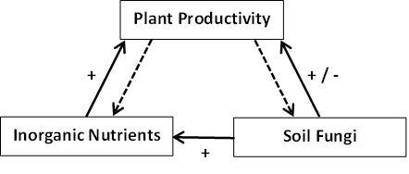

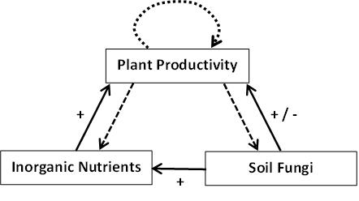

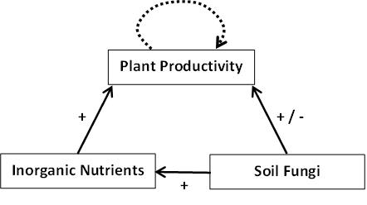

* **Topic Sentence:** Soil nutrient availability influences competition between plants in communities (XXXX), but we do not understand the extent to which this competition for nutrients is influenced by soil fungi.
  + How can fungi influence plants?
    - mycorhizzal fungi …
    - Decomposers
    - Pathogens
    - BUT research has shown that pathogens tend to be host specific (Ask Bradford <bcondon@umn.edu>)

**Mayank**

* Different plants might respond to fungal presence / absence differently
  + Eric’s unpublished paper
  + Unclear whether some plants are positively influenced by fungal presence while others are more negatively influenced by fungal pathogens.

**QUESTIONS**

* Why are simplified plant communities easier to work with?
* By considering simplified plant communities we will try to answer the following questions;
  + What are the synergistic and antagonistic interactions between soil fungi and plants?
  + Is “parent competition” primarily driven by soil nutrients or fungal activity?

**HYPOTHESES**

* Specifically, we hypothesize that …

**Siddarth**

**DATASET AND PROPOSED ANALYSES**

* In order to address these questions we will use a pre-existing long-term dataset from Cedar Creek Biological Station.