**Laptop Setup using PowerShell Script**

**Step-1: Before executing the PowerShell script, we must make sure that Winget is installed in Windows. Please follow the below steps to verify the Winget version.**

**Note: Winget is a Windows package manager designed by Microsoft for installing applications.**

1. Open the command prompt and run **winget –-version** as shown below:

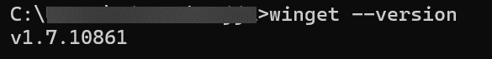

1. After running the command, if it is not showing the version of Winget please use the following setup file to install it.

**Step-2: After the verification, based on the requirement we need to select the script.**

1. If the laptop setup requires user creation, we need to execute the script **Laptop-setup_With_user_creation**.
2. To run this script, please open the **run Text document**.

1. Copy the entire command present in the file.

**Note: This command will run properly only if the script is placed at the location: C:\Users\root1\Documents**

**Step-3: Search for Windows PowerShell in the Windows search bar.**

1. We must open the Windows PowerShell by clicking on run as administrator.

**Step-4: After opening the Windows PowerShell, we need to paste the command that we have copied to execute the script.**

1. After pasting the command, click on enter.



**Step 5: Once you click on enter, the script will start executing. It performs the following actions.**

1. It will enable the Administrator account, rename it to **root,** and set the password.
2. Now, it will ask you to enter the Username, Full Name, and user profile password for the user creation.

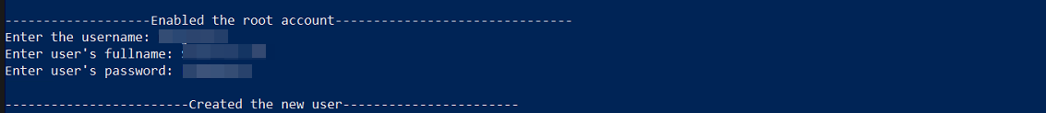

**Step-6:** After the user is created, it will start installing the Basic software which includes **7-Zip, Google Chrome, Mozilla Firefox, Adobe Acrobat Reader, Microsoft Teams, and Microsoft Office.**

1. Initially, you need to agree to all source agreement terms by choosing **Y** as shown below.

1. It will start installing all the applications silently as shown below.

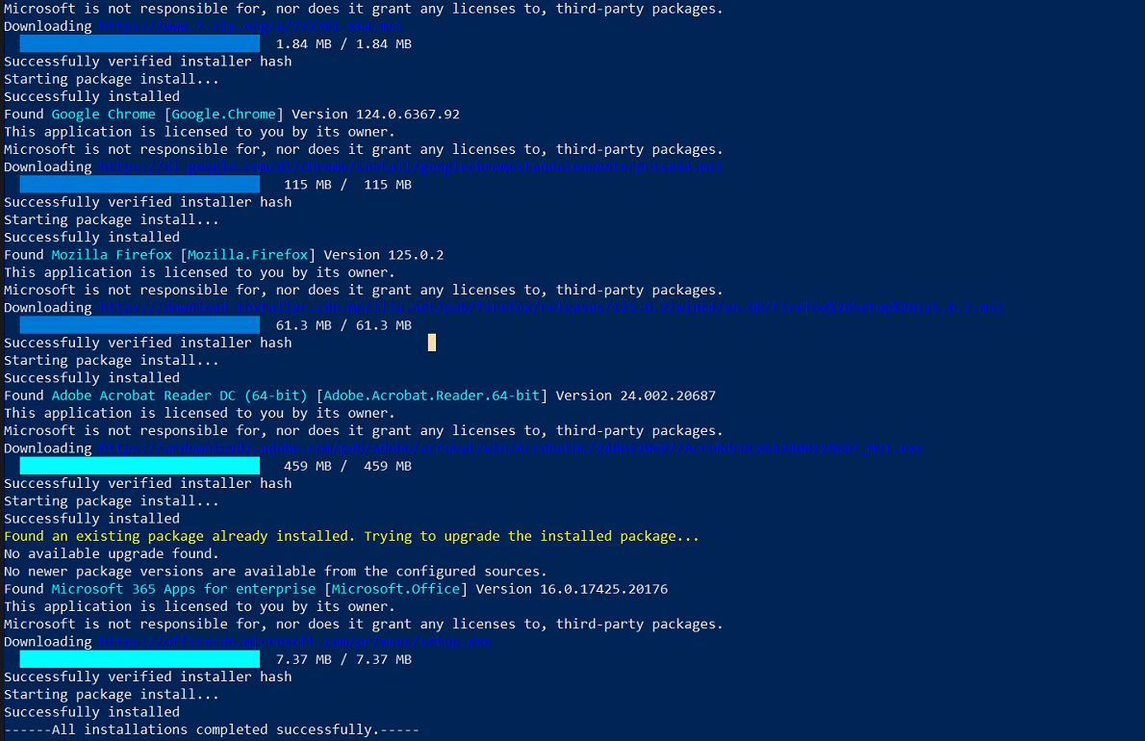

**Step 7: After all applications are installed successfully, it will start Disk Partition.**

1. You need to enter the space that you want to assign to C-Drive based on total disk space. After entering the required space, it will partition the disk as follows:

**Step 8: Now, it will enable the BitLocker for the C-drive and D-drive as shown below.**

**Step 9: After the BitLocker encryption, it will ask you to enter the hostname based on the user.**

1. Enter the hostname for the device.
2. After entering the hostname, it will add the device to the **FGRS** workgroup as shown below.

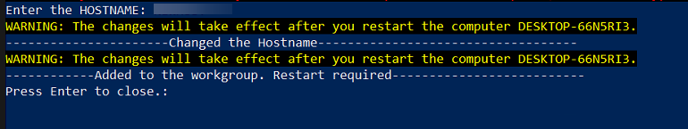

**Step 10: After changing the hostname, we need to restart the laptop to apply the changes.**

**Note: Once the laptop is restarted, we can install the remaining Windows Updates and Trellix Antivirus.**

*****END*****

Freyr IRMS-Confidential Internal