Example knitr/R Markdown document

Your name

22/5/2020

# Load necessary library

if (!require("pacman")) install.packages("pacman")  
 pacman::p_load(ggplot2, tidyr, dplyr, tidyverse, knitr, finalfit, here)

# Demographic Table

# Specify explanatory variables of interest  
explanatory <- c("age", "sex.factor",   
 "extent.factor", "obstruct.factor",   
 "nodes")  
  
colon_s %>%   
 summary_factorlist("differ.factor", explanatory,  
 p=TRUE, na_include=TRUE)

## label levels Well Moderate Poor  
## Age (years) Mean (SD) 60.2 (12.8) 59.9 (11.7) 59.0 (12.8)  
## Sex Female 51 (54.8) 314 (47.4) 73 (48.7)  
## Male 42 (45.2) 349 (52.6) 77 (51.3)  
## (Missing) 0 (0.0) 0 (0.0) 0 (0.0)  
## Extent of spread Submucosa 5 (5.4) 12 (1.8) 3 (2.0)  
## Muscle 12 (12.9) 78 (11.8) 12 (8.0)  
## Serosa 76 (81.7) 542 (81.7) 127 (84.7)  
## Adjacent structures 0 (0.0) 31 (4.7) 8 (5.3)  
## (Missing) 0 (0.0) 0 (0.0) 0 (0.0)  
## Obstruction No 69 (74.2) 531 (80.1) 114 (76.0)  
## Yes 19 (20.4) 122 (18.4) 31 (20.7)  
## (Missing) 5 (5.4) 10 (1.5) 5 (3.3)  
## nodes Mean (SD) 2.7 (2.2) 3.6 (3.4) 4.7 (4.4)  
## p  
## 0.644  
## 0.400  
##   
##   
## 0.081  
##   
##   
##   
##   
## 0.655  
##   
##   
## <0.001

# Generate Final Table

colon_s <- colon_s %>%   
 mutate(  
 nodes = ff_label(nodes, "Lymph nodes involved")  
 )  
  
table1 <- colon_s %>%   
 summary_factorlist("differ.factor", explanatory,   
 p=TRUE, na_include=TRUE,   
 add_dependent_label=TRUE,  
 dependent_label_prefix = "Exposure: "  
 )  
table1

## Exposure: Differentiation Well Moderate  
## Age (years) Mean (SD) 60.2 (12.8) 59.9 (11.7)  
## Sex Female 51 (54.8) 314 (47.4)  
## Male 42 (45.2) 349 (52.6)  
## (Missing) 0 (0.0) 0 (0.0)  
## Extent of spread Submucosa 5 (5.4) 12 (1.8)  
## Muscle 12 (12.9) 78 (11.8)  
## Serosa 76 (81.7) 542 (81.7)  
## Adjacent structures 0 (0.0) 31 (4.7)  
## (Missing) 0 (0.0) 0 (0.0)  
## Obstruction No 69 (74.2) 531 (80.1)  
## Yes 19 (20.4) 122 (18.4)  
## (Missing) 5 (5.4) 10 (1.5)  
## Lymph nodes involved Mean (SD) 2.7 (2.2) 3.6 (3.4)  
## Poor p  
## 59.0 (12.8) 0.644  
## 73 (48.7) 0.400  
## 77 (51.3)   
## 0 (0.0)   
## 3 (2.0) 0.081  
## 12 (8.0)   
## 127 (84.7)   
## 8 (5.3)   
## 0 (0.0)   
## 114 (76.0) 0.655  
## 31 (20.7)   
## 5 (3.3)   
## 4.7 (4.4) <0.001

# Logistic Regression Table

explanatory <- c( "differ.factor", "age", "sex.factor",   
 "extent.factor", "obstruct.factor",   
 "nodes")  
dependent <- "mort_5yr"  
table2 <- colon_s %>%   
 finalfit(dependent, explanatory,   
 dependent_label_prefix = "")  
table2

## Mortality 5 year Alive Died  
## Differentiation Well 52 (56.5) 40 (43.5)  
## Moderate 382 (58.7) 269 (41.3)  
## Poor 63 (42.3) 86 (57.7)  
## Age (years) Mean (SD) 59.8 (11.4) 59.9 (12.5)  
## Sex Female 243 (55.6) 194 (44.4)  
## Male 268 (56.1) 210 (43.9)  
## Extent of spread Submucosa 16 (80.0) 4 (20.0)  
## Muscle 78 (75.7) 25 (24.3)  
## Serosa 401 (53.5) 349 (46.5)  
## Adjacent structures 16 (38.1) 26 (61.9)  
## Obstruction No 408 (56.7) 312 (43.3)  
## Yes 89 (51.1) 85 (48.9)  
## Lymph nodes involved Mean (SD) 2.7 (2.4) 4.9 (4.4)  
## OR (univariable) OR (multivariable)  
## - -  
## 0.92 (0.59-1.43, p=0.694) 0.62 (0.38-1.01, p=0.054)  
## 1.77 (1.05-3.01, p=0.032) 1.00 (0.56-1.78, p=0.988)  
## 1.00 (0.99-1.01, p=0.986) 1.01 (1.00-1.02, p=0.098)  
## - -  
## 0.98 (0.76-1.27, p=0.889) 0.97 (0.73-1.30, p=0.858)  
## - -  
## 1.28 (0.42-4.79, p=0.681) 1.25 (0.36-5.87, p=0.742)  
## 3.48 (1.26-12.24, p=0.027) 3.03 (0.96-13.36, p=0.087)  
## 6.50 (1.98-25.93, p=0.004) 6.80 (1.75-34.55, p=0.010)  
## - -  
## 1.25 (0.90-1.74, p=0.189) 1.26 (0.88-1.82, p=0.206)  
## 1.24 (1.18-1.30, p<0.001) 1.24 (1.18-1.31, p<0.001)

# Odds Ratio Plot

colon_s %>%   
 or_plot(dependent, explanatory,   
 breaks = c(0.5, 1, 5, 10, 20, 30),  
 table_text_size = 2.5)

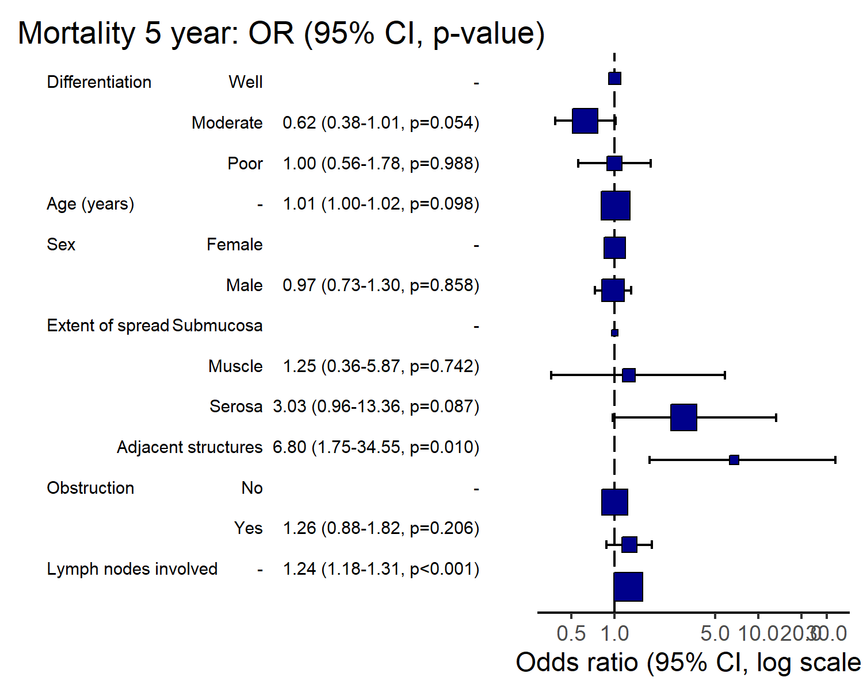

# Save objects for knitr/markdown

# creat folder  
dir.create(here::here("data"), showWarnings = FALSE, recursive = TRUE)  
  
# Verify the path  
file_path <- here::here("data", "out.rda")  
print(file_path)

## [1] "D:/GitHub-winkhaing/code-reference/data/out.rda"

# Save the objects  
save(table1, table2, dependent, explanatory, file = file_path)

## Load Data

load(here::here("data", "out.rda"))

## Table 1 - Demographics

| Exposure: Differentiation |  | Well | Moderate | Poor | p |
| --- | --- | --- | --- | --- | --- |
| Age (years) | Mean (SD) | 60.2 (12.8) | 59.9 (11.7) | 59.0 (12.8) | 0.644 |
| Sex | Female | 51 (54.8) | 314 (47.4) | 73 (48.7) | 0.400 |
|  | Male | 42 (45.2) | 349 (52.6) | 77 (51.3) |  |
|  | (Missing) | 0 (0.0) | 0 (0.0) | 0 (0.0) |  |
| Extent of spread | Submucosa | 5 (5.4) | 12 (1.8) | 3 (2.0) | 0.081 |
|  | Muscle | 12 (12.9) | 78 (11.8) | 12 (8.0) |  |
|  | Serosa | 76 (81.7) | 542 (81.7) | 127 (84.7) |  |
|  | Adjacent structures | 0 (0.0) | 31 (4.7) | 8 (5.3) |  |
|  | (Missing) | 0 (0.0) | 0 (0.0) | 0 (0.0) |  |
| Obstruction | No | 69 (74.2) | 531 (80.1) | 114 (76.0) | 0.655 |
|  | Yes | 19 (20.4) | 122 (18.4) | 31 (20.7) |  |
|  | (Missing) | 5 (5.4) | 10 (1.5) | 5 (3.3) |  |
| Lymph nodes involved | Mean (SD) | 2.7 (2.2) | 3.6 (3.4) | 4.7 (4.4) | <0.001 |

## Table 2 - Association between tumour factors and 5-year mortality

| Mortality 5 year |  | Alive | Died | OR (univariable) | OR (multivariable) |
| --- | --- | --- | --- | --- | --- |
| Differentiation | Well | 52 (56.5) | 40 (43.5) | - | - |
|  | Moderate | 382 (58.7) | 269 (41.3) | 0.92 (0.59-1.43, p=0.694) | 0.62 (0.38-1.01, p=0.054) |
|  | Poor | 63 (42.3) | 86 (57.7) | 1.77 (1.05-3.01, p=0.032) | 1.00 (0.56-1.78, p=0.988) |
| Age (years) | Mean (SD) | 59.8 (11.4) | 59.9 (12.5) | 1.00 (0.99-1.01, p=0.986) | 1.01 (1.00-1.02, p=0.098) |
| Sex | Female | 243 (55.6) | 194 (44.4) | - | - |
|  | Male | 268 (56.1) | 210 (43.9) | 0.98 (0.76-1.27, p=0.889) | 0.97 (0.73-1.30, p=0.858) |
| Extent of spread | Submucosa | 16 (80.0) | 4 (20.0) | - | - |
|  | Muscle | 78 (75.7) | 25 (24.3) | 1.28 (0.42-4.79, p=0.681) | 1.25 (0.36-5.87, p=0.742) |
|  | Serosa | 401 (53.5) | 349 (46.5) | 3.48 (1.26-12.24, p=0.027) | 3.03 (0.96-13.36, p=0.087) |
|  | Adjacent structures | 16 (38.1) | 26 (61.9) | 6.50 (1.98-25.93, p=0.004) | 6.80 (1.75-34.55, p=0.010) |
| Obstruction | No | 408 (56.7) | 312 (43.3) | - | - |
|  | Yes | 89 (51.1) | 85 (48.9) | 1.25 (0.90-1.74, p=0.189) | 1.26 (0.88-1.82, p=0.206) |
| Lymph nodes involved | Mean (SD) | 2.7 (2.4) | 4.9 (4.4) | 1.24 (1.18-1.30, p<0.001) | 1.24 (1.18-1.31, p<0.001) |

## Figure 1 - Association between tumour factors and 5-year mortality

