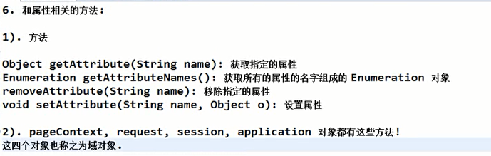

四大域对象：pageContext,request,session,application

