**Create a "Whac-a-Block" game in Minecraft**

[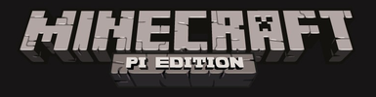](https://github.com/raspberrypilearning/minecraft-whac-a-block-game/blob/master/images/minecraft-pi-banner.png)

**Whac-a-Block**

The game you are going to create is called "Whac-a-Block", inspired by the original arcade game ["Whac-a-Mole"](http://en.wikipedia.org/wiki/Whac-A-Mole). The objective of the game is to whack (or hit with a sword) the blocks that light up as glowstone, and turn them back to stone. You will earn points for each block you turn back to stone and the game is over when all the blocks have been turned into glowstone.

[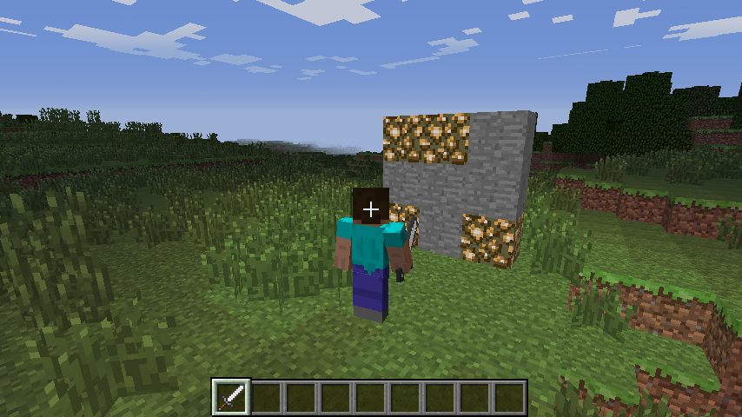](https://github.com/raspberrypilearning/minecraft-whac-a-block-game/blob/master/images/minecraft-whac-a-block.png)

This project is split into five parts.

1. Create the program: starting your Minecraft Python program and making sure everything is working.
2. Build the game board: creating the code which will make game board appear in front of the player.
3. Turn the blocks on: coding the functions to turn the blocks randomly into glowstone.
4. Whack blocks: turn the blocks back to stone when the player hits them.
5. Game over: how many points did you score?

**Create the program**

Boot your Raspberry Pi and from the menu select **Python 3 (IDLE)** from the **Programming** section.

When the Python shell appears, create a new program using File > New Window. You may also want to save your program now using File > Save.

Import the Python libraries you are going to need for this program:

import mcpi.minecraft as minecraft

import mcpi.block as block

import random

import time

* mcpi.minecraft is needed to interact with Minecraft: Pi Edition
* mcpi.block is needed to refer to blocks by name rather than ID
* random is used to create random numbers
* time is used to put delays into your program

Create a connection to Minecraft: Pi Edition and post a message to the chat window:

mc = minecraft.Minecraft.create()

mc.postToChat("Minecraft Whac-a-Block")

You can run the program now. It won't do much, but if everything is set up correctly you should see "Minecraft Whac-a-Block" displayed in the Minecraft chat window.

[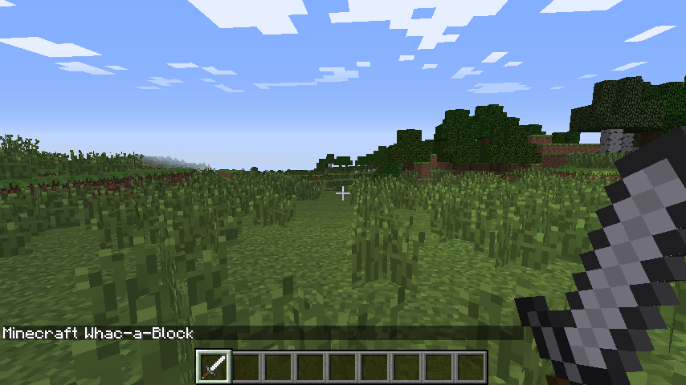](https://github.com/raspberrypilearning/minecraft-whac-a-block-game/blob/master/images/minecraft-message-in-chat.png)

If you haven't done so already, start up Minecraft and create/open a world. Run your program by clicking Run > Run Module in IDLE or by pressing F5. Any errors will appear in red in the Python shell window.

**Build the game board**

The next step is to create the game board; this consists of 3x3 stone blocks, which will randomly turn into glowstone and light up.

The game board will be created just in front of the player, so the first step is to get the player's position using player.getTilePos():

pos = mc.player.getTilePos()

The player's position is then used with the setBlocks() function to create the game board out of stone:

mc.setBlocks(pos.x - 1, pos.y, pos.z + 3,

pos.x + 1, pos.y + 2, pos.z + 3,

block.STONE.id)

[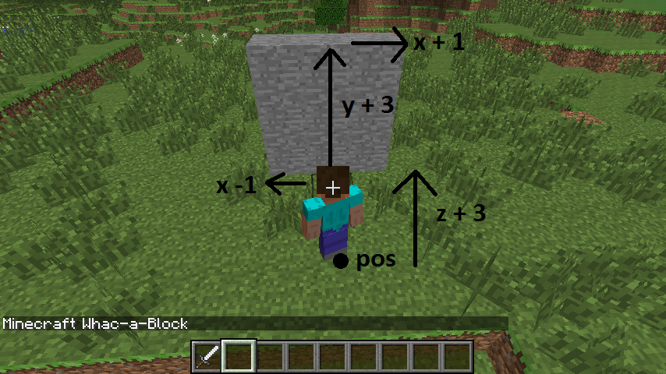](https://github.com/raspberrypilearning/minecraft-whac-a-block-game/blob/master/images/minecraft-game-board.png)

To give the player a warning that the game is about to start, post a couple of messages to the chat window and put a delay into the program using time.sleep(seconds):

mc.postToChat("Get ready ...")

time.sleep(2)

mc.postToChat("Go")

Run the program again. You should see the game board appear directly in front of the player, and the messages "Get ready ..." and "Go".

**Turn the blocks on**

Next, you are going to create the code which will turn the stone blocks to glowstone and light them up. The blocks will turn on randomly; you will use the random.randint(start, end) function to pick the random block on the game board.

Create a variable called blocksLit; this will hold the number of blocks which are currently lit (i.e. turned into glowstone). Next, create a variable called points which will hold how many points the player has scored. As it's the start of the game, set them both to 0:

blocksLit = 0

points = 0

Your program will need to loop until the game is over, or in this case until all the blocks are lit.

Create a while loop which will continue until the blocksLit variable is 9 (i.e. all the blocks are turned to glowstone). Next, put a small delay of 0.2 seconds into the program; otherwise it will run so fast, you won't be able to whack any blocks!

while blocksLit < 9:

time.sleep(0.2)

From now on, the code will be indented under this while loop.

The next step is to randomly turn a block into glowstone. This is more difficult than it sounds: what happens if the block you randomly choose is already glowstone? Your code needs to be able to deal with this.

The method you will use is a really simple one. The code creates a random position, checks to see if that block is stone, and if it isn't (i.e. it's glowstone), it tries again and creates a new random position. The code will continue to do this until it finds a block which is still unlit.

Create a variable called lightCreated then set it to False; next, create a while loop which will continue until lightCreated is set to True. You should also increase the number of blocksLit by 1, to show that another block will be lit:

blocksLit = blocksLit + 1

lightCreated = False

while not lightCreated:

Once a block is successfully turned to glowstone, lightCreated will be set to True and the loop will exit.

Inside this loop use random.randint(start, end) to create a random x (between -1 and 1) and y (between 0 and 2) position on the game board:

xPos = pos.x + random.randint(-1,1)

yPos = pos.y + random.randint(0,2)

zPos = pos.z + 3

[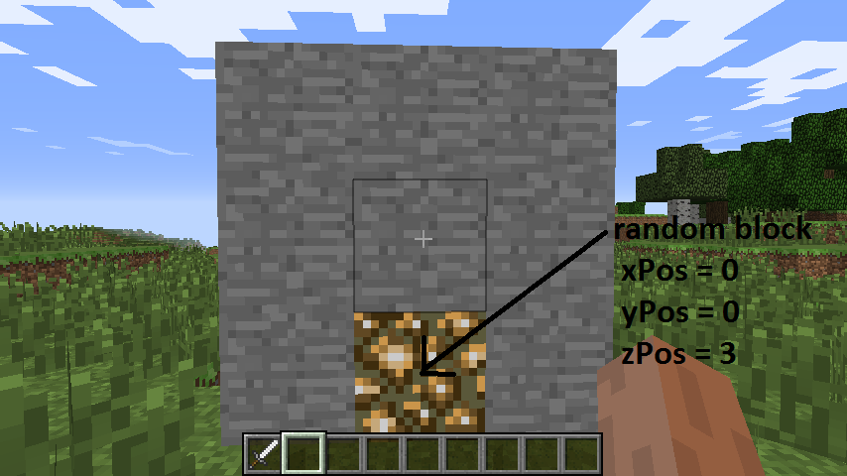](https://github.com/raspberrypilearning/minecraft-whac-a-block-game/blob/master/images/minecraft-random-block.png)

Use getBlock(x,y,z) and an if statement to check if the block at the random position is STONE. If it is, set it to glowstone using setBlock(x,y,z,blockId) and make lightCreated = True; if this is not changed, the code will go back to the start of the loop and find another random position.

if mc.getBlock(xPos, yPos, zPos) == block.STONE.id:

mc.setBlock(xPos, yPos, zPos, block.GLOWSTONE_BLOCK.id)

lightCreated = True

**Note**: Rather than using the ID numbers of blocks (e.g. stone = 1, glowstone = 89), you can use the block module, which holds all the block IDs and their names (e.g. block.STONE.id).

Run the program by clicking Run > Run Module in IDLE or by pressing F5; you should see the game board appear. The stone blocks should then, one by one, turn into glowstone and the program should end when all nine are lit.

**Whack blocks**

The player will whack blocks by hitting them (**right-clicking**) while holding a sword. The Minecraft API has functions which allow you to find out what blocks were hit; these are known as block hit *events*. Using the function events.pollBlockHits()you can get a list of the events that have occurred since it was last called, such as blocks which were hit.

You will use events to find out the position of the block which was hit, before using getBlock(x,y,z) to see if the block hit was glowstone. If it was, you will then use setBlock(x,y,z,blockId) to turn it back to stone, before reducing the number of blocks lit and increasing the player's score.

Indented under the while blocksLit < 9 loop, create the following code to loop through the block hit events list:

for hitBlock in mc.events.pollBlockHits():

**Note**: The hitBlock variable holds the *event* which has happened. It contains lots of information, including which block was hit, what face was hit and who hit it. You can see this information in the Python shell by using print hitBlock.

Use getBlock(x,y,z), the hitBlock event data and an if statement to see if the block hit was glowstone. If it was, use setBlock(x,y,z,blockId) to set it back to stone before reducing the blocksLit variable and adding 1 to the player's points:

if mc.getBlock(hitBlock.pos.x, hitBlock.pos.y, hitBlock.pos.z) == block.GLOWSTONE_BLOCK.id:

mc.setBlock(hitBlock.pos.x, hitBlock.pos.y, hitBlock.pos.z, block.STONE.id)

blocksLit = blocksLit - 1

points = points + 1

Run the program. The game board should appear and this time when the blocks are lit, if you hit them by **right-clicking** with a sword, they should turn off.

**Game over**

The last step in the game is to let the player know it's "Game Over" and to tell them how many points they scored. The very last line of the program should be:

mc.postToChat("Game Over - points = " + str(points))

[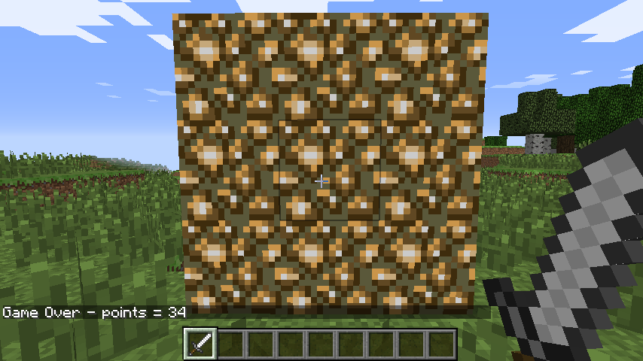](https://github.com/raspberrypilearning/minecraft-whac-a-block-game/blob/master/images/minecraft-game-over.png)

**What next?**

This might be the end of the worksheet, but it doesn't have to be the end of the game.

At the moment the gameplay is pretty simple, and there's a lot you can do, now you have the basic program set up, to make it your own. Here are some ideas to get you started:

1. The difficulty of the game is set by the how long the program waits before lighting another block, currently time.sleep(0.2). By increasing this time you make the game easier, and decreasing it will make the game harder. Experiment and see what works best for you.
2. What if the player gets things wrong and hits a stone block instead of a glowstone block? Can you change the program so that if the player hits a stone block, it lights the block? This forces the player to think more about what block they are hitting and increases the skill required.
3. It is common for video games to start easy and get harder. Can you make the game start easier and the more points you score, the harder it gets?

**API reference:** see an API reference at [stuffaboutcode.com](http://www.stuffaboutcode.com/p/minecraft-api-reference.html).