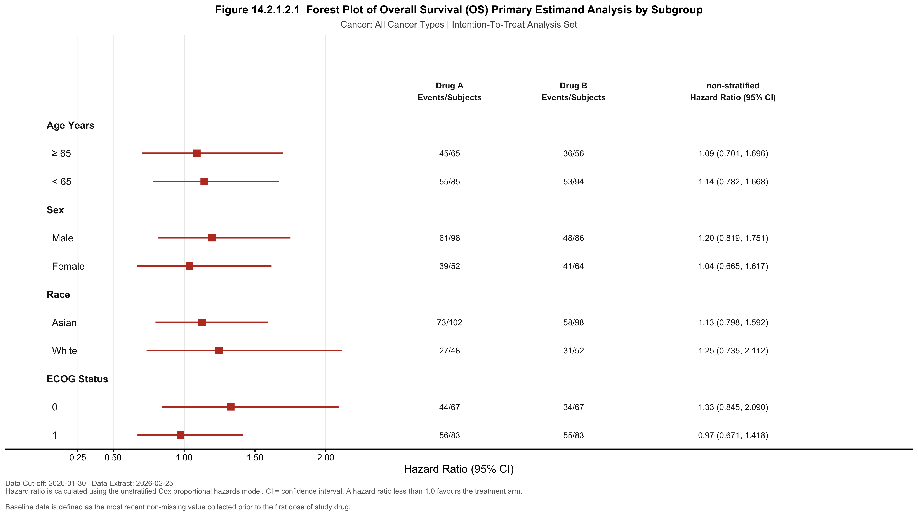

Hazard ratio is calculated using the unstratified Cox proportional hazards model. CI = confidence interval. A hazard
ratio less than 1.0 favours the treatment arm.
Baseline data is defined as the most recent non-missing value collected prior to the first dose of study drug.

