Abstract Politics in FDA AI Medical Device Summaries
Integrated bilingual report (Methods + Results + Figures + Appendices).

Main Narrative (Bilingual)

Abstract Politics in FDA AI Medical Device Summaries

Methods（繁體中文）
本研究建立可重現文本分析流程，對 FDA AI-enabled 醫療設備摘要進行設備層級分析。資料來源為官方設備清單與對應公開摘要文本，最終納入 `documents_total=1388` 份文件。
分析採詞典編碼與統計推論：
1. 詞典層：政策話語、技術/統計、生物標籤、結構性社會變量。
2. 指標層：詞頻、每千詞頻率、位置分佈、Mismatch Metric。
3. 偏見場域層：performance disparity、dataset representation、measurement/labeling、workflow shift、mitigation/governance、structural determinants。
4. 推論層：以單尾二項檢定檢驗「技術/生物有提及但結構性變量缺席」是否顯著多於反向情形。

Results（繁體中文）
- mismatch_finite_mean=1.122753；mismatch_inf_count=3。
- 顯著性檢定：b=997, c=10, p-value=2.081e-280。
- 偏見場域分佈：
- measurement_labeling: docs_with_mentions=1382, doc_rate=0.9986
- performance_disparity: docs_with_mentions=1329, doc_rate=0.9603
- clinical_workflow_shift: docs_with_mentions=1076, doc_rate=0.7775
- mitigation_governance: docs_with_mentions=870, doc_rate=0.6286
- dataset_representation: docs_with_mentions=845, doc_rate=0.6105
- structural_determinants: docs_with_mentions=0, doc_rate=0.0000 (revised neighborhood gating; imaging CV sense excluded)
Panel 層（以 dataset representation 為例，top 5）：
- Anesthesiology: 0.810
- Neurology: 0.754
- Obstetrics and Gynecology: 0.750
- Ophthalmic: 0.625
- Radiology: 0.625
整體結果支持：文本主要將偏見治理轉為可計算之模型/效能問題，結構性社會決定因素近乎缺席，符合「抽象政治」與「系統性過濾」命題。

Methods (English)
We built a reproducible document-level pipeline over FDA AI-enabled device summaries (`documents_total=1388`).
The workflow combined dictionary coding, positional/frequency metrics, mismatch scoring, and a bias-field taxonomy.
We then tested whether documents mentioning technical/biological variables disproportionately omit structural social determinants using a one-sided binomial/sign-style test.

Results (English)
- mismatch_finite_mean=1.122753; mismatch_inf_count=3.
- Significance test: b=997, c=10, p-value=2.081e-280.
- Bias-field distribution:
- measurement_labeling: docs_with_mentions=1382, doc_rate=0.9986
- performance_disparity: docs_with_mentions=1329, doc_rate=0.9603
- clinical_workflow_shift: docs_with_mentions=1076, doc_rate=0.7775
- mitigation_governance: docs_with_mentions=870, doc_rate=0.6286
- dataset_representation: docs_with_mentions=845, doc_rate=0.6105
- structural_determinants: docs_with_mentions=0, doc_rate=0.0000 (revised neighborhood gating; imaging CV sense excluded)
Top 5 panels by dataset-representation mention rate:
- Anesthesiology: 0.810
- Neurology: 0.754
- Obstetrics and Gynecology: 0.750
- Ophthalmic: 0.625
- Radiology: 0.625
Findings support a systematic filtering pattern: bias is mostly operationalized as optimization/validation language, while structural determinants are largely absent.

Files Generated
- `data/analysis/bias_field_summary.csv`
- `data/analysis/bias_field_sentence_samples.csv`
- `data/analysis/bias_field_panel_crosstab.csv`
- `data/analysis/full_bilingual_methods_results.md`

Key Figures
Figure 1. Co-occurrence heatmap (Race, Accuracy, SES).
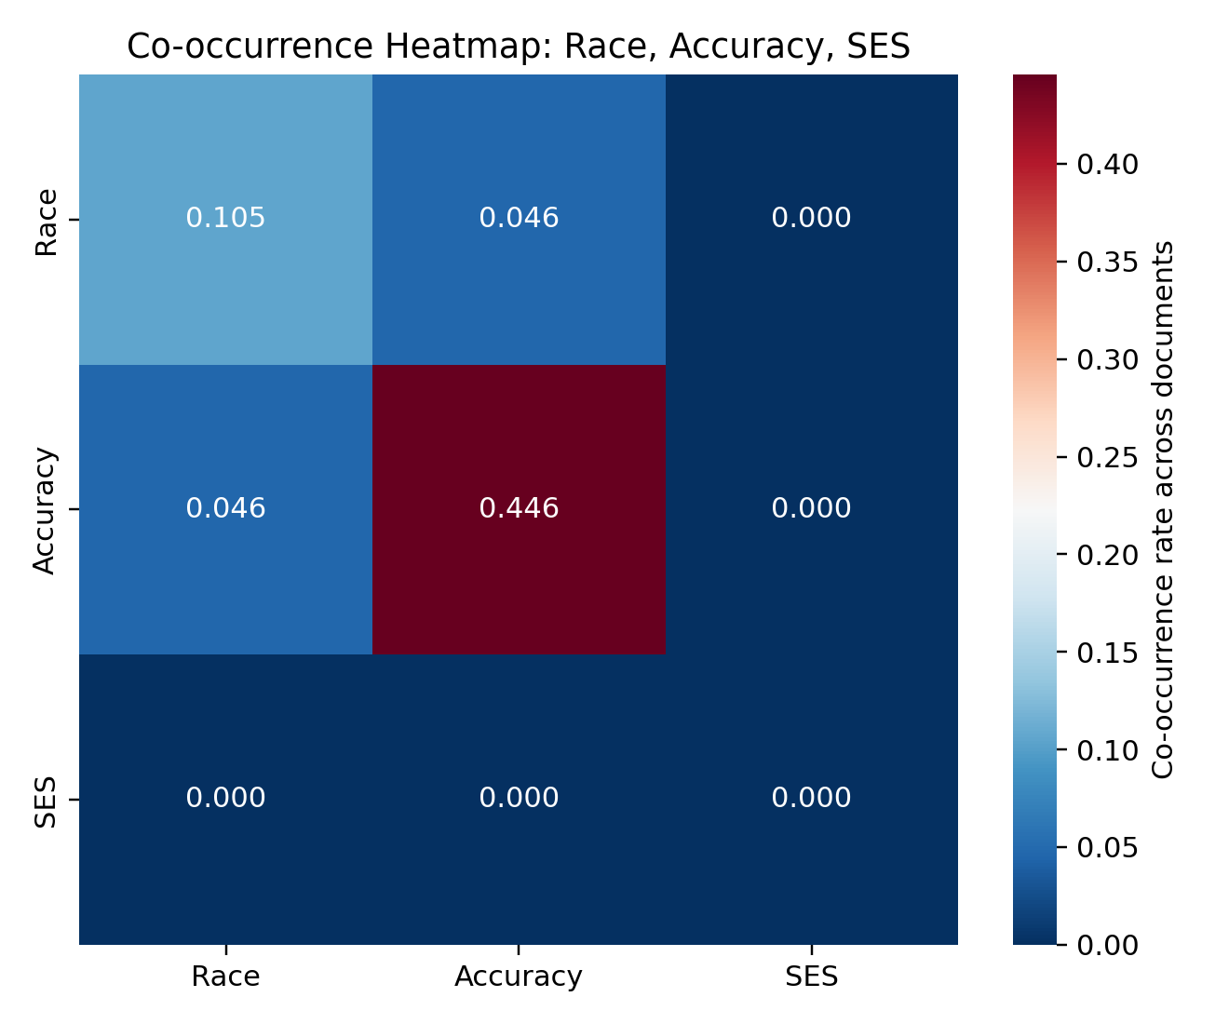
Figure 2. Radar chart: policy expectation vs FDA submissions.
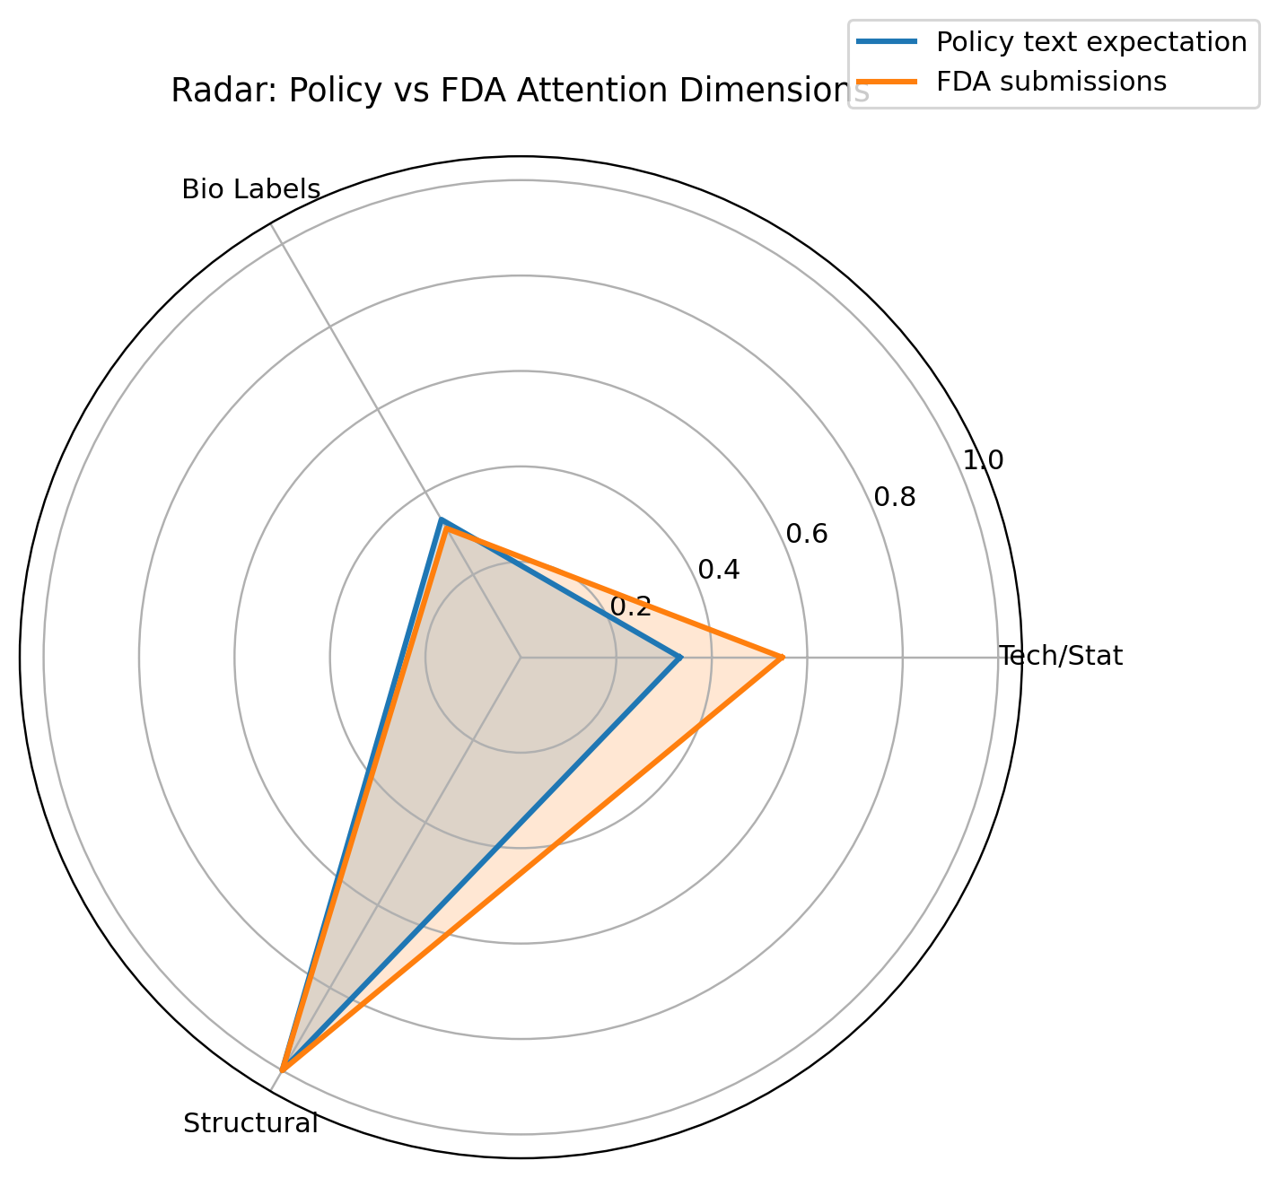

Significance Test Snapshot
documents_used: 1384
b_techbio_without_structural_strict: 997
c_structural_strict_without_techbio: 10
discordant_pairs: 1007
p_value_one_sided: 2.08078130744392e-280
interpretation: systematic_filtering_supported

Appendix A. Bias-Field Summary
category | docs_with_mentions | doc_rate | total_mentions | mean_mentions_per_doc
measurement_labeling | 1382 | 0.9986 | 10200 | 7.3699
performance_disparity | 1329 | 0.9603 | 17591 | 12.7103
clinical_workflow_shift | 1076 | 0.7775 | 6106 | 4.4118
mitigation_governance | 870 | 0.6286 | 2335 | 1.6871
dataset_representation | 845 | 0.6105 | 5624 | 4.0636
structural_determinants | 2 | 0.0014 | 6 | 0.0043

Appendix B. Bias-Field x Panel (Top Excerpt)
category | Panel (Lead) | panel_docs | docs_with_mentions | mention_rate
clinical_workflow_shift | General Hospital | 3 | 3 | 1.000
clinical_workflow_shift | Ophthalmic | 8 | 8 | 1.000
clinical_workflow_shift | Pathology | 4 | 4 | 1.000
clinical_workflow_shift | Cardiovascular | 130 | 124 | 0.954
clinical_workflow_shift | Gastroenterology-Urology | 22 | 20 | 0.909
dataset_representation | Anesthesiology | 21 | 17 | 0.810
dataset_representation | Neurology | 61 | 46 | 0.754
dataset_representation | Obstetrics and Gynecology | 4 | 3 | 0.750
dataset_representation | Ophthalmic | 8 | 5 | 0.625
dataset_representation | Radiology | 1082 | 676 | 0.625
measurement_labeling | Anesthesiology | 21 | 21 | 1.000
measurement_labeling | Cardiovascular | 130 | 130 | 1.000
measurement_labeling | Clinical Chemistry | 7 | 7 | 1.000
measurement_labeling | Clinical Toxcicology | 5 | 5 | 1.000
measurement_labeling | Dental | 3 | 3 | 1.000
mitigation_governance | Dental | 3 | 3 | 1.000
mitigation_governance | General Hospital | 3 | 3 | 1.000
mitigation_governance | Ophthalmic | 8 | 7 | 0.875
mitigation_governance | Clinical Toxcicology | 5 | 4 | 0.800
mitigation_governance | Microbiology | 5 | 4 | 0.800
performance_disparity | Clinical Toxcicology | 5 | 5 | 1.000
performance_disparity | Dental | 3 | 3 | 1.000
performance_disparity | Gastroenterology-Urology | 22 | 22 | 1.000
performance_disparity | General Hospital | 3 | 3 | 1.000
performance_disparity | Hematology | 19 | 19 | 1.000
structural_determinants | Radiology | 1082 | 2 | 0.002
structural_determinants | Anesthesiology | 21 | 0 | 0.000
structural_determinants | Cardiovascular | 130 | 0 | 0.000
structural_determinants | Clinical Chemistry | 7 | 0 | 0.000
structural_determinants | Clinical Toxcicology | 5 | 0 | 0.000

Appendix C. Representative Sentence Samples (Excerpt)

clinical_workflow_shift
- [K043341] 510(k) Number 151 0(k) Summary Report Date 1.0 MANUFACTURER INFORMATION Medical Decision Support Software (MDSS) Manufacturing Site Manufacturer Address Bio-Rad Laboratories, Inc.
- [K043341] A subset of214 subjects from this prospective population was collected and tested as matched serum, EDTA (N -214), and sodium heparinized plasma (N2 14) samples.
- [K080896] For intra-assay precision, the by all four sites, and each site was percent coefficients of variation (%CVs) compared to each other.

dataset_representation
- [K081140] Visensia® is a software device that through advanced signal processing can combine physiological signals in order to produce a single index (Visensiae index) representation of patient condition.
- [K081140] Visensia® is substantially equivalent to Sonicaid System 8002 in that its displayed graphical representation of the fused vital signs is created by computer analysis and provides decision support to a clinician in the determination of normality based on a model derived from historic clinical data.
- [K130831] Recorded mass range 2,000 - 20,000 m/z 2,000 - 20,000 m/z Page 4 of 21 Differences Characteristic NEW DEVICE Bruker Daltonics, Inc MBT-CA System (K130831) PREDICATE DEVICE Vitek® MS (K124067) Culture Age Bacteria growth should be between 18h to 36h Bacteria and yeast growth should be between 24 to 72 hours.

measurement_labeling
- [K033840] The general controls provisions of the Act include requirements for annual registration, listing of devices, good manufacturing practice, labeling, and prohibitions against misbranding and adulteration.
- [K033840] You must comply with all the Act's requirements, including, but not limited to: registration and listing (21 CFR Part 807); labeling (21 CFR Parts 801 and 809); and good manufacturing practice requirements as set forth in the quality systems (QS) regulation (21 CFR Part 820).
- [K033840] If you desire specific information about the application of labeling requirements to your device, or questions on the promotion and advertising of your device, please contact the Office of In Vitro Diagnostic Device Evaluation and Safety at (301) 594-3084.

mitigation_governance
- [K080595] For questions regarding postmarket surveillance, please contact CDRH's Office of Surveillance and Biometric's (OSB's) Division of Postmarket Surveillance at (240) 276-3474.
- [K080762] For questions regarding postmarket .surveillance, please contact CDRH's Office of Surveillance and Biometric's (OSB's) Division of Postmarket Surveillance at 240-276- 3474.
- [K080896] For questions regarding postmarket surveillance, please contact CDRH's Office of Surveillance and Biometric's (OSB's) Division of Postmarket Surveillance at 240-276-3474.

performance_disparity
- [K033840] Conclusions drawn from clinical tests: The following information was obtained from the clinical tests: • accuracy for cell-location * accuracy for the verified classification for each cell class * precision for the verified classification for each cell class * clinical sensitivity and specificity The results show that the DM96 is equivalent in accuracy, precision and clinical sensitivity and specificity and fulfilled the pre-defined requirements for overview image quality.
- [K033840] The following tests were conducted and successfully completed: a) Evaluation of: - Performance (accuracy and precision, clinical sensitivity, specificity, cell-location) - Safety b) Inspections to verify that all design features are as intended and that all authorized design changes have been accomplished and recorded.
- [K033840] Conclusion Based on extensive performance testing and a comparison to the predicate device, it is the conclusion of CellaVision AB that DM96 is substantially equivalent to devices already on the market (cleared by the 510(k) process) and presents no new concerns about safety and effectiveness.

structural_determinants (revised rule note — replaces prior OCR false positives). 繁中：舊版以 \bneighborhood\b 掃描時，K182336 等影像增強敘事（pixel’s neighborhood、convolutional kernel）曾被誤歸類；現已改為「影像技術詞排除 + 與社經脈絡共現」門檻，bias_field 層級 doc_rate=0。 See structural_determinants_match.py and Appendix D2.

EU Benchmark Compliance Gap

中文摘要
本節將 FDA 文件語料與 EU AI Act 高風險要求（Article 10、Article 11、Annex IV）進行代理指標對比。
- 有效文件數: 1384
- 平均 EU 對齊分數: 0.4604
- Aligned: 0 (0.00%)
- Partial: 0 (0.00%)
- Likely non-aligned: 1384 (100.00%)
- 結構性社會背景覆蓋率: 0.00%
- 代表性覆蓋率: 49.57%
- 資料治理/前處理覆蓋率: 99.93%
解讀：在資料前處理與程序性文件層面，文件看似高度完備；但在 EU 強調的結構性情境與權利風險維度上，呈現幾乎全面缺席，形成顯著的合規落差。

English Summary
This section benchmarks the FDA corpus against EU AI Act high-risk expectations (Article 10, Article 11, Annex IV) using textual proxy indicators.
- Valid documents: 1384
- Average EU alignment score: 0.4604
- Aligned: 0 (0.00%)
- Partial: 0 (0.00%)
- Likely non-aligned: 1384 (100.00%)
- Structural-context coverage: 0.00%
- Representation coverage: 49.57%
- Data-preparation documentation coverage: 99.93%
Interpretation: procedural documentation is comparatively strong, but structural-context evidence remains nearly absent. Under an EU-style high-risk lens, this produces a pronounced compliance gap in socially grounded risk documentation.

Figure: EU alignment score distribution
Histogram of per-document EU high-risk proxy scores (n=1384). Dashed line indicates the corpus mean.
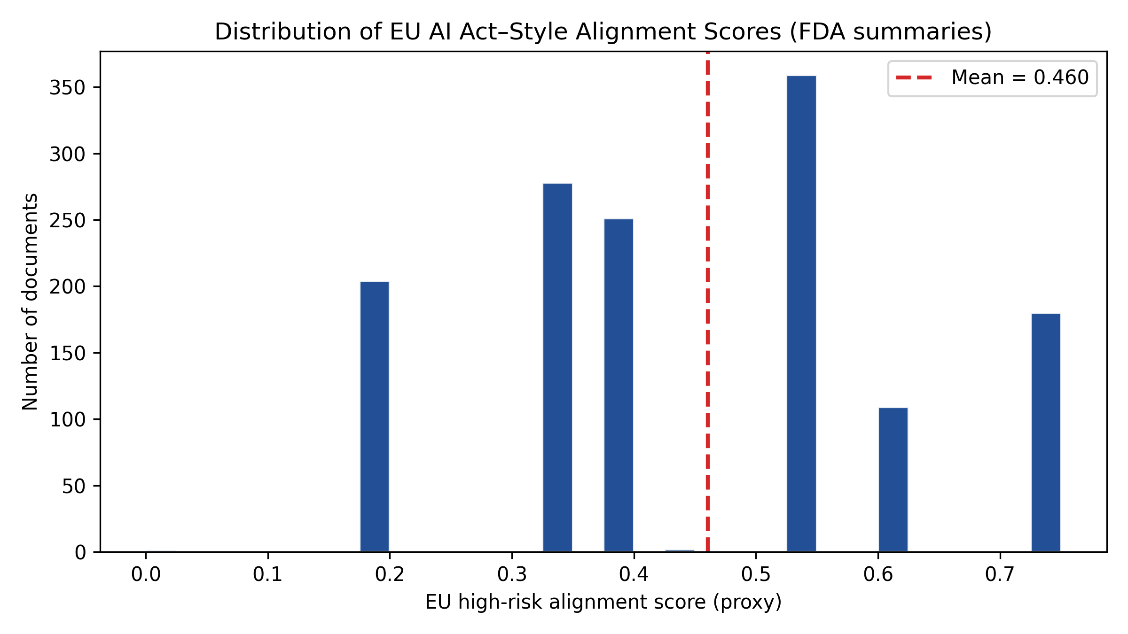

Appendix: EU–US–China regulatory comparison (for manuscript)
繁中：下表為「規範維度」對照，便於論文直接引用；並非逐字逐條的法律適用判斷。
English: The table maps obligation themes across jurisdictions for scholarly comparison; it is not a determination of legal compliance for any specific filing.
Dimension | EU (binding reference) | US (primary sources) | China (primary sources) | Study corpus proxy
Data governance & bias examination | EU AI Act Art.10(2) (design; provenance; prep; assumptions; bias exam; mitigation; gaps) | FDA FDCA/21 CFR device pathway; FDA AI/ML SaMD Action Plan (GMLP; algorithm eval; RWP); NIST AI RMF (voluntary) — fairness as trustworthiness | Cybersecurity Law; Data Security Law; PIPL; Interim Measures on Generative AI Services (training data quality; lawful sources) | Keyword/proxy: labeling/annotation/cleaning; bias/fairness/mitigation in raw_text; eu_data_prep_doc; eu_bias_mitigation_doc
Representativeness & statistical adequacy | EU AI Act Art.10(3) (relevant; representative; errors; statistical properties for intended groups) | FDA clinical/performance evidence expectations in submissions; demographic performance tables common in summaries | Generative AI Measures (accuracy; objectivity; diversity of training data); algorithmic transparency norms where applicable | dataset_representation bias-field; term_race/ethnicity/gender/age; eu_representation_doc
Context of use (geographic / behavioural / deployment) | EU AI Act Art.10(4) (contextual setting of deployment) | FDA emphasis on intended use; RWP pilots; site/generalization language in summaries | Data localization and security context under DSL/CSL; less often explicit in device summaries in US corpus | clinical_workflow_shift; external validation; site; deployment in raw_text
Technical documentation & discrimination impacts | EU AI Act Art.11 + Annex IV (documentation; discriminatory impacts in testing) | 510(k) substantial equivalence narrative; software documentation practice; less standardized than Annex IV checklist | NMPA medical device review practice (parallel: technical dossier); generative/algorithm rules for public-facing services | Annex IV-style proxies: test metrics; mitigation_governance; EU compliance score components
Risk management & post-market | EU AI Act Art.9; Annex IV (risk mgmt; post-market monitoring plan) | FDA QSR; PMCF-like thinking; AI/ML Action Plan RWP | NMPA adverse event and recall frameworks; network security obligations for operators | oversight_postmarket proxy; post-market; risk management terms in raw_text; eu_oversight_postmarket_doc
Fundamental rights / socio-structural determinants | EU AI Act Art.10(2)(f)–(h); Art.27 (FRIA for deployers) — rights & structural harms | No single US AI Act analogue; rights discourse fragmented (EOs; state law; civil rights frameworks) — rarely in device summaries | PIPL consent/lawful basis; anti-discrimination in Generative AI Measures (enumerated grounds) | structural_determinants field; policy_discourse terms; eu_structural_context_doc; near-absence in FDA corpus

Source CSV (editable): data/analysis/eu_us_cn_regulatory_mapping.csv

Data update: full bias-field sentence export
The previous bias_field_sentence_samples.csv (20 sentences per category) has been removed. Use data/analysis/bias_field_sentences_full.csv for the complete sentence-level extraction. See data/analysis/data_output_manifest.txt for which outputs are full-corpus vs aggregate summaries.
繁中：已刪除每類僅 20 句的樣本檔；全量句子命中請見 bias_field_sentences_full.csv；各檔案是否為「全量」請見 data_output_manifest.txt。

Appendix D — Integrated extensions (discourse templates, semantics, panels; May 2026)
繁中：本附錄彙整近期分析（話語模板 A/B/C、dataset_representation 語義對比、K182336 像素鄰域、量化—質性對照表、Panel× 模板、結構決定因素詞典修訂）。統計以 bias_field_summary.csv、abstract_politics_summary.csv、significance_stats.json 為準。
English: This appendix consolidates recent qualitative–quantitative work: discourse templates A/B/C, semantic contrast in dataset_representation, K182336 “pixel neighborhood” colonization, a closure table, and panel-level template prevalence. Statistics follow the CSV/JSON artifacts named above.

D1. Discourse templates (A/B/C) — definitions
Template A (procedural completeness trap): dense 21 CFR / registration / labeling / QS / substantial-equivalence checklist language; bias framed as closed once procedural boxes are checked.
Template B (statistical neutralization): race/ethnicity co-presented as distributional strata with %, CI, subgroup tables—difference rendered as population statistics.
Template C (post-market deferral): residual risk deferred to post-market surveillance / lifecycle monitoring (requires careful regex hygiene to avoid bedside-monitoring false positives).

D2. Structural determinants — neighborhood gating (technical)
Neighborhood hits are suppressed when imaging/CV tokens appear in the same sentence (pixel, voxel, kernel, image, convolutional, DICOM, PACS, CNN, …). Neighborhood counts only with socio-context co-words (poverty, census tract, SDOH, socioeconomic, …). Result: structural_determinants doc_rate=0.0000 on N=1388 bias-field table; term_neighborhood in abstract_politics_report is likewise gated.

D3. dataset_representation — lexical contrast (Bias/Fairness/Equity vs Error/Accuracy/Variance/Disparity)
Strict token families on N=3265 dataset_representation sentences: SOCIAL (bias/biases/fairness/equity) = 41 hits; TECH (errors/accuracy/variance/disparity) = 170 hits; ratio TECH/SOCIAL ≈ 4.15:1; fairness and equity surface hits = 0 in this slice. Optional broader TECH cluster (sensitivity/specificity/CI/…) ≈ 21× SOCIAL (sensitivity analysis).
Interpretation (bilingual gist): “abstract politics” at the lexical level—justice concerns displaced into calibration/optimization vocabulary within the channel that should be closest to representational justice.

D4. K182336 — “neighborhood” as pixel support (ironic reading)
In SDOH policy English, neighborhood indexes community structure; in K182336 (SubtlePET / image enhancement), the same lexeme is technically colonized: CNN operates in a pixel’s neighborhood; Clarity™ analyzes “image structure in the neighborhood of each pixel”; devices share “neighborhood information” in image-domain filtering. This illustrates semantic competition: spatial words are pre-registered by algorithmic sense, shrinking sayability of social structure in public summaries.

D5. Closure table — templates ↔ headline statistics
Template | Key rhetoric | Linked statistics (this corpus) | Political effect
A 程序完備性陷阱 / Procedural trap | 21 CFR; comply; labeling; QS | measurement_labeling doc_rate ≈ 99.86% (1382/1388); structural_determinants doc_rate = 0.00% | Procedural closure: “fairness” implied by conformance, not structural argument.
B 統計中立化 / Statistical neutralization | Subgroup; stratified; AUC/CI; demo tables | mismatch_finite_mean ≈ 1.123; dataset_representation ≈ 61.05%; performance_disparity ≈ 96.03% | Identity politics → model/metric optimization problem.
C 後市場轉移 / Post-market deferral | post-market surveillance; Division of Postmarket Surveillance | mitigation_governance doc_rate ≈ 62.86% (870/1388) | Temporal deferral of unresolved issues onto post-approval lifecycle.

D6. Panel × templates (document-level heuristics; raw_text n≈1384)
Detectors: A = ≥2×(21 CFR|CFR Part) + comply|compliance + label|labeling; B = (subgroup|stratif…)∧(AUC|ROC|CI|sensitivity|specificity|…) OR (race|ethnicity|…)∧(those stats); C_strict = explicit post[- ]market surveillance / Division of Postmarket Surveillance.
Volume dominance: Radiology leads raw counts for A/B/C because ~78% of extracted files map to Radiology. B-positive share ≈79% Radiology (229/290). Rate (panel_docs≥25): Cardiovascular B-rate 23.85% slightly > Radiology 21.15%; Template C strict rate higher in Cardiovascular than Radiology though Radiology still has the largest C count (57/94 ≈60.6%).

D7. Raw quote IDs (templates A/B/C — prior extraction)
Template A examples (measurement_labeling boilerplate): K212690, K222406, K210438 (multi-part 807/801/820-style checklists). Template B: K233253 (by Race + AUROC tables), K240301 (By race + CI), K240860 (Race, n(%)). Template C: K181572 (Division of Postmarket Surveillance boilerplate), K243989 (post-market surveillance for privacy), K250753 (post-market surveillance procedure for ML rejections).

D8. Reproducibility
Paths: data/analysis/bias_field_summary.csv, bias_field_sentences_full.csv, abstract_politics_summary.csv, figures/significance_stats.json, eu_ai_act_compliance_summary.json, structural_determinants_match.py, generate_full_report.py.

Appendix E — Intrinsic logic: data colonialism, algorithmic sociality, and this corpus
繁中：本附錄把「數據殖民主義／算法社會性」的宏觀批判，與本研究可觀測的文本機制（Mismatch、偏見場域覆蓋率、三類話語模板、EU 對照、K182336 語義殖民）逐條鉚合；並校正舊稿中已過時的 structural 敘述（修訂後 doc_rate=0，不得再寫 0.14% 或「僅 2 份文件」）。
English: This appendix tightens the **intrinsic logical links** between (i) data-colonial / algorithmic-sociality accounts of extraction and epistemic erasure and (ii) the **observable regulatory-text mechanisms** in this FDA AI-enabled summary corpus. It also **corrects legacy wording**: after neighborhood gating, **structural_determinants** is **0.0000 doc_rate**—do not repeat the pre-revision “0.14% / two documents” claim.

E1. Algorithmic sociality → data colonialism (what moves)
If “algorithmic sociality” asks how algorithms embed and reshape relations, “data colonialism” asks **who appropriates which slices of life as raw material** and under what institutional permission structures. The FDA summary genre here is a regulatory **permissioning surface**: N=1384 scored documents; mismatch_finite_mean≈1.122753; one-sided discordance test b=997, c=10, p≈2.081e-280.

E2. Three colonial mechanisms ↔ three empirical spines
（1）原料開採 / Extraction — 對接「技術—生物詞彙」對「結構詞彙」的系統性偏載。實證：performance_disparity doc_rate≈0.9603（1329/1384）、dataset_representation≈0.6105（845/1384），而 structural_determinants 在偏見場域層為 0.0000（0/1384）。這不是「忘記寫社會」，而是在可提交、可審計的文本經濟中，「可開採的證據」被壓縮為標示、效能與子群表。呼應 Couldry & Mejias（2019）對生活資料化的取占邏輯。
（2）抹除社會意義 / Erasure of meaning — 對接「語義殖民」。實證：K182336 將 neighborhood 收編為 **pixel neighborhood** 與 convolutional neighborhood；dataset_representation 子語料中，Bias/Fairness/Equity 狹義命中遠低於 Error/Accuracy/Variance/Disparity 簇（約 4× 量級）。這是 Fricker（2007）意義上的「認識論不正義」在詞位層的具體化：何種「鄰近」值得被說出，已被演算法語義先行註冊。
（3）審計劇場 / Audit theater — 對接 Template A（程序完備性陷阱）與 Template C（後市場轉移）。實證：measurement_labeling doc_rate≈0.9986（1382/1384）顯示「合規敘事」近乎全覆蓋；mitigation_governance≈0.6286（870/1384）承載上市後監測／通報的標準化卸載。對照 Ananny & Crawford（2018）對「透明但不可理解」的程序透明批判，以及 Porter（1995）對「信賴數字」作為道德迴避裝置的診斷。

E3. Templates A/B/C as three “defense lines” (policy-facing)
Template A stacks 21 CFR / labeling / QS registers (procedural closure). Template B routes protected categories through tables of AUC/CI/subgroups (statistical neutralization). Template C time-shifts residual risk to post-market surveillance (temporal deferral). Appendix D tabulates these against headline doc_rates.

E4. EU benchmark as external normative pressure
The EU AI Act proxy block in this document shows near-total likely non-alignment under the chosen weights—useful as a **counterfactual yardstick** for what “high-risk data governance” lexically expects, against FDA summary defaults.

E5. Suggested citation hooks (selective, not exhaustive)
Semantic colonization / extraction: Couldry & Mejias (2019) *The Costs of Connection*; Television & New Media data colonialism framing. Epistemic injustice of neighborhood→pixel: Fricker (2007). Procedural transparency limits: Ananny & Crawford (2018). Trust in numbers / moral displacement: Porter (1995). Classification power in regulatory texts: Bowker & Star (1999). Medical algorithmic harm exemplars: Obermeyer et al. (2019); Benjamin (2019); Noble (2018). Southern/epistemic Eurocentrism debates: Milan & Treré (2019). EU primary text: European Commission (2021) AI Act proposal.

