- string
- bool
- integer
- float
- -
- Float
- Float
- Float
- Integer
- Float
- complex
- -
- String

- -
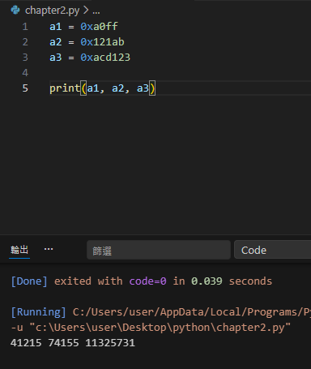
- -

(b)
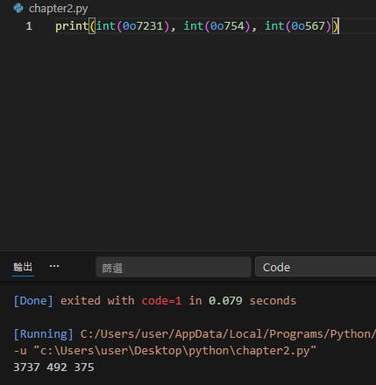

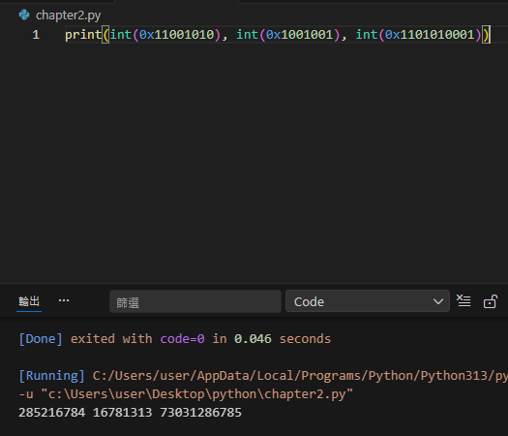
(c)

2.2

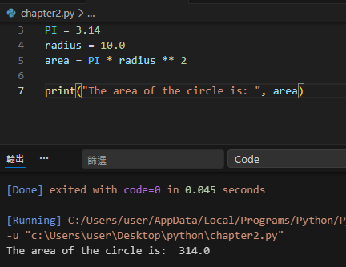
4.

2.3
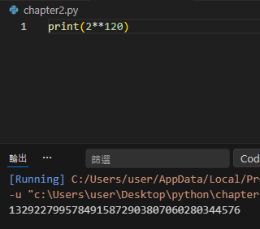
6.

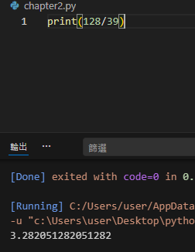
7.

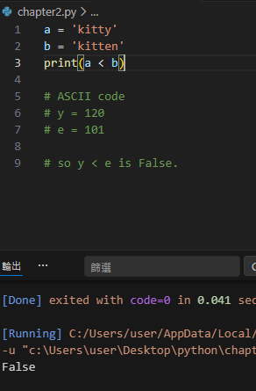
8.

10.
(a) x = 7
(b) x = 21
(c) x = 81
(d) x = 3

12.
(a) 2 + True = 3 # because True value is 1. False value is 0.
(b) 6 + int(17.4) = 23 # because int (17.4) = 17. So 6 + 17 is equal 23.
(c) 21 + 6.5 = 27.5 # 21 change to 21.0 float number.
(d) str(2) + ‘piggy’ = 2piggy . # str(2) change to string ‘2’ .

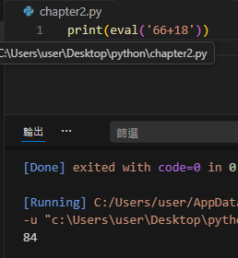
13.
(a)

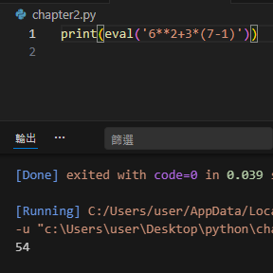
(b)

(c)
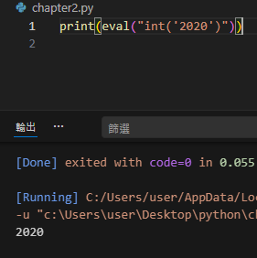

2.6
14.
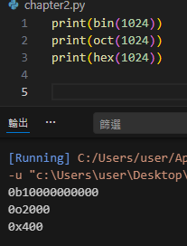
15.
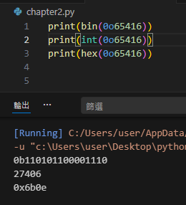
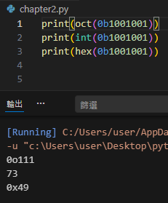
16.

2.7
17.
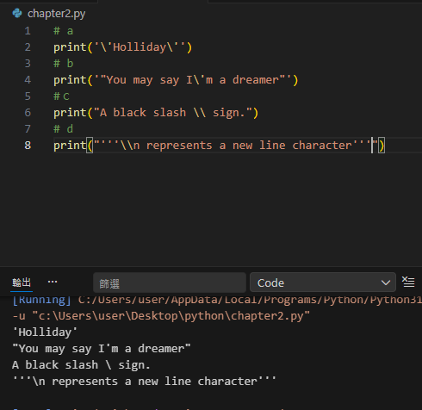

18.
(a)

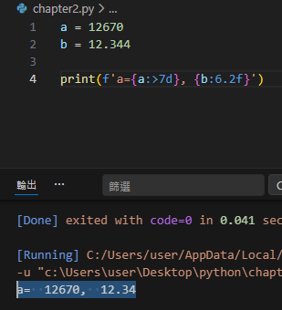

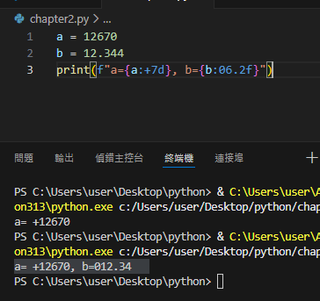
(b)

(c)

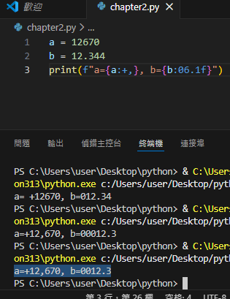

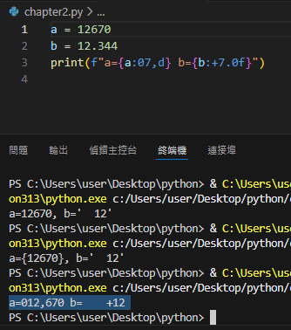
(d)

(e)
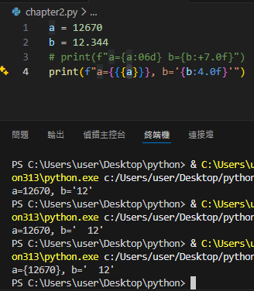

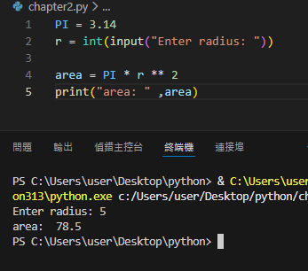
19.

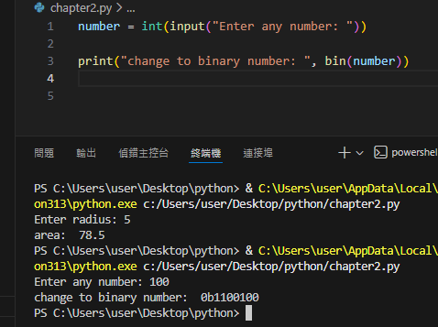
20.

21. answer is (c)

22.
(c) 0.6 / 0.2 = 2.9999999999999996
(f) 0.1 + 0.1 + 0.1 = 0.30000000000000004
# binary systems cannot exactly represent decimal numbers that are not powers of two

