S&P 500 Realized Variance Forecasting
Data Analysis Model Specification and Out-of-Sample Evaluation
This report uses a heterogeneous autoregressive realized volatility model to forecast next-trading-day log realized variance for the S&P 500 Index. The model combines daily, weekly, and monthly volatility information and uses chronological sample splits. Adding Lag 2 lowers mean squared error by approximately 1.47% in five-fold time-series cross-validation and 1.49% on the independent test set. The evidence supports retaining Lag 2, but the gain is small and significant residual autocorrelation remains in the test period.

1 Data and Descriptive Statistics
Descriptive statistics use training-period data only and cover the S&P 500 Index (.SPX), Dow Jones Industrial Average (.DJI), and Russell 2000 Index (.RUT). None of the three series contains an invalid RV5 observation in the training sample. Realized variance measures daily variation, and the model forecasts its logarithm.
Table 1 Training-Period Return and Realized Variance Statistics
Index | N | N Return | Mean Return | Std. Ret. | Skew | Excess Kurt. | Mean RV5 | Invalid
.SPX | 2,791 | 2,791 | -0.000036 | 0.012895 | -0.090205 | 7.370035 | 0.000139 | 0
.DJI | 2,790 | 2,790 | 0.000144 | 0.012617 | 0.073539 | 7.779407 | 0.000141 | 0
.RUT | 2,789 | 2,789 | 0.000640 | 0.012390 | -0.113599 | 5.523270 | 0.000078 | 0
Mean daily returns are close to zero and absolute skewness is below 0.12 for all three indices. Excess kurtosis ranges from 5.52 to 7.78, well above the normal-distribution value of zero. The return distributions are therefore approximately symmetric but sharply peaked and heavy-tailed, so a normal model may understate the frequency of extreme returns.
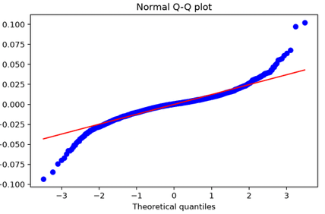
Figure 1 Normal Q-Q Plot of S&P 500 Training-Period Returns
Observations near the center of the Q-Q plot broadly follow the normal reference line, while both tails diverge materially. This is consistent with heavy-tailed returns. The figure concerns the return distribution and does not establish the distribution of forecast errors, which must be assessed separately with out-of-sample residual diagnostics.

2 HAR-RV Model Specification
Realized variance is persistent. HAR-RV uses daily, weekly, and monthly components to represent information operating over different horizons and to forecast the next day. This structure makes the incremental contribution of each horizon easy to examine, but it does not directly model heavy-tailed returns.
The model applies a logarithm to realized variance to compress its scale. The standard specification is:
$${log RV}_{t+1} = β_{0} + β_{d} {log RV}_{t}^{d} + β_{w} {log RV}_{t}^{w} + β_{m} {log RV}_{t}^{m} + ε_{t+1}$$
Table 2 HAR-RV Variable Definitions
Variable | Horizon | Definition
log RV(d) | Daily | Log of current realized variance
log RV(w) | Weekly | Log of mean realized variance over the latest 5 trading days
log RV(m) | Monthly | Log of mean realized variance over the latest 22 trading days
log RV(t+1) | Target | Log realized variance on the next trading day
Here beta 0 is the intercept; beta d, beta w, and beta m are the daily, weekly, and monthly coefficients; and epsilon at t plus 1 is the forecast error. Weekly and monthly components average realized variance over the latest 5 and 22 trading days through date t and then apply the logarithm. Every explanatory variable uses information available no later than t.

3 Validation Design
The sample is divided chronologically into training, validation, and test periods, as shown in Table 3. A random split can train on later observations and evaluate on earlier ones, which is inconsistent with forecasting. The development process uses persistence, where today's log realized variance forecasts the next trading day, as the baseline. Five expanding-window splits are generated with TimeSeriesSplit, leaving a one-observation gap between each training and validation period. MSE and MAE are calculated on the log realized variance scale. The final model is evaluated once on the test set after model selection is complete.
Table 3 Chronological Sample Split
Dataset | Obs. | Target Date Range | Purpose
Training | 2,770 | 2000-02-03 to 2011-02-22 | Fit and initial diagnostics
Validation | 923 | 2011-02-24 to 2014-10-22 | Model selection and residual diagnostics
Test | 924 | 2014-10-27 to 2018-06-26 | Final frozen-model evaluation

4 Introducing and Validating Lag 2
The standard model's validation residuals have lag-2 autocorrelation and partial autocorrelation of approximately 0.088, while lags 3 and 4 are near zero. Lag 2 is therefore treated as a candidate feature and evaluated for out-of-sample error reduction. Residual diagnostics motivate the feature; they do not by themselves prove that it is useful.
When forecasting date t plus 1, Day is log realized variance on t and Lag 2 is log realized variance on t minus 1. They are one and two trading days behind the target, respectively. The extended specification is:
$${log RV}_{t+1} = β_{0} + β_{d} {log RV}_{t} + β_{2} {log RV}_{t-1} + β_{w} {log RV}_{t}^{w} + β_{m} {log RV}_{t}^{m} + ε_{t+1}$$
Table 4 Diagnostic and Forecast Evidence Before and After Lag 2
Evidence | Standard HAR-RV | HAR-RV + Lag 2 | Interpretation
Residual lag-2 ACF | 0.0884 | 0.0043 | Autocorrelation falls close to zero
Residual lag-2 PACF | 0.0875 | 0.0041 | Partial autocorrelation falls close to zero
Ljung-Box lag-5 p-value | 0.0023 | 0.2463 | No longer significant at 5%
Ljung-Box lag-10 p-value | 0.0087 | 0.3207 | No longer significant at 5%
Five-fold mean MSE | 0.350979 | 0.345829 | Mean MSE declines about 1.47%
Final test MSE | 0.429034 | 0.422655 | Test MSE declines about 1.49%
Final test MAE | 0.514996 | 0.511852 | Test MAE declines about 0.61%
After Lag 2 is added, the validation residual ACF and PACF at lag 2 fall to approximately 0.004. Ljung-Box p-values at lags 5 and 10 rise from 0.0023 and 0.0087 to 0.2463 and 0.3207. At the 5% level, these two tests no longer reject the null of no residual autocorrelation, indicating weaker linear dependence over the tested lag ranges. Forecast improvement must still be established with out-of-sample errors.
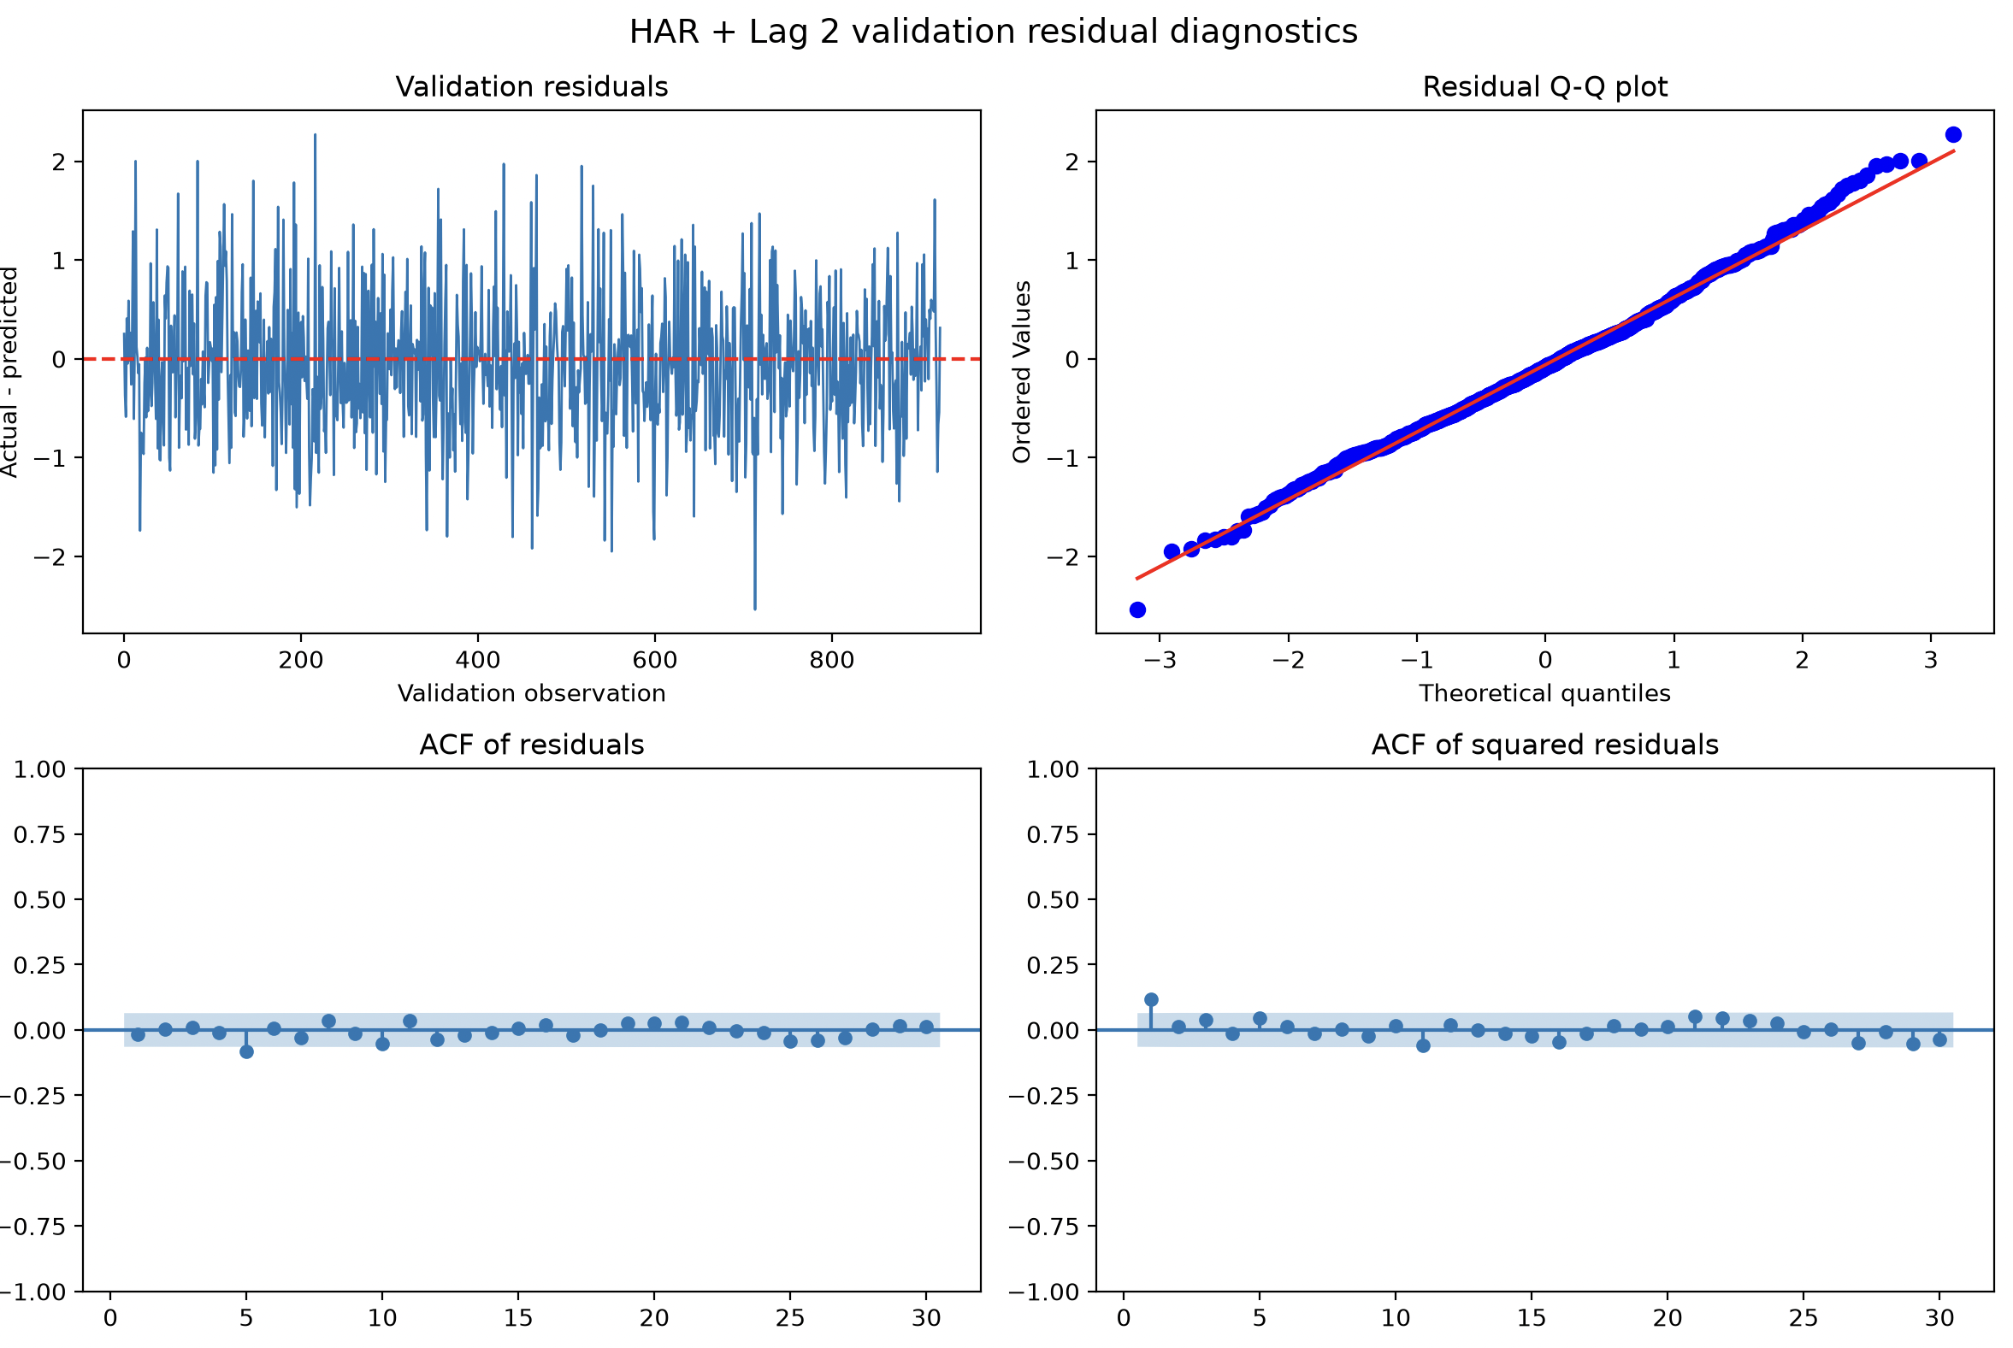
Figure 2 HAR-RV plus Lag 2 Validation Residual Diagnostics
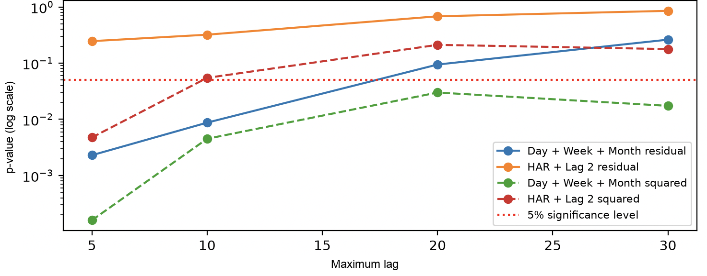
Figure 3 Validation Ljung-Box Comparison Before and After Lag 2

5 Out-of-Sample Performance and Final Model
In time-series cross-validation, mean MSE falls from 0.350979 for standard HAR-RV to 0.345829 after Lag 2 is added, a reduction of approximately 1.47%. MSE declines in all five validation folds. A validation-set ablation that holds Day, Week, and Month fixed lowers MSE from 0.477745 to 0.466884, an improvement of approximately 2.27%. Both comparisons support a small incremental contribution from Lag 2.
Table 5 Independent Test Results
Model | MSE | MAE | MSE Gain vs. Baseline | MAE Gain vs. Baseline
Persistence | 0.478135 | 0.551313 | 0.00% | 0.00%
Standard HAR-RV | 0.429034 | 0.514996 | 10.27% | 6.59%
HAR-RV + Lag 2 | 0.422655 | 0.511852 | 11.60% | 7.16%
The selected model uses Day + Lag 2 + Week + Month. On the independent test set, its MSE and MAE are 1.49% and 0.61% lower than those of standard HAR-RV. The direction agrees with cross-validation and validation ablation results. The evidence supports retaining Lag 2 in this sample, but it does not by itself establish statistical significance.

6 Model Artifacts and Prediction Output
After model selection, the final specification is refitted on 3,693 combined training and validation observations. The saved model is accompanied by metadata recording feature order, coefficients, training dates, software version, and test metrics. Prediction loads this same model version without retraining, which supports reproducibility. Table 6 reports the saved files and an example forecast at the end of the historical sample. Dates use UTC.
Table 6 Final Model Artifacts and Example Historical Forecast
Output | Value | Description
Model file | har_lag2_model.joblib | Loadable linear regression model
Model metadata | har_lag2_model_info.json | Features, coefficients, dates, and test metrics
Forecast target | Next-day log(RV) | Exponentiated without bias correction
Example feature date | 2018-06-26 | Historical feature date recorded in UTC
Predicted log(RV) | -10.076945 | Direct output of the final model
Predicted RV | 4.203763 x 10^-5 | exp(predicted log(RV))
Predicted daily volatility | 0.6484% | sqrt(predicted RV), not annualized

7 Conclusion and Limitations
Standard HAR-RV adds weekly and monthly information to the daily component, and Lag 2 further reduces error in every validation fold and on the independent test set. The result supports retaining Lag 2 for this specification, but the increment is limited and should be re-evaluated in other market regimes.
Ljung-Box tests remain significant at several lags in the final test period, showing that the model omits some linear time dependence. Residuals are defined as actual minus predicted; their mean is approximately -0.082, so the model overpredicts log realized variance on average in the test period. Results for squared residuals also vary by lag, so the model cannot be considered a complete description of conditional variation. Future work could compare leverage-aware HAR variants, rolling estimation, regularized regressions, or tree models while retaining chronological validation and untouched evaluation data.

Appendix Reproduction
From the project root, run python run_pipeline.py --stage all to reproduce the workflow and python -m unittest discover -s tests -v to run the seven automated checks. The saved prediction is historical, not a live market forecast.

