S&P 500 Realized Variance Forecasting
Data Characteristics and Model Specification
This report develops a heterogeneous autoregressive realized volatility model for next-trading-day log realized variance of the S&P 500 Index. The specification combines daily, weekly, and monthly information and divides the sample chronologically to prevent future observations from entering model training. It first examines return-distribution characteristics, then describes the model, variables, validation design, and the evidence used to introduce Lag 2.

1 Data and Descriptive Statistics
Descriptive statistics use training-period data for the S&P 500 Index (.SPX), Dow Jones Industrial Average (.DJI), and Russell 2000 Index (.RUT). None of the three series contains an invalid realized variance observation.
Table 1 Training-Period Return and Realized Variance Statistics
Index | N | N Return | Mean Return | Std. Ret. | Skew | Excess Kurt. | Mean RV5 | Invalid
.SPX | 2,791 | 2,791 | -0.000036 | 0.012895 | -0.090205 | 7.370035 | 0.000139 | 0
.DJI | 2,790 | 2,790 | 0.000144 | 0.012617 | 0.073539 | 7.779407 | 0.000141 | 0
.RUT | 2,789 | 2,789 | 0.000640 | 0.012390 | -0.113599 | 5.523270 | 0.000078 | 0
Mean daily returns are close to zero and absolute skewness is below 0.12 for all three indices. Excess kurtosis ranges from 5.52 to 7.78, substantially above the normal-distribution value of zero. The sample is therefore approximately symmetric but sharply peaked and heavy-tailed.
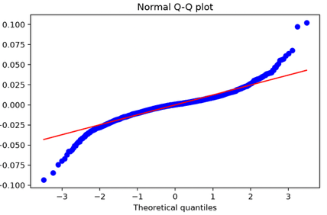
Figure 1 Normal Q-Q Plot of S&P 500 Training-Period Returns
The Q-Q plot supports the same conclusion. Central observations broadly follow the normal reference line, while both tails diverge systematically. Model evaluation should therefore combine out-of-sample forecast errors and residual diagnostics instead of relying only on normal-error assumptions.

2 HAR-RV Model Specification
HAR-RV is motivated by the persistence of realized variance and by market participants operating over different horizons. Daily, weekly, and monthly components approximate this heterogeneity. The model forecasts realized variance dynamics; it does not directly eliminate heavy-tailed returns.
The logarithm reduces scale differences in realized variance. The standard next-day specification is:
$${log RV}_{t+1} = β_{0} + β_{d} {log RV}_{t}^{d} + β_{w} {log RV}_{t}^{w} + β_{m} {log RV}_{t}^{m} + ε_{t+1}$$
Table 2 HAR-RV Variable Definitions
Variable | Horizon | Definition
log RV(d) | Daily | Log of current realized variance
log RV(w) | Weekly | Log of mean realized variance over the latest 5 trading days
log RV(m) | Monthly | Log of mean realized variance over the latest 22 trading days
log RV(t+1) | Target | Log realized variance on the next trading day
Beta 0 is the intercept, beta d, beta w, and beta m measure daily, weekly, and monthly contributions, and epsilon at t plus 1 is the forecast error. Every explanatory variable uses information available no later than date t, so the specification avoids look-ahead bias.

3 Validation Design
Training, validation, and test observations are divided chronologically rather than through random cross-validation. Persistence is the development baseline, and gap-separated time-series cross-validation compares feature combinations. MSE and MAE measure forecast accuracy. Residual ACF, PACF, and Ljung-Box tests then assess whether the fitted model leaves predictable linear dependence. The selected model is evaluated once on the independent test set.

4 Introducing and Validating Lag 2
The standard HAR-RV validation residuals show ACF and PACF values of about 0.088 at lag 2, while lags 3 and 4 are near zero. This suggests omitted short-horizon information associated with the second lag. The pattern motivates a candidate feature, but retention still depends on out-of-sample errors and residual tests.
For a forecast of date t plus 1, Day is realized variance on t and Lag 2 is realized variance on t minus 1. Adding Lag 2 to the daily, weekly, and monthly components gives the extended model:
$${log RV}_{t+1} = β_{0} + β_{d} {log RV}_{t} + β_{2} {log RV}_{t-1} + β_{w} {log RV}_{t}^{w} + β_{m} {log RV}_{t}^{m} + ε_{t+1}$$
Table 3 Incremental Evidence for Lag 2
Evidence | Standard HAR-RV | HAR-RV + Lag 2 | Interpretation
Residual lag-2 ACF | 0.0884 | 0.0043 | Lag-2 autocorrelation is nearly removed
Residual lag-2 PACF | 0.0875 | 0.0041 | Lag 2 adds distinct short-horizon information
Ljung-Box lag-5 p-value | 0.0023 | 0.2463 | No longer significant at 5%
Ljung-Box lag-10 p-value | 0.0087 | 0.3207 | Joint residual dependence weakens
Five-fold mean MSE | 0.351009 | 0.345937 | Out-of-sample error improves about 1.45%
Final test MSE | 0.429034 | 0.422655 | Improves about 1.49% over standard HAR-RV
Final test MAE | 0.514996 | 0.511852 | Improves about 0.61% over standard HAR-RV
After Lag 2 is added, validation residual ACF and PACF at lag 2 fall to about 0.004. Ljung-Box p-values at lags 5 and 10 also rise above 0.05, indicating weaker validation-period linear autocorrelation. Ljung-Box tests assess joint residual dependence rather than coefficient significance or forecast loss, so their results must be interpreted separately from cross-validation.

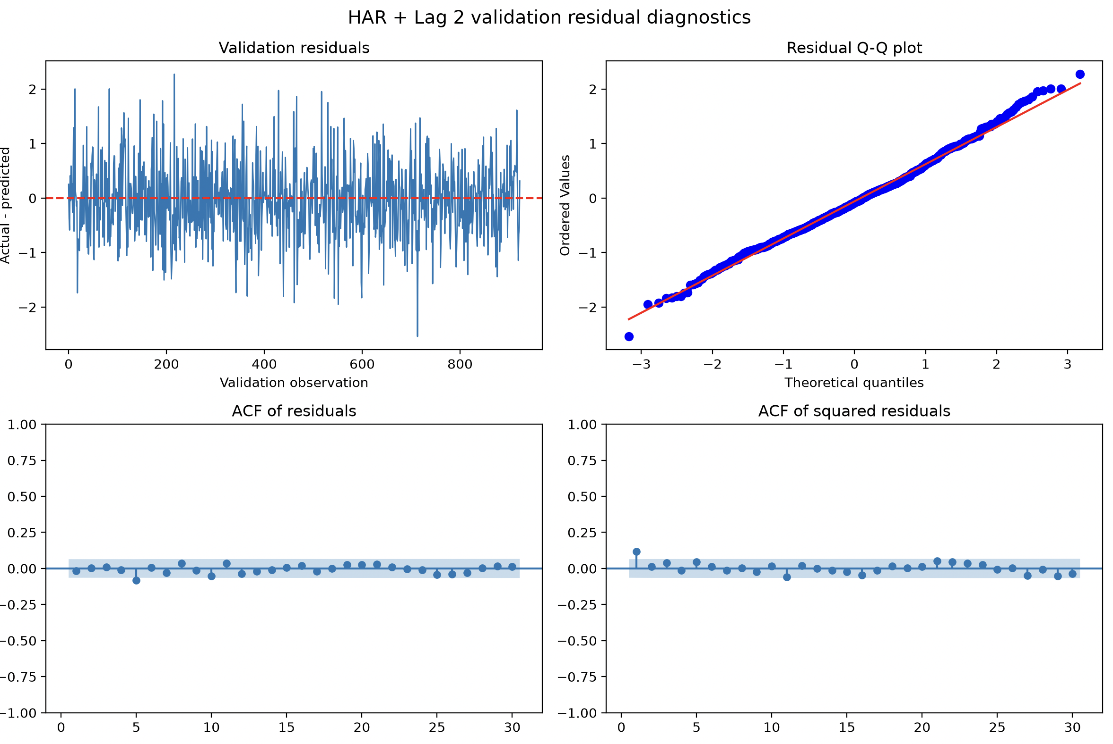
Figure 2 HAR-RV plus Lag 2 Validation Residual Diagnostics
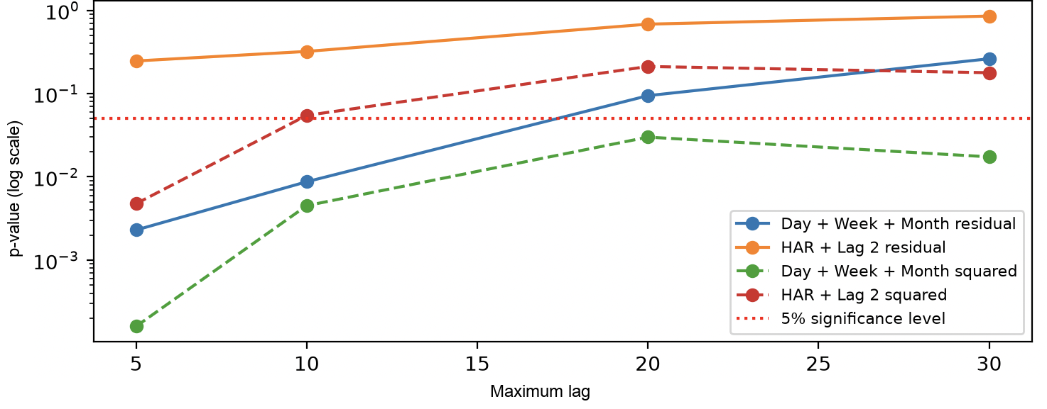
Figure 3 Ljung-Box Comparison for Standard HAR-RV and HAR-RV plus Lag 2

Out-of-Sample Performance and Model Selection
Adding Lag 2 reduces five-fold mean MSE by approximately 1.45%, and error falls in every validation fold. The ablation holds Day, Week, and Month fixed, so the incremental difference is attributable to Lag 2 under this design. Final-test MSE and MAE improve by approximately 1.49% and 0.61%, consistent with the development-stage evidence.
Taken together, residual ACF and PACF, Ljung-Box tests, time-series cross-validation, and feature ablation support Day + Lag 2 + Week + Month as the selected specification. The error reduction is small but consistent across validation folds and the final test. Significant final-test Ljung-Box results remain, so Lag 2 does not capture all time dependence across market regimes.

