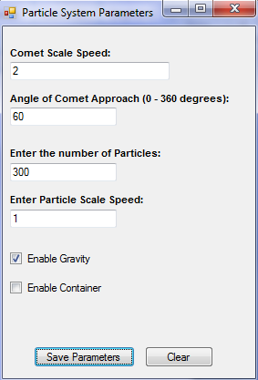

Enable Gravity, Container, both, none, rotate planet each simulation

Increase Particle No to 700

Increase comet speed to 5

Increase particle speed to 3

Increase Particle No to 1500

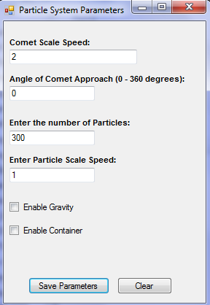

Zoom in on explosion

Then, enable gravity, gravity + container, then disable them increase particles to 10,000

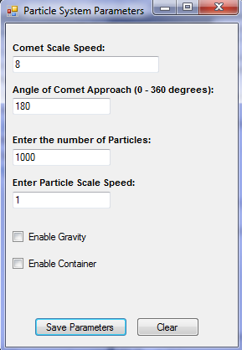

Enable Gravity