**AWS TASK**

1. Watch the video and write down notes

Watched the videos and completed notes**.**

1. configure MFA for aws account

open aws console and sign in .

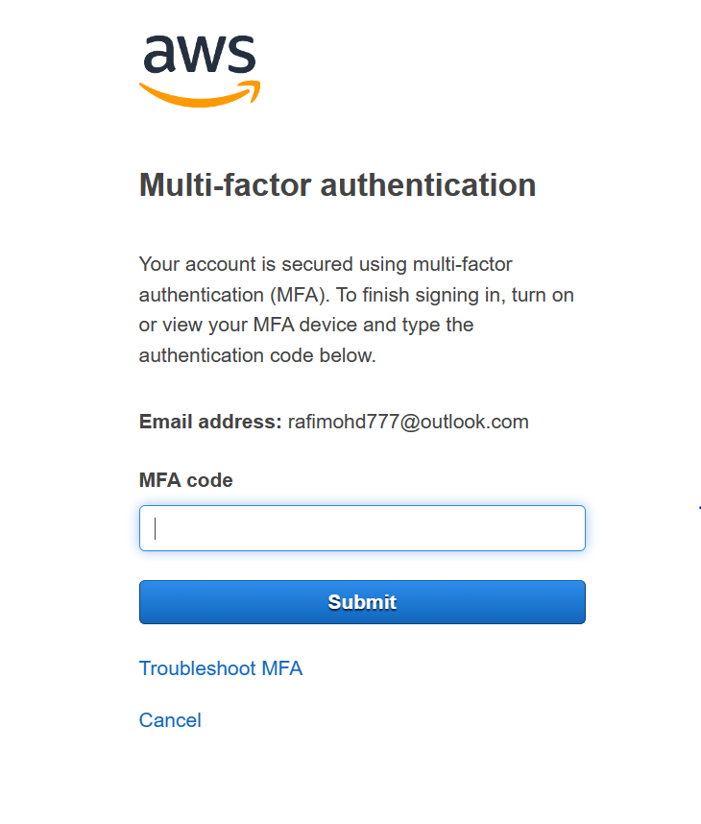

1. Install aws cli in windows.

Go to server and download aws cli and install window.

Aws command 🡪 Aws configure

And copy access and access access key

And put origin name :us-east-1

And out put name :json

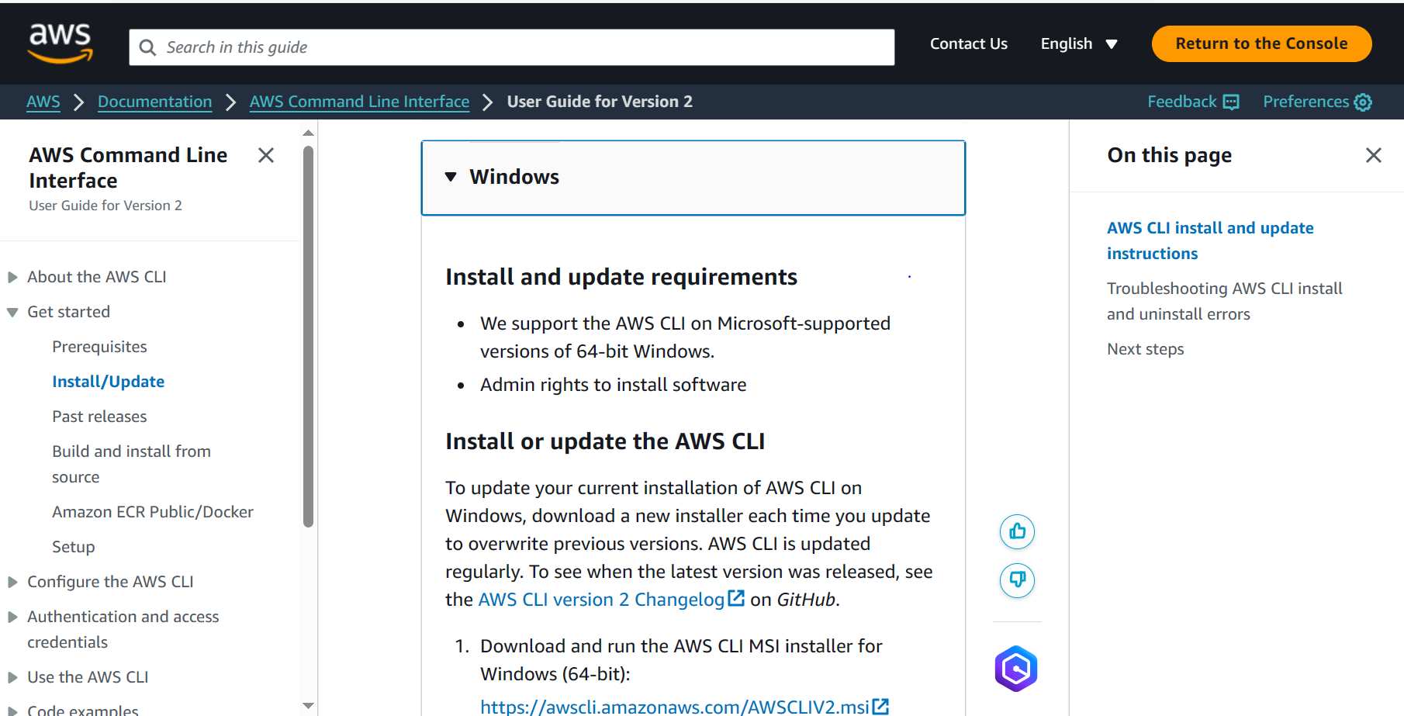

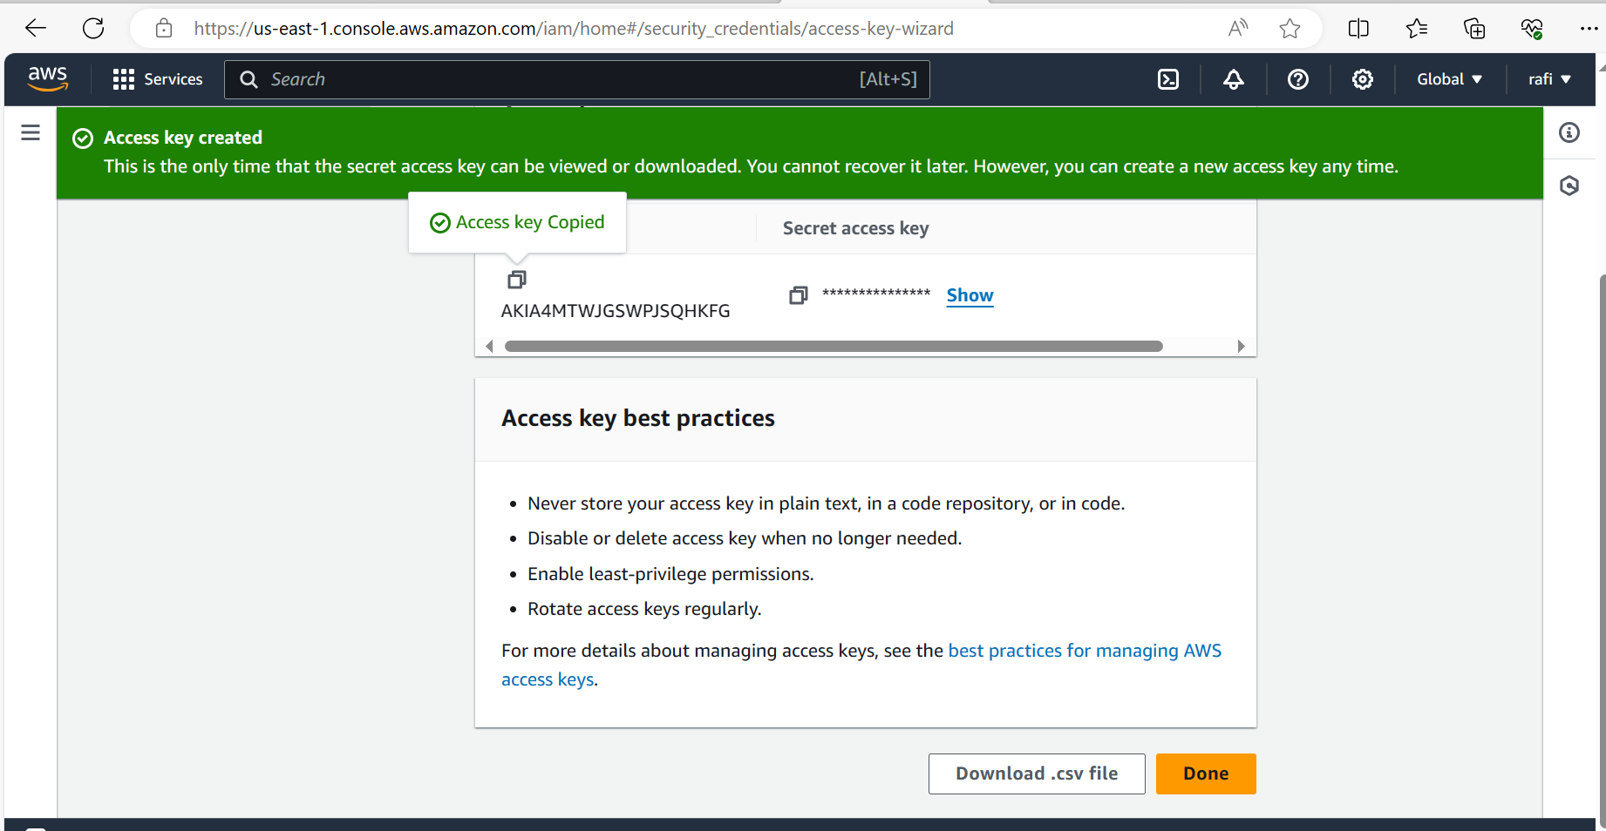

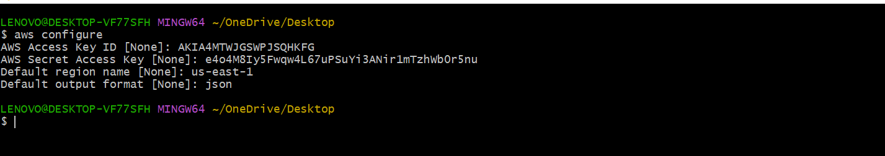

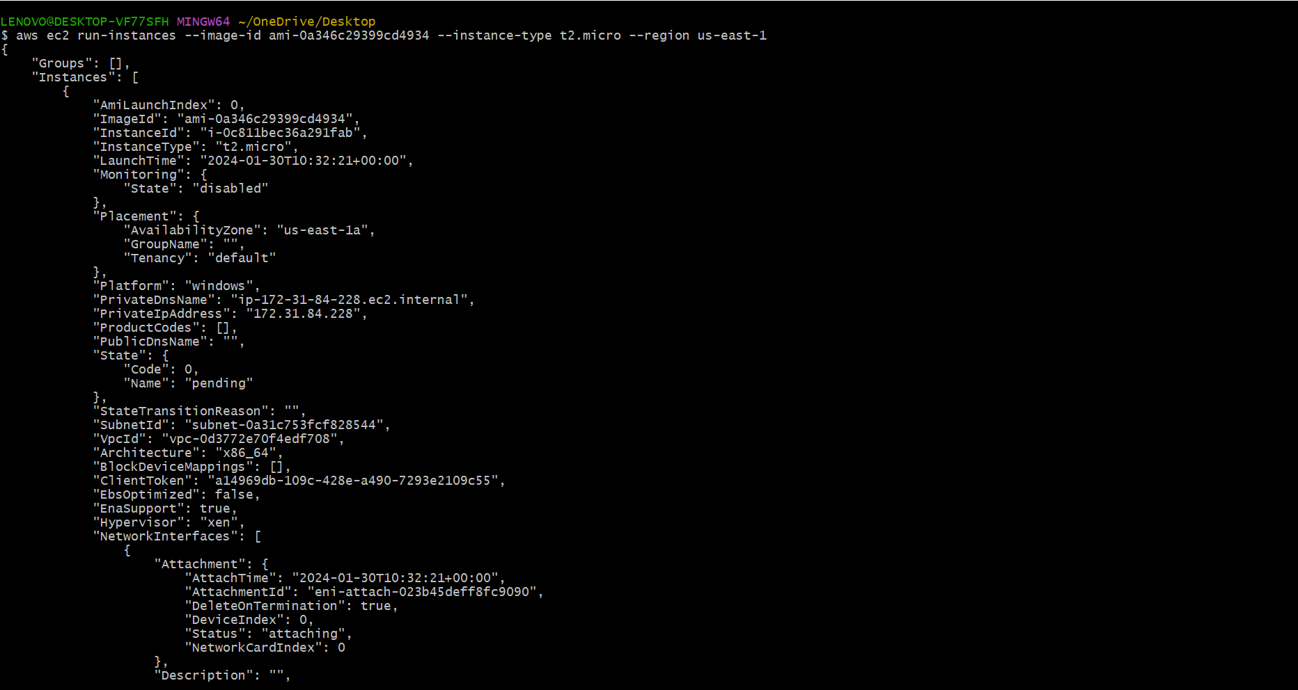

After this go to aws console server and refresh we will see one server is running.

1. Setup ec2 in N.virginia region using aws cli command.

Now to install clin in window use this command

* aws ec2 run-instances --image-id ami-0a346c29399cd4934 --instance-type t2.micro --region us-east-1



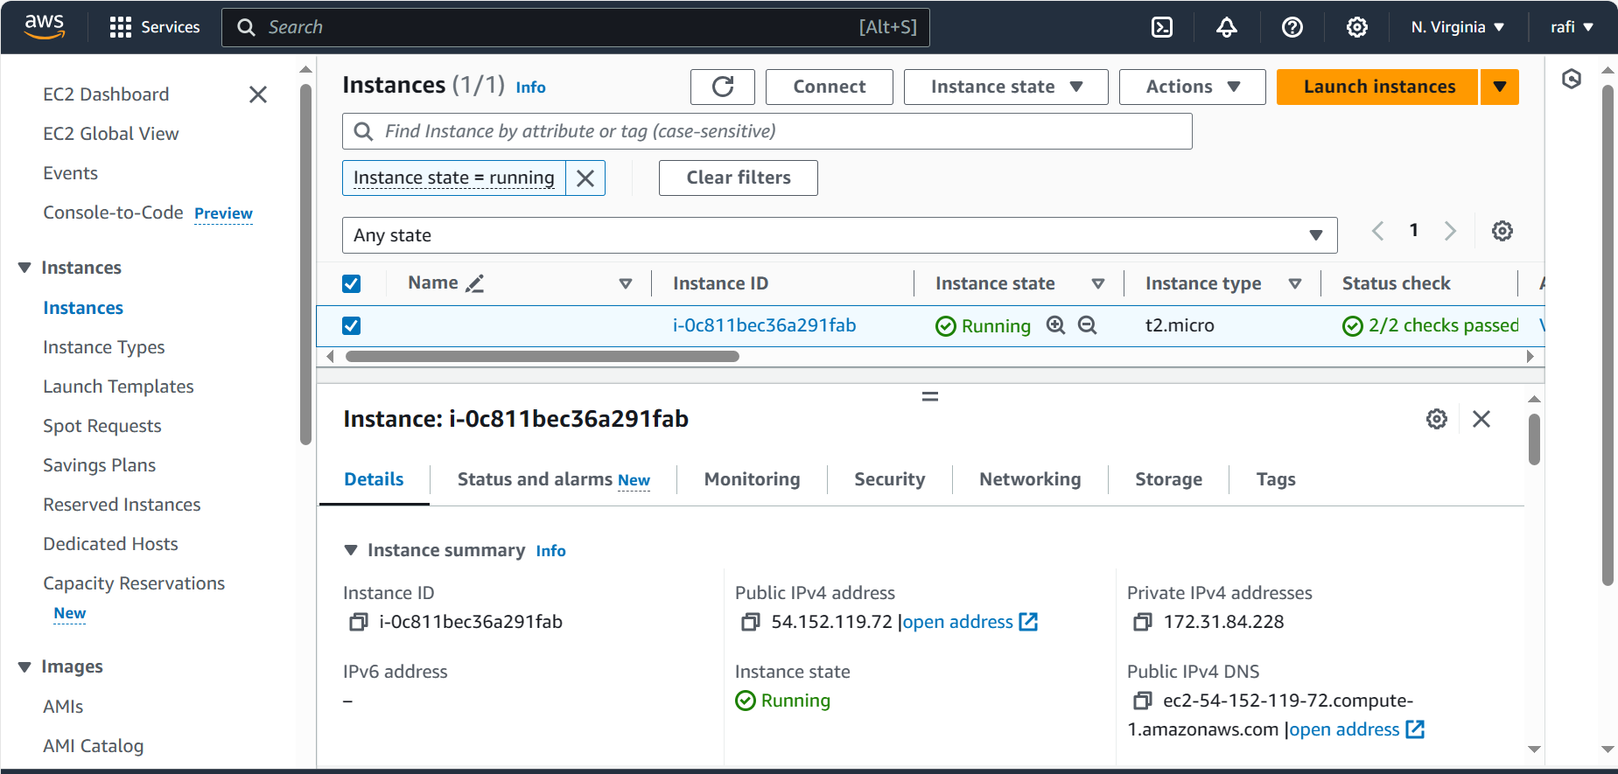

1. Setup security group in ohio region with name - Techie-sg and open port 22

Copy command from chatgpt and add vpc code in vpc id



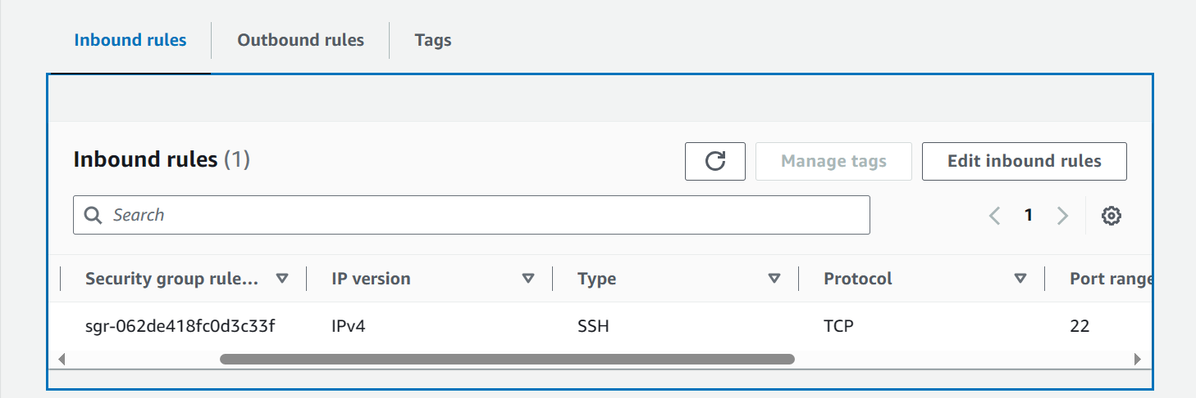

Edit in bound rule and out bound rule and change the port 22

1. setup ec2,security group in Mumbai region using single aws cli command.

Copy command from chatgpt and add vpc code in vpc id

Put command🡪 aws ec2 create-security-group --group-name Techie-sg --description "Techie Security Group" --vpc-id vpc-014a5d6be7bbc179c --region ap-south-1

