How to share references using EndNote?

**Method 1**

1. Find the location of your EndNote library and copy two files (one with the .enl extension, which is the database file, and the other with a .data folder extension) to a folder. Then, send it to the recipient using a USB drive, email, chat software, or any other method.

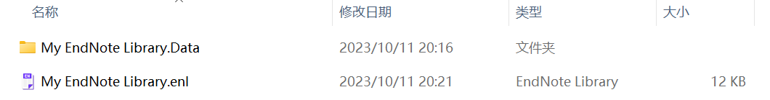

1. The recipient can unzip the two files and copy them to their preferred location on their computer. Then, open EndNote, click on the menu bar, select [File] and [Open Library]. Then choose the file with the .enl extension to import references shared by others.

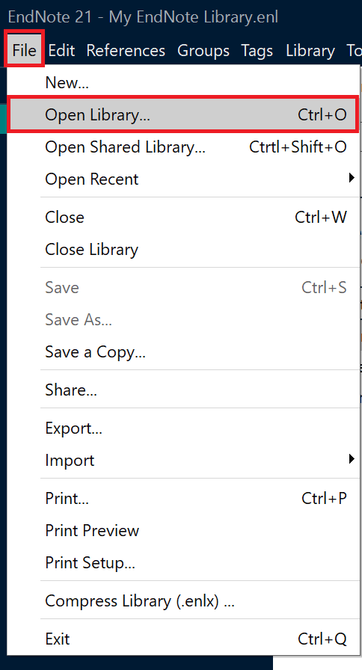

**Method 2**

1. Open the menu page, select [File], [Compressed Library].

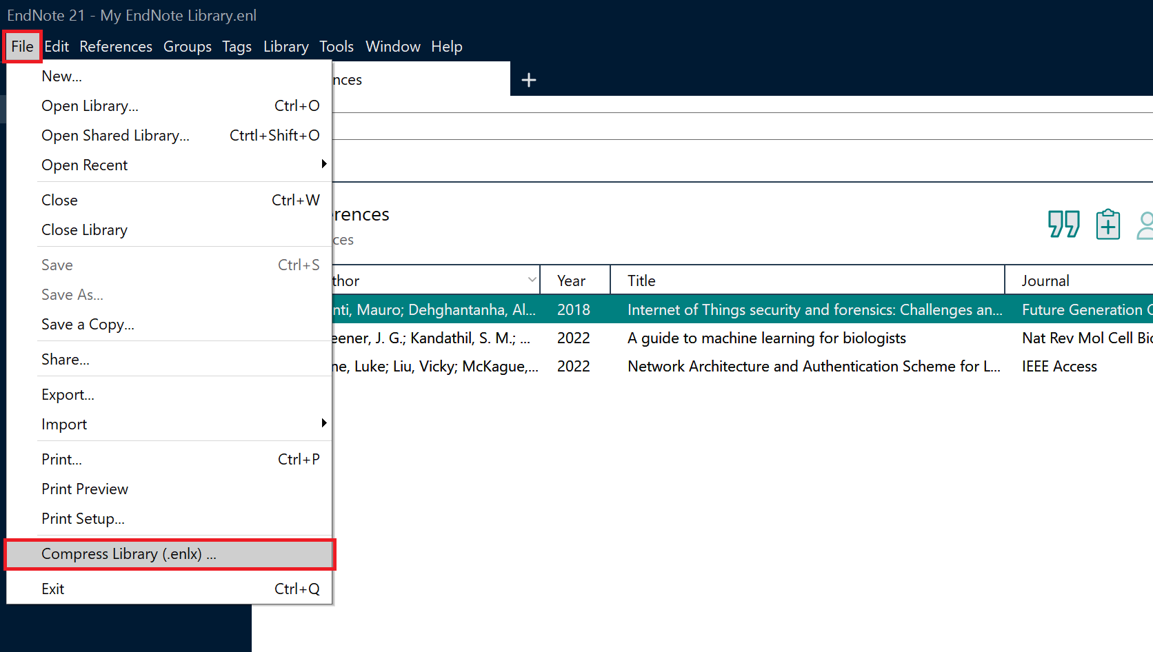

1. On the pop-up page, you can set the corresponding conditions. Here you can choose with or without file attachments, whether you want to include all references or selected references in library or references in group/group set. Then click the [Next] button

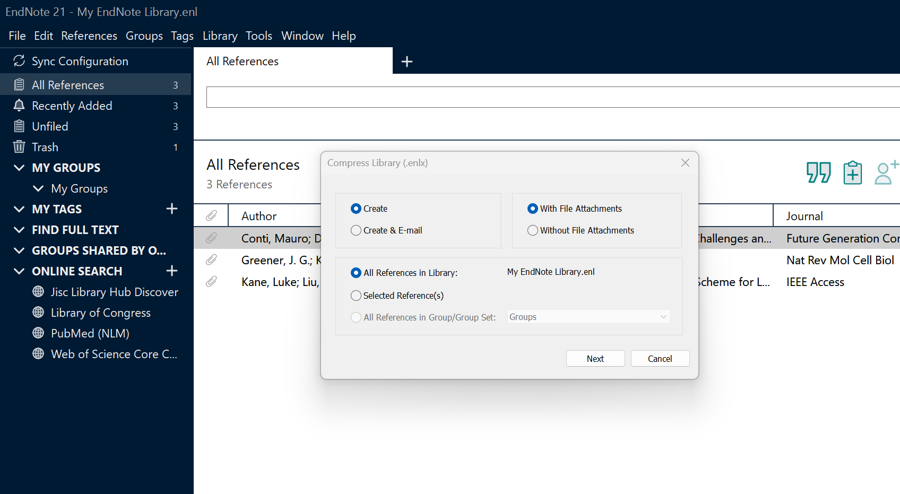

1. EndNote will generate a compressed file with the .enlx extension, and you can then share this compressed file with others.

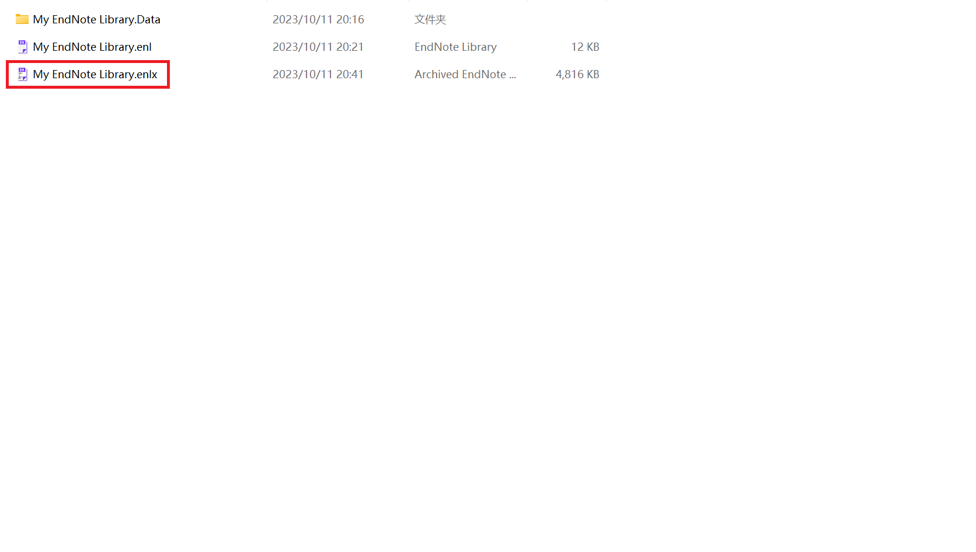

1. The recipient should double-click the file with the .enlx extension. This will extract two files: one with the .enl extension (the EndNote library file) and another with a .data folder extension. This allows the recipient to access the shared references.

