EndNote’s search interface provides a simple way to do basic searches of online databases. To search and retrieve references from an online database:

1. Initiate the online search from the *Tools* menu, select Online Search to display the collection of connection files installed on your computer or click *More* button to select the desired database.

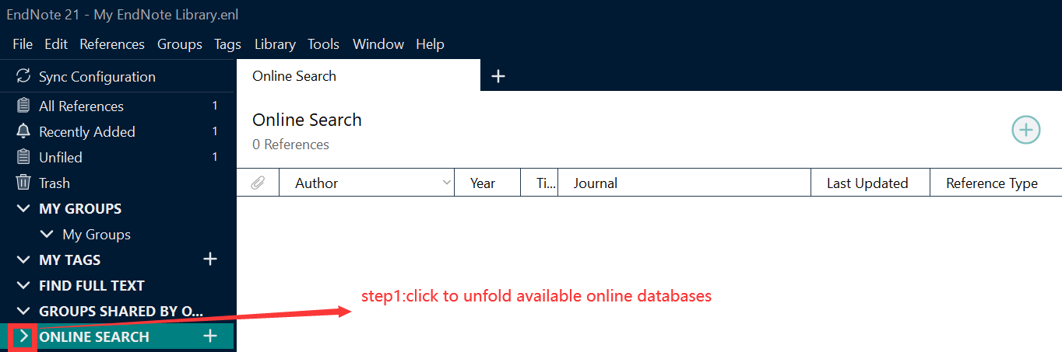

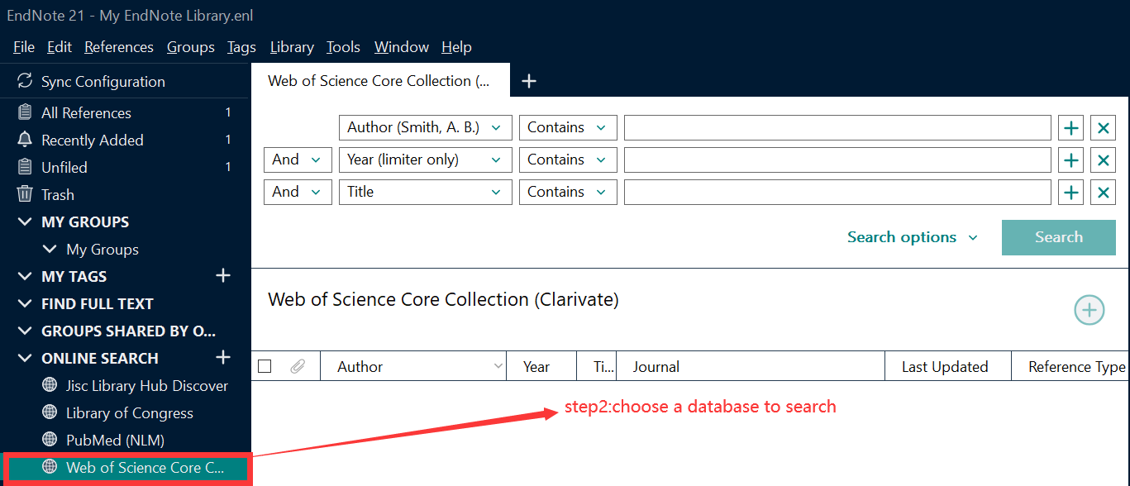

1. Enter your search request in the search fields on the Advanced Search panel, and then click Search. EndNote searches the database and displays the number of references that were found to match your search criteria.

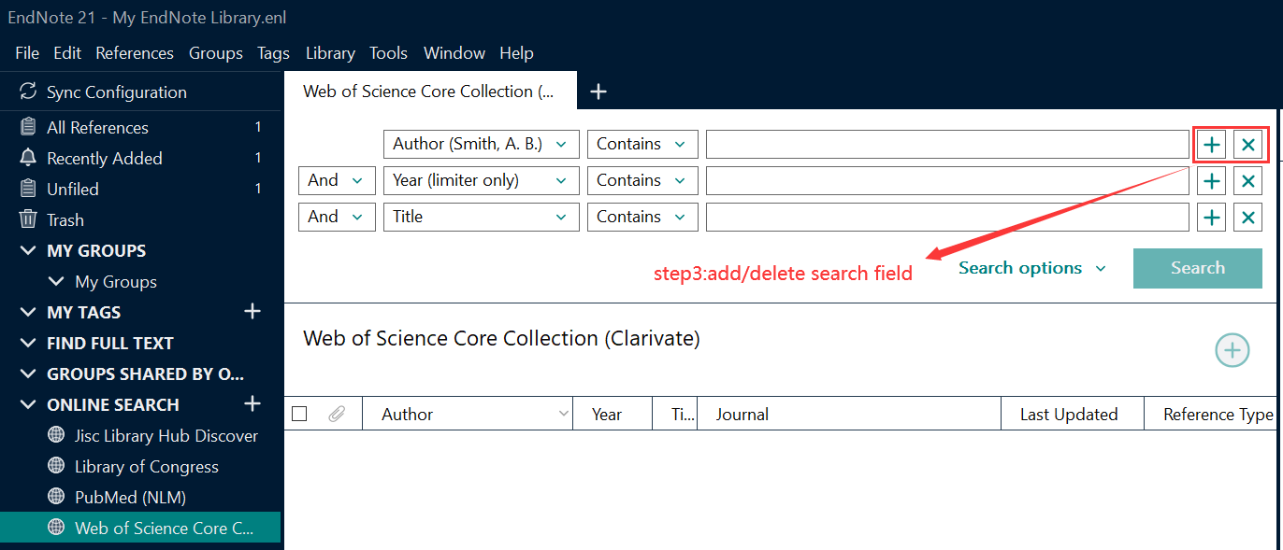

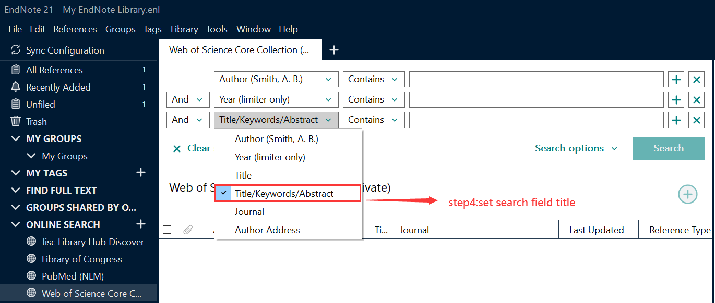

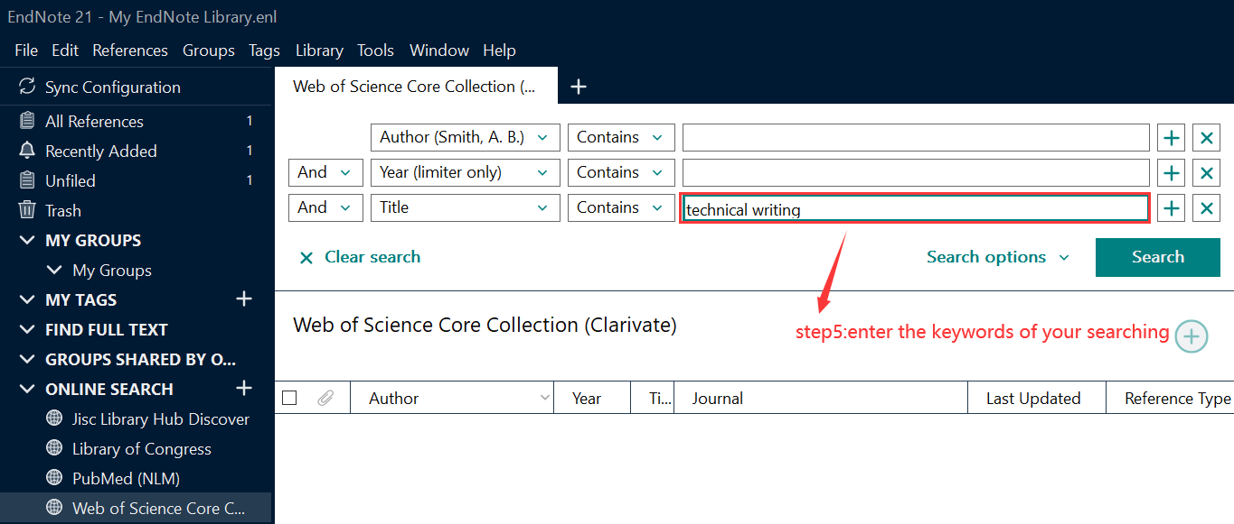

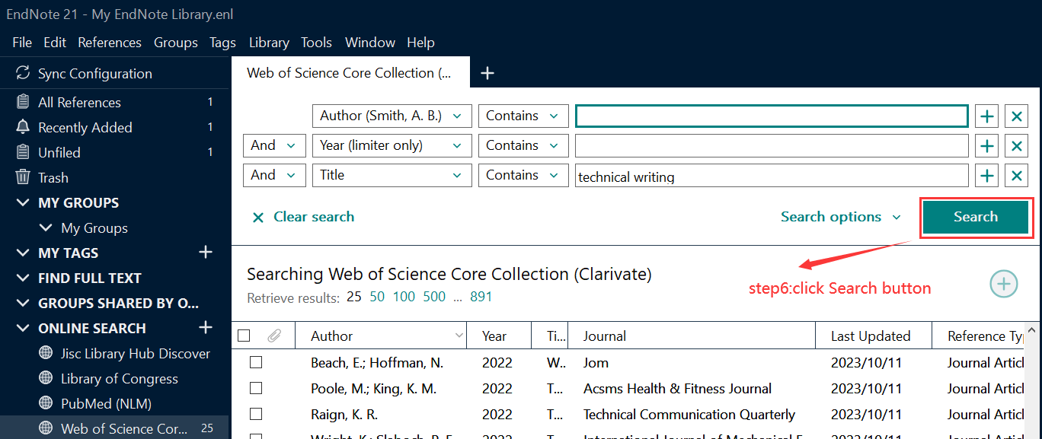

1. You can right click references to Copy or E-mail them or you can just select references then click the Plus button to add them to your local library.

