Ⅰ.User-Defined Filed

Fields are provided for users to mark, recognize, and filter references. Each reference has its own fields, which can be imported from academic resources or written by users themselves, as the following figure shows.

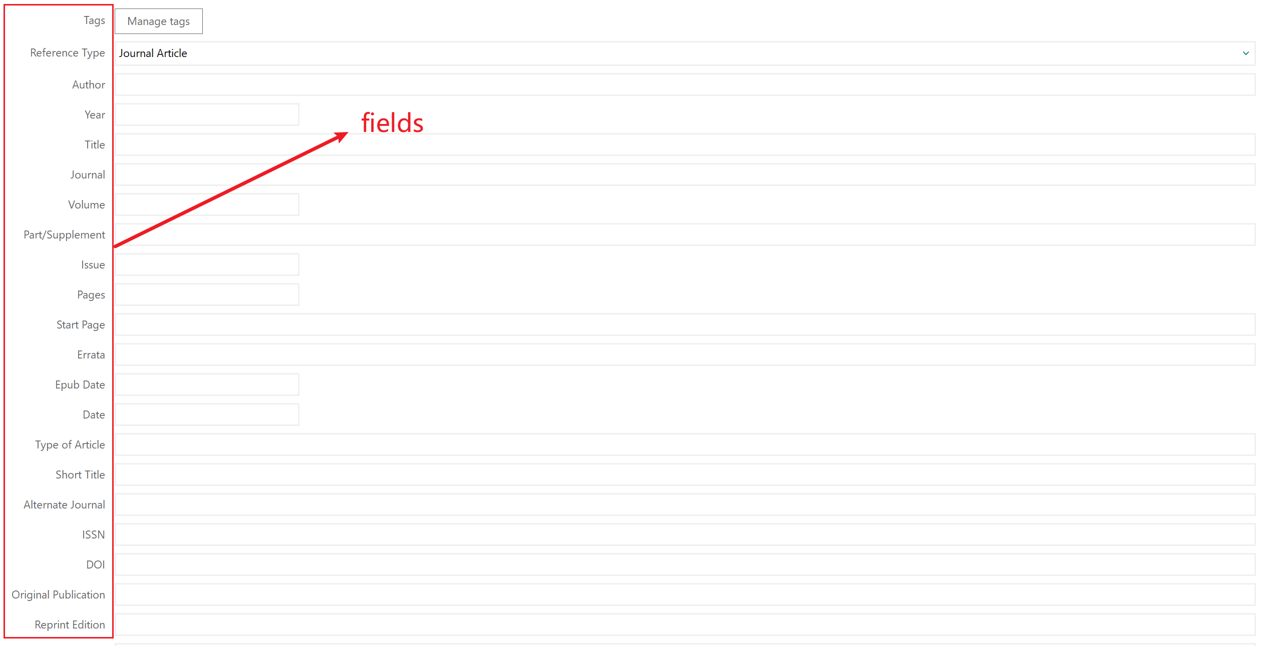

If the default fields provided by Endnote are not sufficient for your needs, you can add a customized field type according to your requirements. Steps are as follows:

1. Manual Entry:

🞄Click on the ‘Edit’ menu.

🞄Select ‘Preferences’.

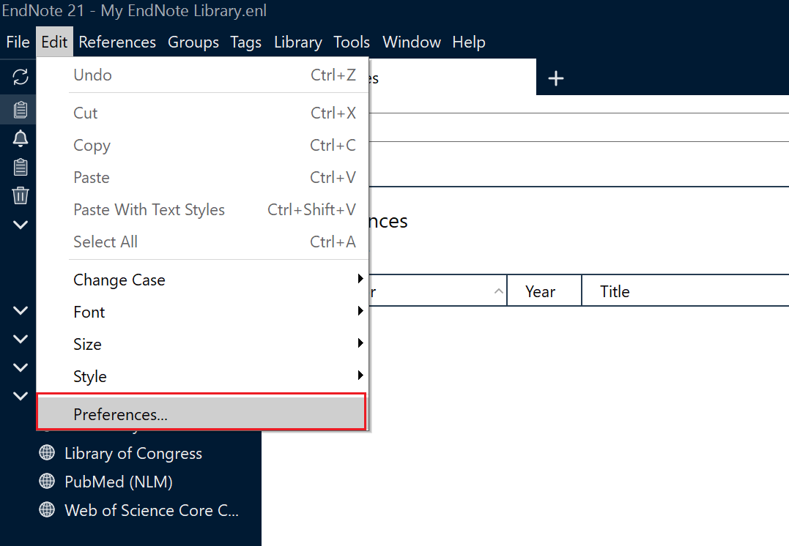

1. Preferences Setting

🞄Click the ‘References Types’.

🞄Choose ‘Default Reference Type’.

🞄Click the ‘Modify Reference Types’.

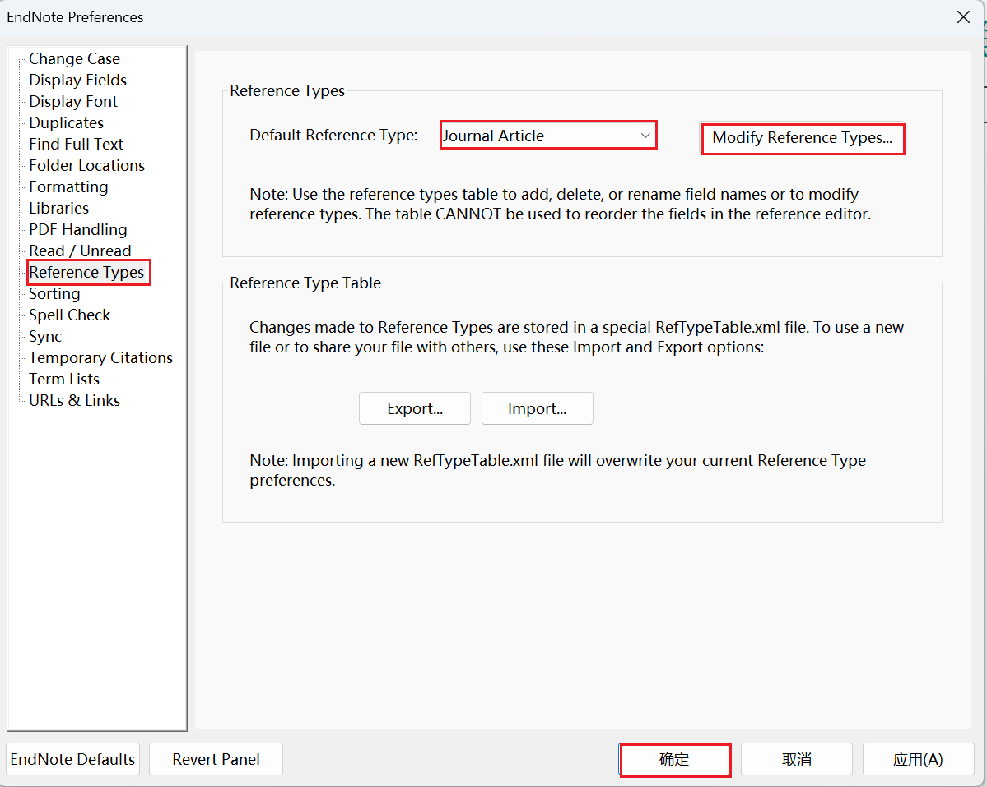

1. Modify References Type

🞄Find the ‘Custom’ bar.

🞄Add the field name you need, e.g. ‘Fit Technical Writing’,.

🞄Click ‘OK’.

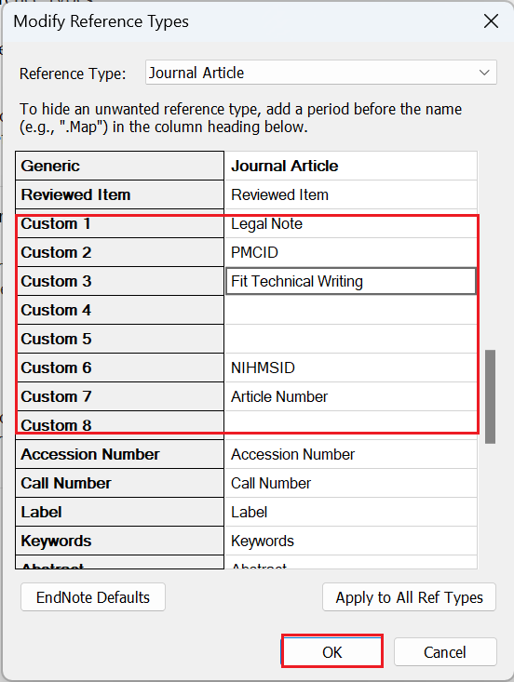

1. Result In Reference Interface

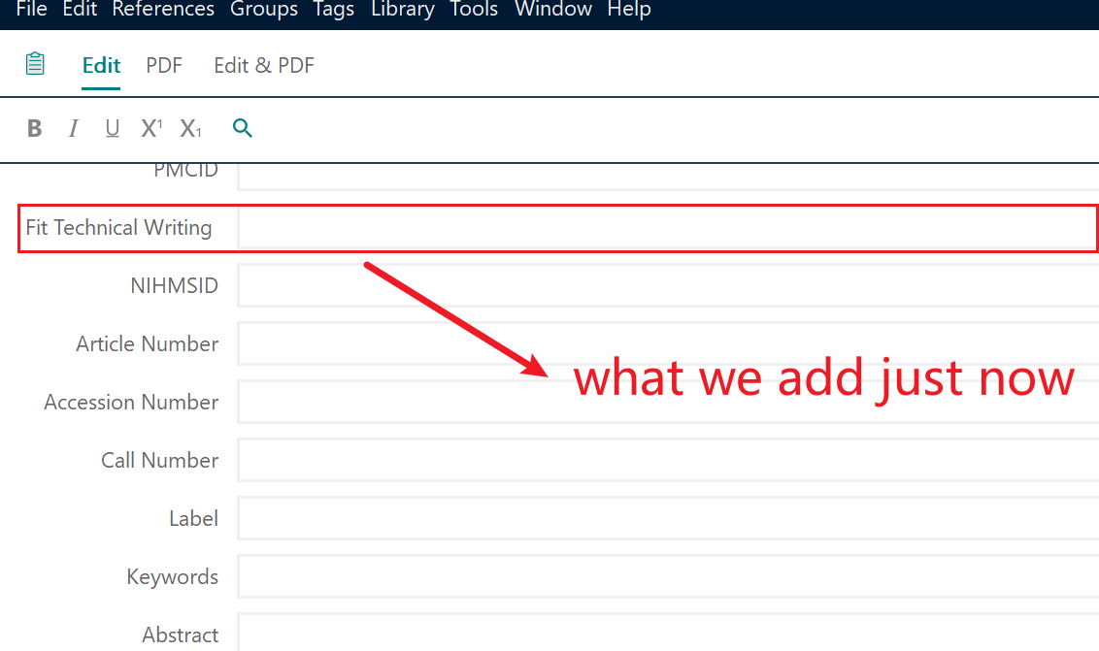

Ⅱ.Display Specific Field

In the area of literatures, default fields are listed as the figure shows.

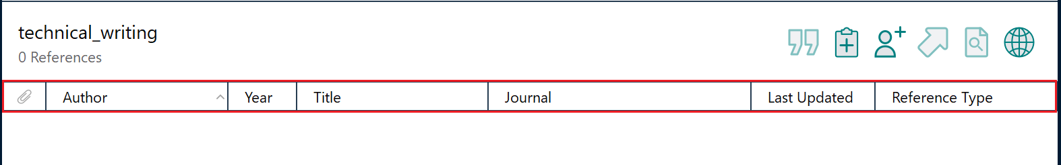

To change the type of fields displayed here, following steps are needed:

1. Open the setting interface through clicking the icon at the right part of the following figure.

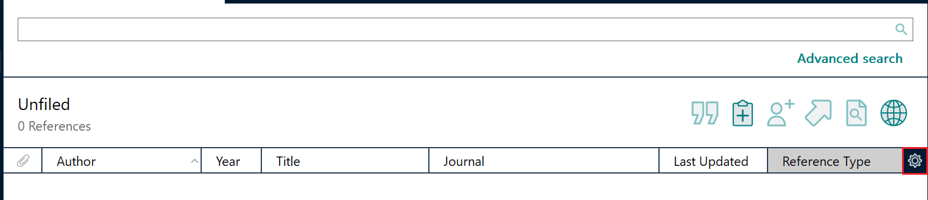

1. Set Display Fields

🞄Change the according field and heading of the column position you want to display.

🞄Click ‘OK’ button.

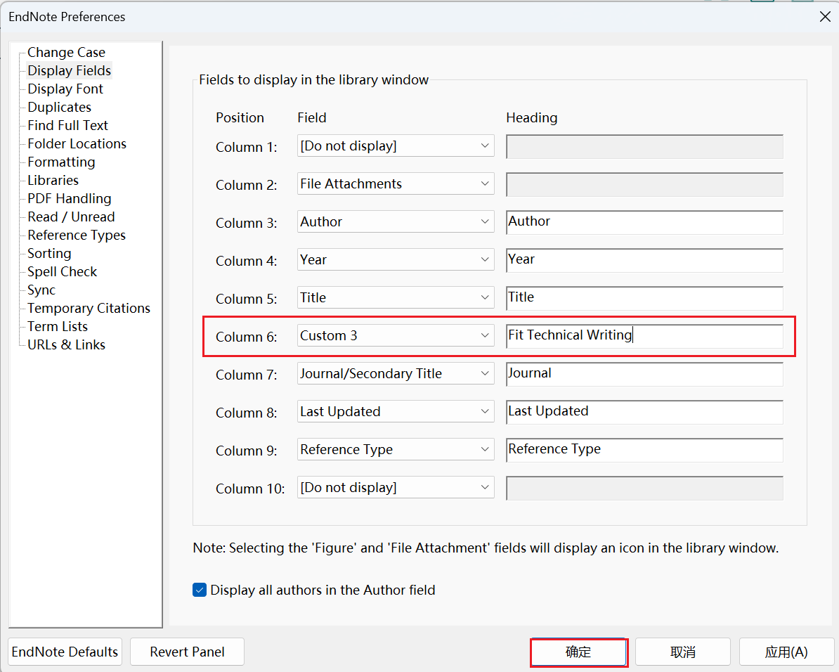

1. Result in Literature Area

