## Literature Sharing

**Method 1**

1. **Copy Files and Send to the Recipient**
   1. Find the location of your EndNote library and copy two files (one with the **.enl** extension, which is the database file, and the other with a **.data** folder extension) to a folder.
   2. **Send** the folder to the recipient using a USB drive, email, chat software, or any other method.

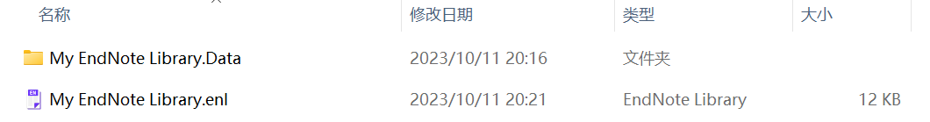

1. **Unzip the File and Import**
   1. The recipient can **unzip** the two files and copy them to their preferred location on their computer.
   2. Open EndNote, click on the menu bar, select **File** and **Open Library**. Then choose the file with the **.enl** extension to import references shared by others. In this way, you can import the literature shared by others.

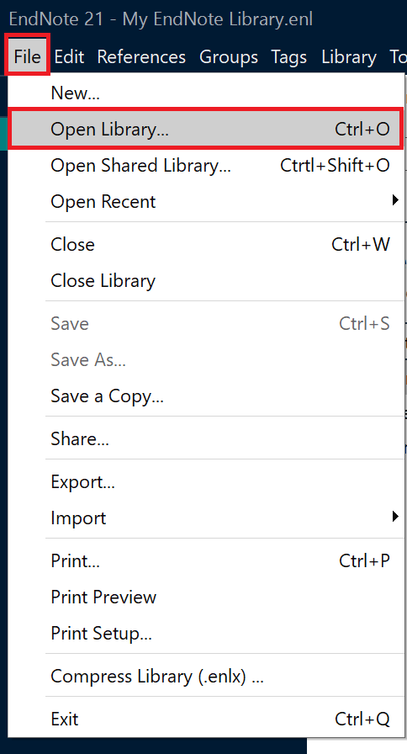

**Method 2**

1. **Generate a File and Send to the Recipient**
   1. Open the menu page, select **File** and **Compressed Library**.

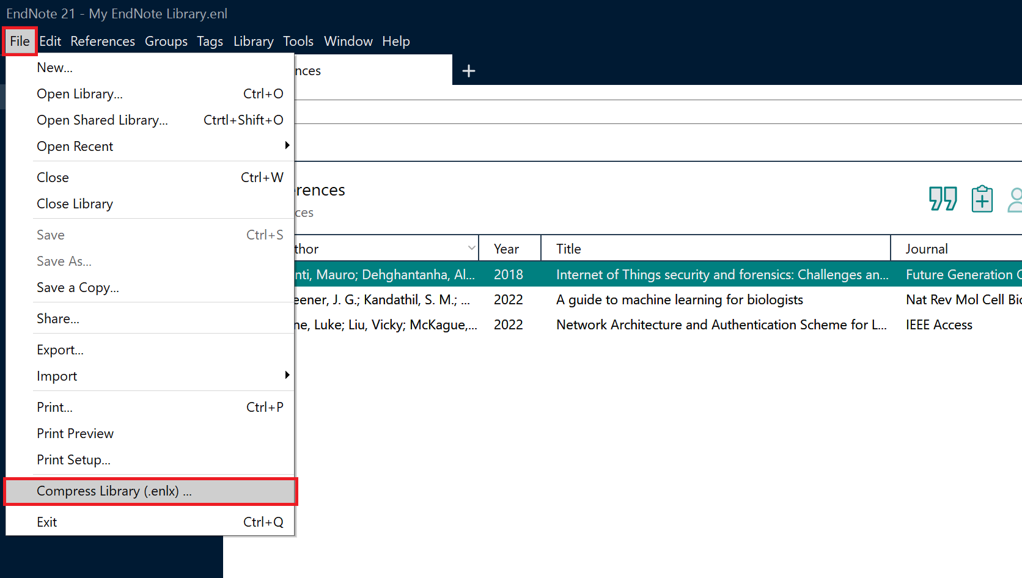

* 1. On the pop-up page, you can set the corresponding conditions. Here you can choose **With** or **Without File Attachments**, whether you want to include **All References** or **Selected Reference(s)** or **All References in Group/Group Set**. Then click the **Next** button.

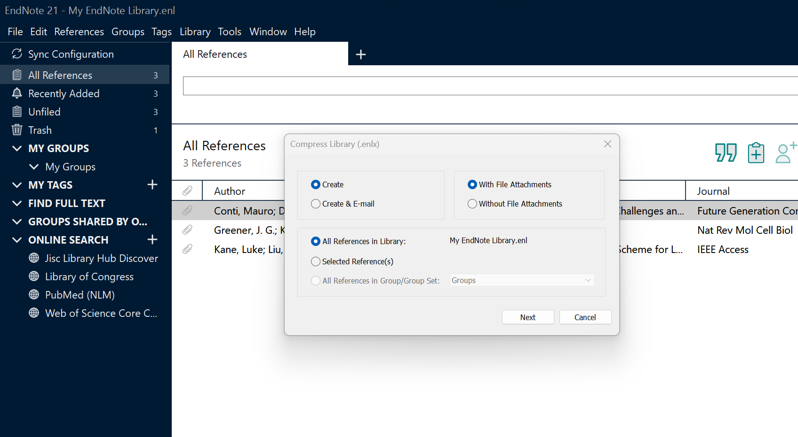

* 1. EndNote will generate a **compressed file** with the **.enlx** extension, and you can then share this compressed file with others.

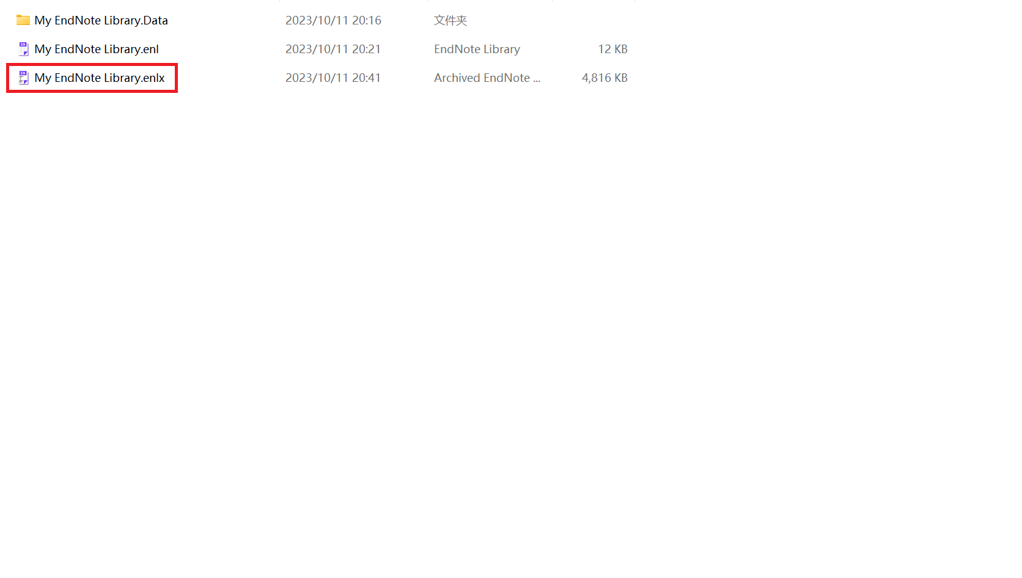

1. **Import**
   1. The recipient can **double-click** the file with the **.enlx** extension. This will extract two files: one with the .enl extension (the EndNote library file) and another with a .data folder extension.

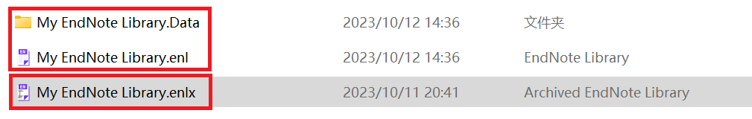

* 1. Open EndNote, click on the menu bar, select **File** and **Open Library**. Then choose the file with the **.enl** extension to import references shared by others. Or instead of unzipping the file first, the recipient can directly choose the file with the **.enlx** extension to import references.

