**How to cite papers**

1. **Getting Started:**
2. Open Endnote 21.



1. If you’re a first-time user, create a new library by going to ‘File’>’New’. Give it a name and choose a location on your computer.

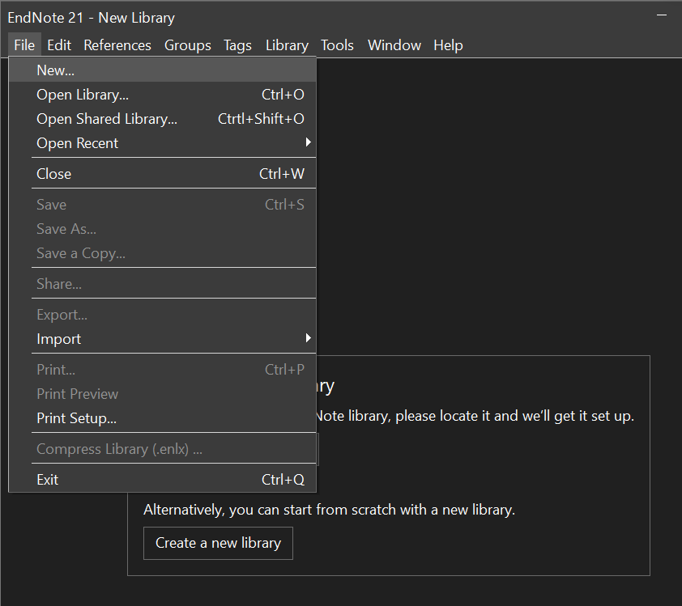

1. **Adding Reference to Your Library:**
2. Manual Entry:

🞄Click on the ‘Reference’ menu.

🞄Select ‘New Reference’.

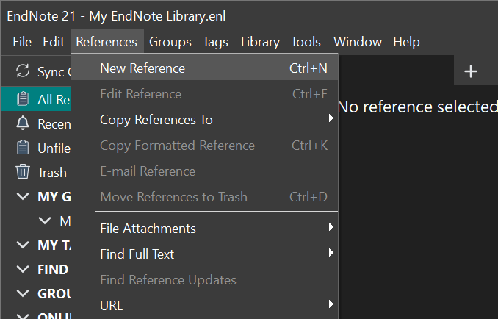

🞄Choose the type of reference you are adding (e.g., Journal Article, Book).

🞄Fill out the relevant details in the fields provided.

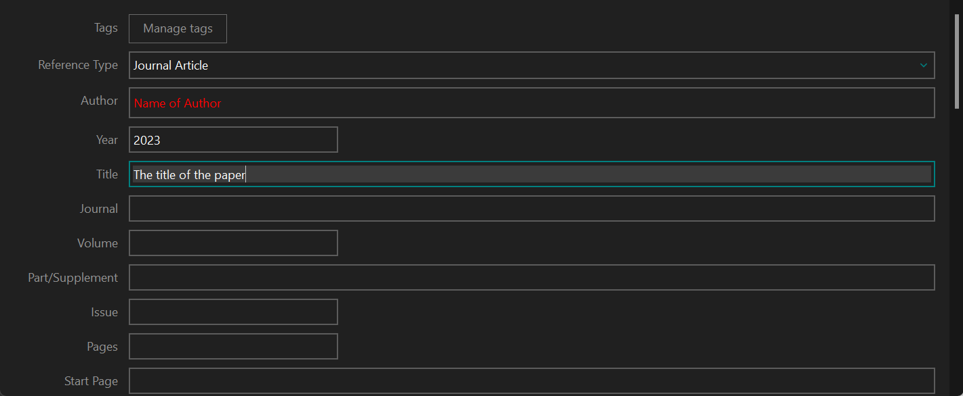

1. Importing from Databases or Journals:

🞄Search your desired database or journal website.

🞄Find the option to export citations (often labeled as “Export to Endnote” or “Citation Manager”), using ACM as an example.

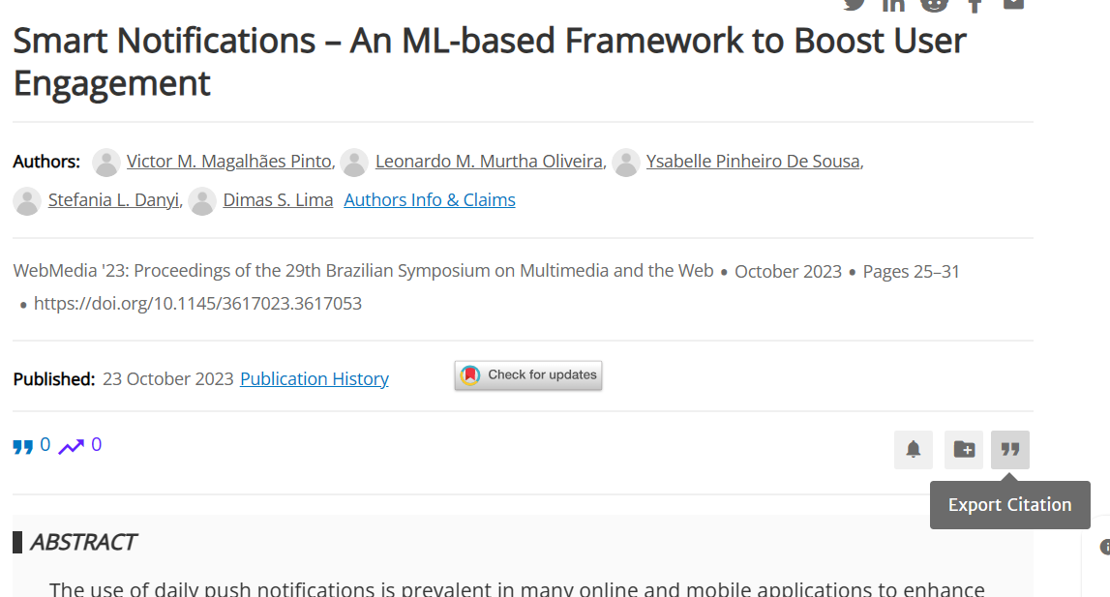

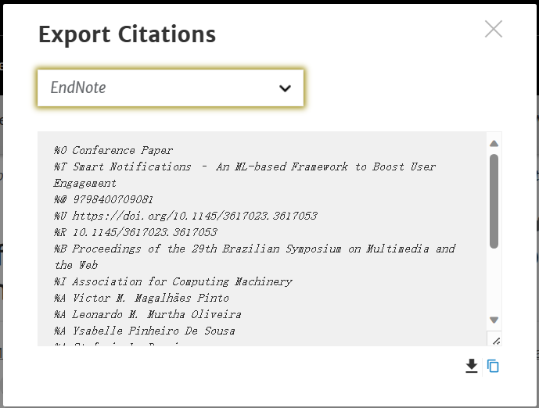

🞄Save the file and then import it into Endnote 21 using ‘File’ > ’Import’.

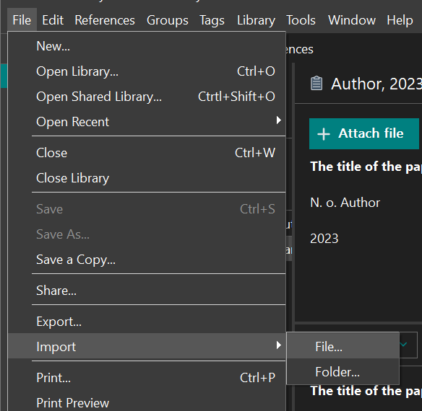

1. **Organizing References:**
2. Create groups to organize reference by topic, project, etc. by right-clicking on “My Groups” and selecting ‘Create Group’.

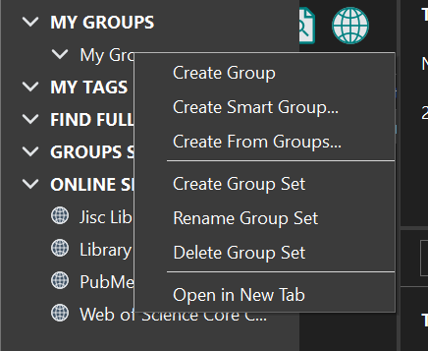

1. Drag and drop references into these groups or use the ‘Add References To’ option.

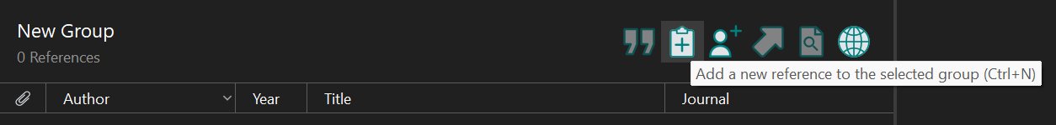

1. **Citing References in Your Document:**

**For Word Users:**

1. Launch your document and position your cursor at the intended citation location.
2. Navigate to the Endnote section in Word.
3. Select ‘Insert Citation’.

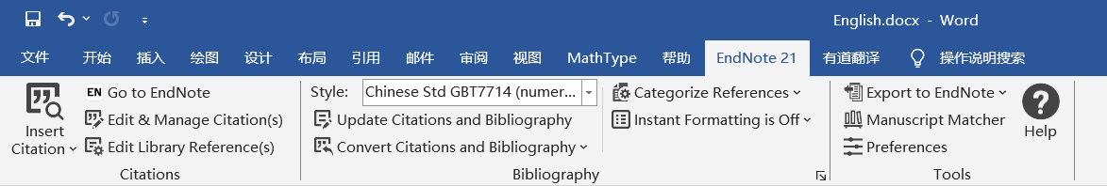

1. Locate and affirm the desired reference.
2. The citation is generated automatically with the selected format.

**For LaTeX Users:**

1. In Endnote 21, pick the reference you want.
2. Save as .bib file:

🞄 Click ‘File’ > ‘Export’

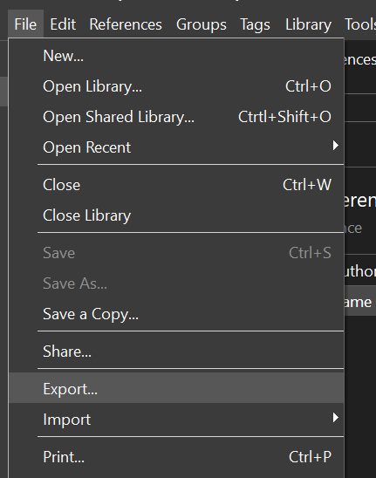

🞄For “Save as type”, choose Bibtex.

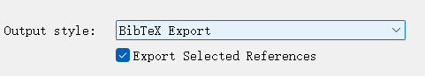

1. Drag the saved '.bib' file into your LaTeX project folder.
2. Use standard LaTeX citation commands(e.g., \cite{key}). The “key” is a name from the '.bib' file for that reference.
3. **Modifying Citation Formats:**
4. In Endnote 21, go to ‘Edit’ > ’Style’.

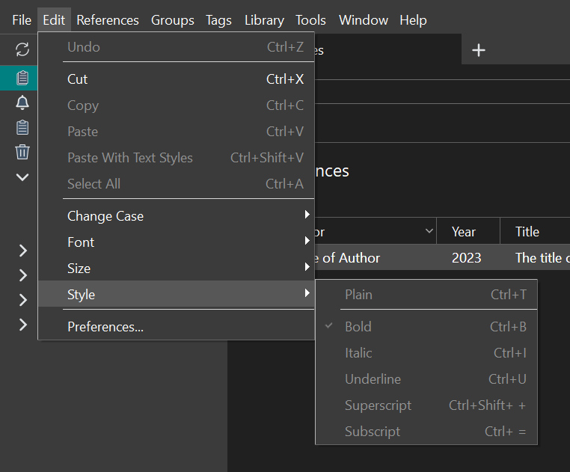

1. Choose the desired style or select Open Style Manager to find more styles.
2. Edit the style if needed and save your changes.
3. **Making a List of References:**

After you’ve added all your citations:

1. Click the Endnote tab at the top.
2. Click ‘Bibliography’ or ‘Insert Bibliography’.

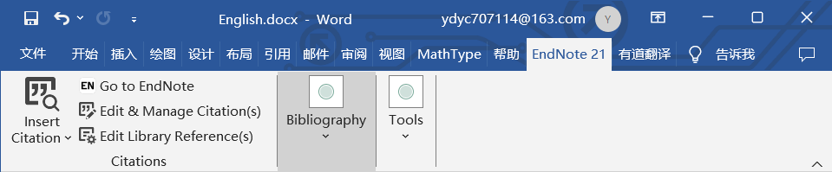

1. The list of all cited references will be generated automatically at the end of your document.