**Organizing references with Endnote­­**

1. **Groups**

The mechanism for organizing your EndNote library is called **‘Groups’**. Like a filing system, you can create a group and add references to that group manually. There are three different groups in EndNote.

* **Group:** A custom set of references
* **Smart Group:** A group based on the search result of an EndNote library. The references in a Smart Group are automatically added or removed according to the search parameters and the search result.
* **Group set:** A set of Groups.

1. **Creating a Group**
   1. In Endnote, select **Create Group** from the **Groups** menu. A new folder will appear in the **MY GROUPS** section in the left side of the user interface. Please feel free to rename the group name and press the **Enter** of **Return** key when finished.

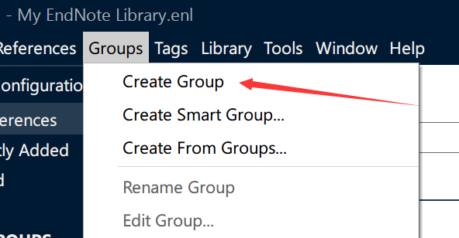

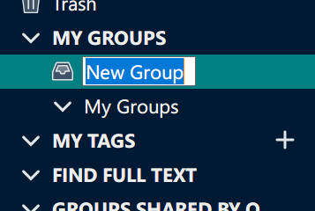

* 1. Select the references you want to add to your new group. By holding down the **CTRL** key and clicking on each reference you want with the mouse cursor, you can select multiple reference at one time. Or you can hold down the **SHIFT** key and click the first and the last reference to select a sequence of references. The selected references will be highlighted in blue.



* 1. right click one of the selected references, select ‘Add References To’ from the left click menu and then select the group that you want to add the selected references to.

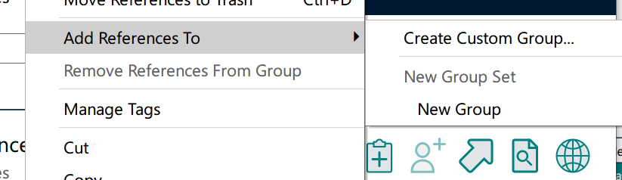

1. **Creating a Smart Group**
   1. In Endnote, select **Create Smart Group** from the **Groups** menu and name the Smart Group in the window appeared.

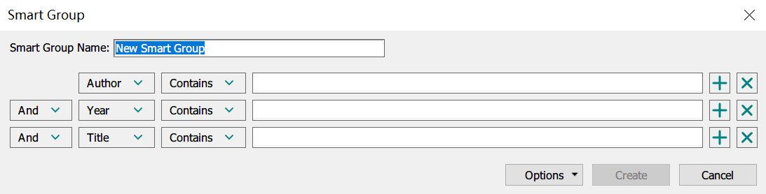

* 1. Still in the window appeared. Customize you search strategy and click **Create** to create the smart group as you need.
  2. All the references that fit your search strategy are added the smart group. It should be known that all the references you add to the library later will be added to the smart group automatically if they fit the rules.

1. **Creating a Group Set:**
   1. In Endnote, select **Create Group Set** from the **Groups** menu. name the new group set.
   2. **Drag and drop** a group into the group set. repeat the procedure until all the groups you want is successful added to the group set.



1. **Creating From Groups**
   1. In Endnote, select **Create From Groups** from the **Groups** menu. name the new group and customize the strategy. Click **Create**.

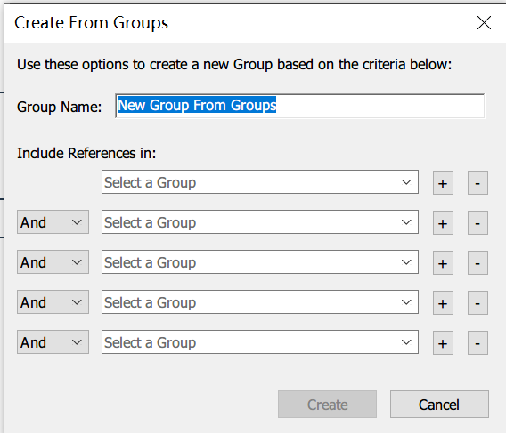

* 1. a new group is created according to your strategy and the existing groups. It should be known that all the references you add to the library later will be added to the group automatically if they fit the rules.